EXPERIMENT 11
MEMORY ALLOCATION METHODS
FIRST FIT
C PROGRAM
#include <stdio.h>
int main()
{
int blockSize[20], processSize[20];
int allocation[20];
int nb, np, i, j;
printf("Enter Number of Blocks: ");
scanf("%d",&nb);
printf("Enter Number of Processes: ");
scanf("%d",&np);
printf("Enter Block Sizes:\n");
for(i=0;i<nb;i++) scanf("%d",&blockSize[i]);
printf("Enter Process Sizes:\n");
for(i=0;i<np;i++) scanf("%d",&processSize[i]);
for(i=0;i<np;i++) allocation[i]=-1;
for(i=0;i<np;i++)
{
for(j=0;j<nb;j++)
{
if(blockSize[j] >= processSize[i])
{
allocation[i]=j;
blockSize[j]-=processSize[i];
break;
}
}
}
printf("\nProcess No\tProcess Size\tBlock No\n");
for(i=0;i<np;i++)
{
printf("%d\t\t%d\t\t",i+1,processSize[i]);
if(allocation[i]!=-1) printf("%d\n",allocation[i]+1);
else printf("Not Allocated\n");
}
return 0;
}
OUTPUT
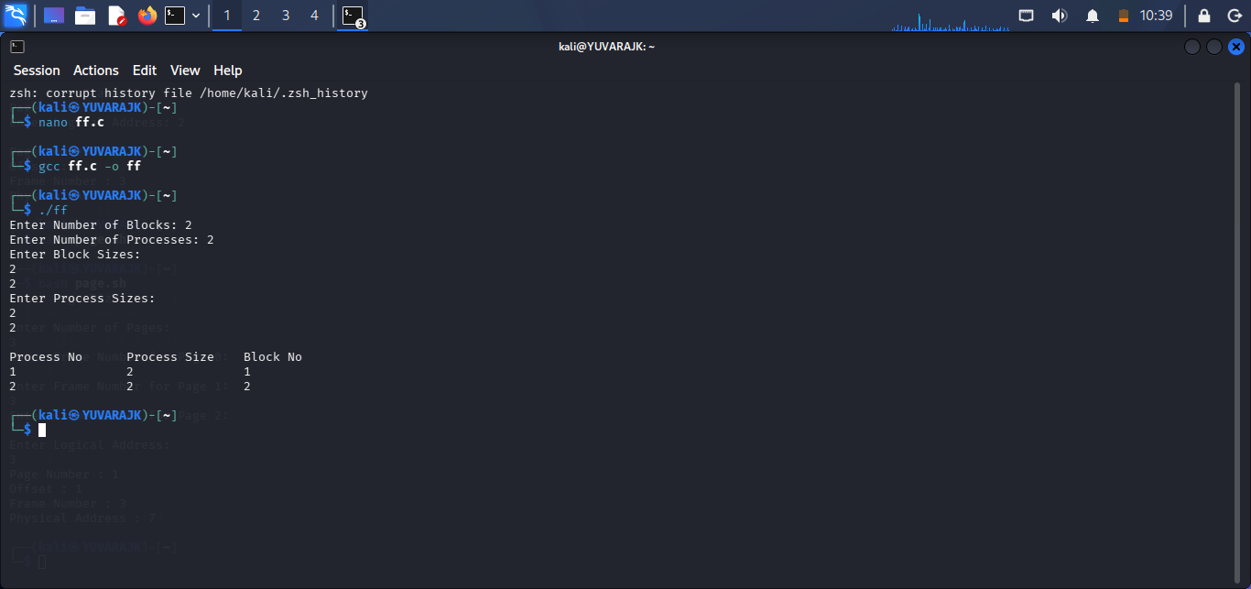
SHELL SCRIPT
#!/bin/bash
echo "First Fit Memory Allocation Demonstration"
blocks=(100 500 200 300 600)
processes=(212 417 112 426)
echo "Memory Blocks: ${blocks[@]}"
echo "Processes: ${processes[@]}"
echo "Allocation Performed Using First Fit"
OUTPUT
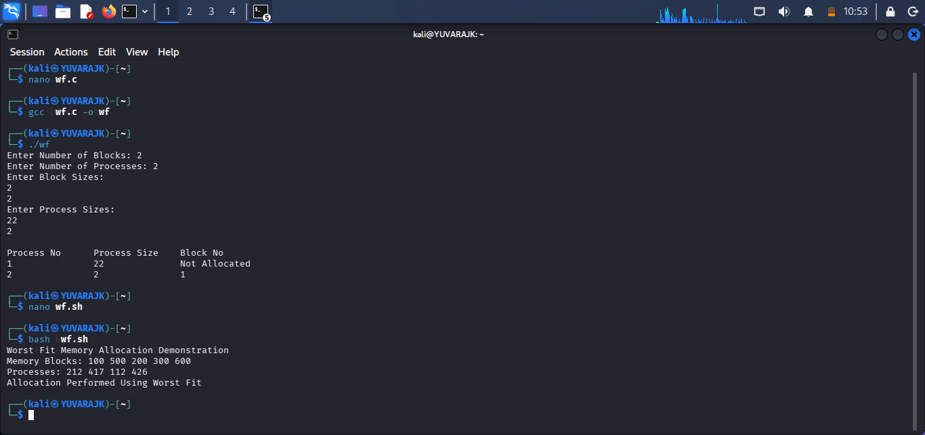

BEST FIT
C PROGRAM
#include <stdio.h>
int main()
{
int blockSize[20], processSize[20];
int allocation[20];
int nb,np,i,j,bestIdx;
printf("Enter Number of Blocks: ");
scanf("%d",&nb);
printf("Enter Number of Processes: ");
scanf("%d",&np);
printf("Enter Block Sizes:\n");
for(i=0;i<nb;i++) scanf("%d",&blockSize[i]);
printf("Enter Process Sizes:\n");
for(i=0;i<np;i++) scanf("%d",&processSize[i]);
for(i=0;i<np;i++) allocation[i]=-1;
for(i=0;i<np;i++)
{
bestIdx=-1;
for(j=0;j<nb;j++)
{
if(blockSize[j] >= processSize[i])
{
if(bestIdx==-1 || blockSize[j] < blockSize[bestIdx]) bestIdx=j;
}
}
if(bestIdx!=-1)
{
allocation[i]=bestIdx;
blockSize[bestIdx]-=processSize[i];
}
}
printf("\nProcess No\tProcess Size\tBlock No\n");
for(i=0;i<np;i++)
{
printf("%d\t\t%d\t\t",i+1,processSize[i]);
if(allocation[i]!=-1) printf("%d\n",allocation[i]+1);
else printf("Not Allocated\n");
}
return 0;
}
OUTPUT
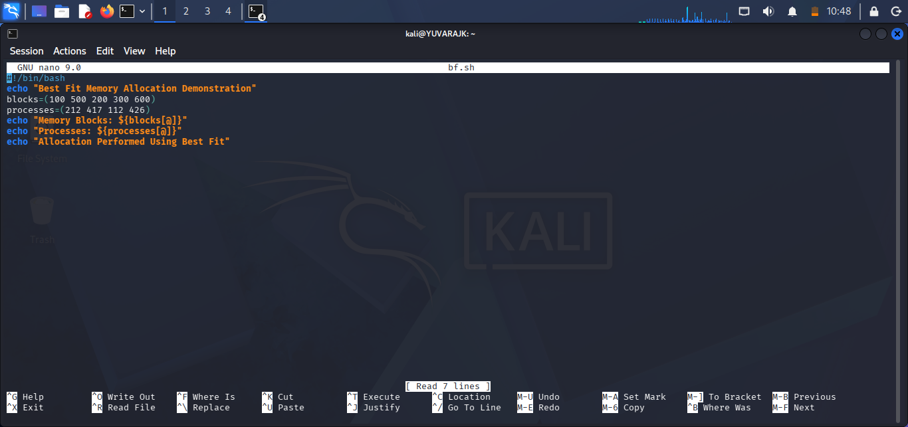
SHELL SCRIPT
#!/bin/bash
echo "Best Fit Memory Allocation Demonstration"
blocks=(100 500 200 300 600)
processes=(212 417 112 426)
echo "Memory Blocks: ${blocks[@]}"
echo "Processes: ${processes[@]}"
echo "Allocation Performed Using Best Fit"
OUTPUT
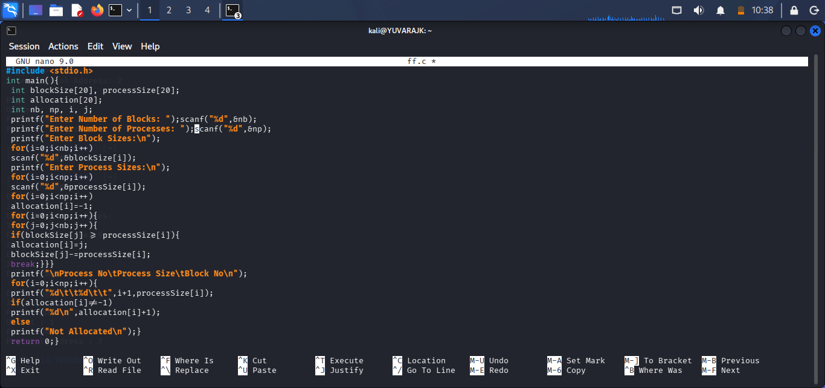

WORST FIT
C PROGRAM
#include <stdio.h>
int main()
{
int blockSize[20], processSize[20];
int allocation[20];
int nb,np,i,j,worstIdx;
printf("Enter Number of Blocks: ");
scanf("%d",&nb);
printf("Enter Number of Processes: ");
scanf("%d",&np);
printf("Enter Block Sizes:\n");
for(i=0;i<nb;i++) scanf("%d",&blockSize[i]);
printf("Enter Process Sizes:\n");
for(i=0;i<np;i++) scanf("%d",&processSize[i]);
for(i=0;i<np;i++) allocation[i]=-1;
for(i=0;i<np;i++)
{
worstIdx=-1;
for(j=0;j<nb;j++)
{
if(blockSize[j] >= processSize[i])
{
if(worstIdx==-1 || blockSize[j] > blockSize[worstIdx]) worstIdx=j;
}
}
if(worstIdx!=-1)
{
allocation[i]=worstIdx;
blockSize[worstIdx]-=processSize[i];
}
}
printf("\nProcess No\tProcess Size\tBlock No\n");
for(i=0;i<np;i++)
{
printf("%d\t\t%d\t\t",i+1,processSize[i]);
if(allocation[i]!=-1) printf("%d\n",allocation[i]+1);
else printf("Not Allocated\n");
}
return 0;
}
OUTPUT
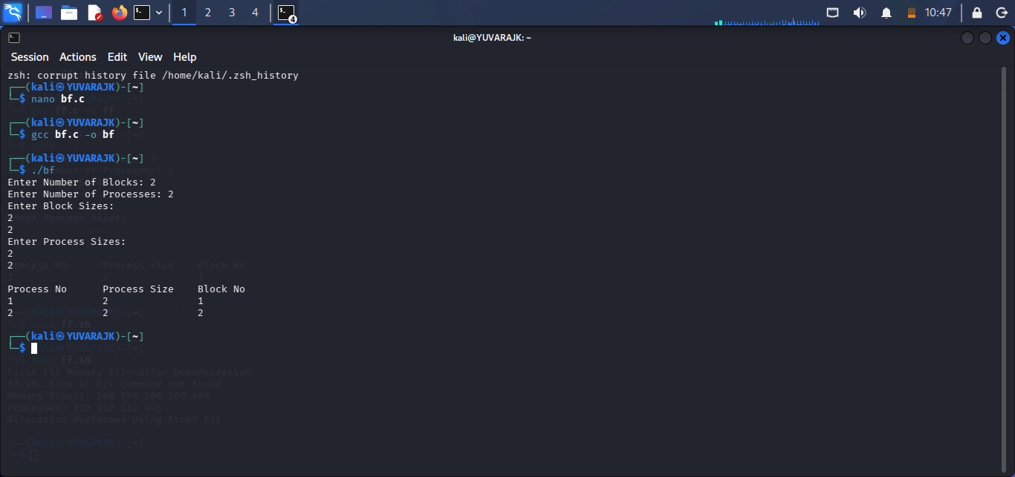
SHELL SCRIPT
#!/bin/bash
echo "Worst Fit Memory Allocation Demonstration"
blocks=(100 500 200 300 600)
processes=(212 417 112 426)
echo "Memory Blocks: ${blocks[@]}"
echo "Processes: ${processes[@]}"
echo "Allocation Performed Using Worst Fit"
OUTPUT
