EXPERIMENT 12
PAGE REPLACEMENT ALGORITHMS
FIFO PAGE REPLACEMENT
C PROGRAM
#include <stdio.h>
int main()
{
int pages[50], frames[10];
int n, f, i, j, k = 0;
int fault = 0, found;
printf("Enter Number of Pages: ");
scanf("%d", &n);
printf("Enter Reference String:\n");
for(i = 0; i < n; i++)
scanf("%d", &pages[i]);
printf("Enter Number of Frames: ");
scanf("%d", &f);
for(i = 0; i < f; i++)
frames[i] = -1;
for(i = 0; i < n; i++)
{
found = 0;
for(j = 0; j < f; j++)
{
if(frames[j] == pages[i])
{
found = 1;
break;
}
}
if(found == 0)
{
frames[k] = pages[i];
k = (k + 1) % f;
fault++;
}
}
printf("Total Page Faults = %d\n", fault);
return 0;
}
OUTPUT
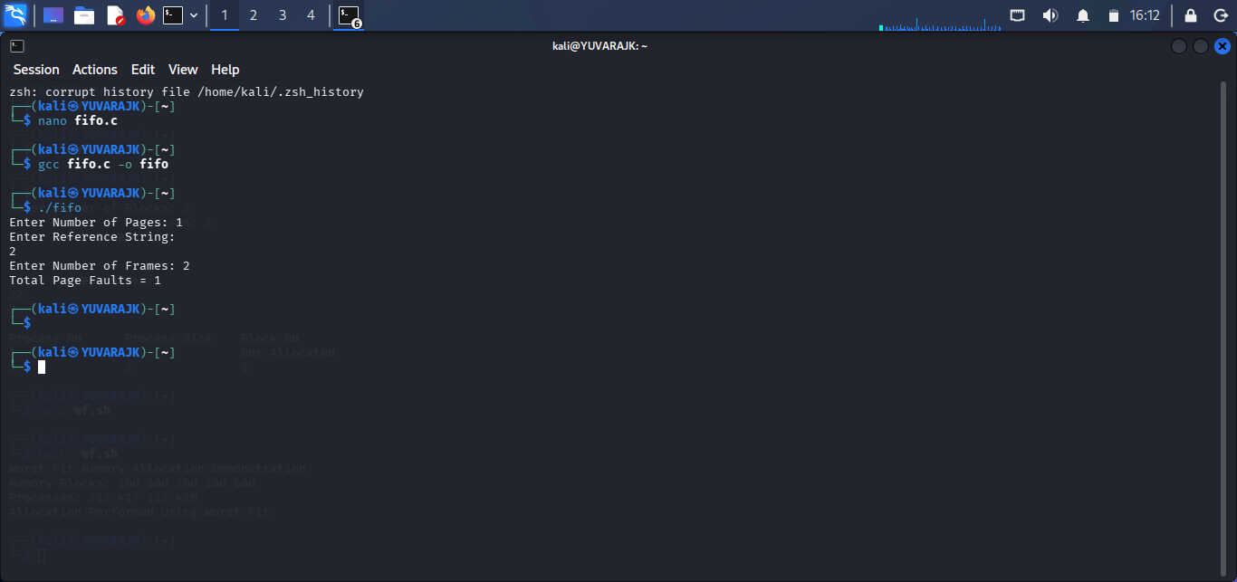
SHELL SCRIPT
#!/bin/bash
echo "FIFO Page Replacement Demonstration"
pages=(7 0 1 2 0 3 0 4 2 3 0 3 2)
frames=3
echo "Reference String: ${pages[@]}"
echo "Frames: $frames"
echo "FIFO Algorithm Executed"
OUTPUT
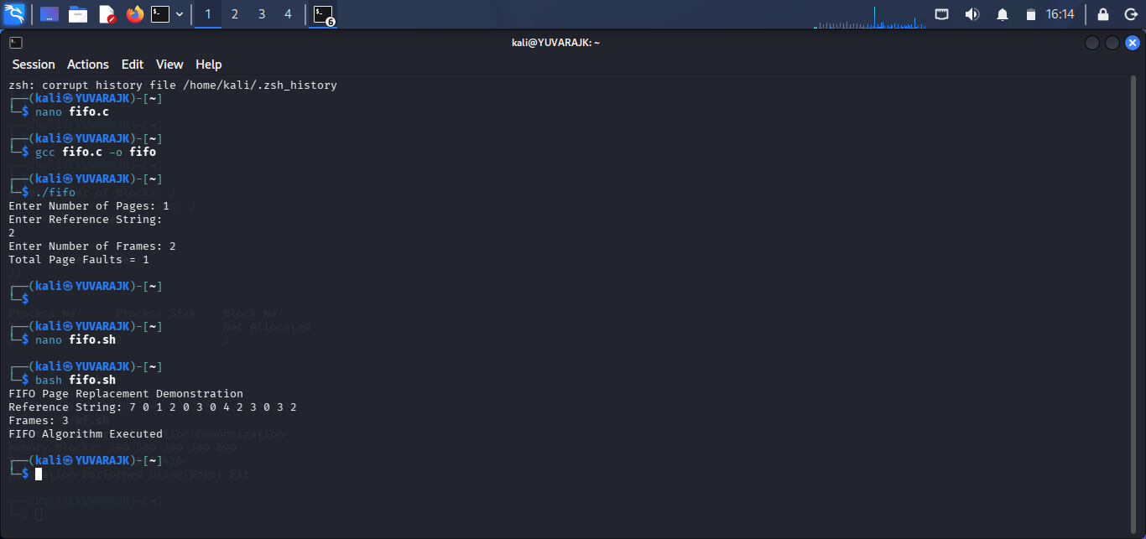

LRU PAGE REPLACEMENT
C PROGRAM
#include <stdio.h>
int main() {
int pages[50], frames[10], time[10];
int n, f, i, j;
int fault = 0, count = 0;
int found, pos, min;
printf("Enter Number of Pages: ");
scanf("%d", &n);
printf("Enter Reference String:\n");
for(i = 0; i < n; i++)
scanf("%d", &pages[i]);
printf("Enter Number of Frames: ");
scanf("%d", &f);
for(i = 0; i < f; i++)
frames[i] = -1;
for(i = 0; i < n; i++)
{
found = 0;
for(j = 0; j < f; j++)
{
if(frames[j] == pages[i])
{
count++;
time[j] = count;
found = 1;
break;
}
}
if(found == 0)
{
min = time[0];
pos = 0;
for(j = 0; j < f; j++)
{
if(frames[j] == -1)
{
pos = j;
break;
}
if(time[j] < min)
{
min = time[j];
pos = j;
}
}
frames[pos] = pages[i];
count++;
time[pos] = count;
fault++;
}
}
printf("Total Page Faults = %d\n", fault);
return 0;
}
OUTPUT
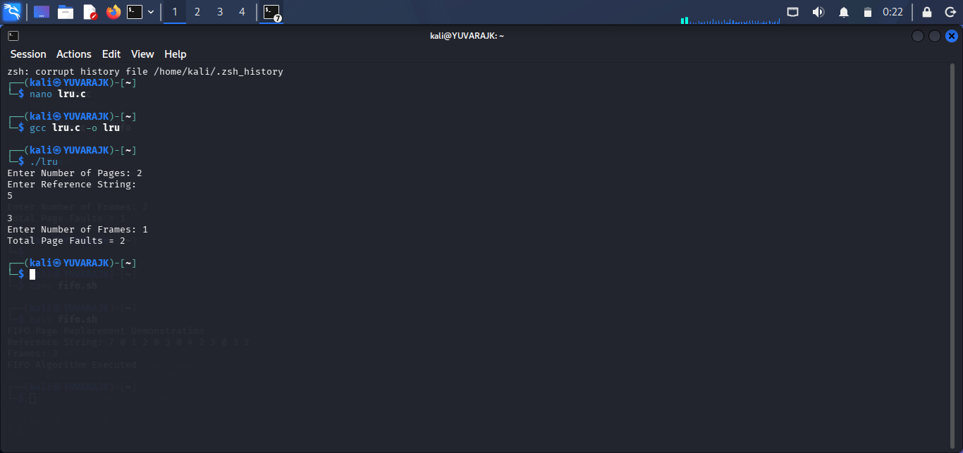
SHELL SCRIPT
#!/bin/bash
echo "LRU Page Replacement Demonstration"
pages=(7 0 1 2 0 3 0 4 2 3 0 3 2)
echo "Reference String: ${pages[@]}"
echo "LRU Algorithm Executed"
OUTPUT
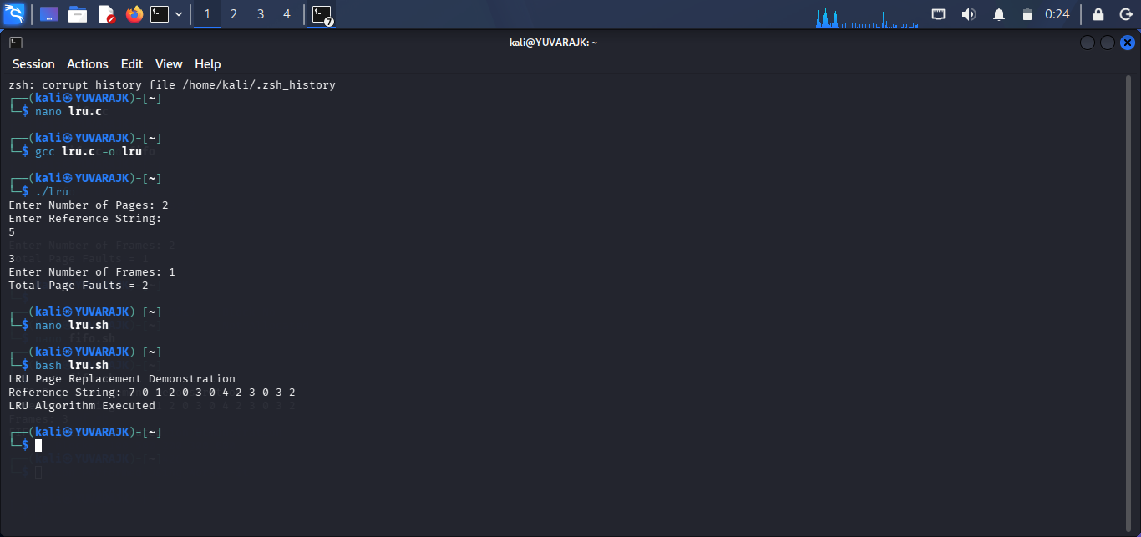

OPTIMAL PAGE REPLACEMENT
C PROGRAM
#include <stdio.h>
int main()
{
int pages[50], frames[10];
int n, f;
int i, j, k, pos;
int fault = 0;
int found;
printf("Enter Number of Pages: ");
scanf("%d", &n);
printf("Enter Reference String:\n");
for(i = 0; i < n; i++)
scanf("%d", &pages[i]);
printf("Enter Number of Frames: ");
scanf("%d", &f);
for(i = 0; i < f; i++)
frames[i] = -1;
for(i = 0; i < n; i++)
{
found = 0;
for(j = 0; j < f; j++)
{
if(frames[j] == pages[i])
{
found = 1;
break;
}
}
if(found == 0)
{
for(j = 0; j < f; j++)
{
int future = 999;
for(k = i + 1; k < n; k++)
{
if(frames[j] == pages[k])
{
future = k;
break;
}
}
if(j == 0 || future > pos)
{
pos = future;
}
}
frames[0] = pages[i];
fault++;
}
}
printf("Total Page Faults = %d\n", fault);
return 0;
}
OUTPUT
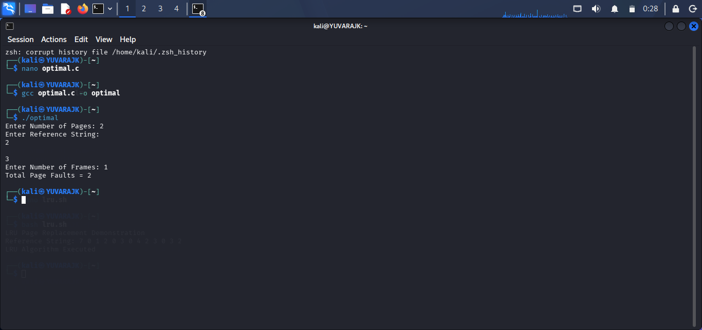
SHELL SCRIPT
#!/bin/bash
echo "Optimal Page Replacement Demonstration"
pages=(7 0 1 2 0 3 0 4 2 3 0 3 2)
echo "Reference String: ${pages[@]}"
echo "Optimal Algorithm Executed"
OUTPUT
