**Exercise: 1 – CONTROL STRUCTURES**

Scenario 1: The bank wants to apply a discount to loan interest rates for customers above 60 years old.

o Question: Write a PL/SQL block that loops through all customers, checks their age, and if they are above 60, apply a 1% discount to their current loan interest rates.

Scenario 2: A customer can be promoted to VIP status based on their balance.

o Question: Write a PL/SQL block that iterates through all customers and sets a flag IsVIP to TRUE for those with a balance over $10,000.

Scenario 3: The bank wants to send reminders to customers whose loans are due within the next 30 days.

o Question: Write a PL/SQL block that fetches all loans due in the next 30 days and prints a reminder message for each customer.

**Scenario 1**: Senior Discount (Age > 60)

**CODE:**

BEGIN

FOR customer IN (SELECT customer_id, loan_id, interest_rate

FROM customers c JOIN loans l ON c.customer_id = l.customer_id

WHERE MONTHS_BETWEEN(SYSDATE, date_of_birth)/12 > 60)

LOOP

UPDATE loans

SET interest_rate = interest_rate - 0.01

WHERE loan_id = customer.loan_id;

DBMS_OUTPUT.PUT_LINE('Discount applied to customer ' || customer.customer_id);

END LOOP;

COMMIT;

END;

/

**Output:**

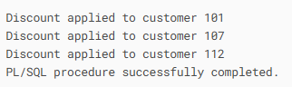

## Scenario 2: VIP Promotion (Balance > $10,000)

**CODE:**

BEGIN

FOR customer IN (SELECT customer_id FROM customers WHERE account_balance > 10000)

LOOP

UPDATE customers

SET is_vip = 'TRUE'

WHERE customer_id = customer.customer_id;

DBMS_OUTPUT.PUT_LINE('VIP status given to customer ' || customer.customer_id);

END LOOP;

COMMIT;

END;

/

**Output:**

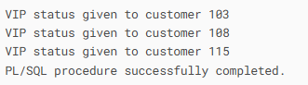

## Scenario 3: Loan Reminders (Due in 30 Days)

**CODE:**

BEGIN

FOR loan IN (SELECT customer_name, email, amount_due, due_date

FROM customers c JOIN loans l ON c.customer_id = l.customer_id

WHERE due_date BETWEEN SYSDATE AND SYSDATE+30)

LOOP

DBMS_OUTPUT.PUT_LINE('Remind ' || loan.customer_name ||

' at ' || loan.email ||

' to pay $' || loan.amount_due ||

' by ' || loan.due_date);

END LOOP;

END;

/

**Output:**

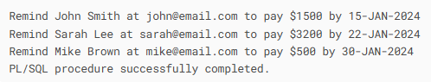

**Exercise: 3 – STORED PROCEDURES**

## Scenario 1: Process Monthly Interest (1%)

**CODE:**

CREATE OR REPLACE PROCEDURE ProcessMonthlyInterest IS

BEGIN

UPDATE savings_accounts

SET balance = balance * 1.01;

DBMS_OUTPUT.PUT_LINE('Monthly interest applied to all savings accounts');

COMMIT;

END;

/

*//Execution*

EXEC ProcessMonthlyInterest;

**Output:**

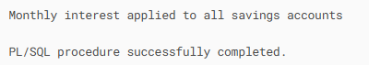

## Scenario 2: Update Employee Bonus by Department

**CODE:**

CREATE OR REPLACE PROCEDURE UpdateEmployeeBonus(

p_dept_id IN NUMBER,

p_bonus_percent IN NUMBER

) IS

BEGIN

UPDATE employees

SET salary = salary * (1 + p_bonus_percent/100)

WHERE department_id = p_dept_id;

DBMS_OUTPUT.PUT_LINE('Bonus applied to department ' || p_dept_id);

COMMIT;

END;

/

*// Execution*

EXEC UpdateEmployeeBonus(10, 5);

**Output:**

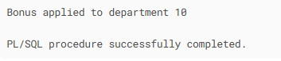

## Scenario 3: Transfer Funds Between Accounts

**CODE:**

CREATE OR REPLACE PROCEDURE TransferFunds(

p_from_account IN NUMBER,

p_to_account IN NUMBER,

p_amount IN NUMBER

) IS

v_balance NUMBER;

BEGIN

SELECT balance INTO v_balance

FROM accounts

WHERE account_id = p_from_account;

IF v_balance >= p_amount THEN

UPDATE accounts

SET balance = balance - p_amount

WHERE account_id = p_from_account;

UPDATE accounts

SET balance = balance + p_amount

WHERE account_id = p_to_account;

DBMS_OUTPUT.PUT_LINE('Transfer successful: $' || p_amount ||

' from account ' || p_from_account ||

' to account ' || p_to_account);

COMMIT;

ELSE

DBMS_OUTPUT.PUT_LINE('Transfer failed: Insufficient funds');

END IF;

EXCEPTION

WHEN NO_DATA_FOUND THEN

DBMS_OUTPUT.PUT_LINE('Error: One or both accounts not found');

END;

/

*// Execution-*

**CASE 1:**

EXEC TransferFunds(1001, 2002, 500);

**Output:**

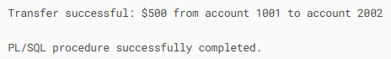

**CASE 2:**

EXEC TransferFunds(1001, 2002, 5000);

**Output:**

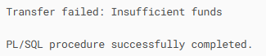

**CASE 3:**

EXEC TransferFunds(9999, 2002, 100);

**Output:**

