Hybrid AI for Stock Markets Transformers & QINN
In propose work we have used Hybrid Transformer by combining Time series stock data with GPT features. GPT features will be extracted from stock news data such as sentiments and events and all those GPT features will be combined with Time series stock data and get trained with Transformer model to form a hybrid AI model.
Another model which we have experimented is QINN (Quantum Inspired Neural Network) a type of forecasting that uses a neural network model inspired by quantum computing principles to predict future values based on historical data.
Among both algorithms QINN is giving better accuracy in terms of R2Score. Both algorithms performance is measured in terms of RMSE and R2score. RMSE refers to difference between true and predicted values so the lower the difference the better is the model. R2score refers to accuracy of forecasting model whose value closer to 1 can be consider as best.
We have code this project using JUPYTER notebook and below are the code and output screens with blue colour comments
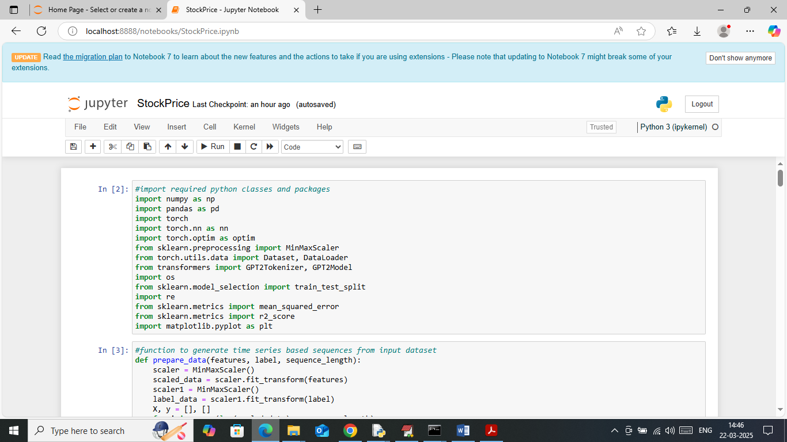
In above screen importing required python classes and packages
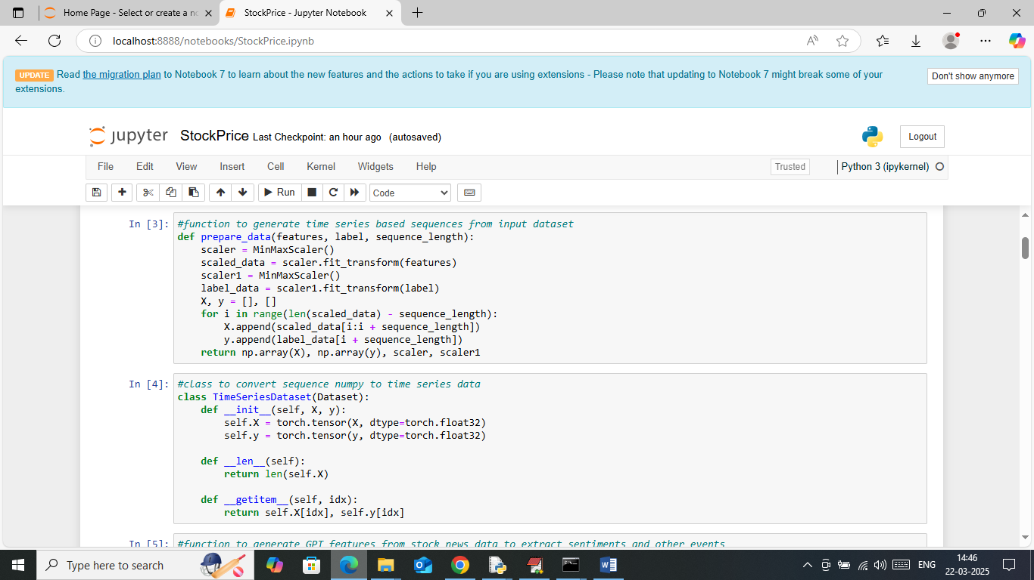
In above screen defining function to generated sequences from dataset and then converting those sequences into Time series
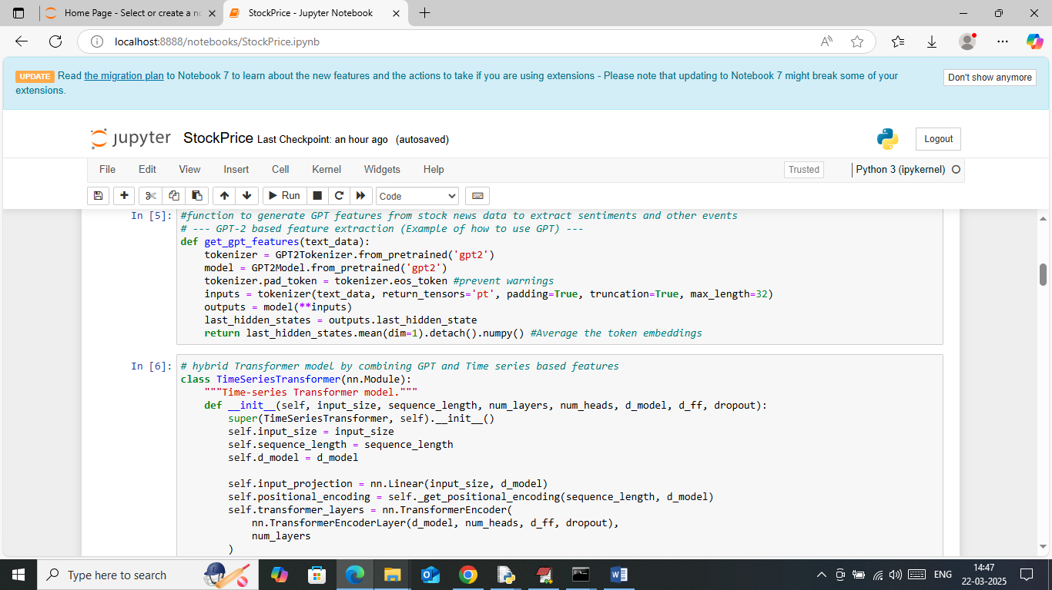
In above screen in first block defining function to extract GPT features from stock news data and then creating Time series class to train transformer
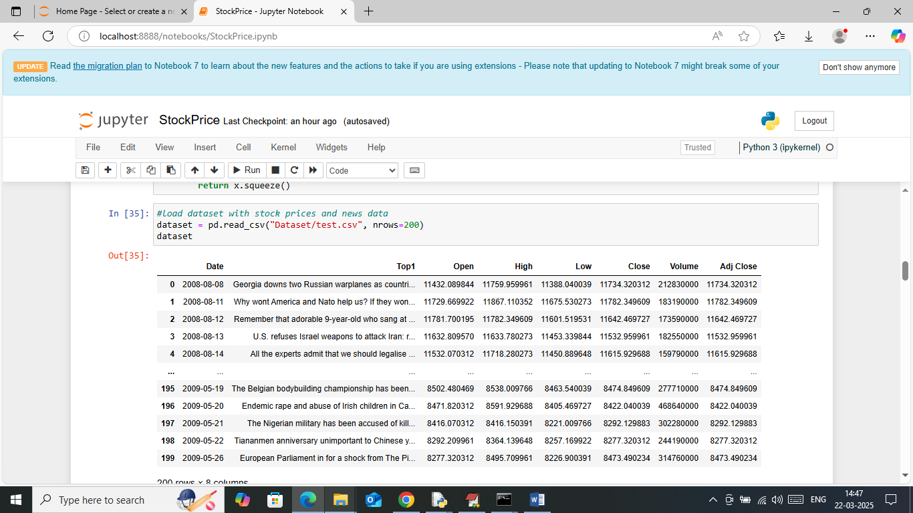
In above screen loading stock data which has news and stock prices values
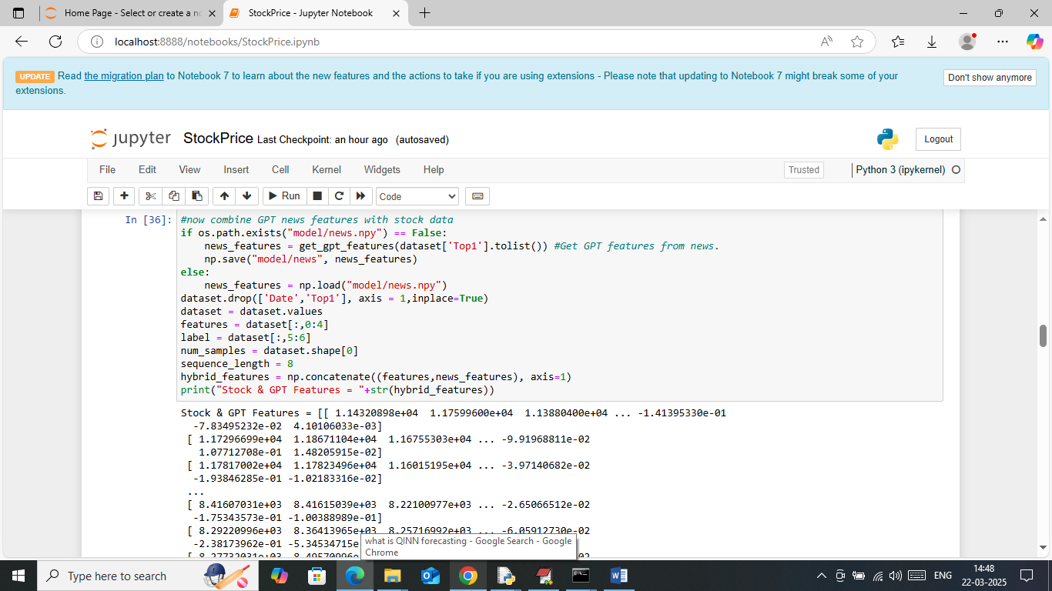
In above screen processing dataset to extract GPT features and stock values and then displaying extracted features
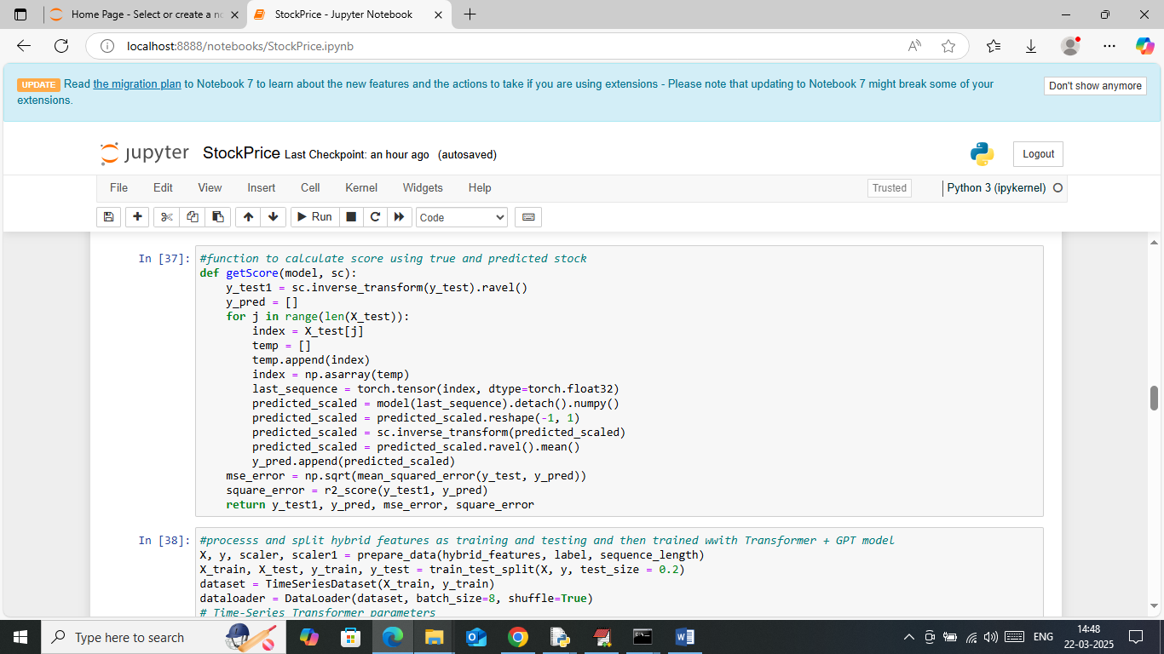
In above screen defining function to calculate R2score and RMSE between true and predicted values
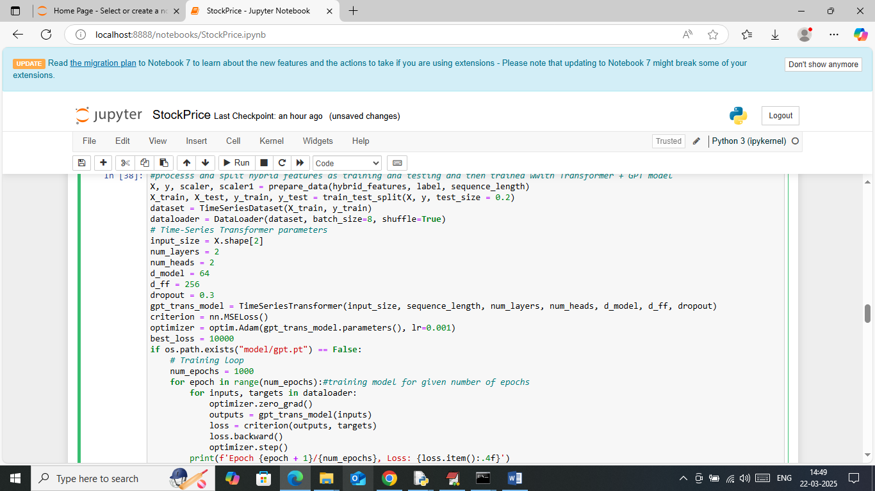
In above screen creating time series transformer model object and then training model with given number of epochs
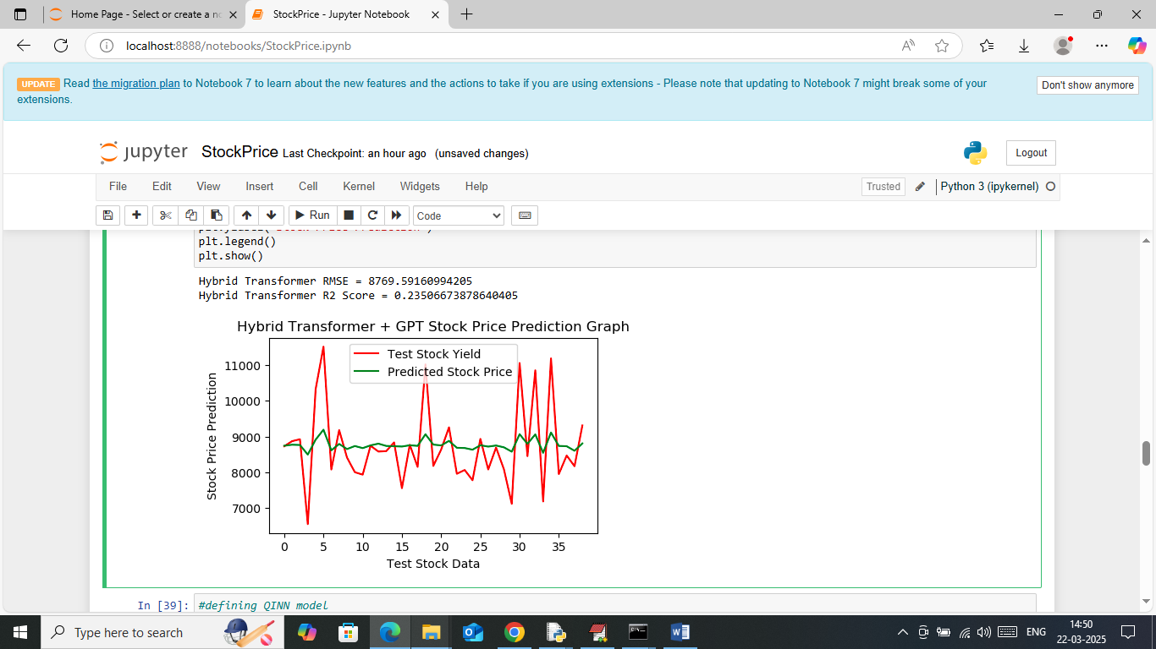
In above screen Hybrid Transformer got 23% R2score and can see RMSE values also. In above graph x-axis represents ‘Number of days’ and y-axis represents Stock Prices and then red line represents True Prices and green line represents Predicted Prices. In above graph can see there is huge gap between true and predicted values so transformer is not accurate
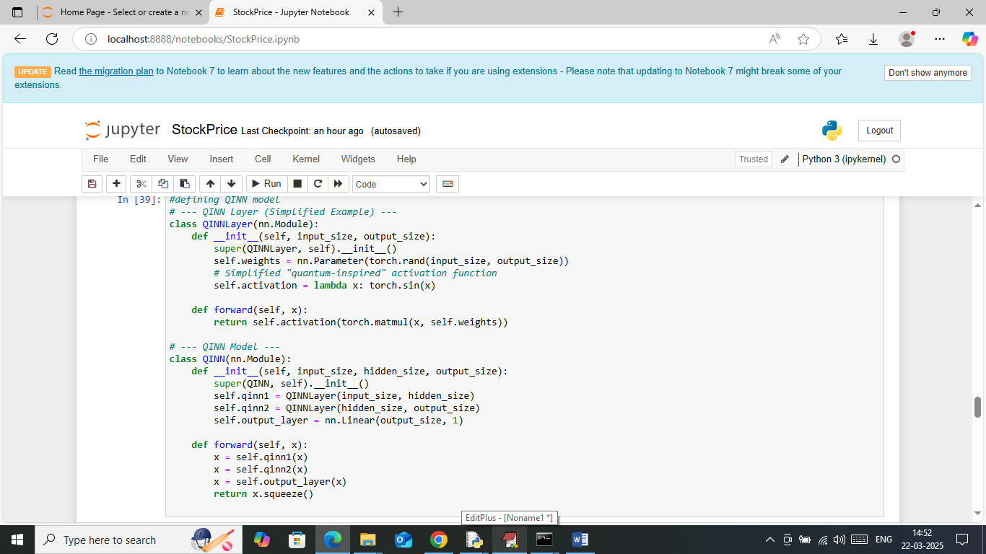
In above screen defining QINN model
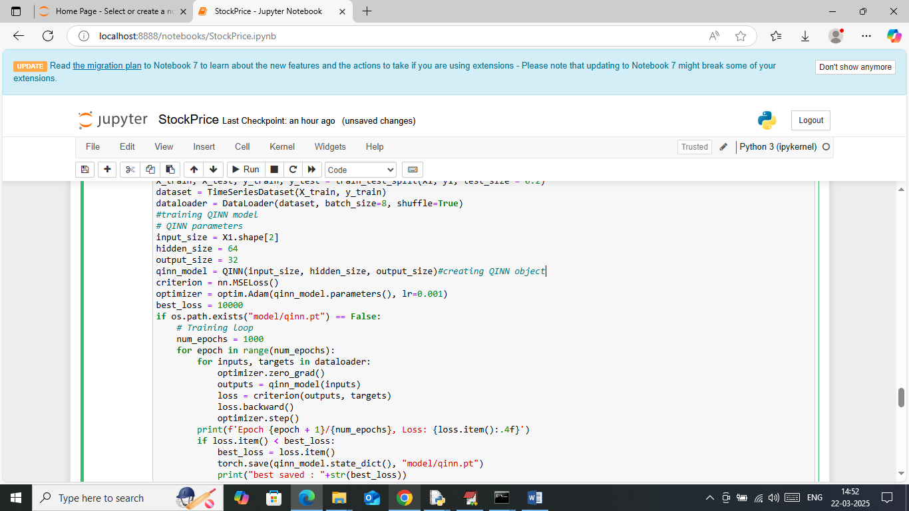
In above screen training QINN model for given number of epochs
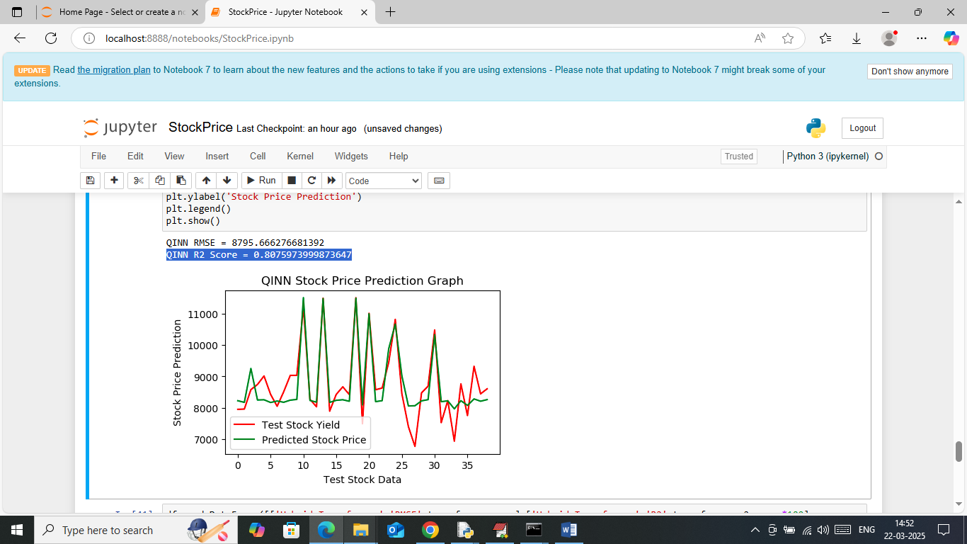
In above screen QINN got 80% R2score and in graph can see both predicted and true values are fully overlapping with minor gap. So QINN is best compare to Transformer
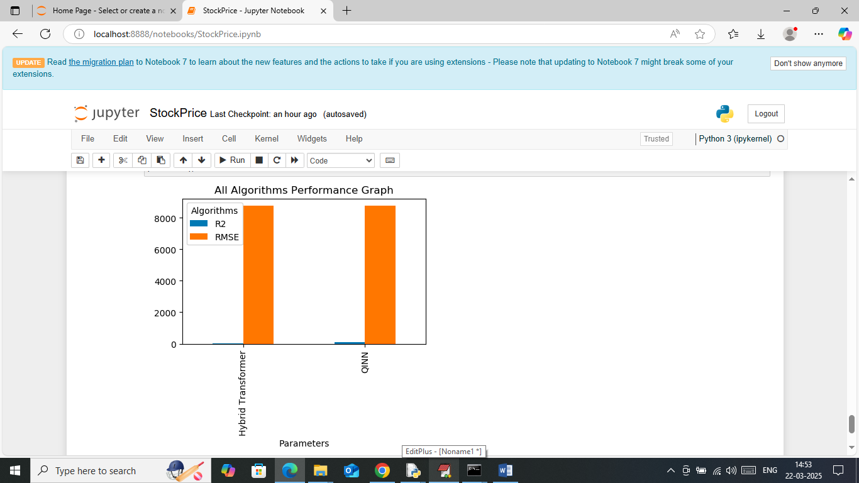
In above screen showing RMSE and R2score comparison of both algorithms where QINN got less RMSE and high R2score and Transformer get high RMSE and less R2 score.

