ADVANCED DATA ANALYSIS AND
VISUALIZATION IN LOGISTICS
Exploratory Analysis of Shipment Performance for SwiftCart Logistics
Week 3 Task — EDA & Visualization Report
Prepared for: Data Science / Logistics Analytics Internship
Date: September 26, 2026

Executive Summary
This report builds on the Week 1 strategic plan and the Week 2 cleaned dataset for SwiftCart Logistics by carrying out an exploratory data analysis (EDA) of a simulated shipment dataset and presenting the results through a series of visualizations. The dataset covers 5,000 shipments across five regions, three carriers, and three transport modes over a twelve-month period, capturing delivery time, transportation cost, shipment volume, and on-time performance. The analysis calculates central tendencies and distributions for the key metrics, examines correlations between distance, cost, and delivery performance, and visualizes the results using histograms, boxplots, scatter plots, a correlation heatmap, a trend line, and a comparative bar chart. The headline finding is that on-time delivery performance is not evenly distributed — it is heavily concentrated in one transport mode and two regions — which points to a specific, actionable bottleneck rather than a general capacity problem.

1. Data Simulation: Dataset Structure
Since this task calls for a hypothetical dataset, a synthetic shipment-level dataset was generated in Python (numpy/pandas) to resemble what SwiftCart's order and telematics systems would realistically produce. Distances, transport-mode speed profiles, regional congestion effects, and cost-per-kilometer rates were parameterized so the resulting relationships mirror real-world logistics dynamics rather than being purely random. The table below defines the dataset schema.
Variable | Description
shipment_id | Unique identifier for each shipment
order_date | Date the shipment was placed (Jan–Dec 2025)
region | Destination region: North, South, East, West, Central
carrier | Carrier fulfilling the shipment (in-house fleet or 1 of 2 partners)
transport_mode | Road, Rail, or Air
distance_km | Distance from distribution center to delivery point
shipment_volume_units | Number of units in the shipment
delivery_time_hrs | Actual time from dispatch to delivery
promised_time_hrs | Delivery window promised to the customer
transportation_cost | Total cost to move the shipment (USD)
on_time_delivery | 1 if delivered within the promised window, else 0
A short preview of the simulated data, generated with the snippet below:
import numpy as np, pandas as pd
rng = np.random.default_rng(42)

N = 5000
regions = ['North', 'South', 'East', 'West', 'Central']
modes = ['Road', 'Rail', 'Air']

# Distance depends on region; delivery time depends on distance,
# transport-mode speed, and a region-specific congestion factor
region_base_dist = {'North': 65, 'South': 80, 'East': 55, 'West': 90, 'Central': 30}
mode_speed_kmh = {'Road': 38, 'Rail': 55, 'Air': 420}
region_delay_factor = {'North': 1.0, 'South': 1.05, 'East': 1.35, 'West': 1.4, 'Central': 0.95}

# ... full generation logic builds distance, cost, delivery time,
# promised time, and on-time flag from these parameters
df.to_csv('shipments.csv', index=False)

2. Exploratory Data Analysis

2.1 Central Tendency and Spread
Summary statistics were computed for the two core numeric metrics. Delivery time has a mean of 8.2 hours and a median of 7.8 hours, with a standard deviation of 5.2 hours — the small gap between mean and median indicates a right-skewed distribution with a long tail of slow deliveries rather than a symmetric spread. Transportation cost has a mean of $105.88 and a median of $95.79, again right-skewed, reflecting a smaller number of high-cost, long-distance or air shipments pulling the average upward.
Metric | Mean | Median | Std. Dev. | Min | Max
Delivery Time (hrs) | 8.21 | 7.76 | 5.15 | 0.95 | 67.52
Transportation Cost ($) | 105.88 | 95.79 | 52.30 | 15.23 | 462.47
print(df[['delivery_time_hrs', 'transportation_cost']].describe())
print('Skew (delivery_time_hrs):', df['delivery_time_hrs'].skew())

2.2 Distribution Shape and Outliers
The histogram below confirms the right skew visually: most shipments cluster between 4 and 11 hours, with a thin tail extending out to nearly 68 hours. Applying the IQR method (upper bound = Q3 + 1.5×IQR) flags 121 shipments (about 2.4% of the dataset) as statistical outliers — these are treated as genuine service failures worth investigating rather than data errors, since Week 2's cleaning pipeline already removed invalid records.
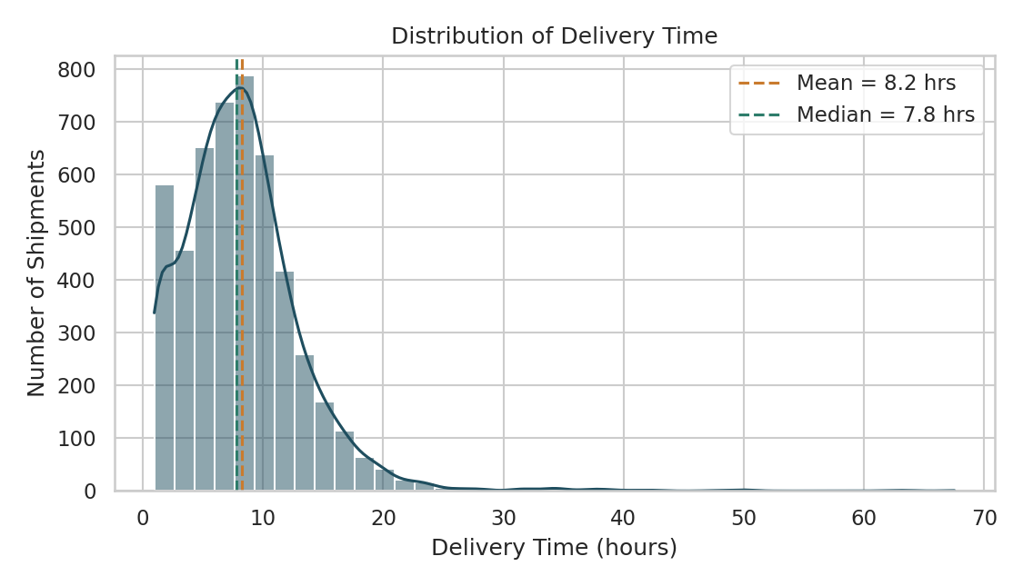
Figure 1. Distribution of delivery time across all shipments, with mean and median marked.
q1, q3 = df['delivery_time_hrs'].quantile([0.25, 0.75])
iqr = q3 - q1
upper_bound = q3 + 1.5 * iqr
outliers = df[df['delivery_time_hrs'] > upper_bound]
print(f'{len(outliers)} outlier shipments above {upper_bound:.1f} hrs')
Breaking delivery time down by transport mode with a boxplot makes the source of that tail clear: Road shipments have both a higher median delivery time and by far the widest spread of outliers, while Air shipments are fast and tightly clustered.
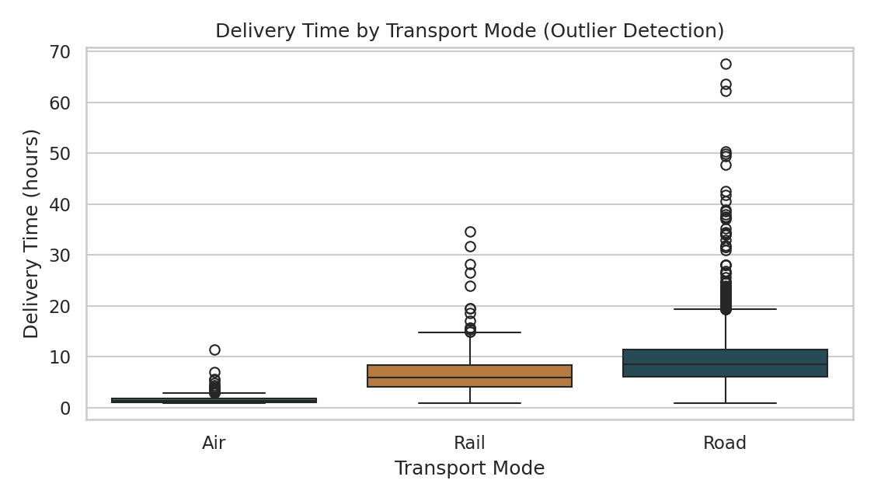
Figure 2. Delivery time distribution by transport mode, showing Road as the primary source of extreme delays.
import seaborn as sns
sns.boxplot(data=df, x='transport_mode', y='delivery_time_hrs',
order=['Air', 'Rail', 'Road'])

2.3 Trend Over Time
Aggregating shipments by month shows that both shipment volume (roughly 380–465 shipments/month) and average transportation cost (roughly $103–$108) stay fairly stable across the year, with no strong seasonal pattern or growth trend in this simulated year. This is a useful negative finding: it suggests that, in this dataset at least, delivery performance issues are structural (mode- and region-based) rather than driven by seasonal demand spikes.
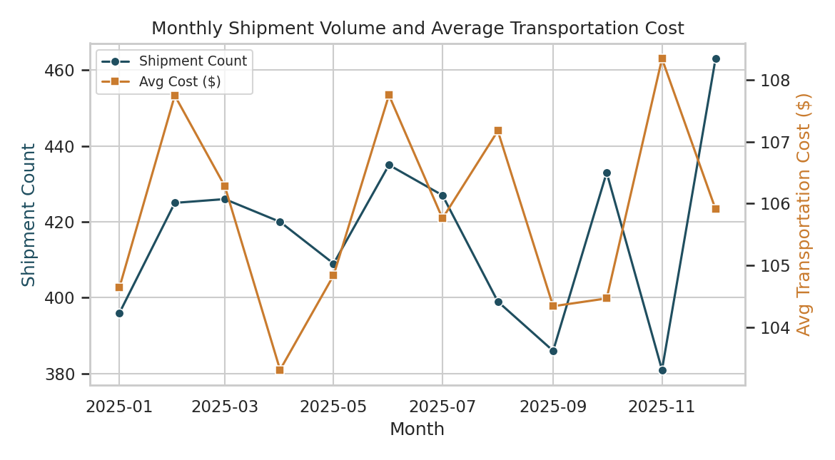
Figure 3. Monthly shipment volume and average transportation cost, Jan–Dec 2025.
monthly = df.groupby(df['order_date'].dt.to_period('M')).agg(
shipments=('shipment_id', 'count'),
avg_cost=('transportation_cost', 'mean'),
).reset_index()

2.4 Relationships Between Variables
A scatter plot of transportation cost against distance, colored by transport mode, shows three clearly separated bands: Air is the steepest and most expensive per kilometer, Road sits in the middle, and Rail is the cheapest per kilometer at a given distance. Within each mode the relationship is close to linear, which is expected since cost was modeled as approximately proportional to distance — but the separation between bands is the more actionable insight, since it quantifies the cost premium of choosing a faster mode.
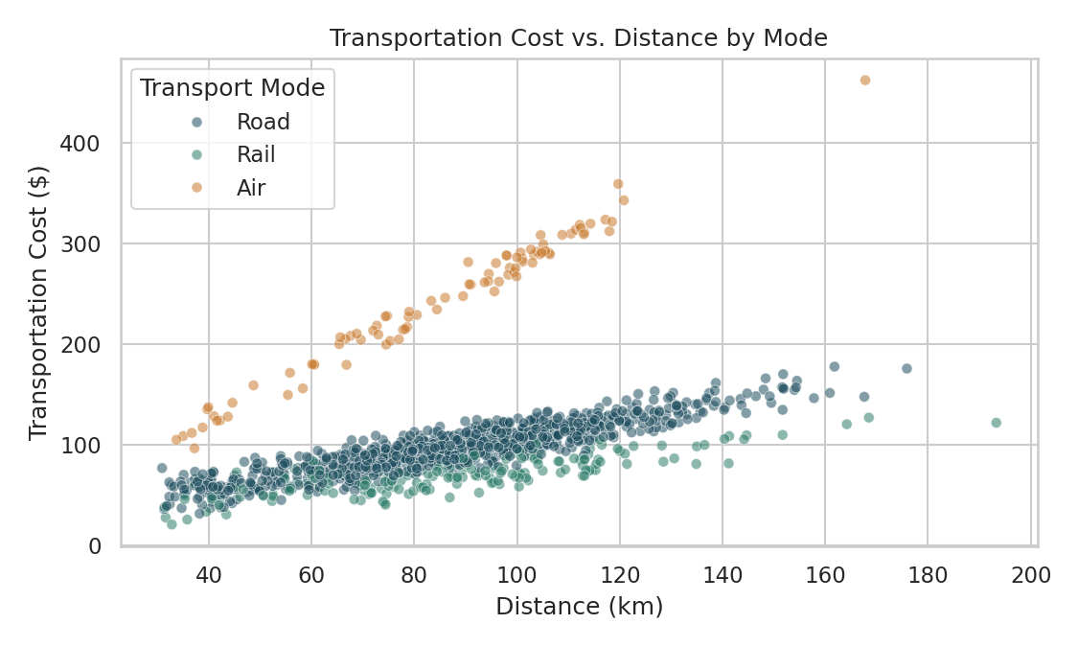
Figure 4. Transportation cost vs. distance, colored by transport mode.
The correlation matrix quantifies these relationships across all numeric variables at once. Delivery time correlates positively with distance (r = 0.57) and negatively with on-time delivery (r = -0.67), confirming that longer, slower shipments are the main driver of missed delivery windows. Distance also correlates negatively with on-time delivery (r = -0.47), while promised time has a weak positive correlation with on-time delivery (r = 0.24), suggesting that more generous delivery windows do help but are not, on their own, enough to offset the effect of mode and distance.
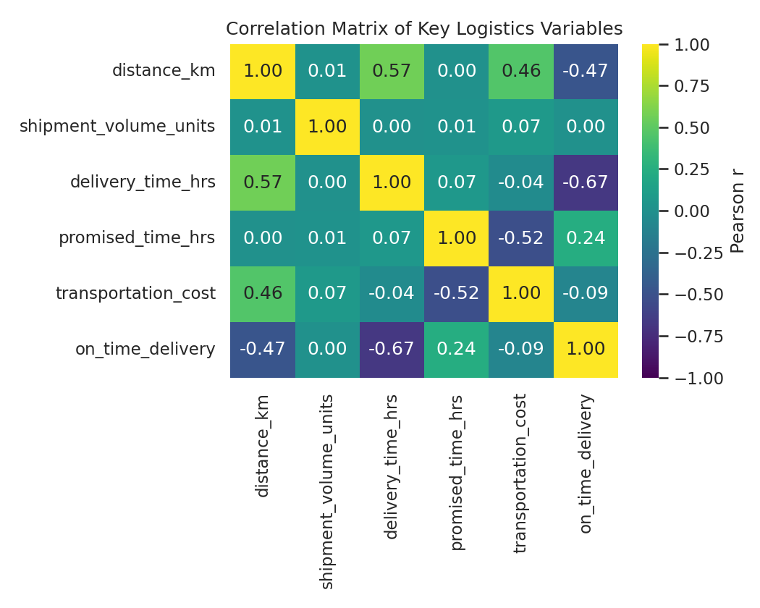
Figure 5. Correlation matrix of key numeric logistics variables.
num_cols = ['distance_km', 'shipment_volume_units', 'delivery_time_hrs',
'promised_time_hrs', 'transportation_cost', 'on_time_delivery']
corr = df[num_cols].corr()
sns.heatmap(corr, annot=True, cmap='viridis', vmin=-1, vmax=1)

2.5 On-Time Performance by Region
On-time delivery rate varies dramatically by region: Central leads at 95.4% (above the 95% target), North follows at 73.6%, and East, South, and West fall well short at 58.8%, 55.0%, and 26.7% respectively. Combined with the mode-level finding in Section 2.2, this points to a specific bottleneck: Road-mode shipments into the East, South, and especially West regions are the dominant source of missed delivery windows, rather than the network as a whole underperforming.
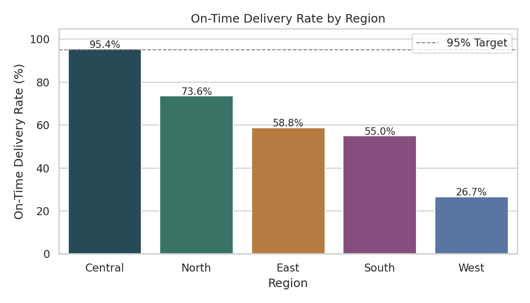
Figure 6. On-time delivery rate by region, with the 95% service-level target shown as a reference line.
region_otd = df.groupby('region')['on_time_delivery'].mean().sort_values(ascending=False) * 100
sns.barplot(x=region_otd.index, y=region_otd.values)

3. Analytical Insights and Recommendations
Taken together, the EDA and visualizations support four concrete conclusions:
- Road transport is the primary bottleneck. Road shipments show the highest median delivery time and almost all of the extreme delay outliers, while Air and Rail stay well within their promised windows. This suggests the delivery-window promise for Road shipments may be set too tight relative to realistic road transit times, or that road routes/scheduling need optimization (tying directly back to the Week 1 routing-optimization roadmap).
- Underperformance is concentrated in specific regions. West, South, and East show on-time rates between 27% and 59%, far below the 95% target, while Central and North perform acceptably. This is a targeting opportunity: operational fixes (added road capacity, revised promised windows, or a shift toward rail for mid-distance shipments) can be piloted in the worst-performing regions first rather than rolled out network-wide.
- Cost and speed trade off predictably by mode. The distance-cost scatter plot shows Air costs roughly 2–3x Rail per kilometer at comparable distances. This gives planners a quantified basis for deciding when the on-time-rate improvement from shifting a shipment to Air or Rail is worth the added cost — particularly for the worst-performing regions identified above.
- Delay is a distance/mode problem, not a volume problem. Shipment volume showed essentially no correlation with delivery time, cost, or on-time performance, and monthly shipment counts were stable with no clear trend. This rules out demand surges as the cause of current service issues and points analytical effort toward routing and mode assignment rather than capacity expansion.
Recommended next steps: (1) re-evaluate promised delivery windows for Road shipments in the West, South, and East regions against actual transit-time data; (2) pilot a partial mode shift (Road to Rail) for mid-distance shipments in those regions where the cost premium is modest; and (3) feed the region- and mode-specific delay patterns identified here into the clustering and route-optimization models proposed in the Week 1 roadmap, so that the routing solution is built around the bottlenecks this analysis actually found rather than a generic assumption.

4. Methodology and Tooling Notes
All analysis was performed in Python. pandas was used for aggregation, grouping, and correlation calculations; matplotlib and seaborn were used for visualization, chosen specifically because each chart type answers a different analytical question: a histogram with a KDE overlay for distribution shape, a boxplot for outlier detection and group comparison, a dual-axis line chart for trend-over-time, a scatter plot for a bivariate relationship, a heatmap for a multivariate correlation overview, and an annotated bar chart for a simple ranked comparison against a target. This mix was chosen deliberately: a single chart type (e.g., only bar charts) would not have been able to surface both the outlier structure in Section 2.3 and the multivariate relationships in Section 2.5.

