PREDICTIVE MODELING AND OPTIMIZATION
IN LOGISTICS SYSTEMS
Forecasting Delivery Time and Translating Model Insight into Operational Action
Week 4 Task — Predictive Modeling Report
Prepared for: Data Science / Logistics Analytics Internship
Date: September 26, 2026

Executive Summary
This report is the fourth stage of the SwiftCart Logistics analytics program, building directly on the cleaned dataset from Week 2 and the exploratory findings from Week 3. It defines and solves a concrete prediction problem — forecasting per-shipment delivery time in hours — trains and compares four regression models, tunes the best-performing model, and evaluates it using RMSE, MAE, R², and 5-fold cross-validation. A tuned Gradient Boosting model achieved the best result (test RMSE = 3.33 hours, MAE = 1.84 hours, R² = 0.578), and its feature-importance output independently confirms the Week 3 finding that distance, Road transport mode, and the West region are the dominant drivers of delivery delay. The report closes by translating these model insights into three optimization strategies — dynamic delivery-window setting, mode-shift rules, and priority-based resource allocation — that use the model's own outputs as their decision input.

1. Problem Definition and Data Simulation

1.1 Prediction Problem
The problem addressed is: given the attributes known at the time a shipment is booked (distance, region, carrier, transport mode, shipment volume, promised delivery window, and order timing), predict the actual delivery time in hours. This is framed as a supervised regression problem with delivery_time_hrs as the continuous target variable. An accurate model here has direct operational value: it lets SwiftCart flag high-risk shipments before dispatch, rather than discovering a missed delivery window after the fact, and it gives the optimization stage (Section 4) a quantitative basis for deciding when a shipment needs a different mode, route, or resourcing.

1.2 Dataset and Features
The same simulated 5,000-shipment dataset introduced in Week 3 is reused here, since it already contains realistic, non-random relationships between distance, mode, region, and delivery outcomes. The feature set used for modeling is summarized below.
Feature | Type | Role
distance_km | Numeric | Predictor — shipment distance
shipment_volume_units | Numeric | Predictor — order size
promised_time_hrs | Numeric | Predictor — committed delivery window
month, day_of_week | Numeric (derived) | Predictor — seasonality / weekday effects
region | Categorical | Predictor — destination region (one-hot encoded)
carrier | Categorical | Predictor — carrier assignment (one-hot encoded)
transport_mode | Categorical | Predictor — Road / Rail / Air (one-hot encoded)
delivery_time_hrs | Numeric | Target variable to forecast

2. Model Selection and Implementation
Four regression approaches were selected to span a range of modeling assumptions, rather than committing to a single technique up front:
- Linear Regression — a simple, highly interpretable baseline. Useful for sanity-checking whether the relationship between features and delivery time is roughly linear once categorical variables are encoded.
- Decision Tree Regressor — captures non-linear splits and interactions (e.g., “Road AND West region”) that a linear model cannot, at the cost of being prone to overfitting if left unconstrained.
- Random Forest Regressor — an ensemble of decision trees that reduces the overfitting risk of a single tree through bagging, generally more stable and accurate.
- Gradient Boosting Regressor — an ensemble that builds trees sequentially to correct prior errors; typically the strongest performer on structured/tabular data of this kind, which is why it was chosen for hyperparameter tuning in Section 3.3.
All four models were wrapped in a single preprocessing pipeline (StandardScaler on numeric features, OneHotEncoder on categorical features) so that data preparation is applied identically and without leakage across every model and every cross-validation fold.

2.1 Data Preparation and Train/Test Split
from sklearn.model_selection import train_test_split
from sklearn.preprocessing import StandardScaler, OneHotEncoder
from sklearn.compose import ColumnTransformer
from sklearn.pipeline import Pipeline

num_features = ['distance_km', 'shipment_volume_units', 'promised_time_hrs',
'month', 'day_of_week']
cat_features = ['region', 'carrier', 'transport_mode']

X = df[num_features + cat_features]
y = df['delivery_time_hrs']

X_train, X_test, y_train, y_test = train_test_split(
X, y, test_size=0.2, random_state=42
) # 4,000 train / 1,000 test shipments

preprocess = ColumnTransformer([
('num', StandardScaler(), num_features),
('cat', OneHotEncoder(handle_unknown='ignore'), cat_features),
])

2.2 Training the Candidate Models
from sklearn.linear_model import LinearRegression
from sklearn.tree import DecisionTreeRegressor
from sklearn.ensemble import RandomForestRegressor, GradientBoostingRegressor

models = {
'Linear Regression': LinearRegression(),
'Decision Tree': DecisionTreeRegressor(max_depth=6, random_state=42),
'Random Forest': RandomForestRegressor(n_estimators=200, max_depth=10,
random_state=42, n_jobs=-1),
'Gradient Boosting': GradientBoostingRegressor(n_estimators=200, max_depth=3,
learning_rate=0.08, random_state=42),
}

for name, model in models.items():
pipe = Pipeline([('prep', preprocess), ('model', model)])
pipe.fit(X_train, y_train)
preds = pipe.predict(X_test)
# ... evaluate with RMSE / MAE / R2 (see Section 3)

3. Evaluation and Validation

3.1 Evaluation Metrics
Three complementary metrics were used. RMSE (root mean squared error) penalizes large errors more heavily than small ones, which matters here because a handful of extreme delivery delays are the shipments that most damage customer trust. MAE (mean absolute error) gives a more intuitive, outlier-resistant read on typical error size. R² (coefficient of determination) shows what share of the variance in delivery time the model explains, giving a normalized sense of overall fit. Using all three avoids over-relying on any single number — a model could have a deceptively low MAE while still handling the worst delays poorly, which RMSE would expose.

3.2 Cross-Validation and Model Comparison
Each model was evaluated on a held-out 20% test split (1,000 of 5,000 shipments) and additionally validated with 5-fold cross-validation on the training set, so that performance is not dependent on one particular train/test split. The results are summarized below.
Model | Test RMSE (hrs) | Test MAE (hrs) | Test R² | CV RMSE mean ± std
Gradient Boosting | 3.36 | 1.84 | 0.570 | 3.36 ± 0.31
Linear Regression | 3.42 | 2.00 | 0.555 | 3.39 ± 0.35
Random Forest | 3.47 | 1.96 | 0.543 | 3.44 ± 0.32
Decision Tree | 3.56 | 1.96 | 0.518 | 3.40 ± 0.36
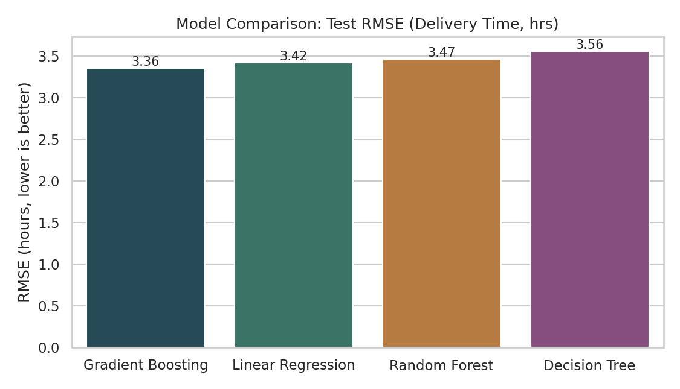
Figure 1. Test RMSE comparison across all four candidate models (lower is better).
Gradient Boosting achieved the lowest RMSE and the tightest cross-validation spread, so it was selected for hyperparameter tuning. Notably, Linear Regression performed only marginally worse than the tree-based ensembles on RMSE, suggesting the relationship between the core predictors (distance, mode, region) and delivery time is fairly close to linear once mode and region are properly encoded — the tree-based models' advantage comes mainly from capturing the interaction between mode and region (e.g., Road shipments specifically in the West being disproportionately slow).
from sklearn.model_selection import KFold, cross_val_score

kf = KFold(n_splits=5, shuffle=True, random_state=42)
cv_scores = cross_val_score(pipe, X_train, y_train, cv=kf,
scoring='neg_root_mean_squared_error')
print('CV RMSE:', -cv_scores.mean(), '+/-', cv_scores.std())
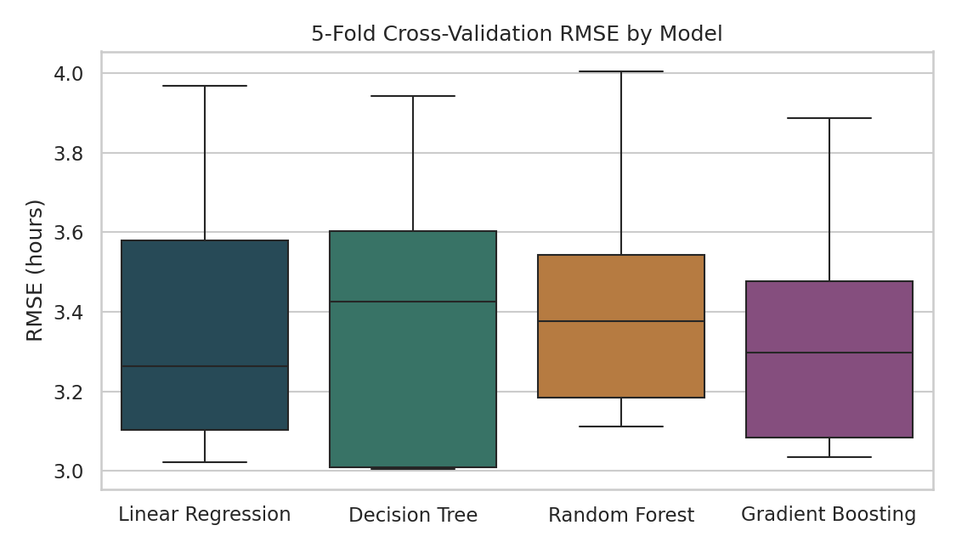
Figure 2. Spread of 5-fold cross-validation RMSE for each model.

3.3 Hyperparameter Tuning
Gradient Boosting was tuned with a grid search over number of estimators, tree depth, and learning rate, using 3-fold cross-validation on the training set to select the best combination without touching the held-out test set.
from sklearn.model_selection import GridSearchCV

param_grid = {
'model__n_estimators': [100, 200, 300],
'model__max_depth': [2, 3, 4],
'model__learning_rate': [0.05, 0.08, 0.1],
}
grid = GridSearchCV(gb_pipe, param_grid, cv=3,
scoring='neg_root_mean_squared_error', n_jobs=-1)
grid.fit(X_train, y_train)

best_pipe = grid.best_estimator_
print(grid.best_params_)
# {'model__learning_rate': 0.05, 'model__max_depth': 4, 'model__n_estimators': 100}
The tuned model (learning_rate=0.05, max_depth=4, n_estimators=100) improved test performance to RMSE = 3.33 hours, MAE = 1.84 hours, and R² = 0.578 — a modest but meaningful gain over the untuned version, achieved with fewer, shallower trees, which also reduces overfitting risk and inference cost.
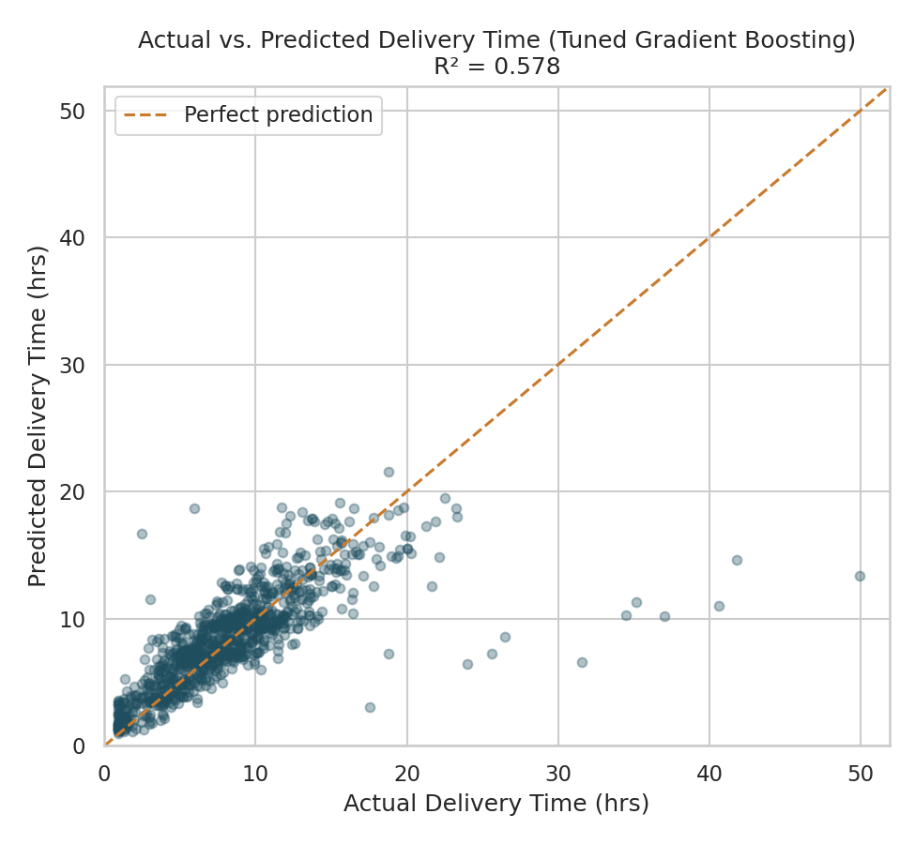
Figure 3. Actual vs. predicted delivery time on the test set for the tuned model.
The actual-vs-predicted plot shows the model tracking well for the bulk of shipments (under ~20 hours), clustering tightly around the diagonal “perfect prediction” line. The handful of points in the lower-right — long actual delivery times the model under-predicts — correspond to the extreme-delay outliers identified in Week 3. This is an expected and informative limitation: rare, severe delays are driven by one-off disruptions (e.g., a breakdown or an exceptional congestion event) that are not fully captured by the routine features in this dataset, and the residual plot below confirms the same pattern.
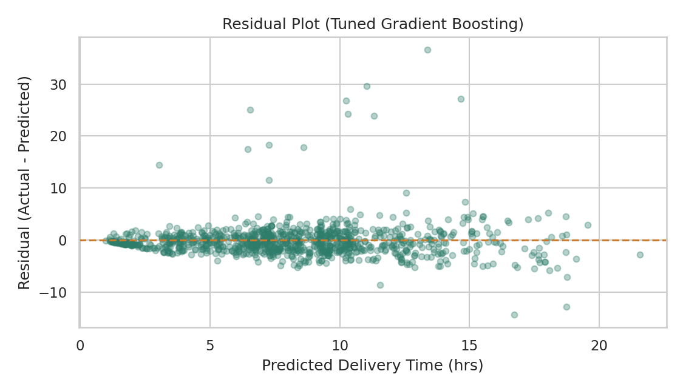
Figure 4. Residuals vs. predicted delivery time for the tuned model.

3.4 Feature Importance
The tuned Gradient Boosting model's feature importances independently confirm the Week 3 exploratory findings: distance is by far the strongest predictor, followed by whether the transport mode is Road, whether it is Air, and whether the region is West — the same factors flagged as the operational bottleneck in the prior report. This convergence between an unsupervised exploratory finding and a supervised model's learned importances is a strong signal that the bottleneck is real rather than an artifact of how the EDA charts were built.
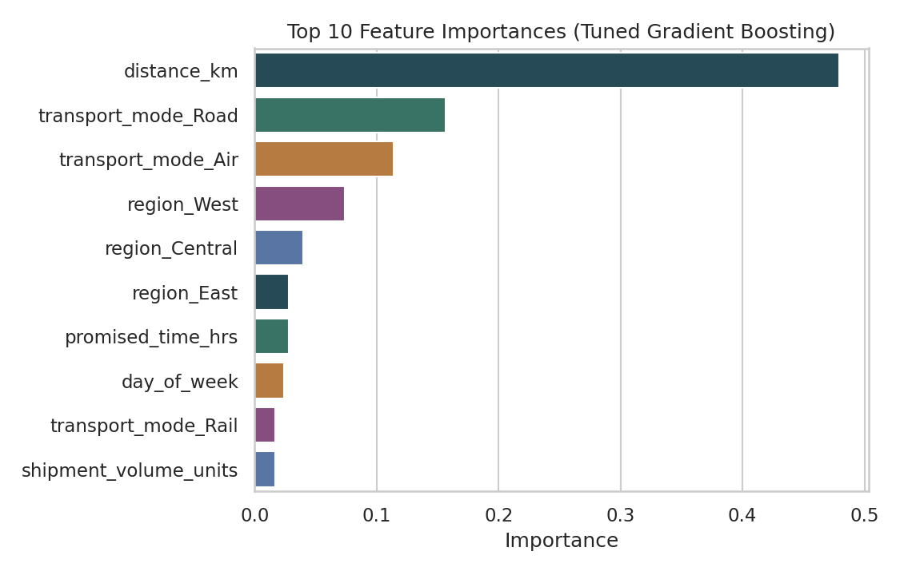
Figure 5. Top 10 feature importances from the tuned Gradient Boosting model.
importances = best_pipe.named_steps['model'].feature_importances_
feature_names = (num_features + list(
best_pipe.named_steps['prep']
.named_transformers_['cat'].get_feature_names_out(cat_features)
))
imp_df = pd.DataFrame({'feature': feature_names, 'importance': importances})
print(imp_df.sort_values('importance', ascending=False).head(10))

4. Optimization Strategies Based on Model Insights
The predictive model is most useful not as a standalone forecast but as an input to operational decisions. Three optimization strategies are proposed, each one using a specific model output as its trigger or constraint.

4.1 Dynamic, Risk-Based Delivery-Window Setting
Rather than quoting a single fixed delivery window per mode, use the trained model to predict expected delivery time for each shipment at booking time, and set the promised window as a function of that prediction plus a safety margin calibrated to the model's known error (RMSE ≈ 3.3 hours). This directly targets the Week 3 finding that promised windows for Road shipments were too tight relative to real transit times, and it does so at the shipment level rather than uniformly, so reliable short-distance Road shipments are not penalized with unnecessarily loose windows.
predicted_time = best_pipe.predict(new_shipment_features)
safety_margin = 1.5 * rmse # ~5 hours, tuned to service-level target
promised_window = predicted_time + safety_margin

4.2 Mode-Shift Rule for High-Risk Shipments
For shipments the model flags as high-risk (predicted delivery time exceeding the customer's required window under Road transport), apply a rule that evaluates the cost/benefit of shifting to Rail or Air using the Week 3 cost-per-kilometer relationships. This turns the correlation between mode, region, and delay into a concrete dispatch decision, applied selectively — only to shipments the model actually flags — rather than a blanket, costly shift for the whole network.
risk_flag = predicted_time > customer_required_window
if risk_flag and region in ['West', 'South', 'East']:
candidate_mode = 'Rail' if distance_km < 100 else 'Air'
if extra_cost(candidate_mode) < delay_penalty_cost:
reassign_mode(shipment_id, candidate_mode)

4.3 Resource Allocation by Predicted Risk
Aggregate the model's shipment-level risk predictions by region and day to identify where additional road-fleet capacity, expedited handling, or staffing would have the greatest effect on the overall on-time delivery rate, rather than allocating resources evenly across all five regions. Since the model already shows that West, South, and East drive the majority of predicted delays, this converts a general capacity-planning question into a targeted, quantified allocation problem — directly extending the Week 1 roadmap's optimization phase with model-driven inputs instead of assumptions.
daily_risk = (
shipments_today.assign(risk=best_pipe.predict(shipments_today[features]))
.groupby('region')['risk']
.apply(lambda x: (x > x.quantile(0.75)).sum())
)
# Allocate extra vehicles/staff proportional to daily_risk by region

5. Conclusion and Recommendations
This stage of the project shows that a moderately accurate, well-validated model (tuned Gradient Boosting, RMSE ≈ 3.3 hours, R² ≈ 0.58) is enough to generate real operational value — not because it predicts every shipment perfectly, but because its errors are concentrated in a small, identifiable set of rare extreme-delay events, while its feature importances reliably confirm which structural factors (distance, Road mode, West region) drive typical performance. The three recommended next steps are: (1) deploy the tuned model to generate a per-shipment delivery-time prediction at booking time and use it to set dynamic, risk-adjusted delivery windows; (2) implement the mode-shift rule for flagged high-risk shipments in the West, South, and East regions as a pilot before any network-wide rollout; and (3) feed the model's daily, region-level risk aggregates into fleet and staffing allocation decisions, closing the loop between the predictive model built here and the route-optimization and resource-allocation strategy first outlined in the Week 1 roadmap.

