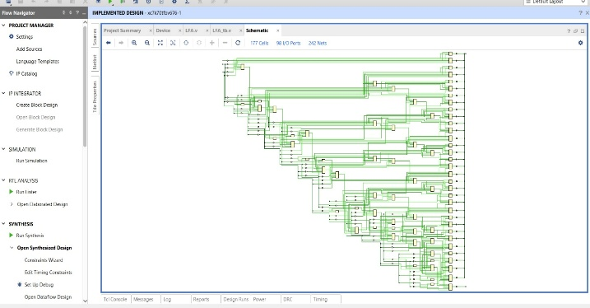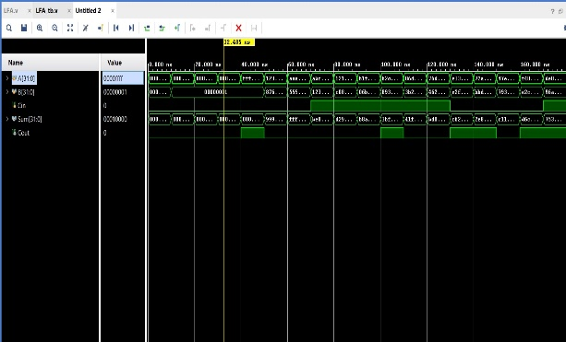

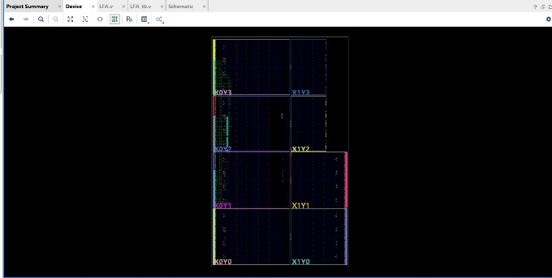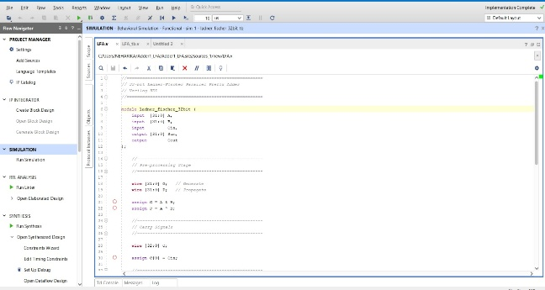

Design Verilog Code
// 32-bit Ladner-Fischer Parallel Prefix Adder
module ladner_fischer_32bit (
input [31:0] A,
input [31:0] B,
input Cin,
output [31:0] Sum,
output Cout);
// Pre-processing Stage
wire [31:0] G; // Generate
wire [31:0] P; // Propagate
assign G = A & B;
assign P = A ^ B;
// Carry Signals
wire [32:0] C;
assign C[0] = Cin;
// Carry Generation Logic
genvar i;
generate
for(i = 0; i < 32; i = i + 1)
begin : CARRY_GEN

assign C[i+1] =
G[i] |
(P[i] & C[i]);
end
endgenerate
// Post-processing Stage
generate
for(i = 0; i < 32; i = i + 1)
begin : SUM_GEN
assign Sum[i] = P[i] ^ C[i];
end
endgenerate
// Final Carry Out
assign Cout = C[32];
endmodule

Test Bench code
`timescale 1ns / 1ps
module ladner_fischer_32bit_tb;
// Inputs
reg [31:0] A;
reg [31:0] B;
reg Cin;
// Outputs
wire [31:0] Sum;
wire Cout;
// Instantiate the DUT
ladner_fischer_32bit DUT (
.A(A),
.B(B),
.Cin(Cin),
.Sum(Sum),
.Cout(Cout)
);
// Test Procedure

initial
begin
// Monitor Values
$monitor("TIME = %0t | A = %h | B = %h | Cin = %b | Sum = %h | Cout = %b",
$time, A, B, Cin, Sum, Cout);
// Test Case 1
A = 32'h00000000;
B = 32'h00000000;
Cin = 1'b0;
#10;
// Test Case 2
A = 32'h00000001;
B = 32'h00000001;
Cin = 1'b0;
#10;
// Test Case 3

A = 32'h0000000F;
B = 32'h00000001;
Cin = 1'b0;

#10;
// Test Case 4
A = 32'h0000FFFF;
B = 32'h00000001;
Cin = 1'b0;

#10;
// Test Case 5
A = 32'hFFFFFFFF;
B = 32'h00000001;
Cin = 1'b0;

#10;
// Test Case 6

A = 32'h12345678;
B = 32'h87654321;
Cin = 1'b0;

#10;

// Test Case 7

A = 32'hAAAAAAAA;
B = 32'h55555555;
Cin = 1'b0;

#10;
// Test Case 8

A = 32'hABCDEF12;
B = 32'h12345678;
Cin = 1'b1;

#10;
// Random Test Cases

repeat(10)
begin

A = $random;
B = $random;
Cin = $random % 2;

#10;

end
// End Simulation
$finish;

end

endmodule

