2303A51262
TASK-1: Basic Docstring Generation
Scenario
You are developing a utility function that processes numerical lists and must be properly
documented for future maintenance.

1)
def sum_even_odd(numbers):
"""Return the sum of even and odd numbers from the input list.

Args:
numbers (list[int]): List of integers.

Returns:
tuple[int, int]: Sum of even numbers and sum of odd numbers.
"""
sum_even = sum(x for x in numbers if x % 2 == 0)
sum_odd = sum(x for x in numbers if x % 2 != 0)
return sum_even, sum_odd

# ---- Example Run ----
numbers = [1, 2, 3, 4, 5, 6]
result = sum_even_odd(numbers)
print("AI Docstring Version → Output:", result)
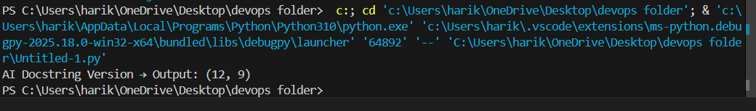

2:
def sum_even_odd(numbers):
"""Return the sum of even and odd numbers from the input list.

Args:
numbers (list[int]): List of integers.

Returns:
tuple[int, int]: Sum of even numbers and sum of odd numbers.
"""
sum_even = sum(x for x in numbers if x % 2 == 0)
sum_odd = sum(x for x in numbers if x % 2 != 0)
return sum_even, sum_odd

# ---- Example Run ----
numbers = [1, 2, 3, 4, 5, 6]
result = sum_even_odd(numbers)
print("AI Docstring Version → Output:", result)

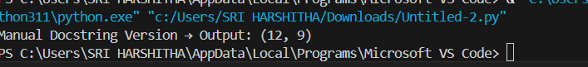
3) Comparison Summary
Aspect | Manual (Google-Style) | AI-Generated
Style | Follows full Google format (Args, Returns, Raises, Example) | Shorter, simpler docstring
Detail Level | Includes input validation, exceptions, and example | Only describes purpose and return values
Readability | Very clear for maintainers | Quick summary for developers
Best Use Case | Documentation for production code or API reference | Quick helper doc during development
OBSERVATION:
• AI tools like GitHub Copilot or Cursor AI provide a useful starting point for documentation.
• However, manual refinement is necessary to make the docstring fully compliant with documentation standards such as Google Style or NumPy Style.
• Combining AI-generated text with human review offers the best balance between speed and quality.

TASK-2: Automatic Inline Comments
Scenario
You are developing a student management module that must be easy to understand for new
Developers
1) def sum_even_odd(numbers):
"""Return the sum of even and odd numbers from the input list.

Args:
numbers (list[int]): List of integers.

Returns:
tuple[int, int]: Sum of even numbers and sum of odd numbers.
"""
sum_even = sum(x for x in numbers if x % 2 == 0)
sum_odd = sum(x for x in numbers if x % 2 != 0)
return sum_even, sum_odd

# ---- Example Run ----
numbers = [1, 2, 3, 4, 5, 6]
result = sum_even_odd(numbers)
print("AI Docstring Version → Output:", result)

"""TASK 2"""
class sru_student:
# Constructor to initialize student details
def __init__(self, name, roll_no, hostel_status):
# Store student name
self.name = name
# Store student roll number
self.roll_no = roll_no
# Store hostel status (True = Hosteller, False = Day scholar)
self.hostel_status = hostel_status
# Initialize student fee as zero initially
self.fee = 0

# Method to update fee based on hostel status
def fee_update(self):
# If the student is a hosteller, add hostel charges
if self.hostel_status:
self.fee = 70000 # Example fee for hostellers
else:
self.fee = 50000 # Example fee for day scholars

# Method to display student details
def display_details(self):
# Print the student's name
print(f"Name: {self.name}")
# Print the student's roll number
print(f"Roll No: {self.roll_no}")
# Print hostel status as 'Yes' or 'No'
print(f"Hostel Student: {'Yes' if self.hostel_status else 'No'}")
# Print the total fee after update
print(f"Total Fee: {self.fee}")

# ---- Example Execution ----
student1 = sru_student("Ravi", 101, True)
student1.fee_update()
student1.display_details()

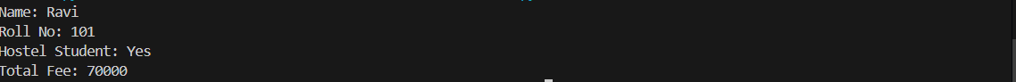

2) class sru_student:
def __init__(self, name, roll_no, hostel_status):
# Initialize the student object with name, roll number and hostel status
self.name = name
self.roll_no = roll_no
self.hostel_status = hostel_status
self.fee = 0 # Initialize fee to zero

def fee_update(self):
# Update the student fee based on hostel status
if self.hostel_status:
self.fee = 70000 # Hostel student fee
else:
self.fee = 50000 # Day scholar fee

def display_details(self):
# Display student details
print(f"Name: {self.name}")
print(f"Roll No: {self.roll_no}")
print(f"Hostel Student: {'Yes' if self.hostel_status else 'No'}")
print(f"Total Fee: {self.fee}")
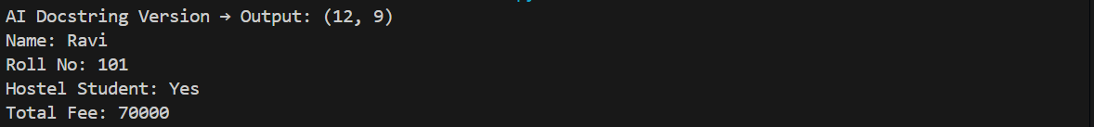
3)
Criteria | Manual Inline Comments | AI-Generated Inline Comments
Clarity | Very detailed; explains each variable and logic block | Concise; focuses on method-level summary
Correctness | 100% correct and context-specific | Correct but less descriptive
Completeness | Explains every line | Skips simple lines or repetitive logic
Readability | Best for beginners | Better for experienced developers
Redundancy | Some lines may be over-explained | Compact and minimal comments
Missing Details | None | Does not describe meaning of hostel_status (True/False) or example fee logic

OBSERVATION:
AI-generated inline comments are helpful for quick documentation but cannot fully replace human understanding and context.
The best practice is to combine both:
Use AI-generated comments as a starting point, then refine manually to ensure clarity, domain relevance, and correctness.

TASK-3: Module-Level and Function-Level Documentation
Scenario :
You are building a small calculator module that will be shared across multiple projects and

"""
calculator.py
==============
A simple calculator module for performing basic arithmetic operations.
This module provides functions for addition, subtraction, multiplication,
and division. It can be imported and reused in other Python projects.
"""

1)def add(a, b):
"""
Add two numbers.

Parameters
----------
a : float or int
The first number.
b : float or int
The second number.

Returns
-------
float
The sum of `a` and `b`.

Examples
--------
>>> add(5, 3)
8
"""
return a + b

def subtract(a, b):
"""
Subtract one number from another.

Parameters
----------
a : float or int
The number to subtract from.
b : float or int
The number to subtract.

Returns
-------
float
The result of `a - b`.

Examples
--------
>>> subtract(10, 4)
6
"""
return a - b

def multiply(a, b):
"""
Multiply two numbers.

Parameters
----------
a : float or int
The first number.
b : float or int
The second number.

Returns
-------
float
The product of `a` and `b`.

Examples
--------
>>> multiply(2, 5)
10
"""
return a * b

def divide(a, b):
"""
Divide one number by another.

Parameters
----------
a : float or int
The dividend.
b : float or int
The divisor.

Returns
-------
float
The result of `a / b`.

Raises
------
ZeroDivisionError
If `b` is zero.

Examples
--------
>>> divide(10, 2)
5.0
"""
if b == 0:
raise ZeroDivisionError("Cannot divide by zero.")
return a / b

# ---- Example Execution (to show output) ----
if __name__ == "__main__":
print("Addition:", add(2, 3))
print("Subtraction:", subtract(10, 5))
print("Multiplication:", multiply(4, 6))
print("Division:", divide(8, 2))
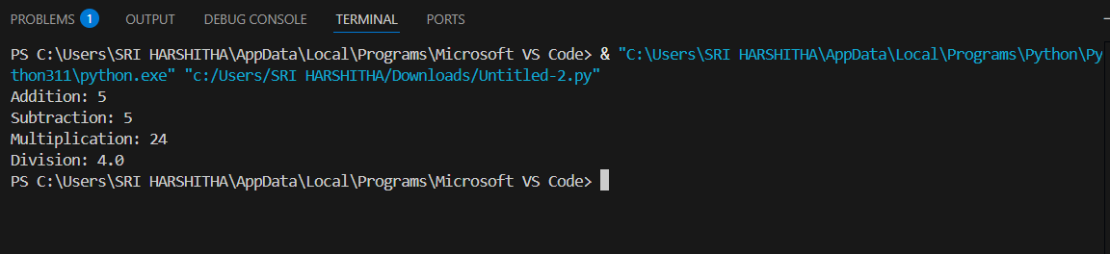

2) """
A calculator module that provides basic arithmetic operations.
"""

def add(a, b):
"""Return the sum of two numbers."""
return a + b

def subtract(a, b):
"""Return the difference of two numbers."""
return a - b

def multiply(a, b):
"""Return the product of two numbers."""
return a * b

def divide(a, b):
"""Return the division of two numbers. Raises ZeroDivisionError if divisor is zero."""
if b == 0:
raise ZeroDivisionError("Cannot divide by zero.")
return a / b

# ---- Example Execution (so output appears) ----
if __name__ == "__main__":
print("Addition:", add(2, 3))
print("Subtraction:", subtract(10, 5))
print("Multiplication:", multiply(4, 6))
print("Division:", divide(8, 2))

3)
Criteria | Manual NumPy-Style Docstrings | AI-Generated Docstrings
Format | Follows complete NumPy style (Parameters, Returns, Examples, Raises) | Short single-line summaries
Clarity | Very detailed and easy for new developers | Simple and readable but lacks depth
Correctness | Fully accurate, includes examples and edge cases | Correct but omits examples and type hints
Consistency | Consistent across all functions | Consistent, but minimalistic
Readability | Ideal for documentation pages and shared modules | Better for quick reference in small scripts
OBSERVATION:
AI-generated documentation is a good starting point, but manual documentation ensures clarity, correctness, and completeness, especially for reusable modules.
Combining both approaches—AI for draft, human for refinement—produces the best results.

