ASSIGNMENT- 8.3
Name:Unni Harika
HT.No: 2303A51262
Batch: 19

Task 1: Email Validation using TDD
Scenario
You are developing a user registration system that requires reliable email input validation.
Requirements
- Must contain @ and . characters
- Must not start or end with special characters
- Should not allow multiple @ symbols
- AI should generate test cases covering valid and invalid email formats
- Implement is_valid_email(email) to pass all AI-generated test cases
Expected Output
- Python function for email validation
- All AI-generated test cases pass successfully
- Invalid email formats are correctly rejected
- Valid email formats return True
CODE:
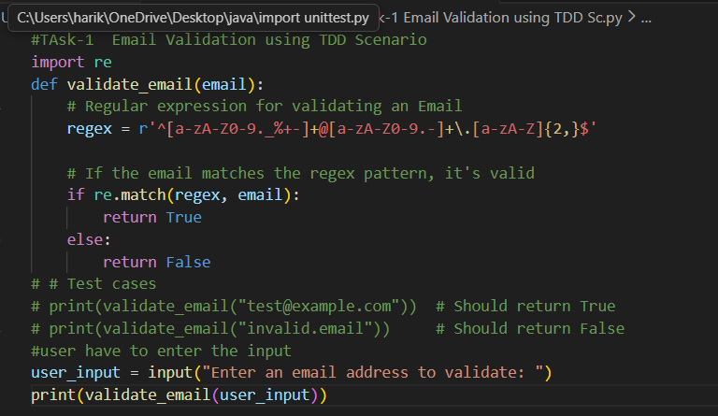
OUTPUT:
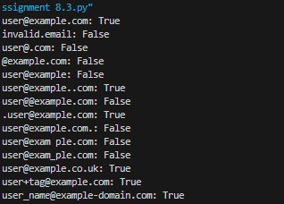

Task 2: Grade Assignment using Loops
Scenario
You are building an automated grading system for an online examination platform.
Requirements
- AI should generate test cases for assign_grade(score) where:
- 90–100 → A
- 80–89 → B
- 70–79 → C
- 60–69 → D
- Below 60 → F
- Include boundary values (60, 70, 80, 90)
- Include invalid inputs such as -5, 105, "eighty"
- Implement the function using a test-driven approach
Expected Output
- Grade assignment function implemented in Python
- Boundary values handled correctly
- Invalid inputs handled gracefully
- All AI-generated test cases pass
CODE:
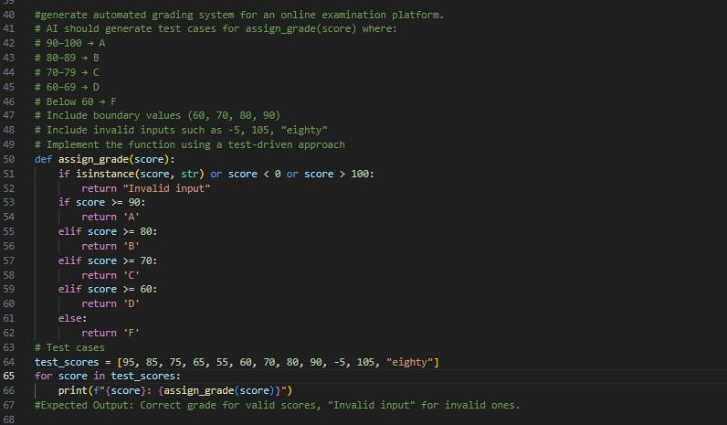

OUTPUT:

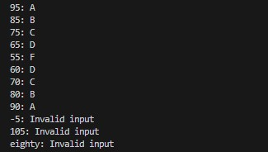

Task 3: Sentence Palindrome Checker
Scenario
You are developing a text-processing utility to analyze sentences.
Requirements
- AI should generate test cases for is_sentence_palindrome(sentence)
- Ignore case, spaces, and punctuation
- Test both palindromic and non-palindromic sentences
- Example:
– "A man a plan a canal Panama" → True
Expected Output
- Function correctly identifies sentence palindromes
- Case and punctuation are ignored
- Returns True or False accurately
- All AI-generated test cases pass
CODE:

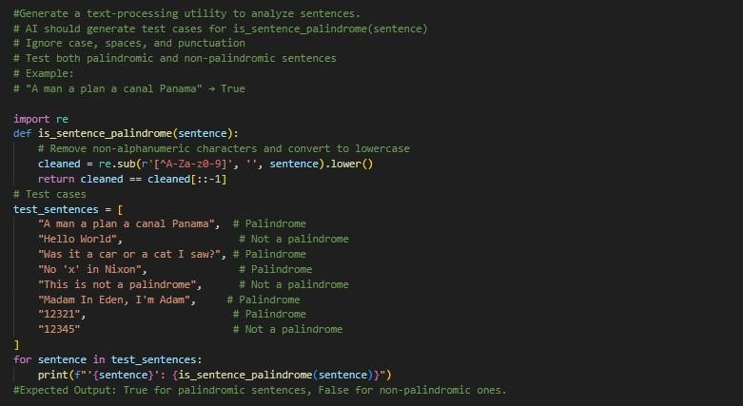

OUTPUT:

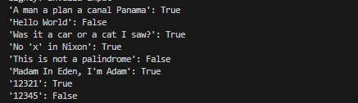

Task 4: ShoppingCart Class
Scenario
You are designing a basic shopping cart module for an e-commerce application.
Requirements
- AI should generate test cases for the ShoppingCart class
- Class must include the following methods:
- add_item(name, price)
- remove_item(name)
- total_cost()
- Validate correct addition, removal, and cost calculation
- Handle empty cart scenarios
Expected Output
- Fully implemented ShoppingCart class
- All methods pass AI-generated test cases
- Total cost is calculated accurately • Items are added and removed correctly
CODE:
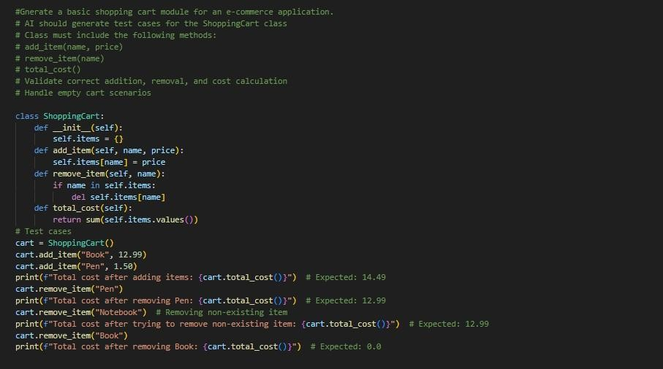

OUTPUT:

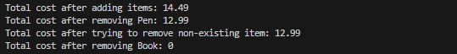

Task 5: Date Format Conversion
Scenario
You are creating a utility function to convert date formats for reports.
Requirements
- AI should generate test cases for convert_date_format(date_str)
- Input format must be "YYYY-MM-DD" • Output format must be "DD-MM-YYYY"
- Example:
– "2023-10-15" → "15-10-2023"
Expected Output
- Date conversion function implemented in Python
- Correct format conversion for all valid inputs
- All AI-generated test cases pass successfully
CODE:
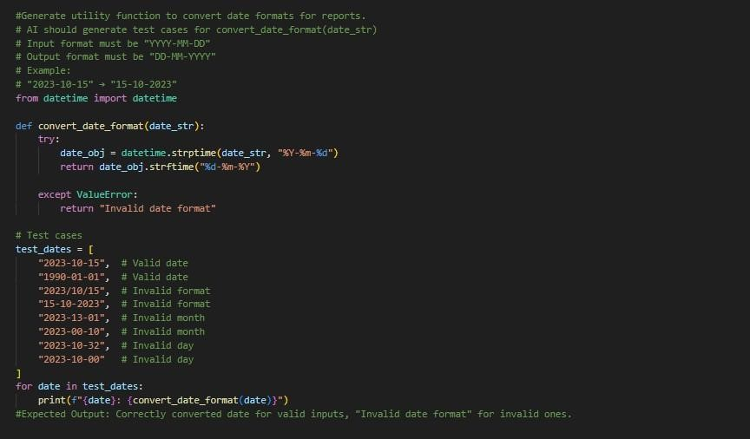

OUTPUT:

