Linux

History:

Year - 1960’s

● US Defence developed a powerful system in terms of security for internal use, for that matter under project name of Advanced Research Projects Agency Network (ARPANET) few developers were hired from Bell Labs.

● Like Mr. Dennis Ritchie and Mr. Ken Thomson were Project leads

Year 1969

● Bell lab’s used code of Mr. Ken Thomson and developed a new system called UNIX. ( using DOS )

Year 1973

● Dennis Ritchie developed ‘C’ language

Year 1974

● Unix was Re-developed using DOS and C, Unix licensed to universities only.

Unix ﬂavours

* A & T system V BSD ( Berkeley system Distribution)

Types of OS:

Flavours:

All below are commercial license products -

● By 1980, a lot of unix ﬂavours came into market

● Year 1984, Richard Stallman started “ GNU” ,-- General Not Unix, goal - create free unix like software., movement started across globe to create free open source unix like OS

OS structure:



Fie system hierarchy:

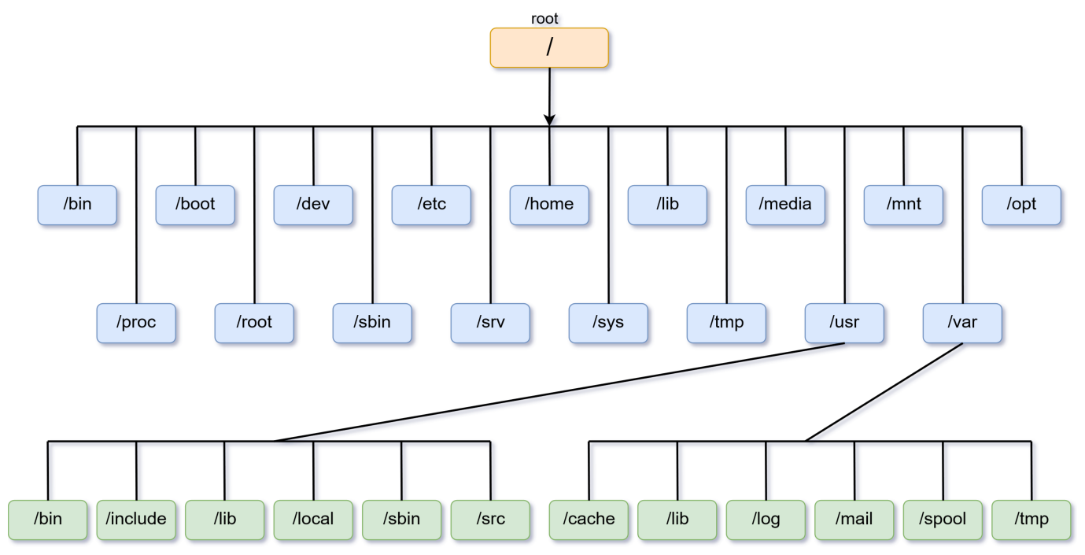

All linux commands: