Hall Ticket: 2303A510i0
Batch: 30
Assessment: 20.2
Task 1: Password Security Enhancement Prompt:
Generate a Python script for user registration storing username and password. Code:
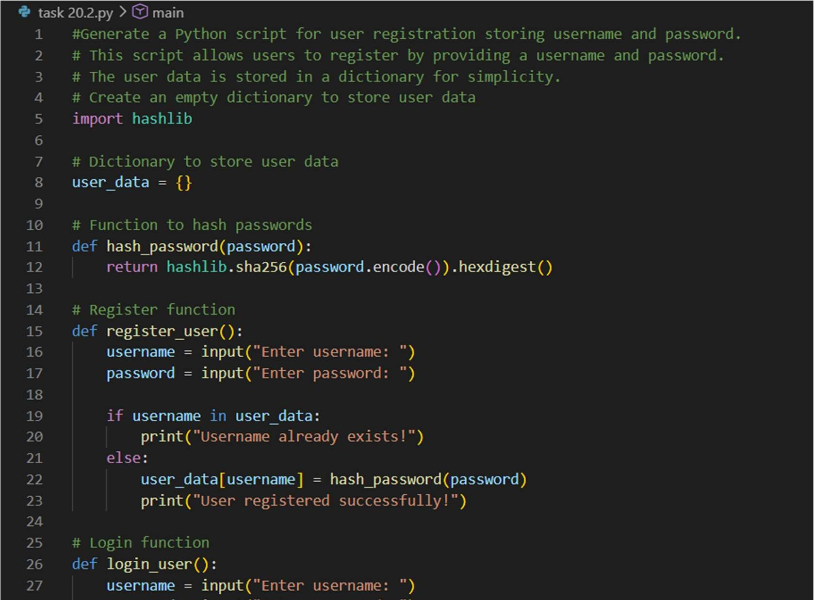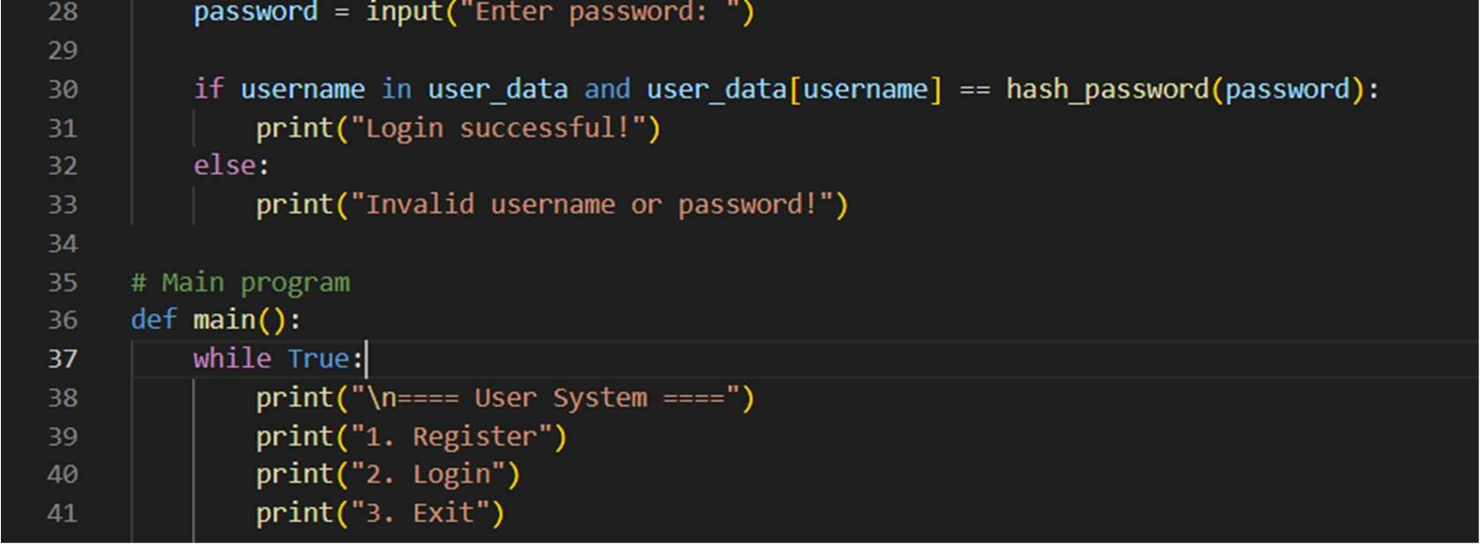
Output:
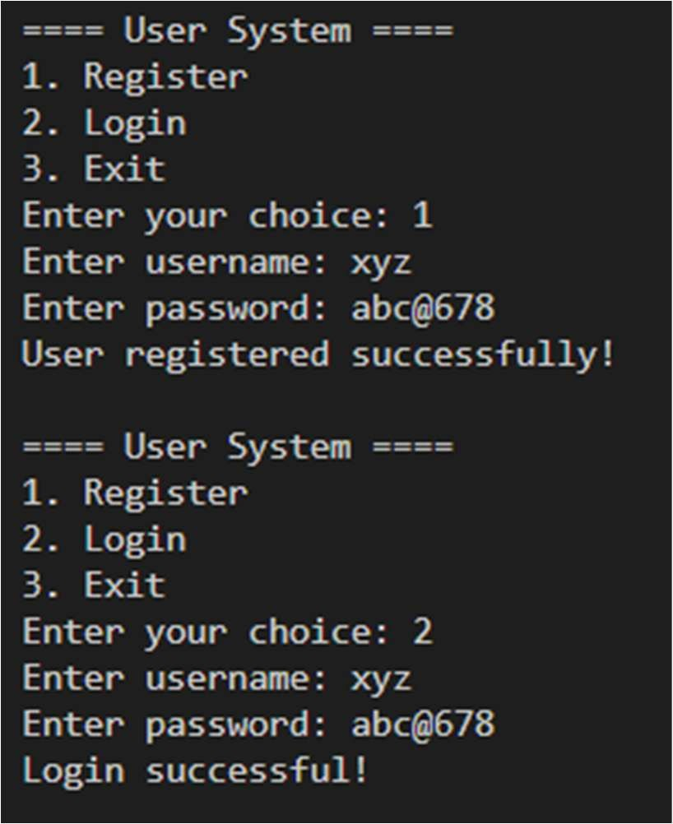
Significance:
This task shows the importance of securing user passwords by avoiding plain-text storage. Hashing ensures passwords are protected even if data is leaked, improving authentication security.

Task 2: Secure API Key Management Prompt:
Generate a Python script that calls an API using an API key.
Code:
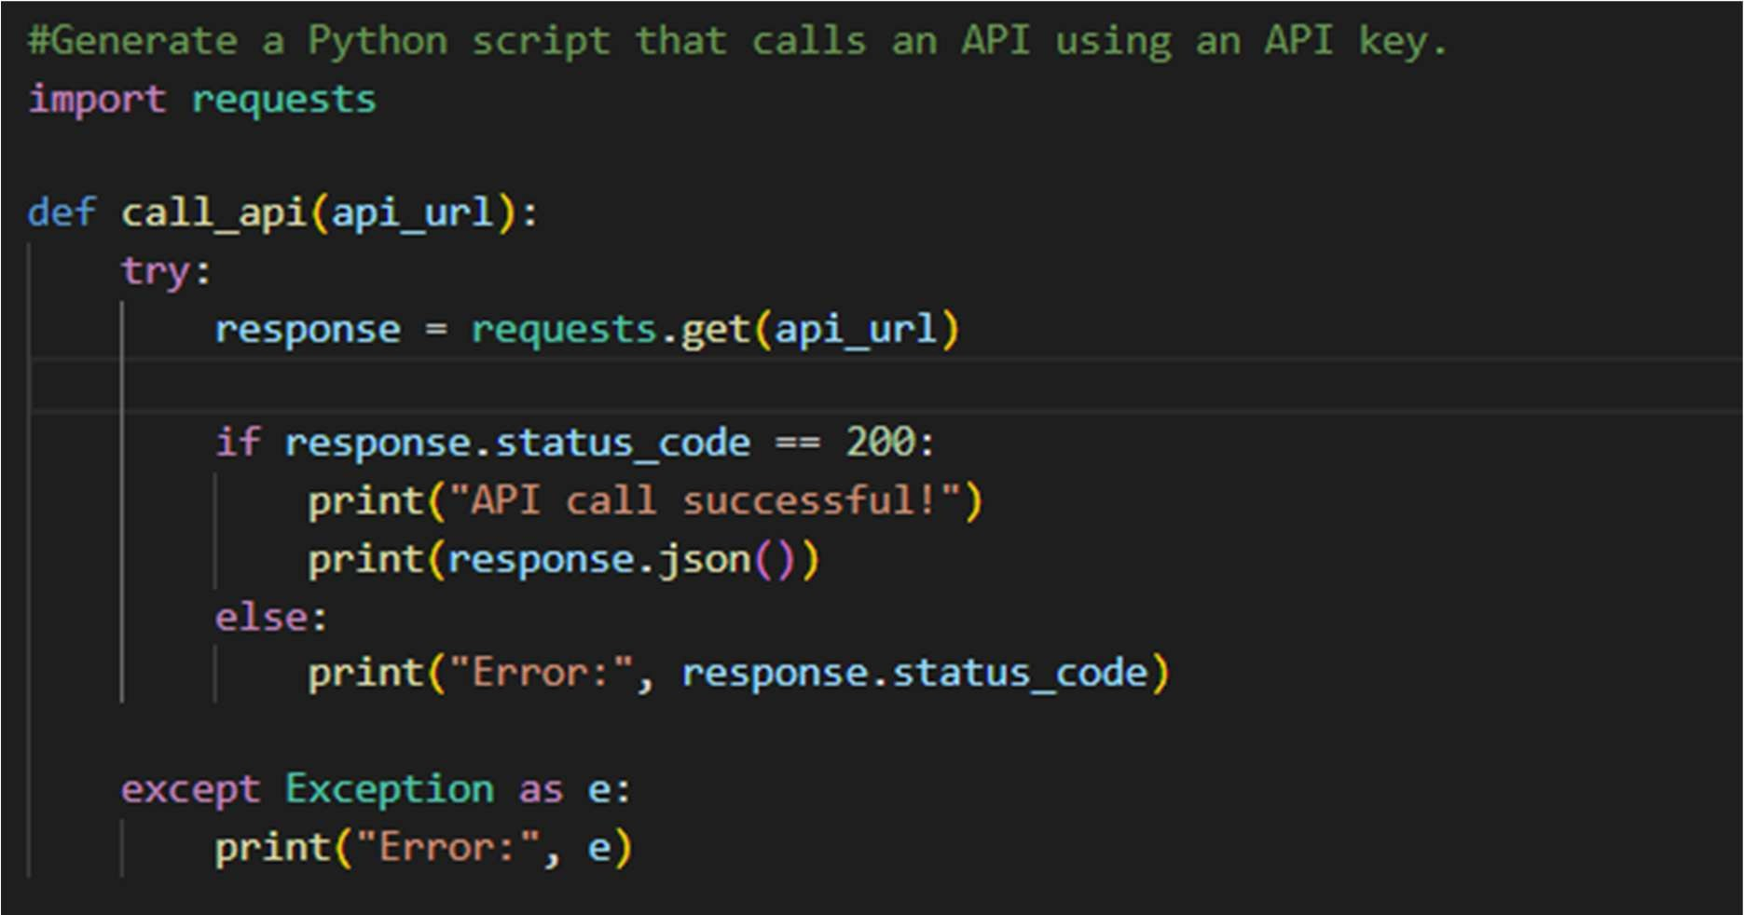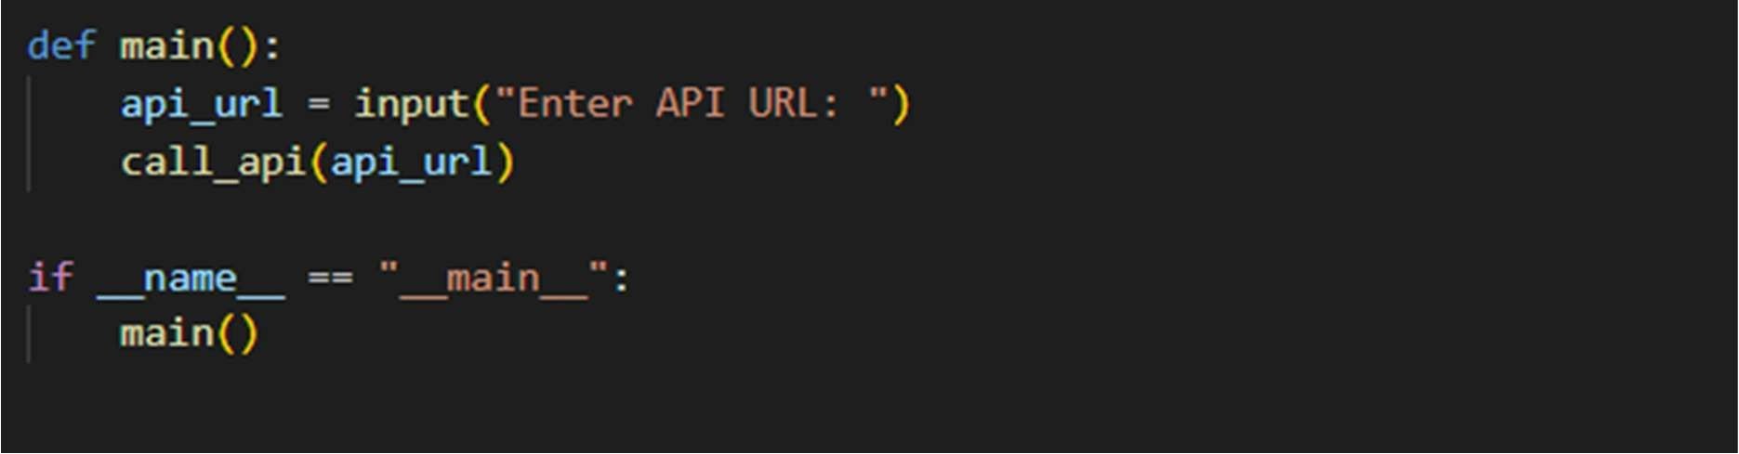
Output:
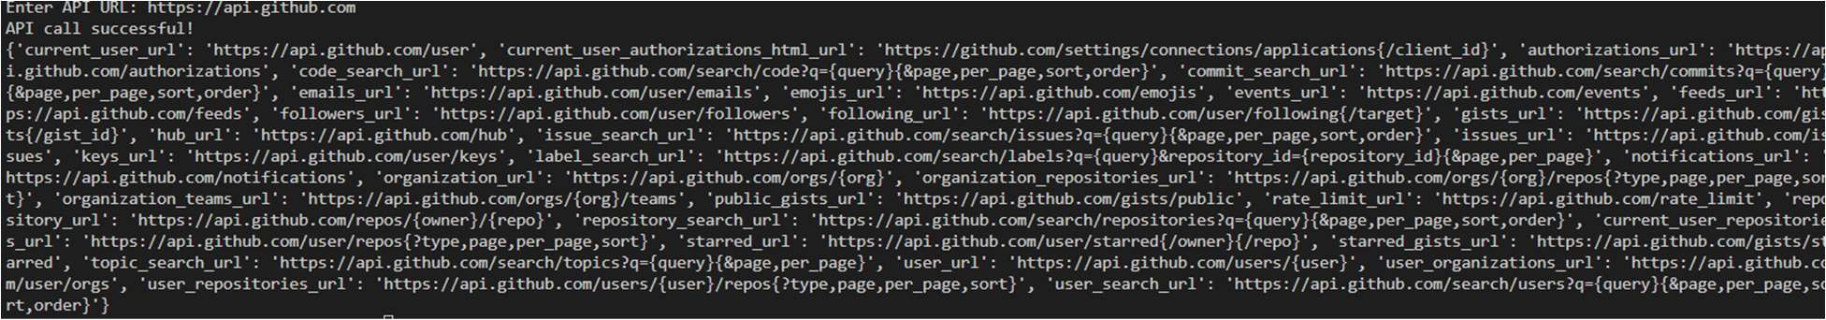
Significance:
This task highlights the risk of exposing API keys in source code. Using environment variable
Task 3: Weak Encryption Detection Prompt:
Generate a simple encryption-decryption program.” Code:
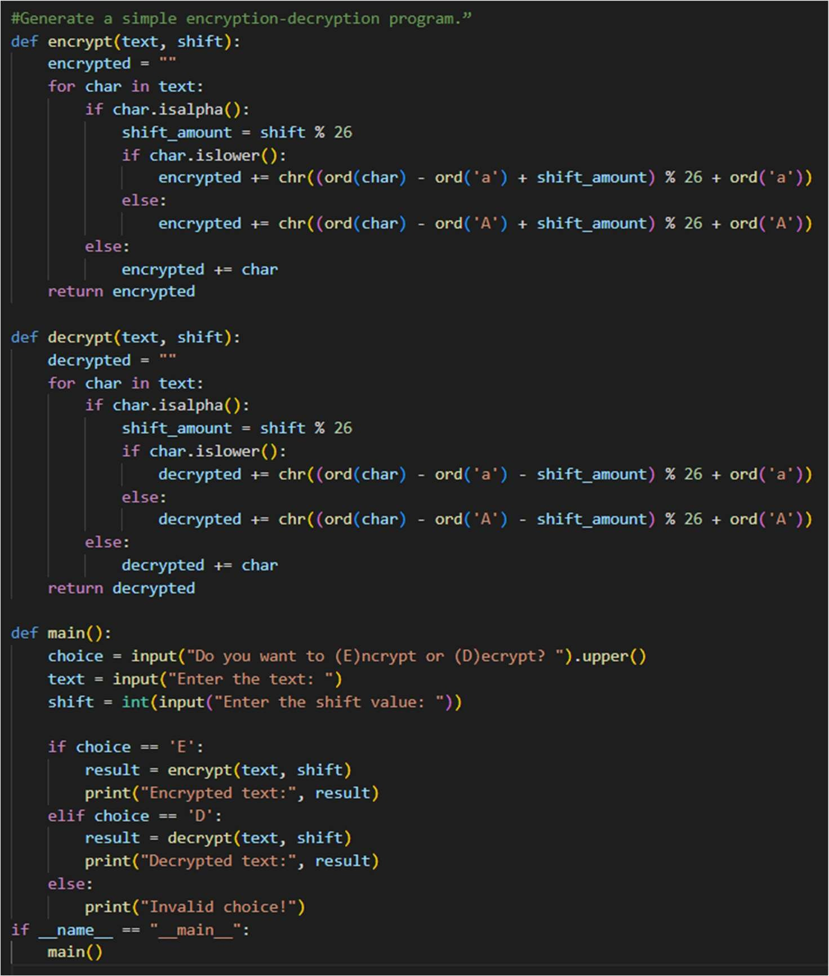
Output:
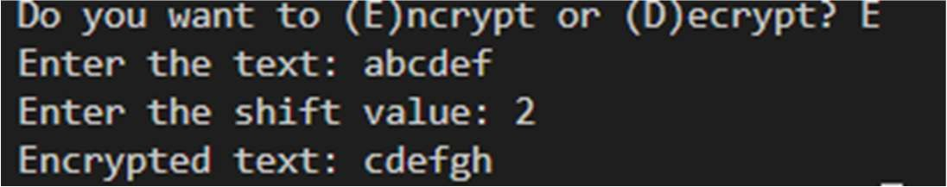
Significance:
This task emphasizes replacing weak encryption with stronger algorithms. It ensures sensitive data remains secure and cannot be easily decoded by attackers. Task 4: Real-Time Application: Security Review of AI-Generated Web Service Prompt:
Generate a simple Python Flask web service with a login API that takes username and password from a POST request and validates them. Do not focus on security.
Code:
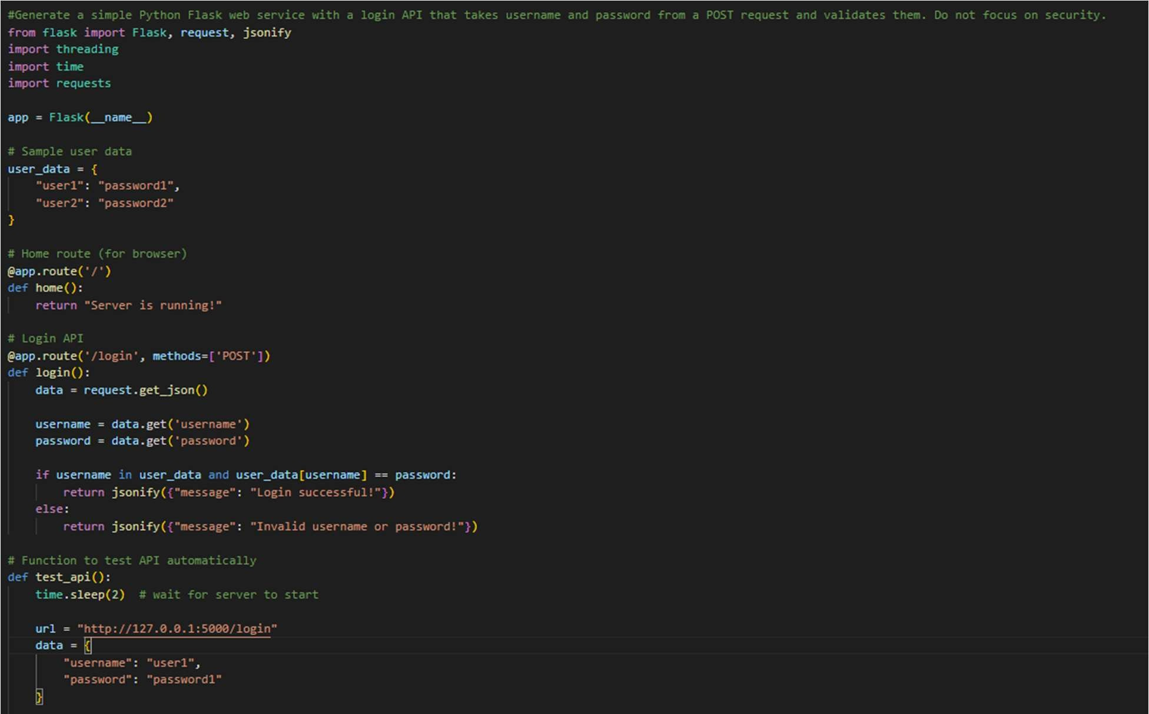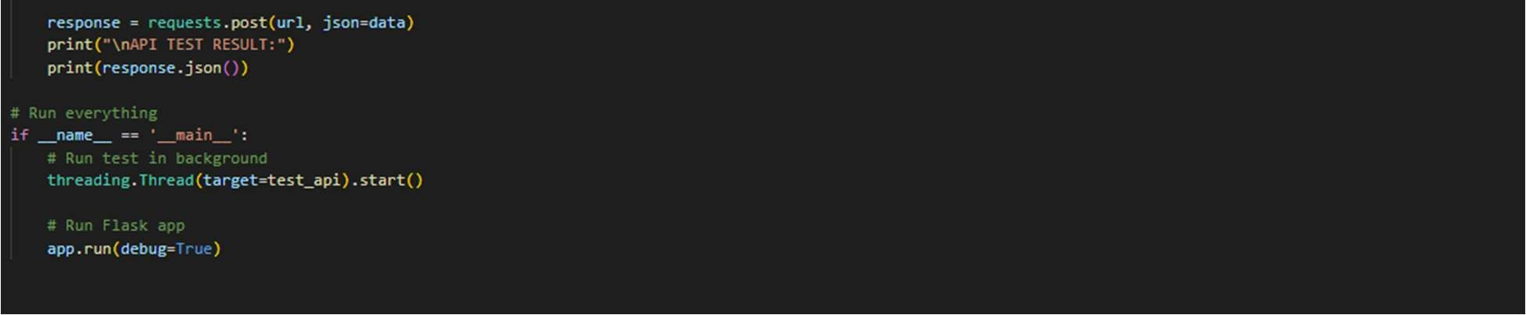
Output:
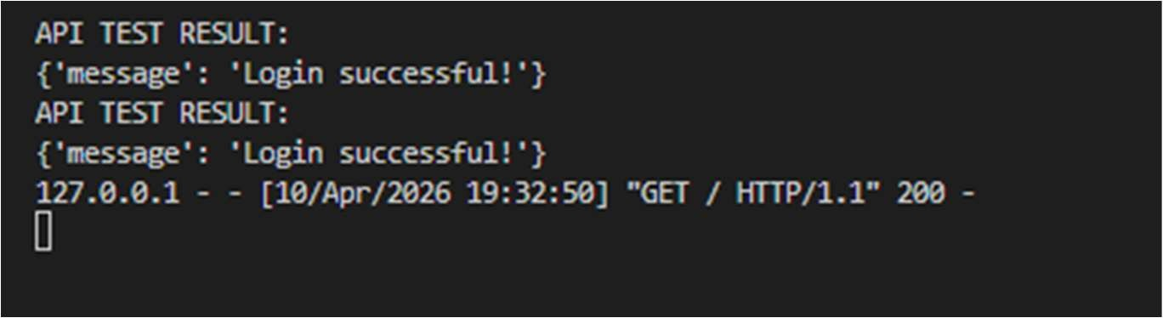
Significance:
This task helps identify common vulnerabilities in web applications. It improves secure coding practices and prepares students for real-world security challenges.
Task 5: Exception Handling Improvement Prompt:
Generate a simple Python program that takes two numbers as input from the user and performs division without using exception handling.
Code:
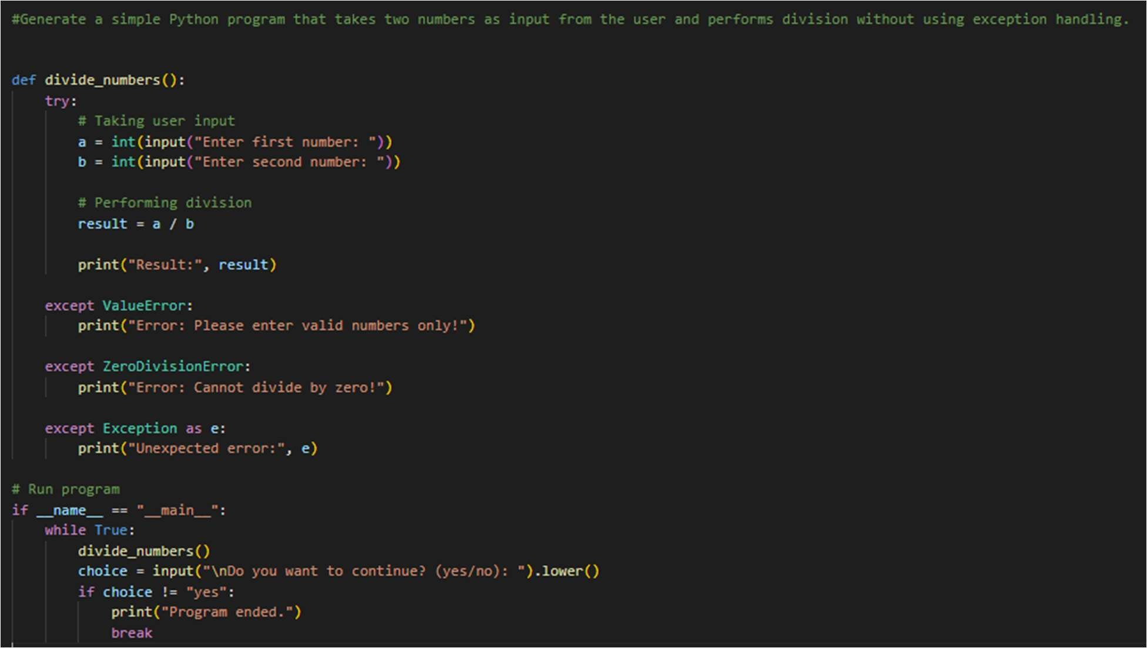
Output:
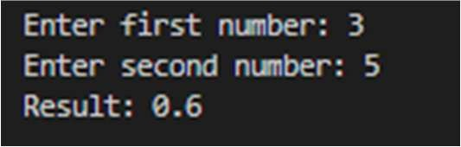
Significance:
This task improves program reliability by handling runtime errors. It prevents crashes and provides user-friendly error messages for better experience.

