ASSIGNMENT 1_5
V.Harika
2303a510i0
Batch :30
Task 1:
Code:
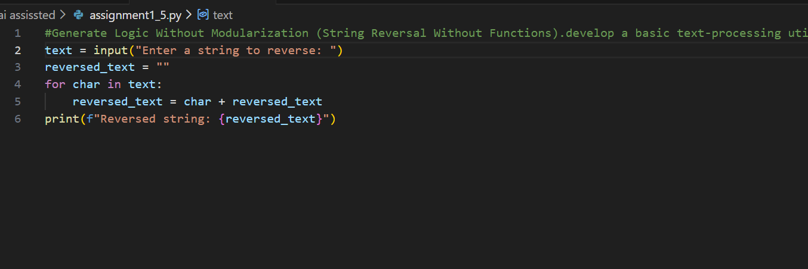
Output: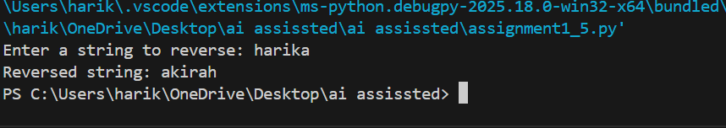
Justification:
The non-modular approach directly places logic in the main code, making it simple and quick to implement. However, it reduces clarity and reusability since the reversal logic cannot be reused elsewhere. It’s suitable for very small, one-time scripts but not for scalable applications.

Task 2:
Code:
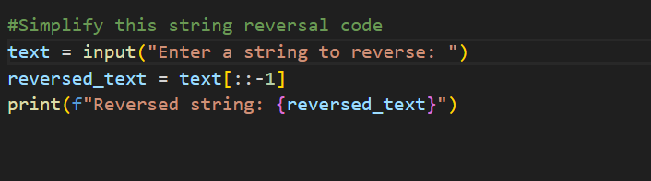
Output:
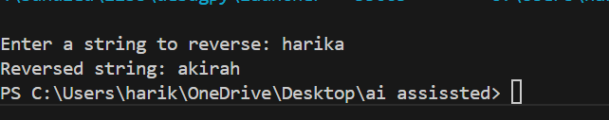
Justification:
Optimizing the Copilot-generated code improves readability and reduces unnecessary operations. By removing extra variables or loops, the program becomes easier to understand and maintain. Although time complexity remains O(n), reduced overhead makes execution slightly faster and cleaner.

Task 3:
Code:
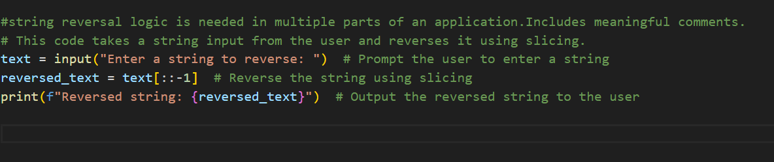
Output:
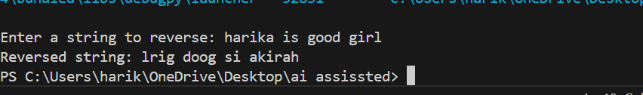
Justification:
Using functions introduces modularity, allowing the string reversal logic to be reused across multiple parts of the application. It improves clarity, debugging, and scalability. Functions also make the code more professional and maintainable for larger projects.

Task 4:
Code:
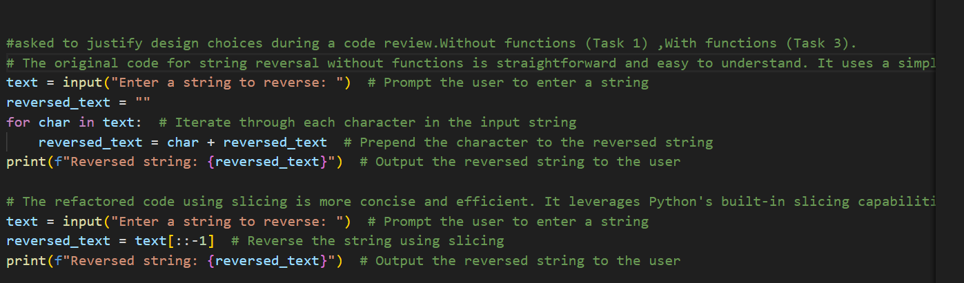
Output:
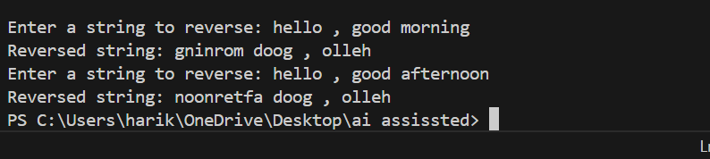
Justification:
Procedural (without functions) is straightforward but limited in clarity and reusability. Modular (with functions) is better for debugging, reuse, and large-scale applications. The comparison highlights that modular design is more suitable for collaborative development and long-term maintenance.

Task 5:
Code:
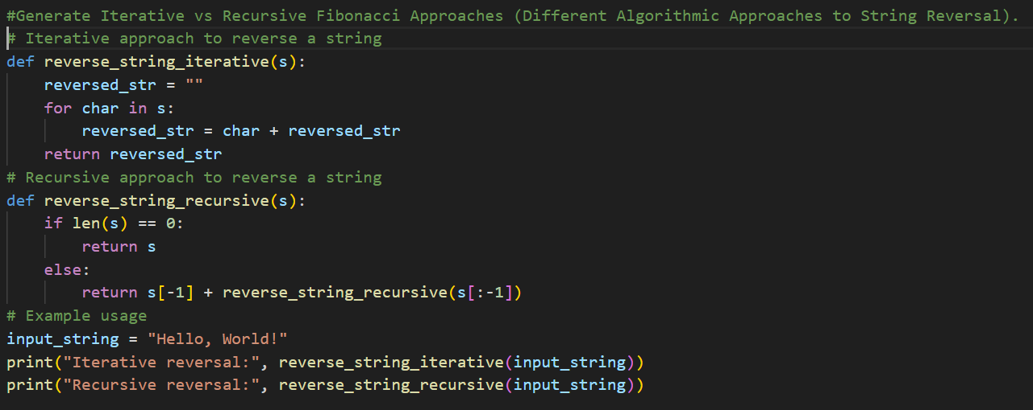
Output:
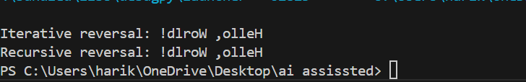
Justification:
The loop-based reversal explicitly shows execution flow, making it educational but slightly verbose. The slicing approach is concise, efficient, and Pythonic, with the same O(n) complexity but less overhead. For large inputs, slicing is faster, while loops are useful for demonstrating algorithmic logic.

