Assignment_12.5
Batch_30
2303A510i0
Task Description #1 :(Sorting – Merge Sort Implementation)
Prompt: Generate a Python program that implements
the Merge Sort algorithm.
Code &Output:
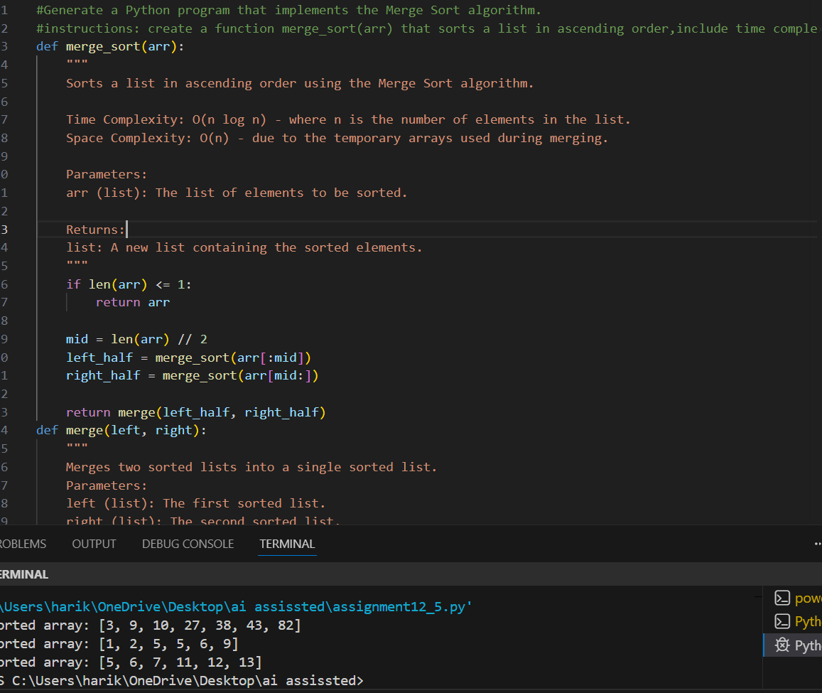

Task Description #2 : (Searching – Binary Search with AI
Optimization)
Prompt: create a binary search function that finds a target element in a sorted list
Code&Output:
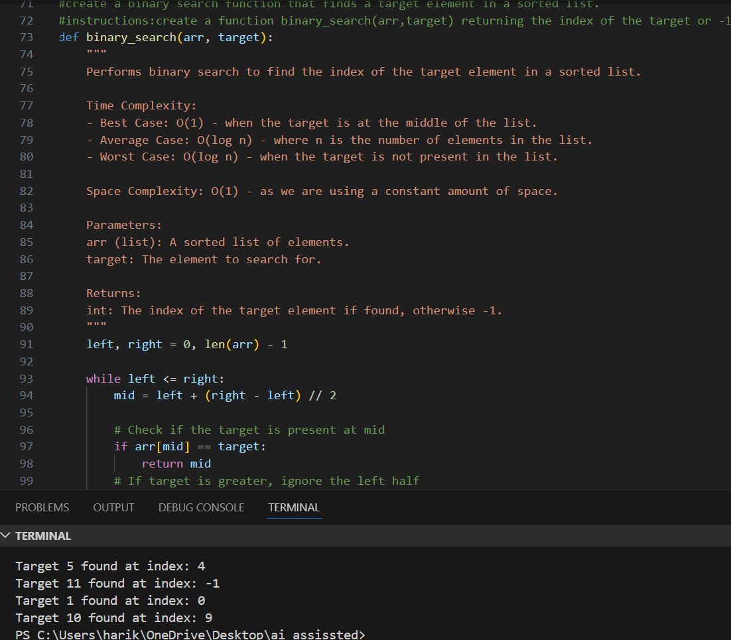
Task Description #3: Smart Healthcare Appointment Scheduling
System
Prompt: Design a healthcare appointment system in Python. The system stores appointment ID, patient name, doctor name, appointment time, and consultation fee. Recommend suitable searching and sorting algorithms, explain why they are appropriate, and implement them in Python to:
- Search appointments by appointment ID.
- Sort appointments by appointment time or consultation fee.

Code&output:
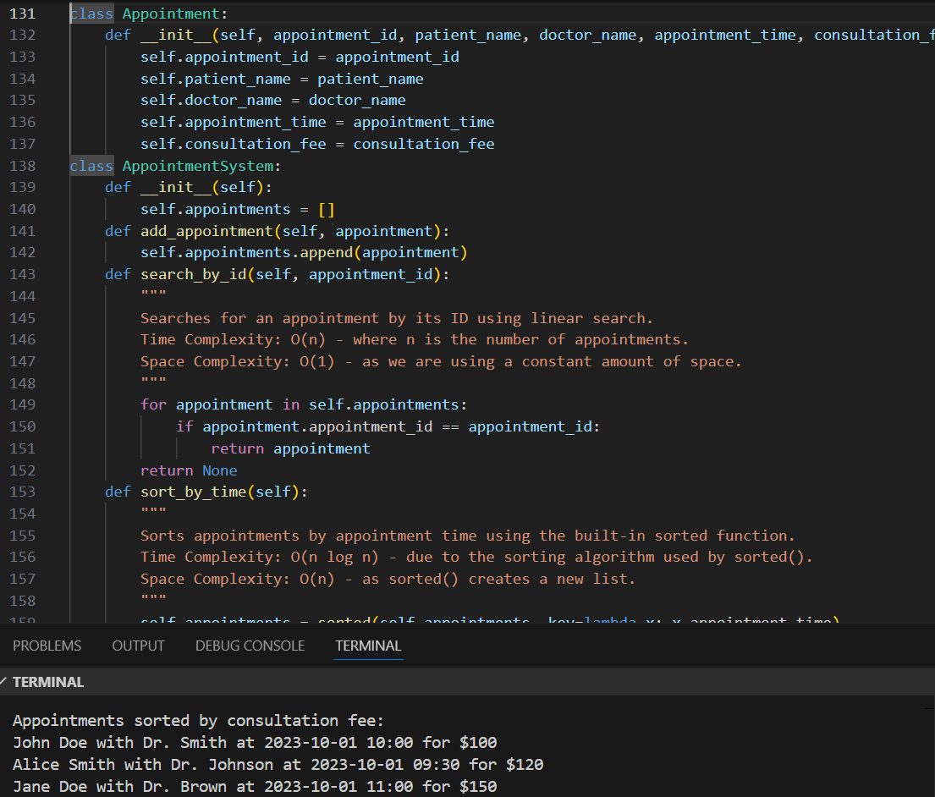

Task Description #4: Railway Ticket Reservation System
Prompt: Design a railway reservation system in Python. The system stores ticket ID, passenger name, train number, seat number, and travel date. Recommend efficient searching and sorting algorithms, explain why they are suitable, and implement them in Python to:
- Search tickets by ticket ID.
- Sort bookings by travel date or seat number.

Code&output:
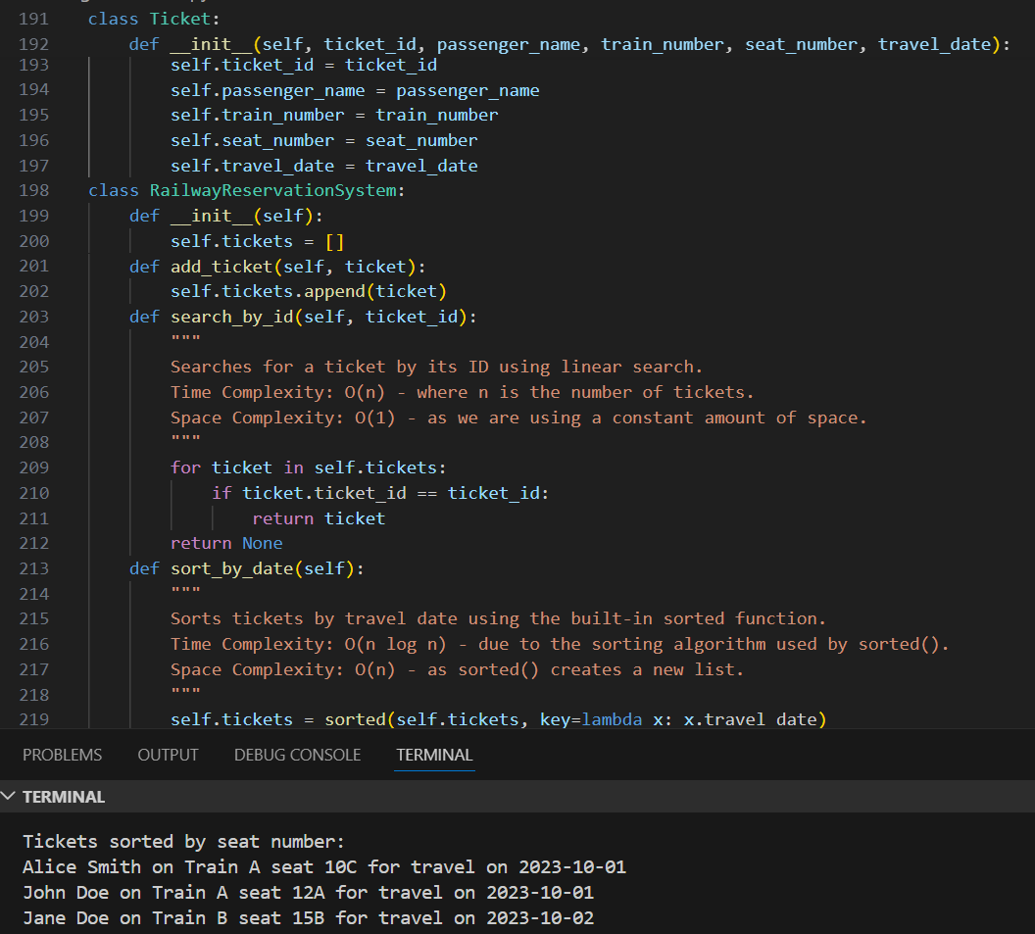

Task Description #5: Smart Hostel Room Allocation System
Prompt: Design a hostel management system in Python. The system stores student ID, room number, floor, and allocation date. Recommend optimized searching and sorting algorithms, explain why they are suitable, and implement them in Python to:
- Search allocation details by student ID.
- Sort records by room number or allocation date.

Code&Output:
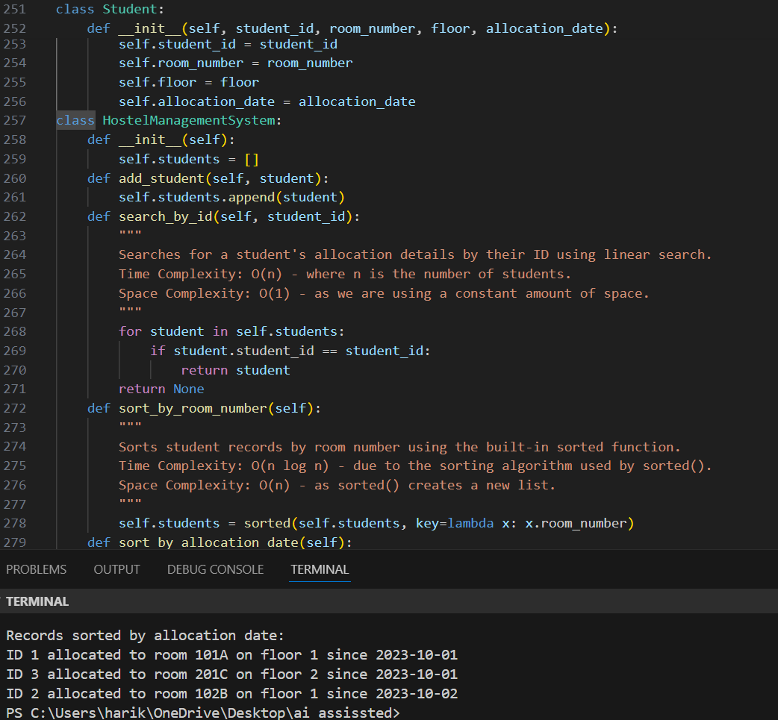

Task Description #6: Online Movie Streaming Platform
Prompt: Design a streaming service system in Python that stores movie ID, title, genre, rating, and release year, and recommend efficient searching and sorting algorithms, justify why they are suitable, and implement Python functions to search movies by movie ID and sort movies based on rating or release year.
Code & Output:
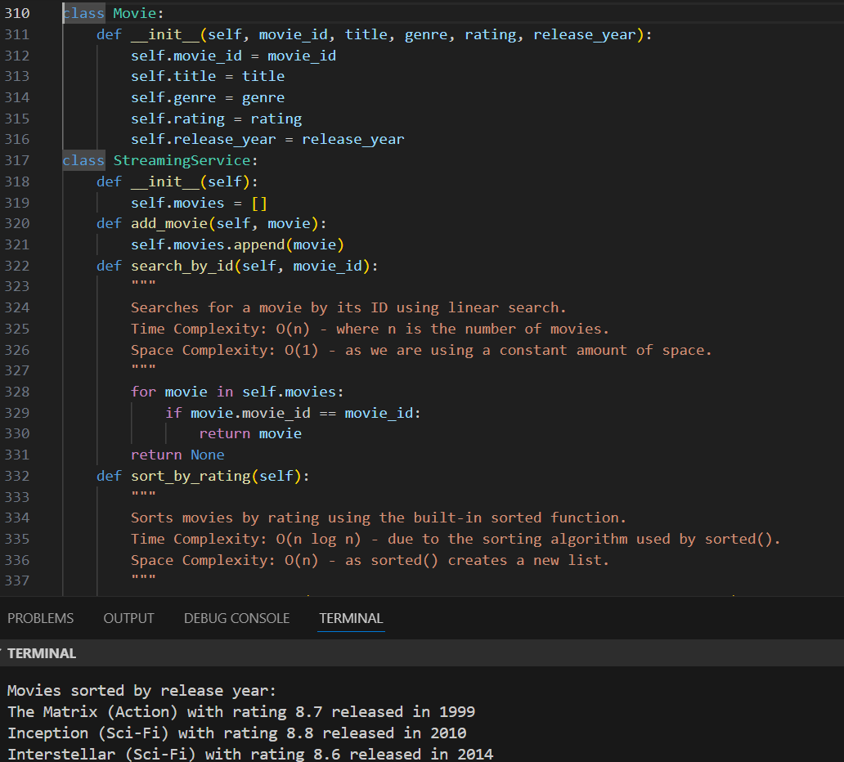

Task Description #7: Smart Agriculture Crop Monitoring System
Prompt: Design an agriculture monitoring system in Python that stores crop ID, crop name, soil moisture level, temperature, and yield estimate, and use AI-assisted reasoning to recommend optimized searching and sorting algorithms, justify why they are suitable, and implement Python functions to search crop details by crop ID and sort crops based on moisture level or yield estimate.
Code& output:
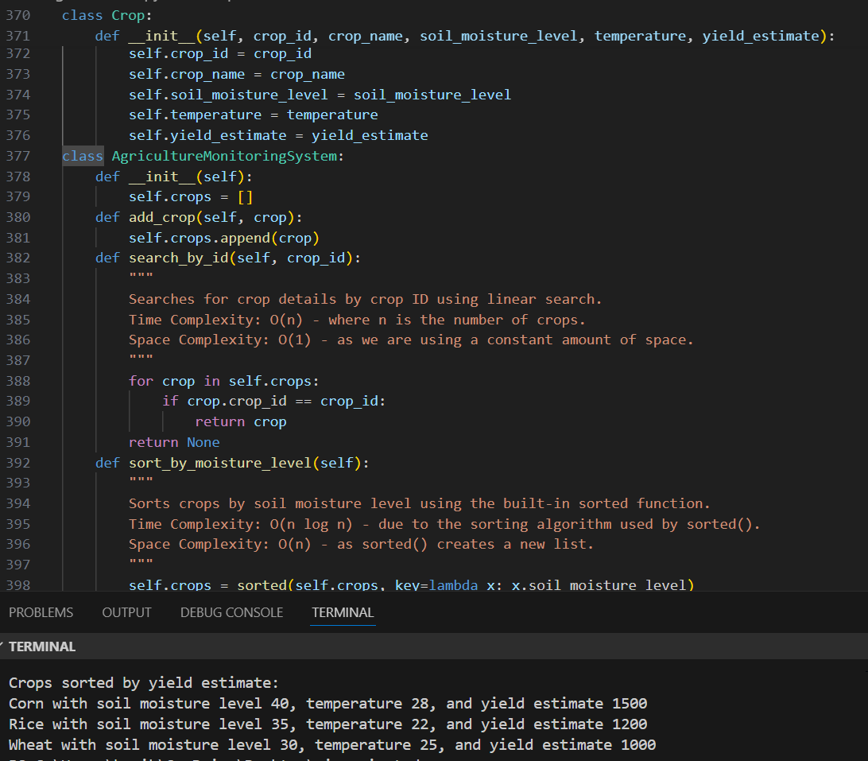
Task Description #8: Airport Flight Management System
Prompt: Design an airport flight management system in Python that stores flight ID, airline name, departure time, arrival time, and status, and use AI to recommend efficient searching and sorting algorithms, justify why they are suitable, and implement Python functions to search flight details by flight ID and sort flights based on departure time or arrival time.
Code& Output:
