Assignment – 8.2
2303A510i0
TASK 1: Test-Driven Development for Even/Odd Number Validator
PROMPT :
generate test cases for a function is_even(n) and then implement the function so that it satisfies all generated tests
CODE & OUTPUT :
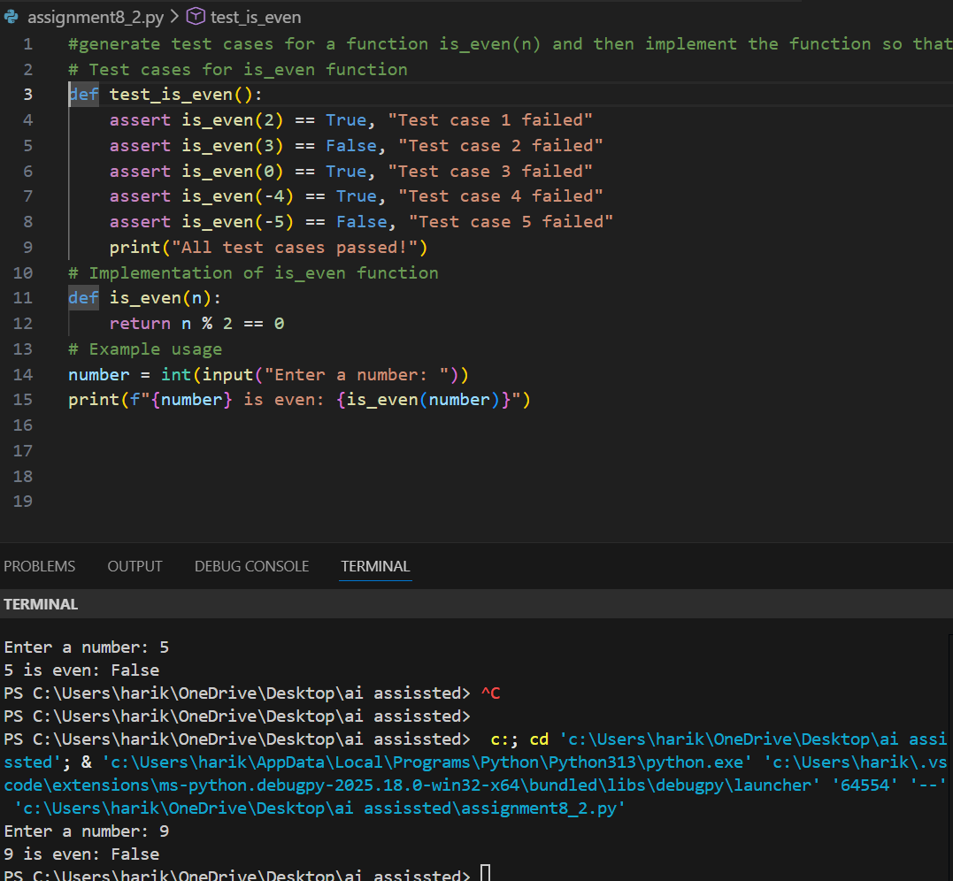

Justification : The test cases ensure correctness across edge cases like zero, negatives, and large integers. By defining tests first, the is_even() function is forced to handle all scenarios without assumptions. This prevents logical gaps and guarantees robustness in mathematical validation.
TASK 2: Test-Driven Development for String Case Converter
PROMPT : generate test cases for two functions: to_uppercase(text),to_lowercase(text)
CODE & OUTPUT :
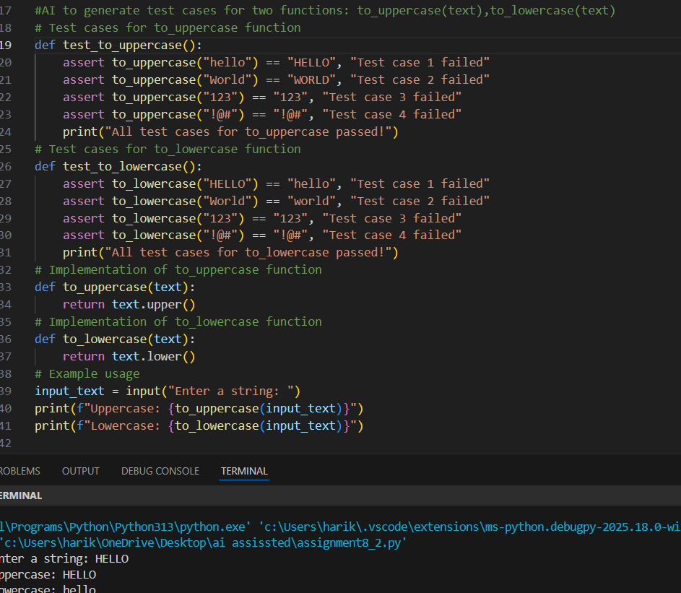

Justification :
Test cases cover empty strings, mixed-case input, and invalid inputs like numbers or None. Writing tests upfront ensures the functions handle both normal and exceptional cases safely. This enforces defensive programming and avoids runtime errors in real-world usage.

TASK 3: Test-Driven Development for list Sum Calculator
PROMPT :
Getting an index out of range error identify the cause for the error and fix it.
CODE & OUTPUT :
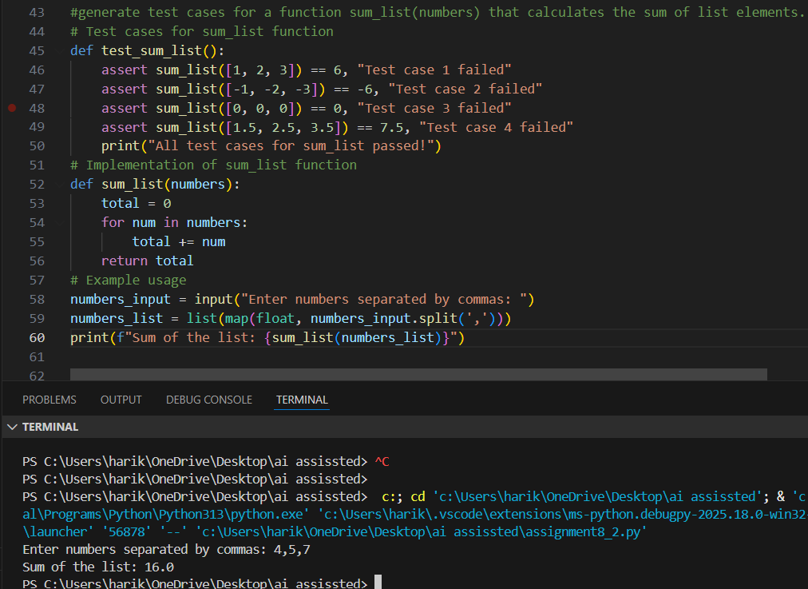

Justification :
The tests include empty lists, negatives, and mixed data types. This ensures the sum_list() function is resilient and avoids crashes when encountering non-numeric values. TDD here guarantees predictable behavior and safe handling of irregular inputs.
TASK 4:
Test Cases for Student Result Class
PROMPT :
Generate test cases for a StudentResultclass with the following methods:add_marks(mark),calculate_average(),get_result().

CODE & OUTPUT :
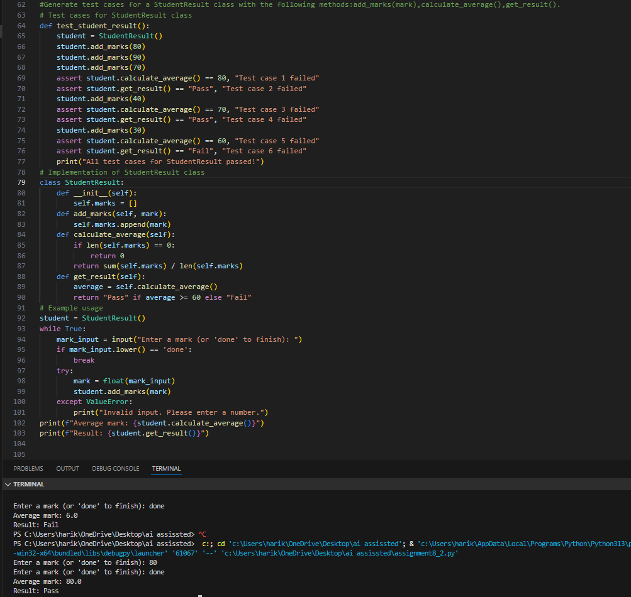

Justification :
By generating tests for valid marks, invalid marks, and pass/fail thresholds, the class is validated against both expected and erroneous inputs. TDD ensures the class enforces rules (0–100 range) and produces consistent results, making it reliable for academic evaluation systems.

TASK 5: Test-Driven Development for Username Validator
PROMPT : Generate test cases for a Username Validator class with the following methods:is_valid(username).Minimum length: 5 characters, No spaces allowed, Only alphanumeric characters
CODE & OUTPUT :
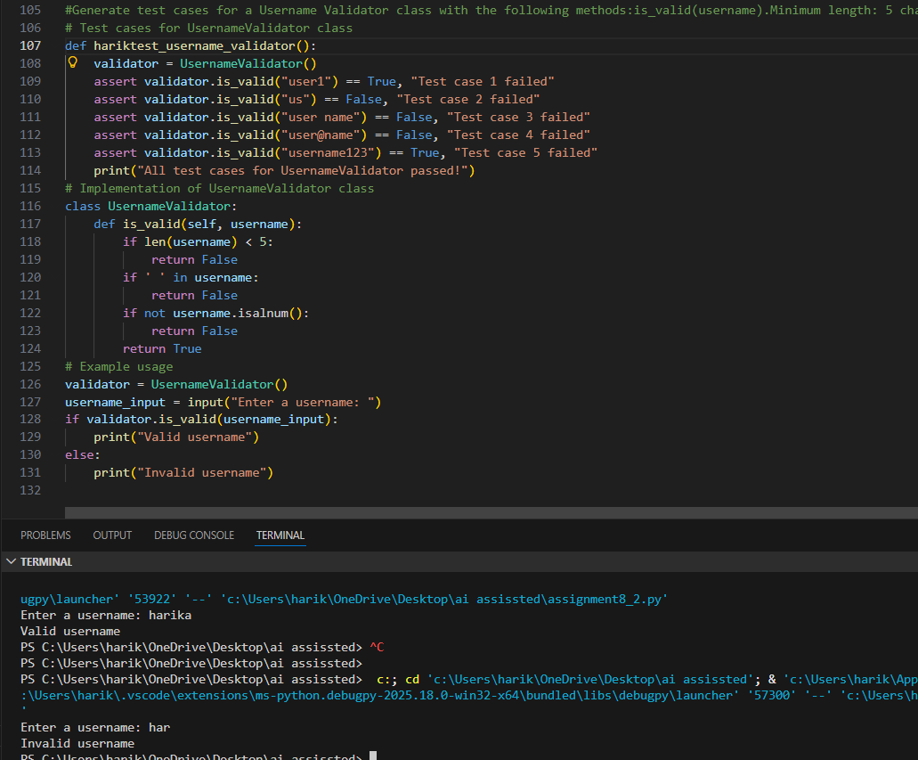

Justification :
The tests enforce rules like minimum length, no spaces, and alphanumeric-only input. Writing these tests first ensures the validator is strict, consistent, and secure. TDD prevents weak or invalid usernames from passing through, which is critical for authentication systems.

