Assignment_13.5
Batch_30
2303A510i0
Task Description #1 (Refactoring – Removing Global Variables)
Prompt: liminate unnecessary global variables from the code.
Code:
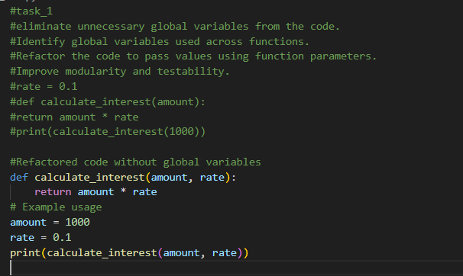
Output:
Task Description #2 : (Refactoring Deeply Nested Conditionals)
Prompt: Refactor deeply nested if–elif–else logic into a cleaner structure.

Code:
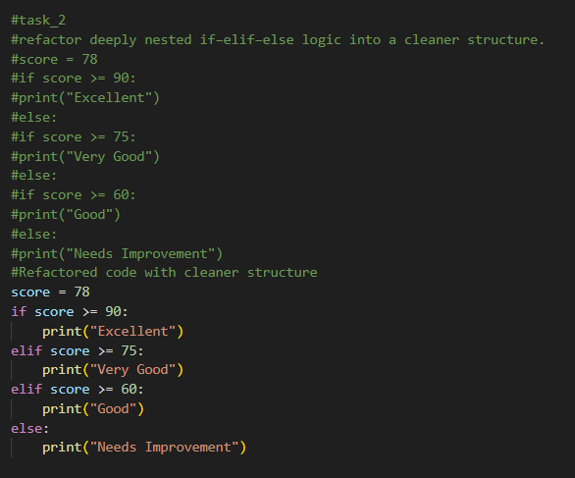
Output:
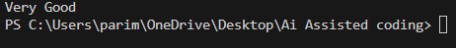
Task 4 (Optimizing Search Logic)
Prompt: Refactor inefficient linear searches using appropriate data structures.
Code:
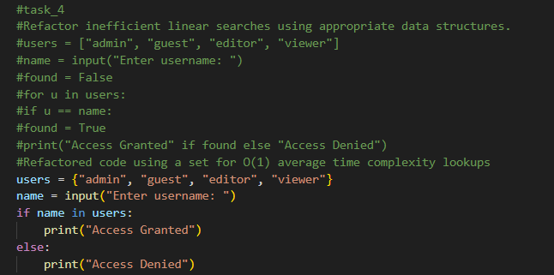
Output:
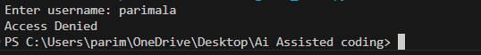
Task 5 (Refactoring Procedural Code into OOP Design)
Prompt: refactor procedural code into a class-based design.
Code:

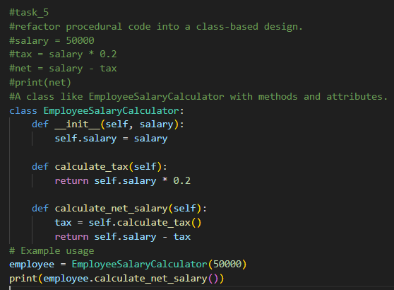
Task 6 (Refactoring for Performance Optimization)
Prompt:refactor a performance-heavy loop handling large data.
Code:
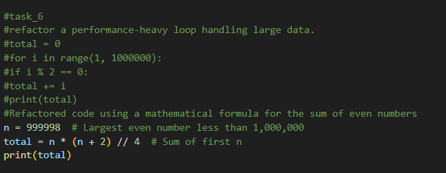
Output:
Task 7 (Removing Hidden Side Effects)
Prompt: Refactor code that modifies shared mutable state.
Code:
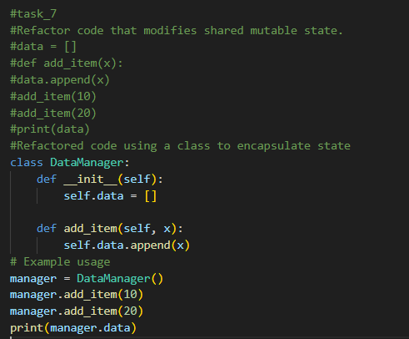
Task 8 (Refactoring Complex Input Validation Logic)
Prompt: simplify and modularize complex validation rules.
Code:
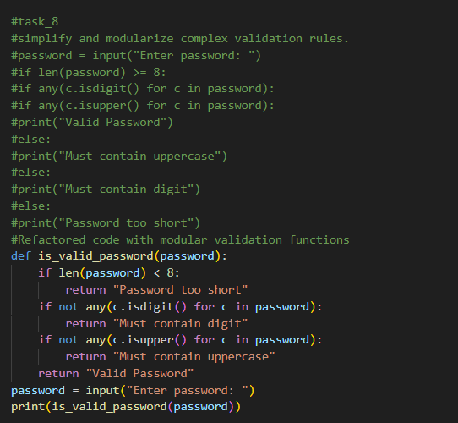
Output:
