Assignment_11.5
Batch_30
2303A510i0
Task Description #1 Stack Implementation
Prompt: Generate a Stack class with push, pop, peek, and is_empty methods.
Code &Output:
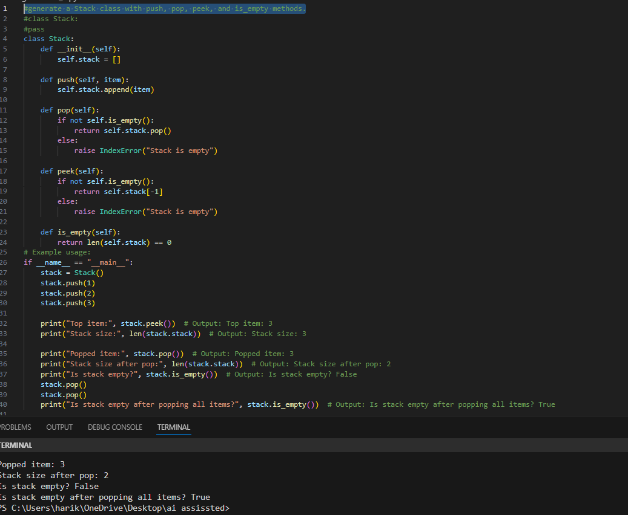

Task Description #2 : Queue Implementation
Prompt: implement a Queue using Python lists
Code&Output:
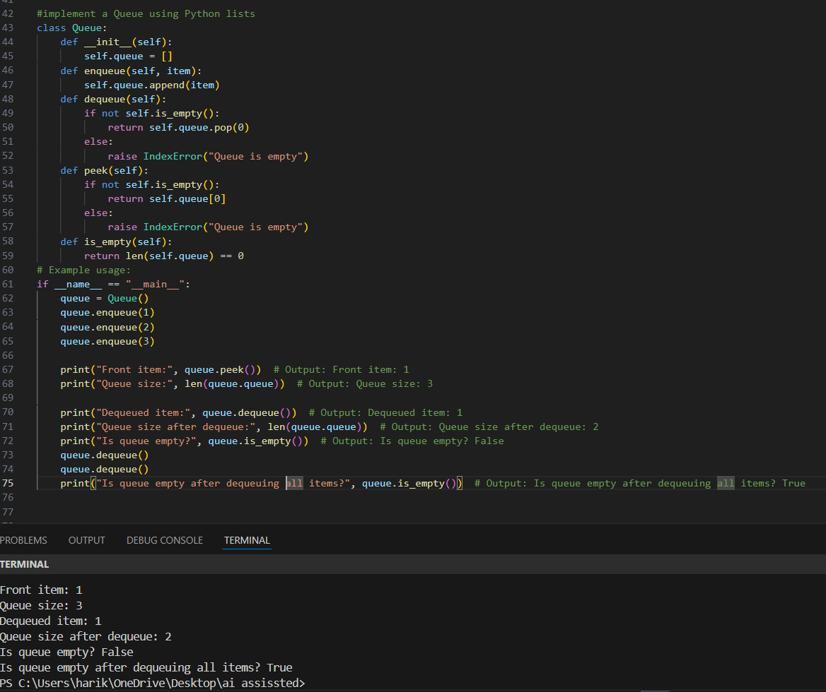

Task Description #3: Linked List
Prompt: Generate a Singly Linked List with insert and display
methods.
Code&output:
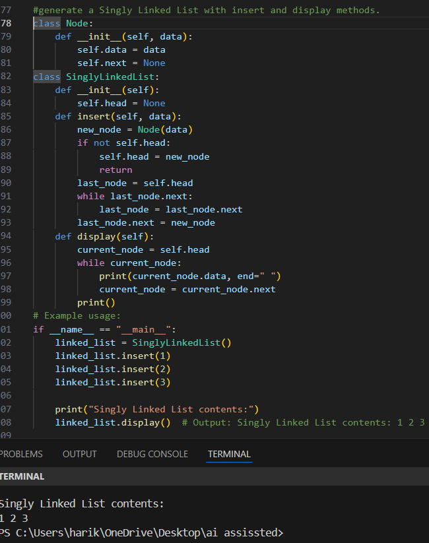

Task Description #4: Hash Table
Prompt: Implement a hash table with basic insert, search, and
delete methods.
Code&output:
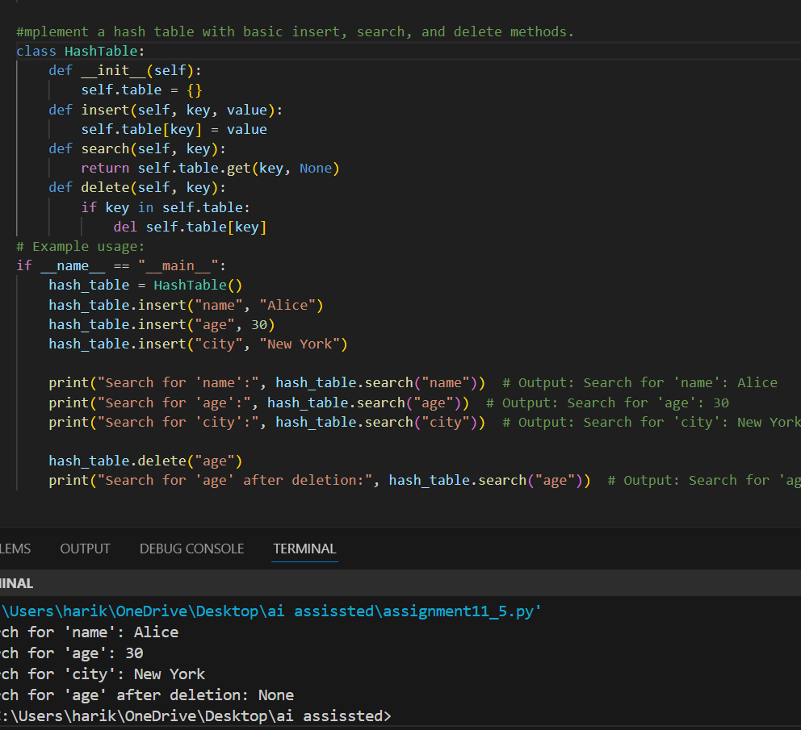

Task Description #5: Graph Representation
Prompt: Implement a graph using an adjacency list.
Code&Output:
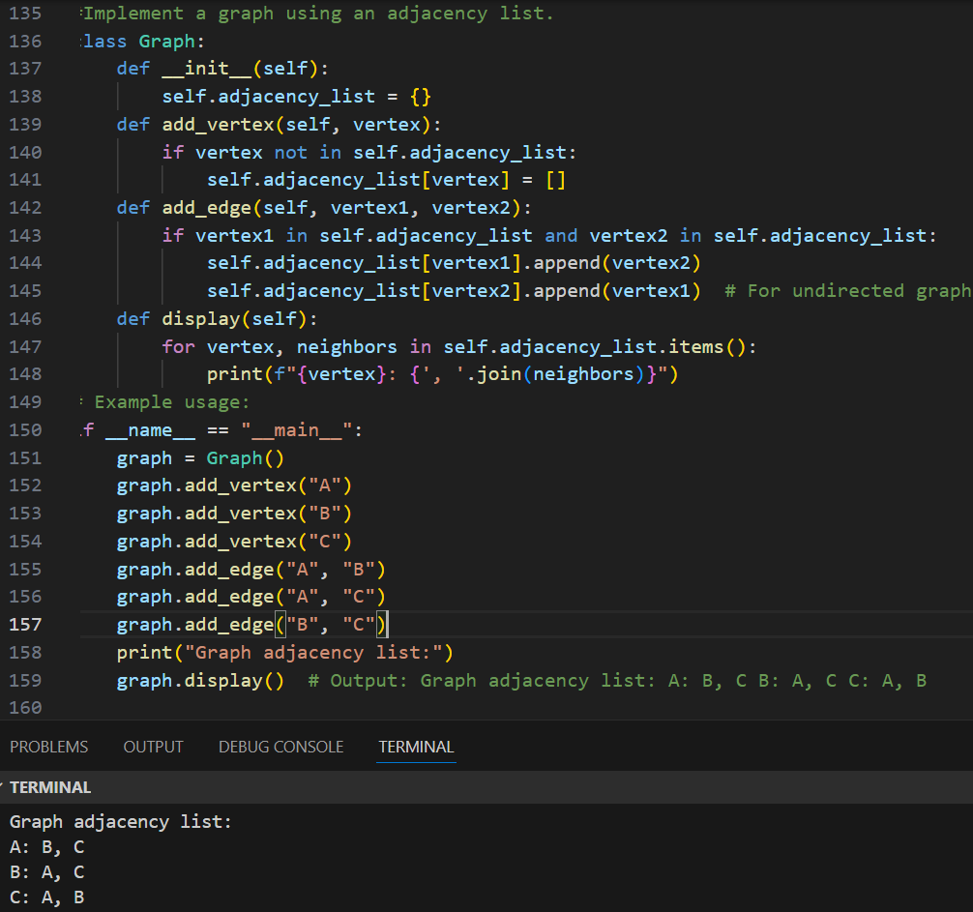
Task Description #6: Smart Hospital Management System – Data
Structure Selection
Prompt: A hospital needs to manage emergency patients where critical cases must be treated first regardless of arrival order.
Implement a Priority Queue in Python.Include methods to add patients with a priority level and treat patients in order of urgency.Use docstrings and comments for clarity.Demonstrate usage with sample patients (normal and critical).
Code & Output:
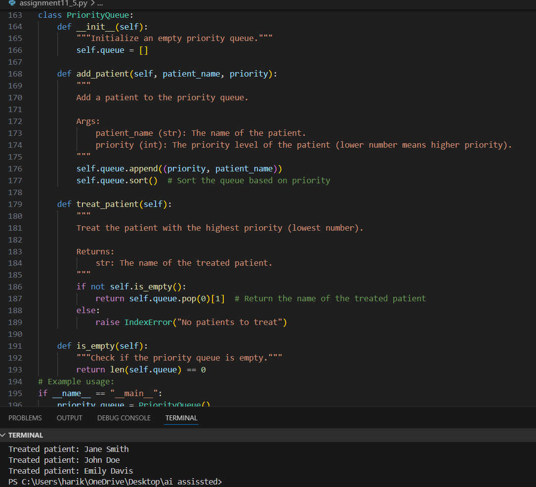
Task Description #7: Smart City Traffic Control System
Prompt: Write a Python program to implement Emergency Vehicle Priority Handling using a priority queue with heapq. Include docstrings and comments.
Code& output:
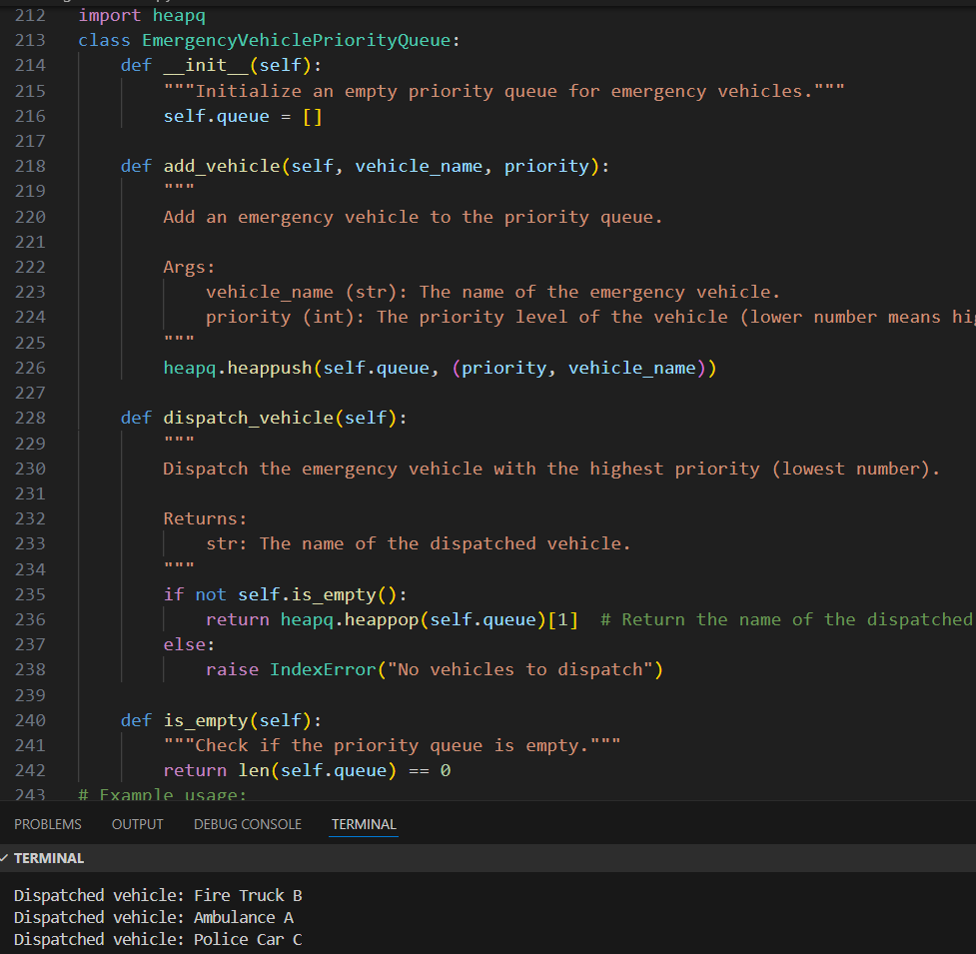
Task Description #8: Smart E-Commerce Platform – Data Structure
Challenge
Prompt: Write a Python program to implement Shopping Cart Management using a linked list. Include docstrings, comments, and example usage.
Code& Output:
