Assignment_11.2
Batch_30
2303A510i0
Task Description #1 (Stack Using AI Guidance)
Prompt: Design and implement a Stack data structure supporting basic stack operations.
Code &Output:
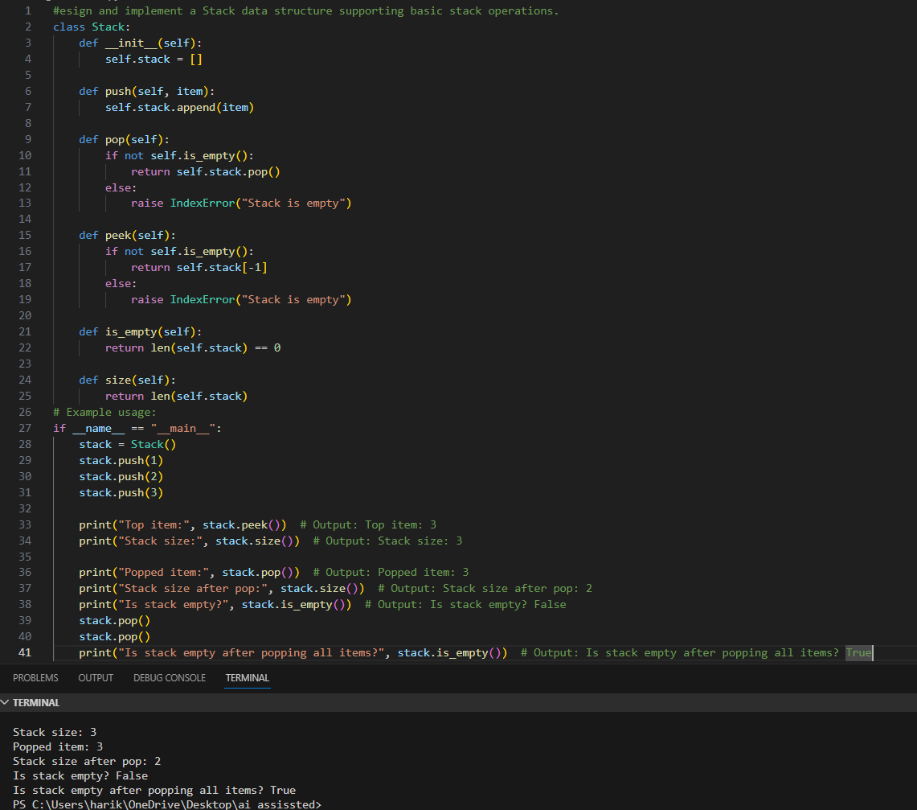

Task Description #2 : (Queue Design)
Prompt: create a Queue data structure following FIFO principles
Code&Output:
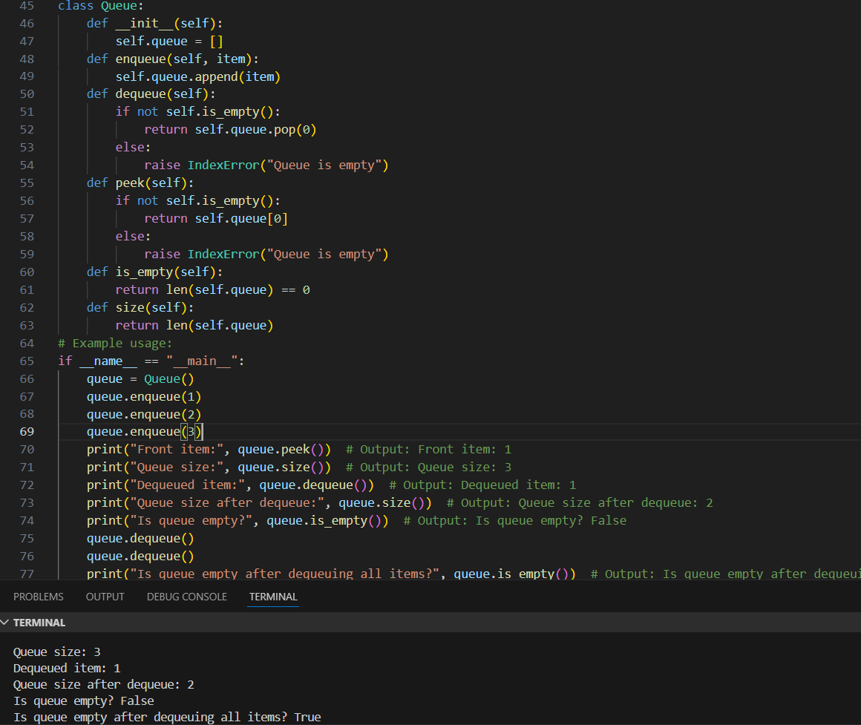
Task Description #3: (Singly Linked List Construction)
Prompt: Build a singly linked list supporting insertion
and traversal.
Code&output:
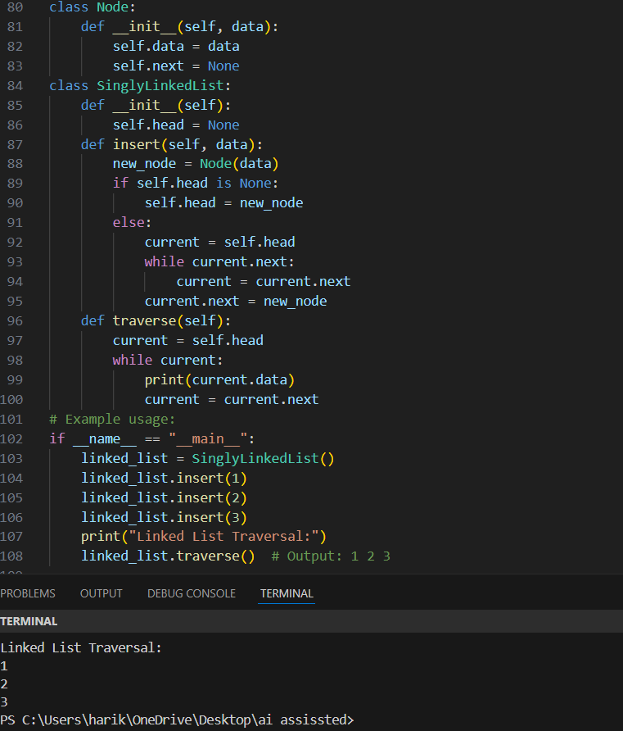

Task Description #4: (Binary Search Tree Operations)
Prompt: Implement a Binary Search Tree with AI support focusing
on insertion and traversal.
Code&output:
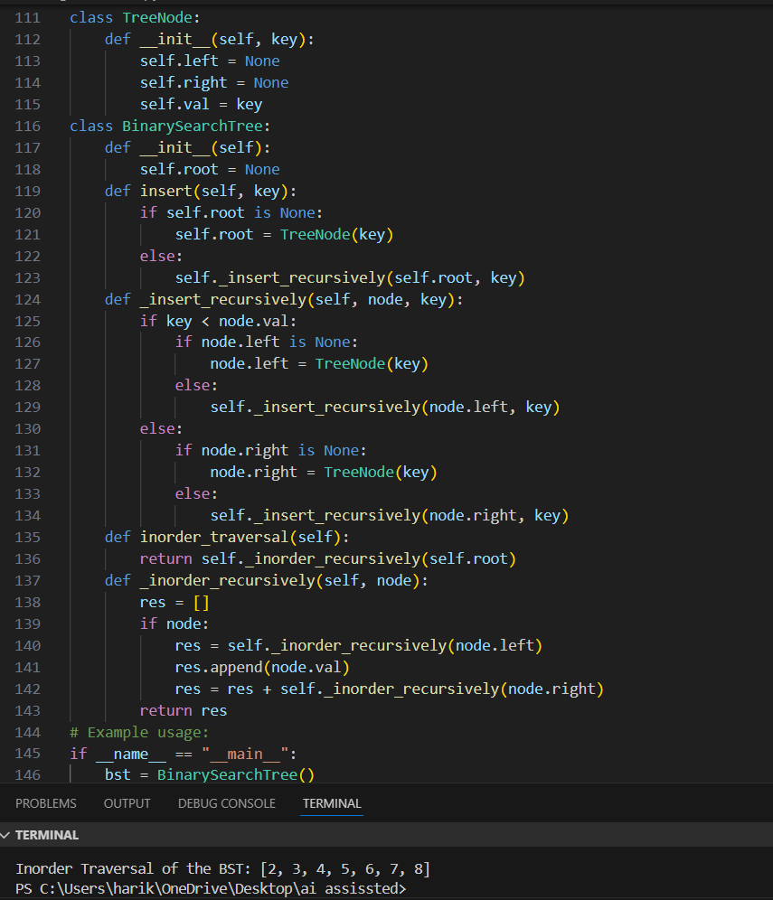

Task Description #5: (Hash Table Implementation)
Prompt: Create a hash table using AI with collision handling
Code&Output:
