ENCRYPTION OF SYSTEM FILES FOR FUTURE RECOVERY.

Introduction

The rising issues of stealing sensitive data owned by individuals is a common
problem in real life scenarios as well as in storage security. Present existing systems are
designed for personal use and only cover the needs of enterprise-class organizations, but
the needs and security of public-class is still not to the fullest. The study estimated the average
worth of a single stolen laptop to be about a million dollars.

Here, we formalize general encryption model for storage security. We present the
design and implementation to ensure flexibility, transparent usage of this model. This
system will not prevent from attacks but it will protect the data from being exposed to
unauthorized parties, and even the filesystem is accessed by unauthorized by other parties,
they are in encrypted form which makes them inadequate to read them, and if local
administrative is unable to physically access the file, then for the file recovery there is a
backup button setup where he can retrieve his lost data back with key management system.
So third parties are not benefited even if they steal them and also owner will have back his
data back with just key management and backup setup.
Aim:
Encrypting file system enhances an advanced key management scheme to provide a high grade of security while remaining transparent and easily usable. So, encrypting the file
systems would entitle flexibility to the public class users.

Algorithm
AES ALGORITHM
-> Derive the set of round keys from the cipher key (i.e. password given by the user initially).
-> Initialize the state array with the block data (user file for future recovery).
-> Add the initial round key to the starting state array.
Perform nine rounds of state manipulation.
Perform the tenth and final round of state manipulation.
Copy the final state array out as the encrypted data (encrypted file will be generated).

Encryption in detail
The order of operation in decryption is:
Perform initial decryption round:
XorRoundKey
InvShiftRows
InvSubBytes
Perform nine full decryption rounds:
XorRoundKey
InvMixColumns
InvShiftRows
InvSubBytes
Perform final XorRoundKey
The same round keys are used in the same order.

NOTE:
It takes a 128-bit block of data and transform it into ciphertext.
Here all the operations are based on byte values and operations that are simple to implement in digital logic gates.

AES ALGORITHM IMPLEMENTATION
we used AES algorithm because it achieves the goal of being both secure and practical for real systems. Our algorithm uses inbuilt java libraries to encrypt and decrypt.
The S-Box was generated when libraries were included, but not displayed in any step.
It's used in every round in the SubBytes step.
The S-box is constant. You could see it as a function taking a byte and returning a byte. It is used to reduce algebraic properties.
LIBRARIES USED:
import javax.crypto.Cipher;
import javax.crypto.spec.SecretKeySpec;
This class provides the functionality of a cryptographic cipher for encryption and decryption. It forms the core of the Java Cryptographic Extension (JCE) framework.
In order to create a Cipher object, the application calls the Cipher's getInstance method, and passes the name of the requested transformation to it. Optionally, the name of a provider may be specified.
A transformation is a string that describes the operation (or set of operations) to be performed on the given input, to produce some output. A transformation always includes the name of a cryptographic algorithm (e.g., AES), and may be followed by a feedback mode and padding scheme.
Cipher c = Cipher.getInstance("AES/CBC/PKCS5Padding");
block ciphers can encrypt data in units smaller than the cipher's actual block size so supporting that we request a mode "AES/OFB32/PKCS5Padding" transformations.
The javax.crypto package defines classes and interfaces for various cryptographic operations.
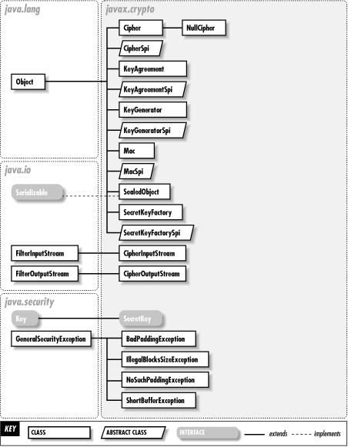

conclusion
For Decryption of files, only local administration is only capable of retrieving the
data. The theft of a personal laptop or a USB leaves the victim vulnerable to the
risk of identity theft in addition to the loss of personal or financial data and intellectual
property.

