SR UNIVERSITY

School of Computer Science and Artificial Intelligence

Lab Assignment 8.5

Program | : B. Tech (CSE)
Course Title | : AI Assisted Coding
Course Code | : 23CS002PC304
Semester | : III
Academic Session | : 2025-2026
Name of Student | : Harika Jupaka
Enrollment No. | : 2403A51L31
Batch No. | : 52
Date | : 30-1-2026

Task 1:
Prompt: Generate at least 3 Python assert test cases for a function is_valid_username(username). Conditions: Username length must be between 5 and 15 characters, must contain only letters and digits, must not start with a digit, and must not contain spaces. print the results if conditions satisfied true else false Code:
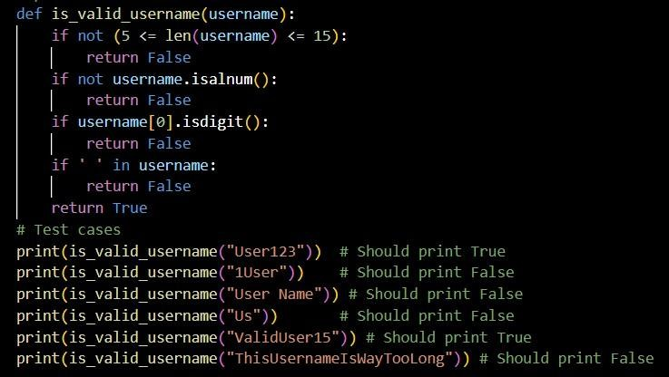
Output:
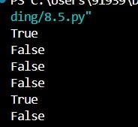
Explanation:
The function is_valid_username checks if a given username meets specific criteria:
- Length: The username must be between 5 and 15 characters long.
- Characters: The username must contain only letters and digits (no special characters).
- Starting Character: The username must not start with a digit.
- Spaces: The username must not contain any spaces.
The function returns True if all conditions are satisfied, otherwise it returns False.
Task 2:
Prompt : Write a Python function named classify_value(x) that classifies the input based on the following rules:
- If the input is not a number, return "Invalid Input".
- If the input is 0, return "Zero".
- If the input is an integer: Return "Even" if the number is divisible by 2, Return "Odd" if the number is not divisible by 2
Also generate at least 3 assert test cases to verify the function works correctly.
Code:
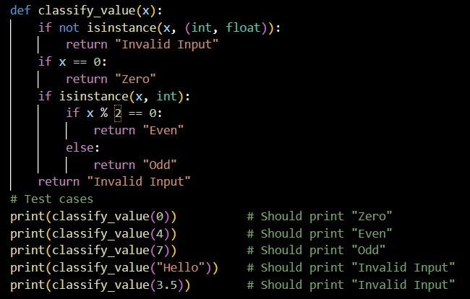
Output:
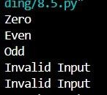
Explanation:
The function classify_value takes an input x and classifies it based on the specified rules:
- It first checks if x is a number (either int or float). If not, it returns "Invalid Input".
- If x is 0, it returns "Zero".
- If x is an integer, it checks if it is even or odd and returns "Even" or "Odd" accordingly.
- If x is a float, it returns "Invalid Input" since the classification only applies to integers.
Task 3 :
Prompt: Write a Python function called is_palindrome(text) that checks whether a string is a palindrome.
Requirements: Ignore uppercase/lowercase differences, Ignore spaces , Ignore punctuation and special characters , Handle edge cases like empty strings and single characters
Also generate at least 3 assert test cases to verify the function.
Code:
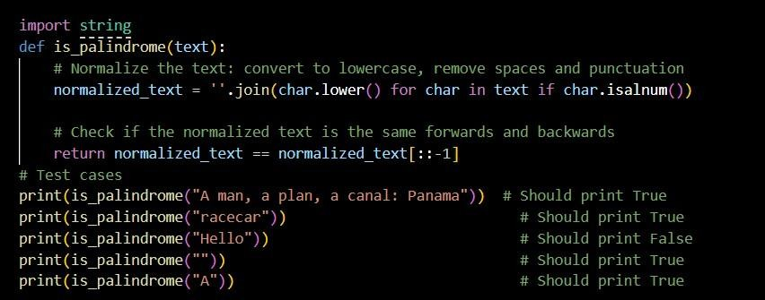
Output:
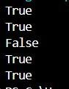
Explanation:
The function is_palindrome checks if a given string is a palindrome by:
- Normalizing the input string by converting it to lowercase and removing all non-alphanumeric characters (including spaces and punctuation).
- Comparing the normalized string to its reverse.
If they are the same, it returns True, indicating that the string is a palindrome; otherwise, it returns False.
Task 4:
Prompt: Create a Python class called BankAccount.
The class should: Be initialized with a starting balance, Have a method deposit(amount) that adds money to the balance , Have a method withdraw(amount) that subtracts money only if sufficient funds exist, Have a method get_balance() that returns the current balance . Also generate at least 3 assert-based test cases to verify the class works correctly. Keep the implementation simple and beginner-friendly.
Code:
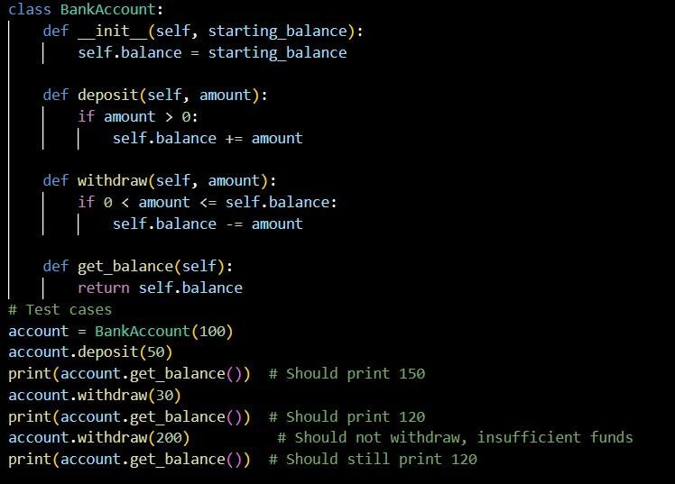
Output:
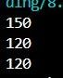
Explanation:
The BankAccount class simulates a simple bank account with the following features:
- Initialization: The account is initialized with a starting balance.
- Deposit Method: The deposit method allows adding money to the account balance, but only if the amount is positive.
- Withdraw Method: The withdraw method allows subtracting money from the balance, but only if there are sufficient funds.
- Get Balance Method: The get_balance method returns the current balance of the account.
Task 5 :
Prompt: Write a Python function called validate_email(email) to check whether an email address is valid. Requirements: Must contain exactly one "@" symbol Must contain at least one "." after the "@" Must not start or end with special characters like "@", ".", or spaces , Should return False for clearly invalid formats ,Keep the logic simple using basic string checks (beginner-friendly).Also generate at least 3 assert test cases to verify the function works correctly.
Code:
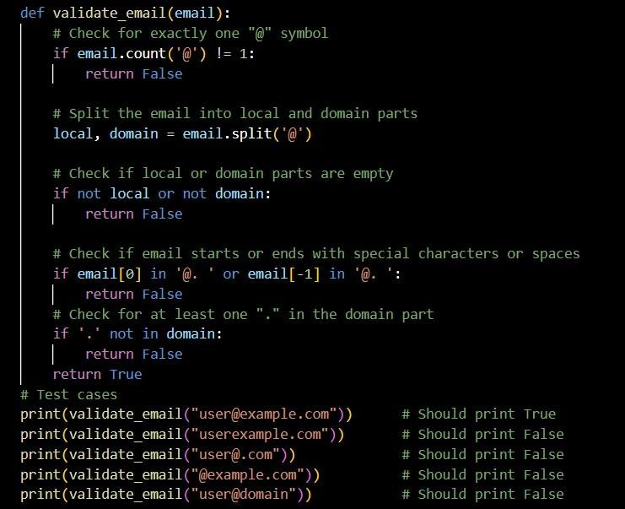
Output:
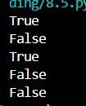
Explanation:
The function validate_email checks if a given email address is valid based on specific criteria:
- It ensures there is exactly one "@" symbol in the email.
- It splits the email into local and domain parts and checks that neither is empty.
- It checks that the email does not start or end with special characters like "@", ".", or spaces.
- It verifies that there is at least one "." in the domain part of the email.

