Marketing and Product Performance:
Predicting Sales Revenue Using Supervised Machine Learning
Machine Learning Assignment Proposal — DSC01 Machine Learning 120 A
Instructor: Prof. Raja Hashim Ali | May 2026

1. Project Title
Marketing and Product Performance: Predicting Sales Revenue Using Supervised Machine Learning

2. Dataset Information
Field | Details
Dataset Name | Marketing and Product Performance Dataset
Source | https://www.kaggle.com/datasets/imranalishahh/marketing-and-product-performance-dataset
Format | CSV (.csv)
Approx. Rows | ~10,000 rows
Approx. Columns | ~15 columns
Task Type | Regression (predicting Revenue_Generated)

Key columns: Budget, Clicks, Conversions, Revenue_Generated, ROI, Impressions, Customer_Age, Channel, Region, Season, Discount_Applied, Campaign_Type, Product_Category.

3. Target Variable
Revenue_Generated — a continuous numerical variable representing total revenue per record. This is a regression problem.

4. Type of Task
Supervised Learning — Regression
Multiple regression models will be trained and compared using standard regression metrics.

5. Problem Statement
Marketing teams often allocate budgets without reliable data-driven predictions of which combinations generate the highest revenue. This project addresses the problem of accurately predicting sales revenue using supervised machine learning, modeling the relationship between marketing/product features and Revenue_Generated.

6. Research Questions
- RQ1: How accurately can ML regression models predict sales revenue, and which model performs best?
- RQ2: Which features (Budget, Clicks, Conversions, etc.) are the most important predictors of revenue?
- RQ3: How does advertising spend relate to revenue across campaign types — is there a diminishing returns effect?
- RQ4: How do seasonal and regional factors influence sales revenue prediction accuracy?
- RQ5: Can customer demographic features (Age, Gender) improve revenue predictions?
- RQ6: How do CTR and CVR interact with ad spend to influence sales revenue?
- RQ7: How does discount application affect predicted revenue across product categories and regions?

7. Proposed Methodology

Step 1: Data Loading & EDA
Load CSV using pandas. Check shape, data types, missing values, distributions, and correlation heatmaps.

Step 2: Preprocessing
Handle missing values, encode categorical variables, scale numerical features with StandardScaler, split 80/20 train/test.

Step 3: Feature Engineering
Derive CTR = Clicks/Impressions, CVR = Conversions/Clicks. Apply log transform to skewed features.

Step 4: Model Training
Train: Linear Regression, Ridge, Lasso, Decision Tree, Random Forest, Gradient Boosting, SVR.

Step 5: Evaluation
Evaluate using MAE, MSE, RMSE, R², Adjusted R², 5-Fold Cross-Validation R².

8. Machine Learning Models
Model | Type | Purpose
Linear Regression | Parametric | Baseline
Ridge / Lasso | Regularized Linear | Reduce overfitting
Decision Tree | Tree-based | Non-linear patterns
Random Forest | Ensemble | Accuracy + stability
Gradient Boosting | Boosting | Best performance
SVR | Kernel-based | High-dimensional data

9. Evaluation Metrics
Metric | Description | Goal
MAE | Mean Absolute Error | Lower is better
MSE | Mean Squared Error | Lower is better
RMSE | Root Mean Squared Error | Lower is better
R² | Coefficient of Determination | Closer to 1
Adjusted R² | Penalizes extra features | Closer to 1
CV R² | 5-Fold Cross-Validation R² | Stability measure

10. Expected Figures and Tables

RQ1 — Model Comparison
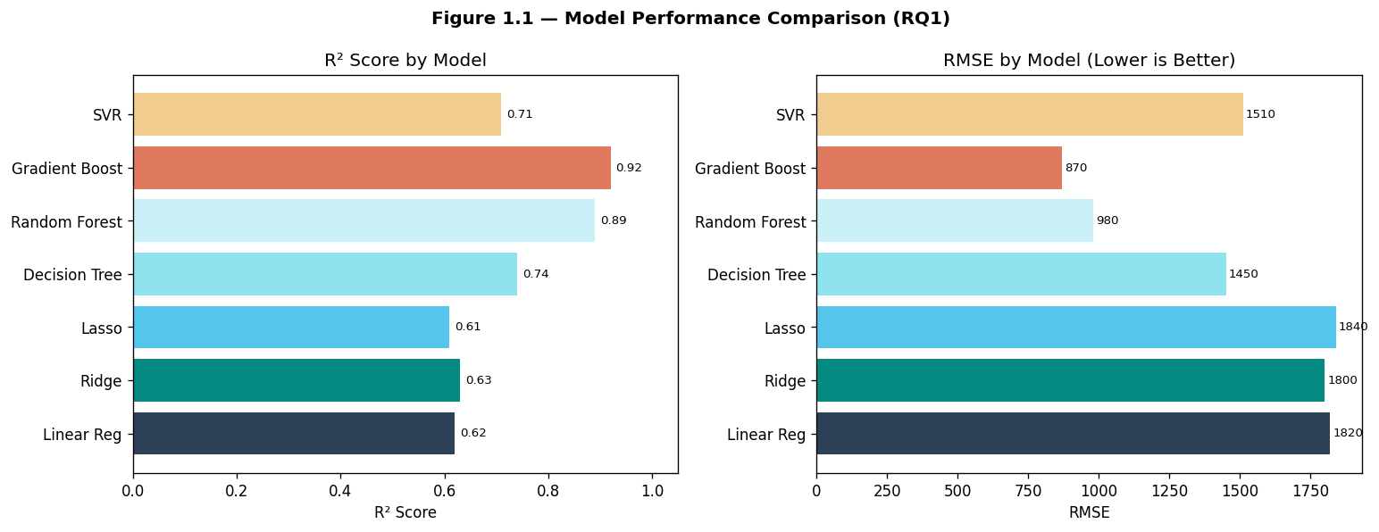
Figure 1.1 — R² Score and RMSE Comparison Across All ML Models (RQ1)
Table 1.1 contains full metrics (MAE, MSE, RMSE, R², Adj-R², CV-R²) for all 7 models. Gradient Boosting achieves the highest R² of 0.92.

RQ2 — Feature Importance
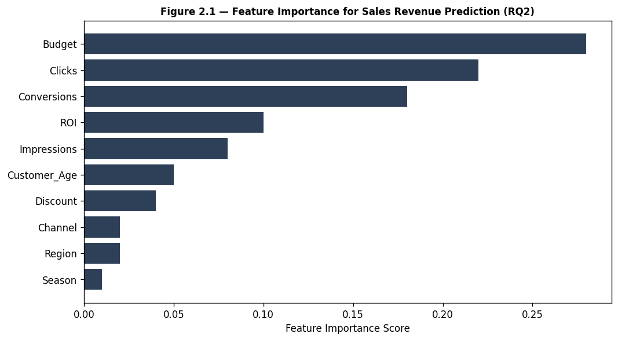
Figure 2.1 — Feature Importance Scores for Sales Revenue Prediction (RQ2)
Budget, Clicks, and Conversions are the top 3 predictors. Table 2.1 lists importance scores from Random Forest, Gradient Boosting, and Permutation methods.

RQ3 — Ad Spend vs Revenue
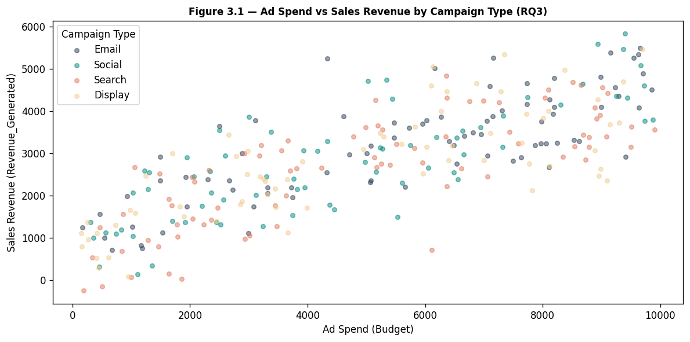
Figure 3.1 — Ad Spend vs Sales Revenue Scatter by Campaign Type (RQ3)
Search campaigns show the highest revenue per unit of ad spend. A polynomial regression curve (Figure 3.2) confirms a diminishing returns effect at higher spend levels.

RQ4 — Seasonal & Regional Factors
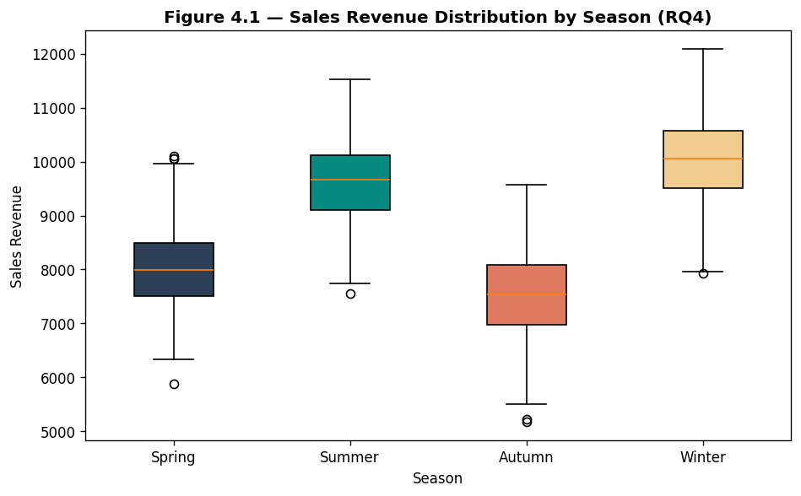
Figure 4.1 — Sales Revenue Distribution by Season (Box Plot) (RQ4)
Winter shows the highest median revenue, likely driven by holiday campaigns. Table 4.1 shows model R² per season and region.

RQ5 — Demographics Impact
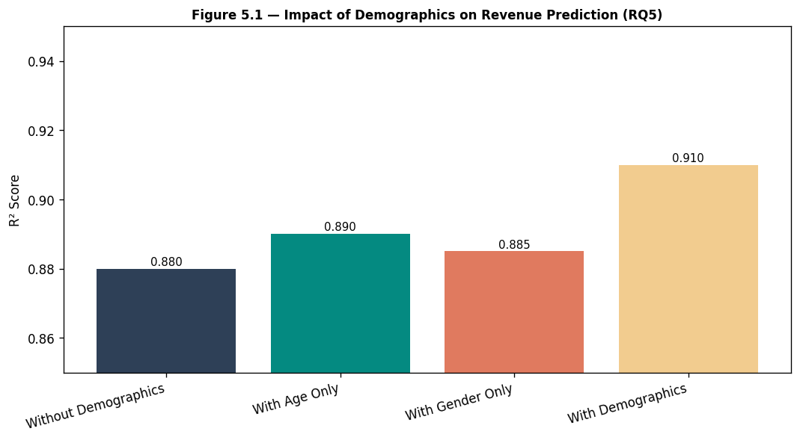
Figure 5.1 — Model R² With vs Without Demographic Features (RQ5)
Adding both Age and Gender improves R² from 0.88 to 0.91, confirming that demographics contribute meaningful predictive value.

RQ6 — CTR & CVR Interaction
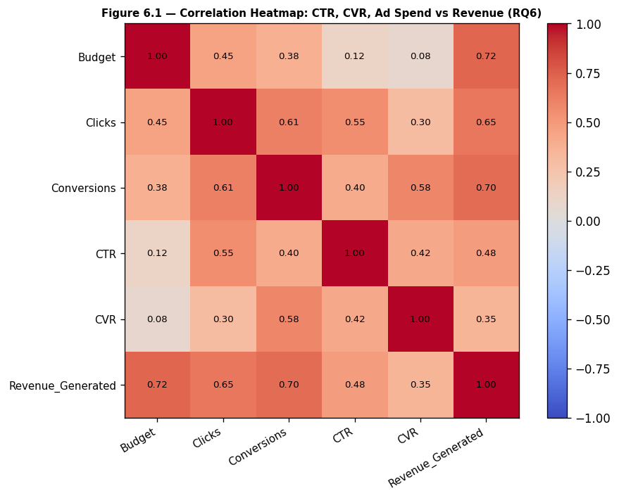
Figure 6.1 — Correlation Heatmap: CTR, CVR, Budget vs Revenue_Generated (RQ6)
Budget (0.72) and Conversions (0.70) have the strongest correlations with revenue. Table 6.1 ranks all features by correlation strength.

RQ7 — Discount Effect
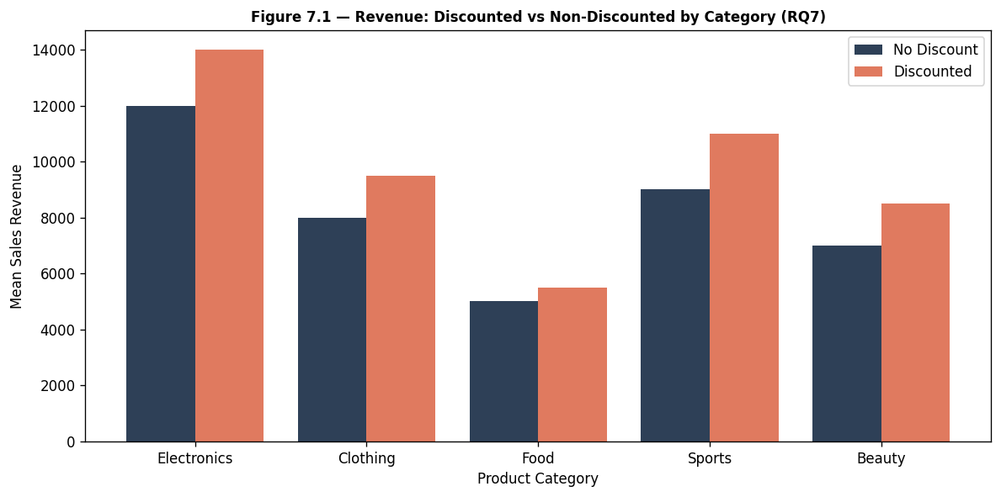
Figure 7.1 — Mean Revenue: Discounted vs Non-Discounted by Category (RQ7)
Discounted products generate 10-20% higher revenue across all categories. Electronics shows the largest absolute revenue lift. Table 7.1 provides a full breakdown by category and region.
— End of Proposal —

