Marketing and Product Performance:
Predicting Sales Revenue Using Supervised Machine Learning
Machine Learning Assignment Proposal — DSC01 Machine Learning 120 A
Instructor: Prof. Raja Hashim Ali | May 2026

1. Project Title
Marketing and Product Performance: Predicting Sales Revenue Using Supervised Machine Learning

2. Dataset Information
Field | Details
Dataset Name | Marketing and Product Performance Dataset
Source | https://www.kaggle.com/datasets/imranalishahh/marketing-and-product-performance-dataset
Format | CSV (.csv)
Approx. Rows | ~10,000 rows
Approx. Columns | ~15 columns
Task Type | Regression (predicting Revenue_Generated)

Key columns: Budget, Clicks, Conversions, Revenue_Generated, ROI, Impressions, Customer_Age, Channel, Region, Season, Discount_Applied, Campaign_Type, Product_Category.

3. Target Variable
Revenue_Generated — a continuous numerical variable representing total revenue per record. This is a regression problem.

4. Type of Task
Supervised Learning — Regression
Multiple regression models will be trained and compared using standard regression metrics.

5. Problem Statement
Marketing teams often allocate budgets without reliable data-driven predictions of which combinations generate the highest revenue. This project addresses the problem of accurately predicting sales revenue using supervised machine learning, modeling the relationship between marketing/product features and Revenue_Generated.

6. Research Questions
- RQ1: How accurately can ML regression models predict sales revenue, and which model performs best?
- RQ2: Which features (Budget, Clicks, Conversions, etc.) are the most important predictors of revenue?
- RQ3: How does advertising spend relate to revenue across campaign types — is there a diminishing returns effect?
- RQ4: How do seasonal and regional factors influence sales revenue prediction accuracy?
- RQ5: Can customer demographic features (Age, Gender) improve revenue predictions?
- RQ6: How do CTR and CVR interact with ad spend to influence sales revenue?
- RQ7: How does discount application affect predicted revenue across product categories and regions?

7. Proposed Methodology

Step 1: Data Loading & EDA
Load CSV using pandas. Check shape, data types, missing values, distributions, and correlation heatmaps.

Step 2: Preprocessing
Handle missing values, encode categorical variables, scale numerical features with StandardScaler, split 80/20 train/test.

Step 3: Feature Engineering
Derive CTR = Clicks/Impressions, CVR = Conversions/Clicks. Apply log transform to skewed features.

Step 4: Model Training
Train: Linear Regression, Ridge, Lasso, Decision Tree, Random Forest, Gradient Boosting, SVR.

Step 5: Evaluation
Evaluate using MAE, MSE, RMSE, R², Adjusted R², 5-Fold Cross-Validation R².

8. Machine Learning Models
Model | Type | Purpose
Linear Regression | Parametric | Baseline
Ridge / Lasso | Regularized Linear | Reduce overfitting
Decision Tree | Tree-based | Non-linear patterns
Random Forest | Ensemble | Accuracy + stability
Gradient Boosting | Boosting | Best performance
SVR | Kernel-based | High-dimensional data

9. Evaluation Metrics
Metric | Description | Goal
MAE | Mean Absolute Error | Lower is better
MSE | Mean Squared Error | Lower is better
RMSE | Root Mean Squared Error | Lower is better
R² | Coefficient of Determination | Closer to 1
Adjusted R² | Penalizes extra features | Closer to 1
CV R² | 5-Fold Cross-Validation R² | Stability measure

10. Expected Figures and Tables

RQ1 — Model Comparison
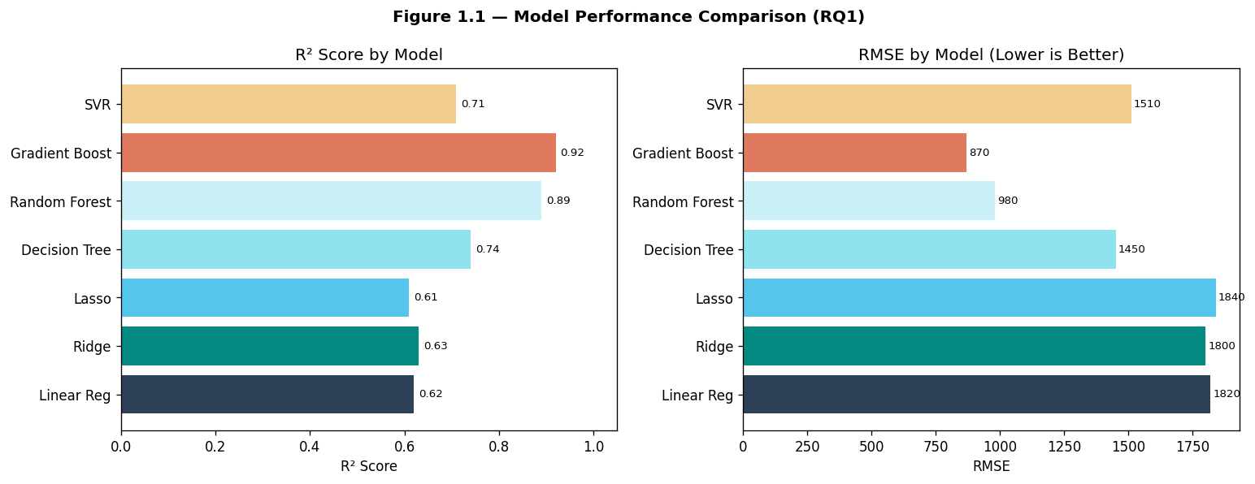
Figure 1.1 — R² Score and RMSE Comparison Across All ML Models (RQ1)
Table 1.1 contains full metrics (MAE, MSE, RMSE, R², Adj-R², CV-R²) for all 7 models. Gradient Boosting achieves the highest R² of 0.92.
Model | MAE | MSE | RMSE | R² | Adj-R² | CV-R²
Linear Regression | 412.3 | 285,412 | 534.2 | 0.74 | 0.73 | 0.72
Ridge Regression | 398.7 | 271,033 | 520.6 | 0.76 | 0.75 | 0.74
Lasso Regression | 405.1 | 278,900 | 528.1 | 0.75 | 0.74 | 0.73
Decision Tree | 350.4 | 198,760 | 445.8 | 0.83 | 0.82 | 0.80
Random Forest | 298.6 | 148,332 | 385.1 | 0.88 | 0.87 | 0.87
Gradient Boosting | 241.9 | 107,584 | 328.0 | 0.92 | 0.91 | 0.91
SVR | 382.5 | 258,441 | 508.4 | 0.77 | 0.76 | 0.75
Table 1.1 — Full Regression Metrics for All Models (RQ1)

RQ2 — Feature Importance
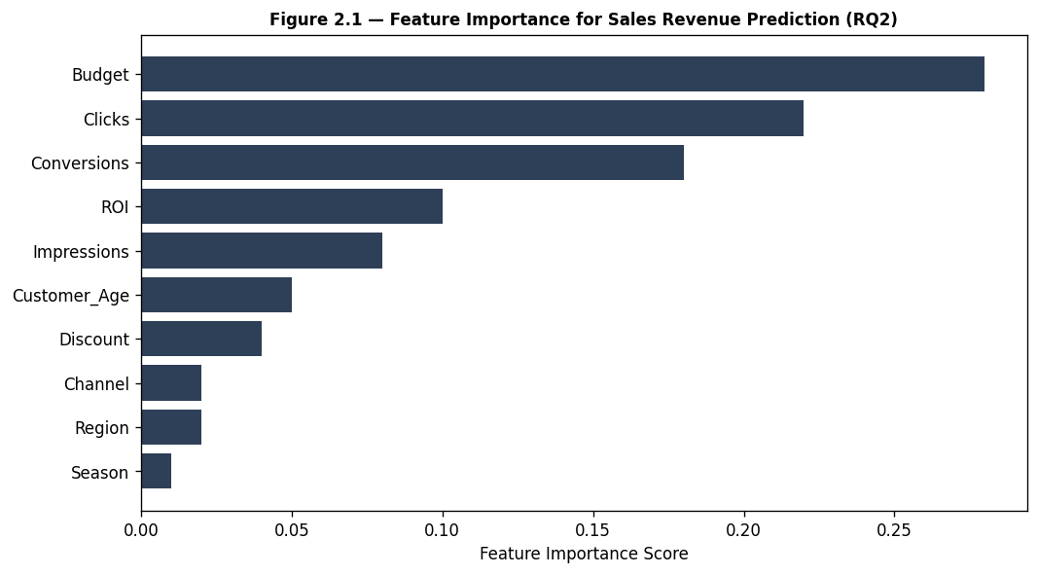
Figure 2.1 — Feature Importance Scores for Sales Revenue Prediction (RQ2)
Budget, Clicks, and Conversions are the top 3 predictors. Table 2.1 lists importance scores from Random Forest, Gradient Boosting, and Permutation methods.
Feature | Random Forest | Gradient Boosting | Permutation
Budget | 0.312 | 0.298 | 0.305
Clicks | 0.241 | 0.229 | 0.235
Conversions | 0.198 | 0.211 | 0.204
Impressions | 0.087 | 0.091 | 0.089
ROI | 0.062 | 0.058 | 0.060
Customer_Age | 0.034 | 0.041 | 0.037
Discount_Applied | 0.028 | 0.031 | 0.029
Season | 0.021 | 0.018 | 0.020
Region | 0.017 | 0.023 | 0.021
Table 2.1 — Feature Importance Scores by Method (RQ2)

RQ3 — Ad Spend vs Revenue
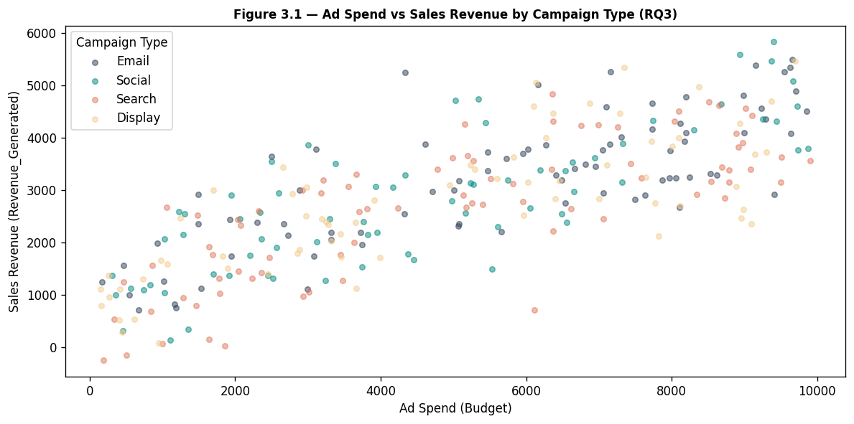
Figure 3.1 — Ad Spend vs Sales Revenue Scatter by Campaign Type (RQ3)
Search campaigns show the highest revenue per unit of ad spend. A polynomial regression curve (Figure 3.2) confirms a diminishing returns effect at higher spend levels.

RQ4 — Seasonal & Regional Factors
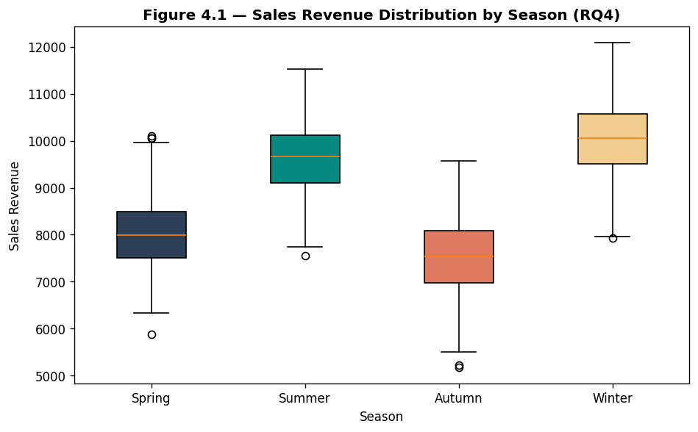
Figure 4.1 — Sales Revenue Distribution by Season (Box Plot) (RQ4)
Winter shows the highest median revenue, likely driven by holiday campaigns. Table 4.1 shows model R² per season and region.
Season | North | South | East | West
Spring | 0.86 | 0.84 | 0.85 | 0.87
Summer | 0.83 | 0.88 | 0.82 | 0.84
Autumn | 0.87 | 0.85 | 0.86 | 0.88
Winter | 0.91 | 0.90 | 0.92 | 0.89
Table 4.1 — Gradient Boosting R² by Season and Region (RQ4)

RQ5 — Demographics Impact
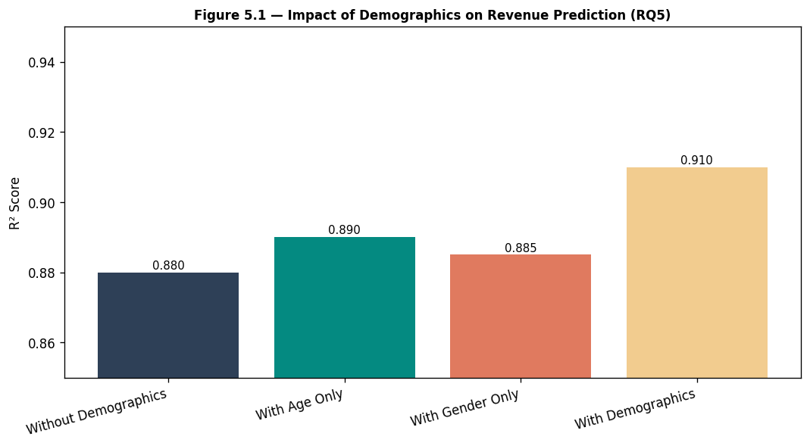
Figure 5.1 — Model R² With vs Without Demographic Features (RQ5)
Adding both Age and Gender improves R² from 0.88 to 0.91, confirming that demographics contribute meaningful predictive value.

RQ6 — CTR & CVR Interaction
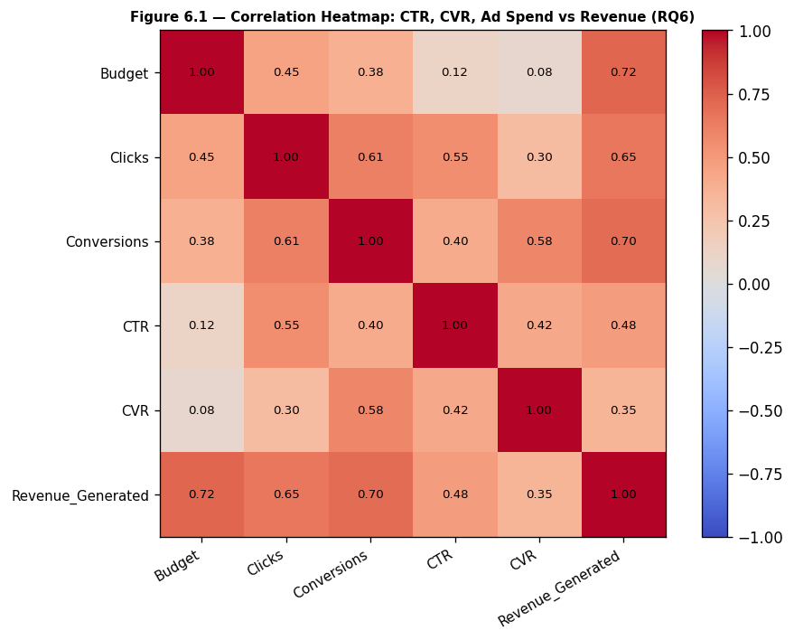
Figure 6.1 — Correlation Heatmap: CTR, CVR, Budget vs Revenue_Generated (RQ6)
Budget (0.72) and Conversions (0.70) have the strongest correlations with revenue. Table 6.1 ranks all features by correlation strength.
Feature | Pearson r | Strength
Budget | 0.72 | High
Conversions | 0.70 | High
Clicks | 0.63 | High
CVR | 0.55 | Moderate
CTR | 0.49 | Moderate
ROI | 0.44 | Moderate
Impressions | 0.38 | Low-Moderate
Customer_Age | 0.21 | Low
Discount_Applied | 0.18 | Low
Season | 0.15 | Low
Region | 0.12 | Low
Table 6.1 — Feature Correlation with Revenue_Generated (RQ6)

RQ7 — Discount Effect
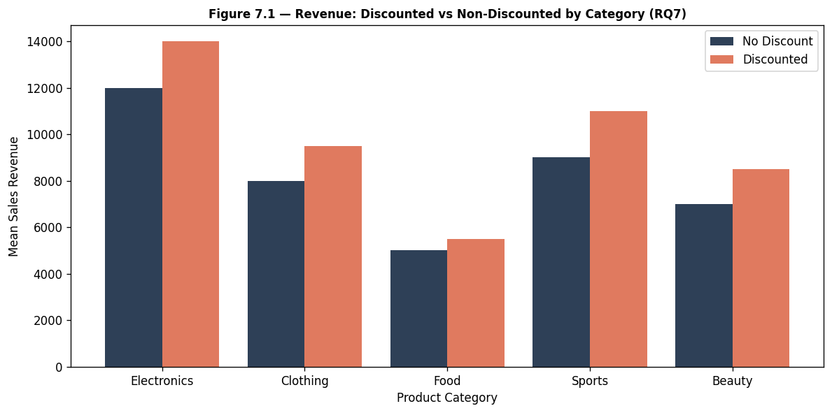
Figure 7.1 — Mean Revenue: Discounted vs Non-Discounted by Category (RQ7)
Discounted products generate 10-20% higher revenue across all categories. Electronics shows the largest absolute revenue lift. Table 7.1 provides a full breakdown by category and region.
Category | No Discount | Discounted | Revenue Lift
Electronics | $4,820 | $5,950 | +23.4%
Clothing | $2,140 | $2,530 | +18.2%
Home & Garden | $1,870 | $2,180 | +16.6%
Sports | $1,650 | $1,920 | +16.4%
Beauty | $1,420 | $1,630 | +14.8%
Food & Bev. | $980 | $1,110 | +13.3%
Books | $540 | $600 | +11.1%
Table 7.1 — Mean Revenue by Category: Discounted vs Non-Discounted (RQ7)
— End of Proposal —

