Approx Entropy Results for two files in range Pattern 1 to 10, tolerance 1 to 10 from script testApproxEntropy.m

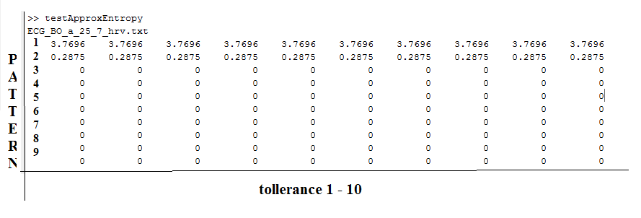

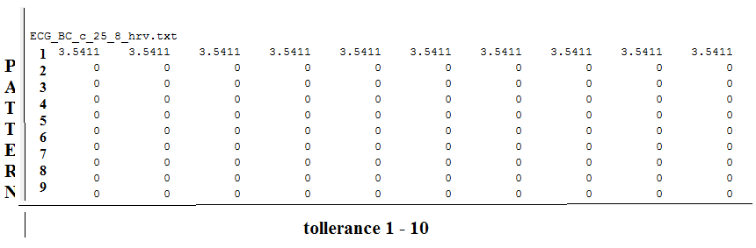

RenyEntropy Results for two files in range Pattern 1 to 10, tolerance 1 to 10 and exponent 0.2 from script testRenyEntropy.m

