Lab-05

RIP Protocol

**Topology**

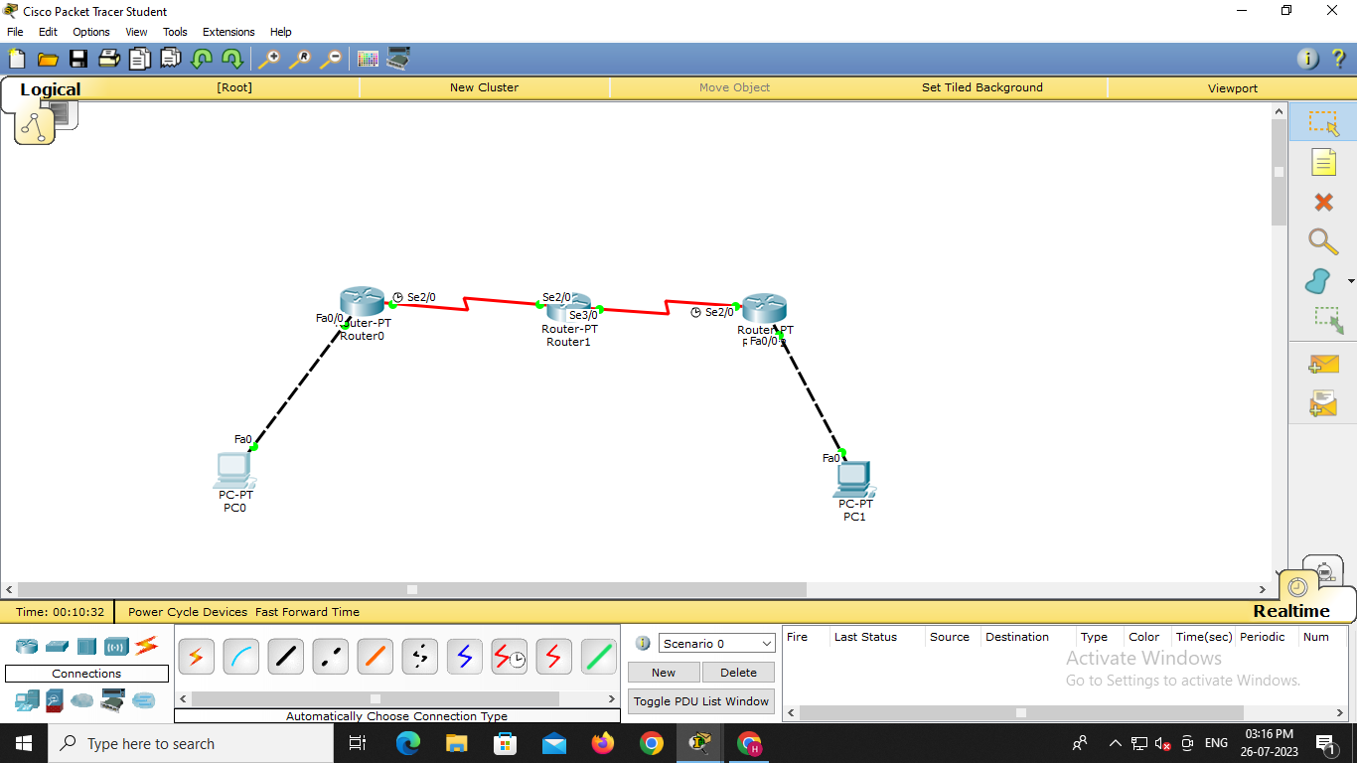

**CMD Output**

Source – 10.0.0.10

Destination – 40.0.0.10

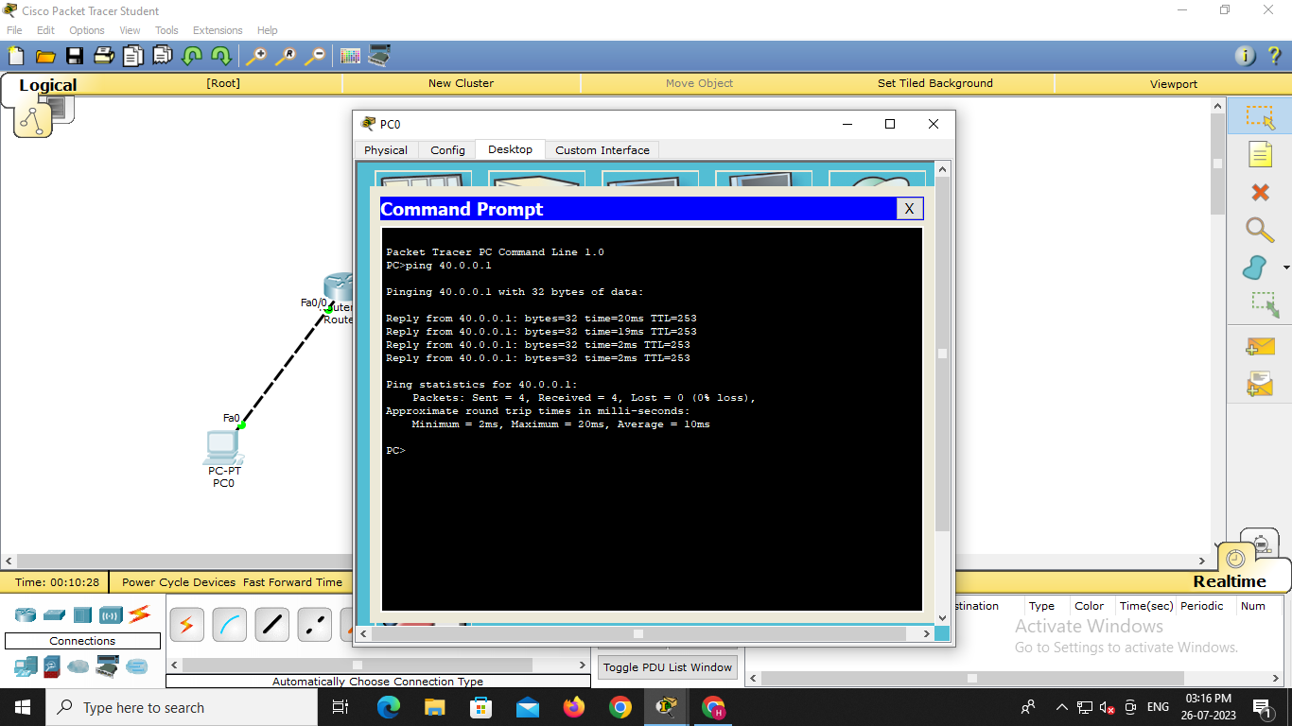

**Simulation Output**

