**Lab1**

**Date: 05/04/24**

**Write a python program to import and export data using Pandas library functions**

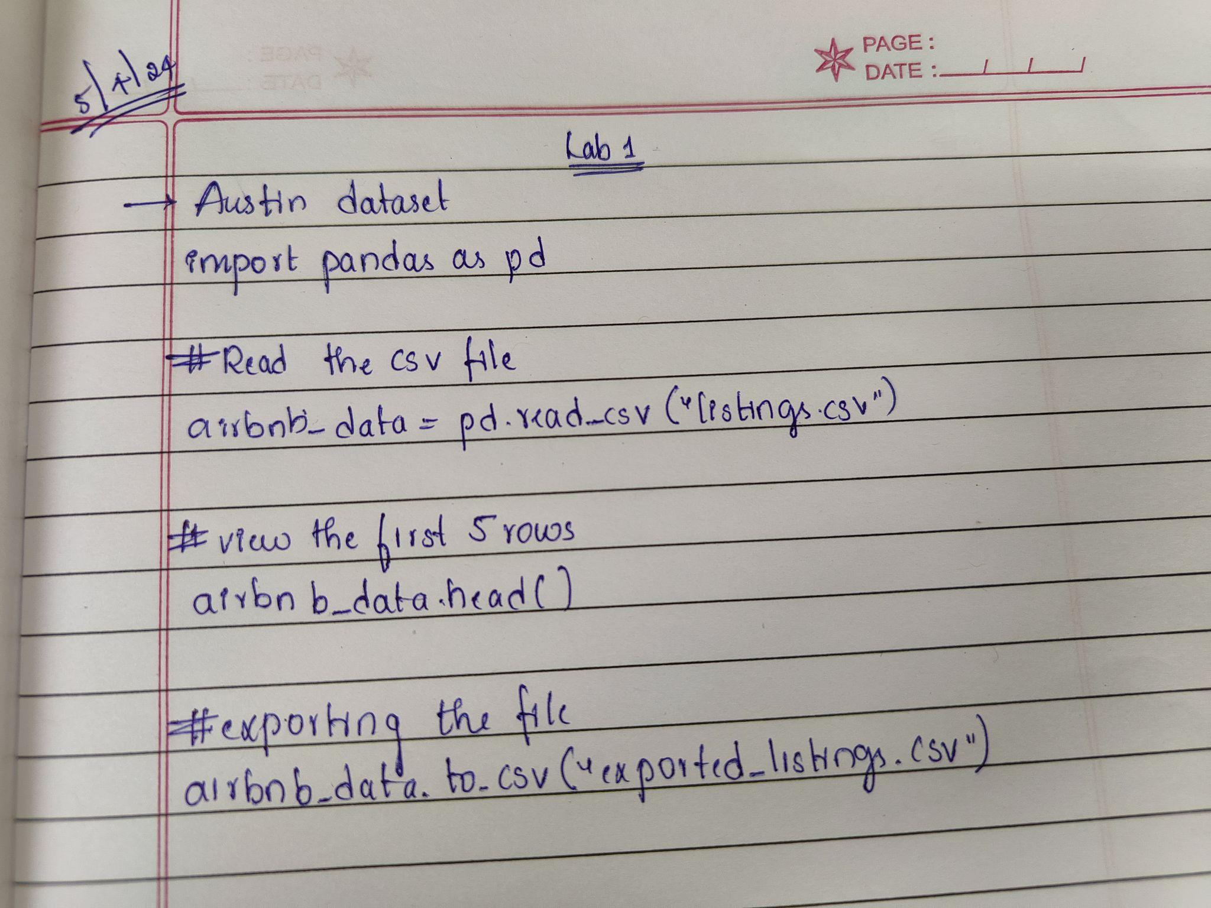

import pandas as pd

# Read the CSV file

airbnb_data = pd.read_csv("data/listings_austin.csv")

# View the first 5 rows

airbnb_data.head()

**Output:**

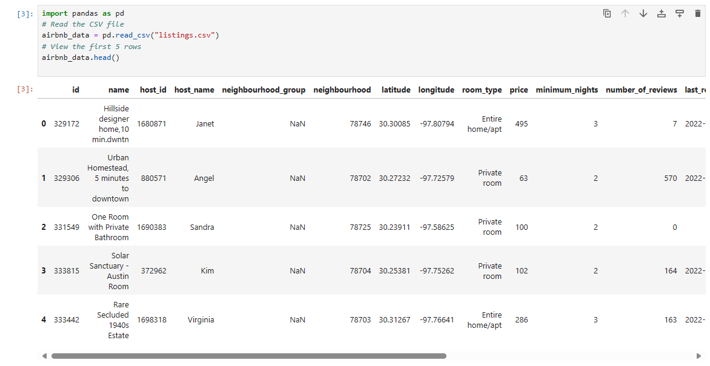

airbnb_data.to_csv("exported_listings.csv")

**Output:**

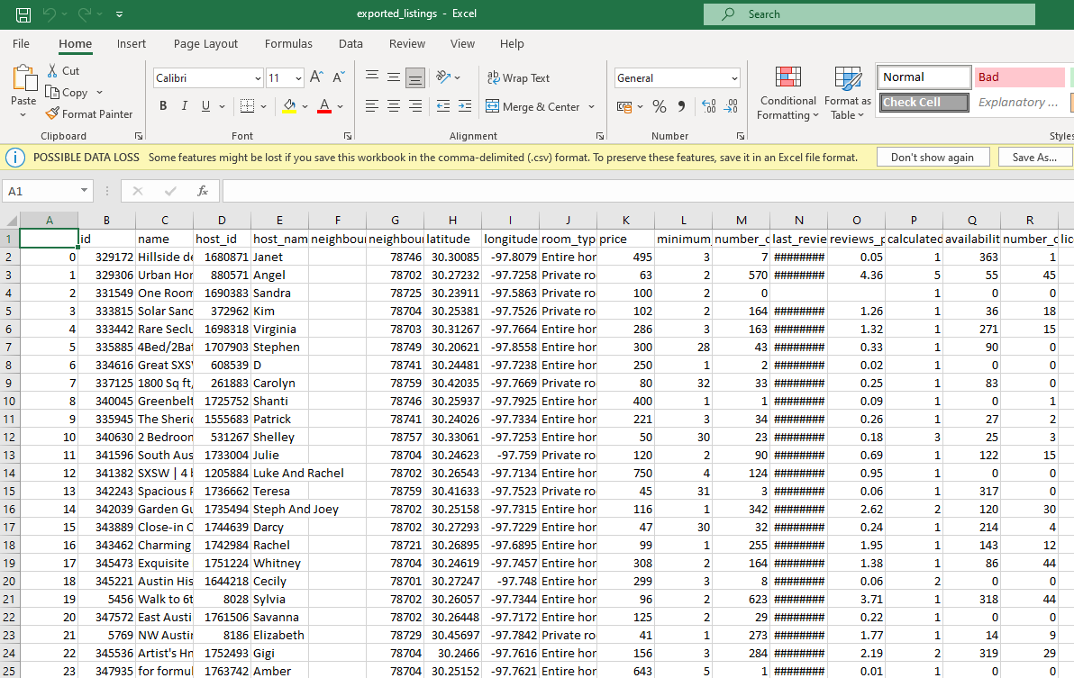

IRIS DATASET

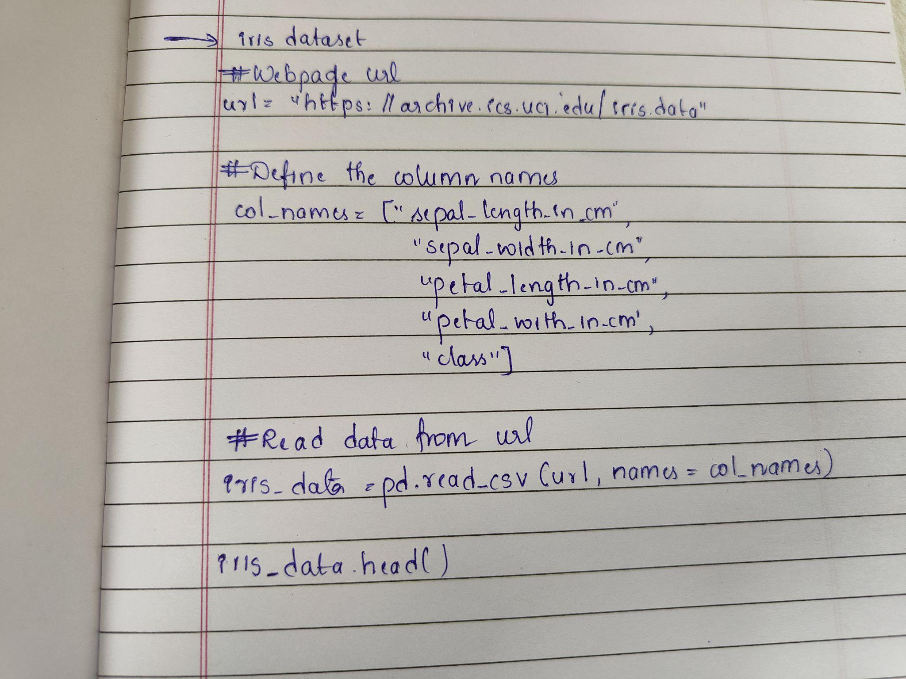

# Webpage URL

url = "https://archive.ics.uci.edu/ml/machine-learning-databases/iris/iris.data"

# Define the column names

col_names = ["sepal_length_in_cm",

"sepal_width_in_cm",

"petal_length_in_cm",

"petal_width_in_cm",

"class"]

# Read data from URL

iris_data = pd.read_csv(url, names=col_names)

iris_data.head()

