CAREER GUIDANCE USING CHATBOT

INTRODUCTION:

A chatbot(also known as talkbot, chatterbot, Bot, IM
bot, interactive agent, or Artificial Conversational Entity) is a computer program or an artificial intelligence which conducts a conversation via auditory or textual methods. In this programs are designed for our convenience as human would interact with a machine in a friendly manner and it behaves as a conversational partner, thereby passing the turing test.These are used in dialogue systems for various practical purposes including custom service or informatiom acqistion.some chatterbots use sophisticated natural language processing systems, but many simpler systems scan for keywords within the input, then pull a reply with the most maching keywords are the most similar wording pattern, from a database.

The term “chatterbot” was originally coined by
Michael Mauldin(creator of the first verbot, julia) in 1994 to describe these conversational programs.Today, most chatbots are either accessed via virtual assistants such as google assistant and amazon alexa, via messaging apps such as facebook messenger or wechat, or via individual organisations apps and websites.chatbots can be classified into usage categories such as conversational commerce(e_commerce via chat), analytics, communication,customer support, design, developer tools, education, shopping etc.,

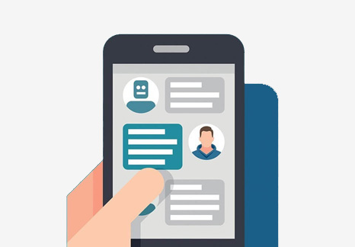

over view of content:
Seven main sections:
1. Project Management Plan
2. Requirements Specification
3. Analysis
4. Design
5. Implementation

1.project management plan:
overview of project
Career guidance chat bot is used for interaction between human and bot .where a large set of data is passed inform of raw data and it is trained to the machine,where machine performs task by taking queries as input and analysis best output.

Team members:
1.CH.KIRAN REDDY
2.KEERTHI REDDY
3.ANGEL REDDY
4.HARIKA REDDY
5.SHIVANI
6.PREETHI
7.K.HARI SHANKAR PRASAD

2.Requirements specification:

To build chat bot the requirements are needed
1.importing chatter bot module
-to get chatter bot install we use pip install chatterbot
2. import listTrainer
3.data sets to analyze/ to be trained

3.Analysis:
ChatBot is trainer so that students get interacted with the bot .the chatbot helps
them to know more information on particular topics which are pre defined.it helps students/parents to get information from one expertized machine than interacting between many people


DESIGN:



Implementation:
code:

from chatterbot import ChatBot
from chatterbot.trainers import ListTrainer
import os

these are the modules to be imported before building a chatBot.ListTrain is used to train the data present in text format

bot=ChatBot('Bot')
bot.set_trainer(ListTrainer)

creating an instance to ChatBot and training data by passing ListTrainer as argument.

Code for implementation:

from chatterbot import ChatBot
from chatterbot.trainers import ListTrainer
import os

bot=ChatBot('Bot')
bot.set_trainer(ListTrainer)

for files in os.listdir('/home/harishankar/Downloads/chatterbot-corpus-master/chatterbot_corpus/data/english/'):
data = open('/home/harishankar/Downloads/chatterbot-corpus-master/chatterbot_corpus/data/english/'+files,'r').readlines()

bot.train(data)

while True:
message=raw_input('You:')
if message.strip()!='Bye':
reply=bot.get_response(message)
print('ChatBot:',reply)
if message.strip() =='Bye':
print('Chatbot : Bye')
break

