ANDROID BASED REMOTE PROGRAMMABLE SEQUENTIAL

ABSTRACT
The project is designed to switch industrial loads using a user programmable logic control device and Android application for sequential operation. This operation is generally used for repetitive nature of work. Remote operation is achieved by any smart-phone/Tablet etc., with Android OS, upon a GUI (Graphical User Interface) based touch screen operation.
Programmable logic controllers used in industrial applications are very expensive for simple operations like sequential switching of loads. In this project we demonstrate the working of this simple operation using a microcontroller of 8051 family. The development of this application requires the configuration of the program through Android application. In industries, there are many tasks are carried out which requires some repeated operation in various orders and time intervals. For example, certain loads need to be switched ON/OFF in specific time intervals. In order to achieve this, microcontroller is programmed in such a way that the loads a can be operated in three modes: Set mode, Auto mode and Manual mode. In set mode, through timers, the machinery works based on input time set by the user where as in auto mode it works on default time settings and finally in the manual mode it functions while respective switches are pressed depending on the user’s need and flexibility. All the modes and status of loads are displayed on an LCD.

Thus, tasks performed by costly PLCs can now be achieved using a microcontroller making the device cost effective. Further the project can be enhanced by interfacing it with a GSM modem where by sending an SMS to the control system we can select the mode and timing remotely.

BLOCK DIAGRAM
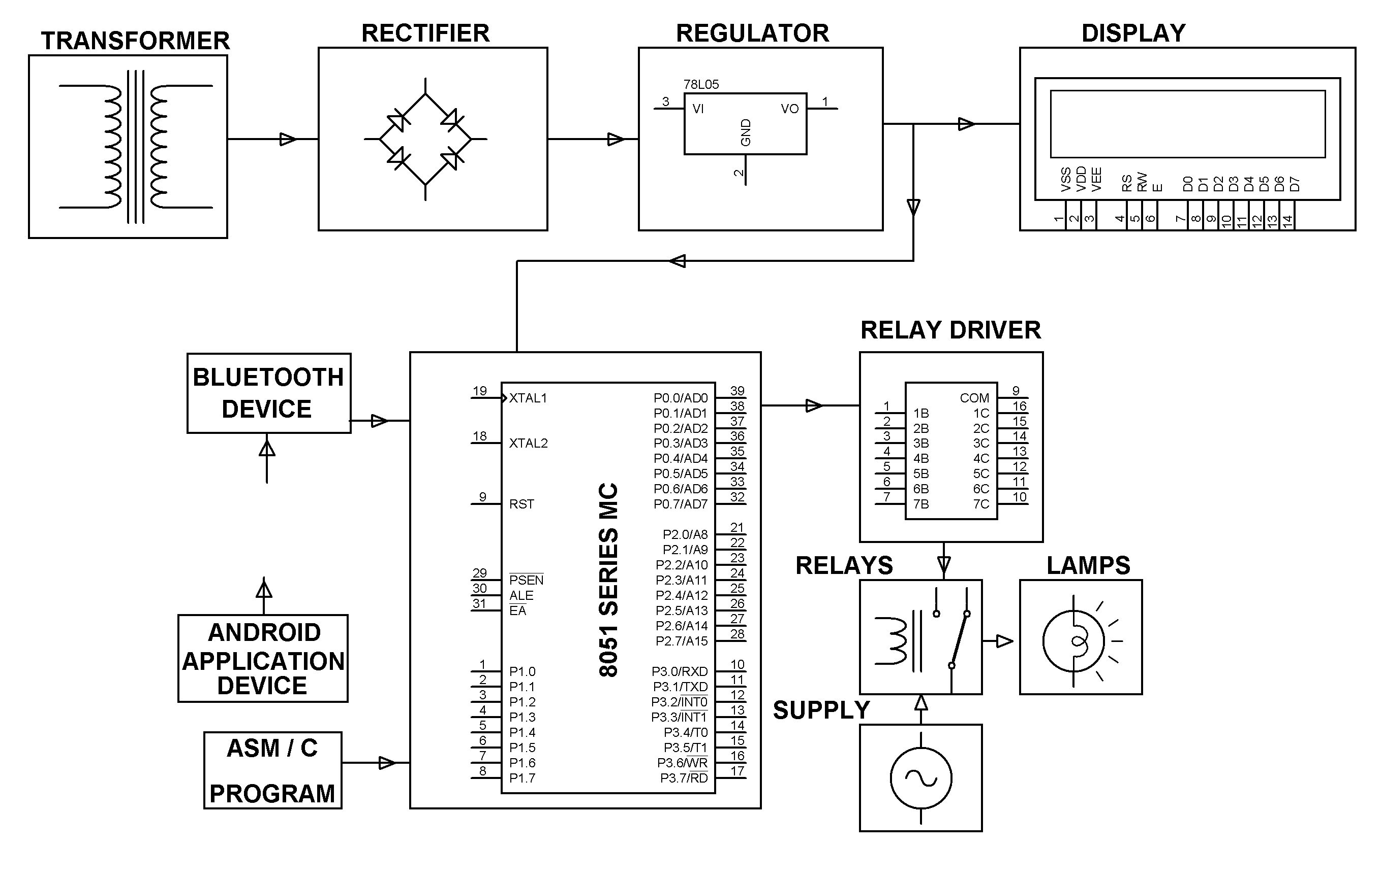
HARDWARE REQUIREMENTS:
8051 series Microcontroller, Bluetooth Device, LCD, Relay Driver, Relays, Resistors, Capacitors, LEDs, Crystal, Diodes, Transformer, Voltage Regulator, Push Button, Lamps.

SOFTWARE REQUIREMENTS:
Keil compiler

Language: Embedded C or Assembly.
Android Application.

