PRAMAN – A WEB 3 ACADEMIC CREDENTIAL APPLICATION
A Project Report

Submitted in the partial fulfilment of the Requirements For the award of Degree of

BACHELOR OF TECHNOLOGY IN INFORMATION TECHNOLOGY
Submitted By:
Harikesh Pandey (59203)
Gaurav Pant (59358)
Lokesh Bhatt (59259)
Aryan Sarwalia (58932)

Under the guidance of
Dr. Subodh Prasad, Assistant Professor

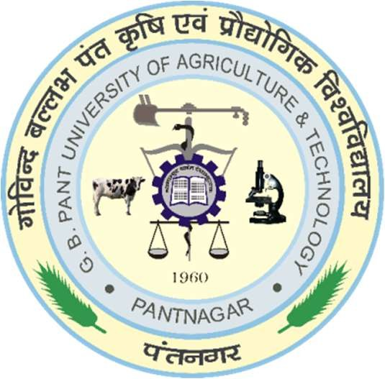


CERTIFICATE

This is to certify that project entitled “Praman – A web 3 academic credential application” which is submitted by:

Group members | Id. No.
Harikesh Pandey | 59203
Gaurav Pant | 56358
Lokesh Bhatt | 59259
Aryan Sarwalia | 58932
This project is a record of students’ work carried out by them in the partial fulfilment of the requirements for the award of degree of Bachelor of Technology in Information Technology, College of Technology, Govind Ballabh Pant University of Agriculture and Technology, Pantnagar.

Dr. Subodh Prasad Dr. Rajeev Singh
Project Guide Head of Dept.

