LEGAL METROLOGY COMPLIANCE SYSTEM

INSPECTION REPORT
Inspection ID: LM-2026-00129 Inspection Date: 04 Sep 2026 Generated: 05 Sep 2026, 12:35

1. INSPECTION INFORMATION
Inspection ID | LM-2026-00129
Inspection Date | 04 Sep 2026 10:15
Inspector | Inspector A. Sharma
Department | Legal Metrology Enforcement
Location | MG Road, Hyderabad
Retailer / Store | FreshMart Supermarket
Status | FINALIZED

2. PRODUCT / PACKAGE INFORMATION
Product Name | ABC Premium Rice 5 kg
Brand | —
Category | food_grain
Package Type | rigid
Net Quantity | 5 kg
Best Before | 6 Months from Packing
Mrp Value | ₹450
Manufacturer Name | ABC Foods Pvt. Ltd.
Date Of Packing | AUG 2026
Product Name | ABC PREMIUM RICE
Manufacturer Address | Hyderabad, Telangana - 500 001

4. APPLICABLE LEGAL / RULE BASIS
Base Regulation | Legal Metrology (Packaged Commodities) Rules, 2011
Rule Set Version | Current consolidated rule set (seeded)
Effective Date | 2026-09-04
Amendments | Legal Metrology (Packaged Commodities) (Amendment) Rules, 2017, Legal Metrology (Packaged Commodities) (Amendment) Rules, 2022
Engine | RE-2.0
Rules Evaluated | 20

5. FINAL INSPECTION ASSESSMENT
Final Assessment | NON_COMPLIANT
Automated Result | NON_COMPLIANT
Final Remarks | Confirmed non-compliant: four violations verified.

6. COMPLIANCE SUMMARY
Rules Checked | 20
Compliant | 16
Non-Compliant | 2
Manual Review | 1
Potential Non-Compliance | 1

7. CONFIRMED FINDINGS
- F-001 — MRP must be accompanied by 'Inclusive of all taxes' (or equivalent) wording.
Observed: Wording not detected | Evidence: IMG-00129-02
- F-002 — Consumer care contact (name/address with telephone or e-mail) must be declared.
Observed: Not detected | Evidence: IMG-00129-02
- F-003 — Mandatory declarations must be printed in a minimum prescribed size on the principal display panel.
Observed: Mrp Value: ₹450 | Evidence: IMG-00129-01
- F-004 — Declared package values should match the value offered for sale online.
Observed: Package: 5 kg vs Listing: 4 kg | Evidence: IMG-00129-01

7A. VIOLATION EVIDENCE
Evidence for: PC-R6-9 — “Inclusive of all taxes” accompanying wording
Source image: IMG-00129-02 (back)
Description: “Inclusive of all taxes” wording — observed declaration not detected on the captured panels — expected required declaration present on the package. Rule citation: Rule 6 6(1)(e) (PC-R6-9) — Legal Metrology (Packaged Commodities) Rules, 2011.
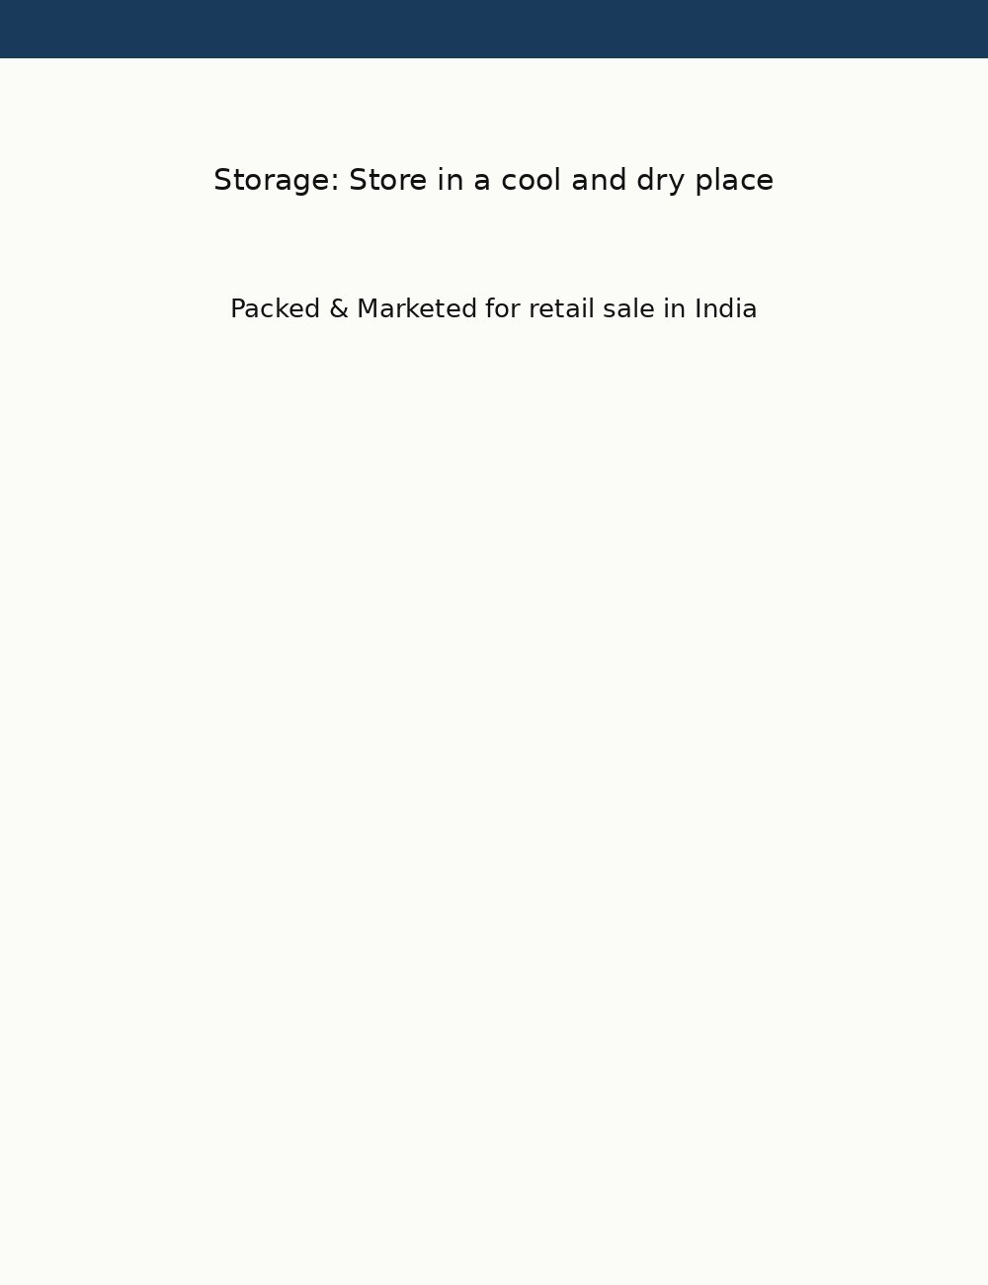
Evidence item: EVD-003 · inclusive_taxes_phrase
Evidence for: PC-R6-10 — Consumer care details
Source image: IMG-00129-02 (back)
Description: Consumer Care Number — observed declaration not detected on the captured panels — expected required declaration present on the package. Rule citation: Rule 6 6(1)(f) (PC-R6-10) — Legal Metrology (Packaged Commodities) Rules, 2011.
Evidence item: EVD-004 · consumer_care_number
Evidence for: PC-R7-2 — Minimum font size of declarations
Source image: IMG-00129-01 (front)
Description: MRP (Retail Sale Price) — observed estimated declared text height ratio 0.0177 — expected minimum estimated declared text height ratio 0.02. Rule citation: Rule 7 7(3) (as amended) (PC-R7-2) — Legal Metrology (Packaged Commodities) Rules, 2011.
Evidence item: EVD-005 · mrp_value
Evidence for: PC-CROSS-2 — Online listing vs package comparison
Source image: IMG-00129-01 (front)
Description: Net Quantity — observed 5 kg (package declaration) vs 4 kg (ExampleMart online listing (product page)) — expected package declaration must match the online listing value. Rule citation: (PC-CROSS-2) — Legal Metrology (Packaged Commodities) Rules, 2011.

Evidence item: EVD-006 · net_quantity

9. FONT & READABILITY ASSESSMENT
Declarations Analysed | 4
Readable | —
Review Required | 1
Note | Font assessment uses relative height estimates. Physical (mm) measurement requires a calibration reference and is therefore not claimed automatically.

12. INSPECTOR OBSERVATIONS
—
Final remarks: Confirmed non-compliant: four violations verified.
Reviewed By: LM-INS-00125 Reviewed At: 05 Sep 2026

