**Working procedure of Twilio**

Step 1- Create a twilio account

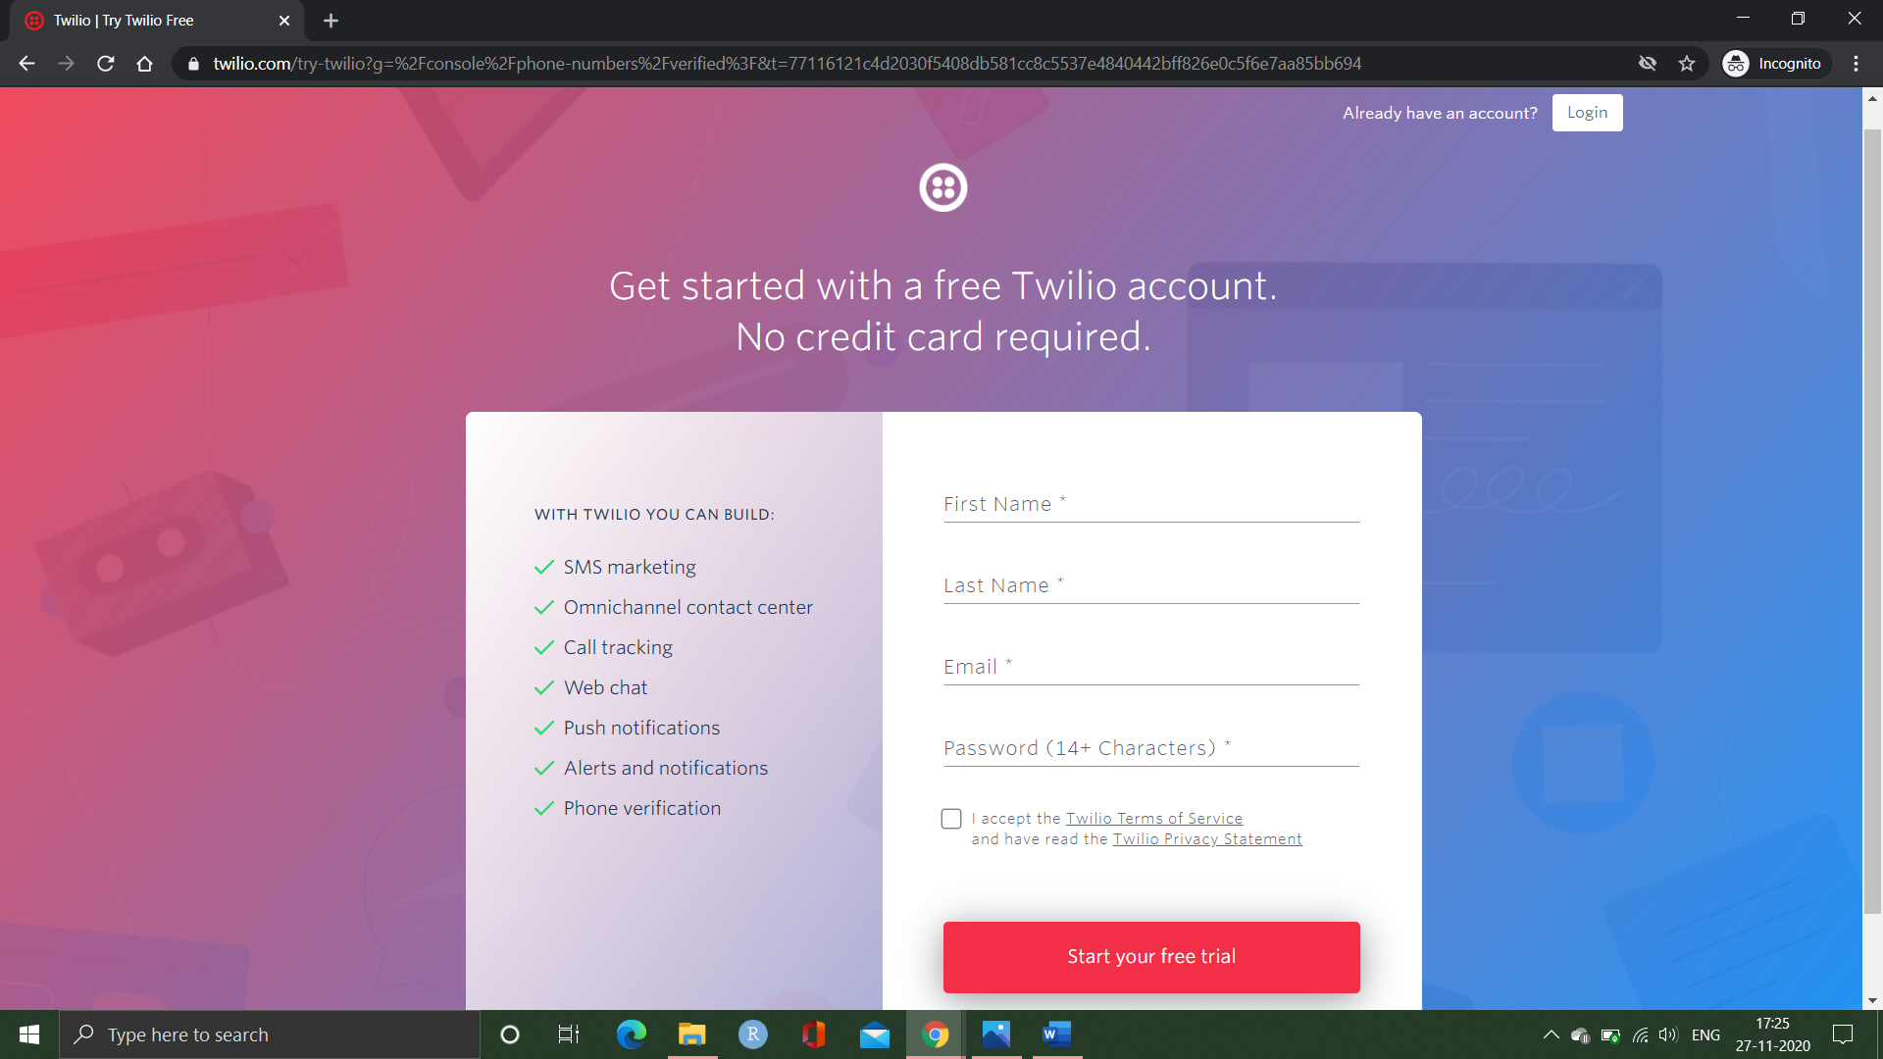

Step 2- Get a trail number to send the messages to participants

Step 3- Collect the mobile numbers of people whom you want to send the sms (if there is abnormality) and add the numbers in verified caller id’s as shown

Step 4- Go to API explorer and select programable messaging from drop down menu and click on messages

Step 5-Click on create message

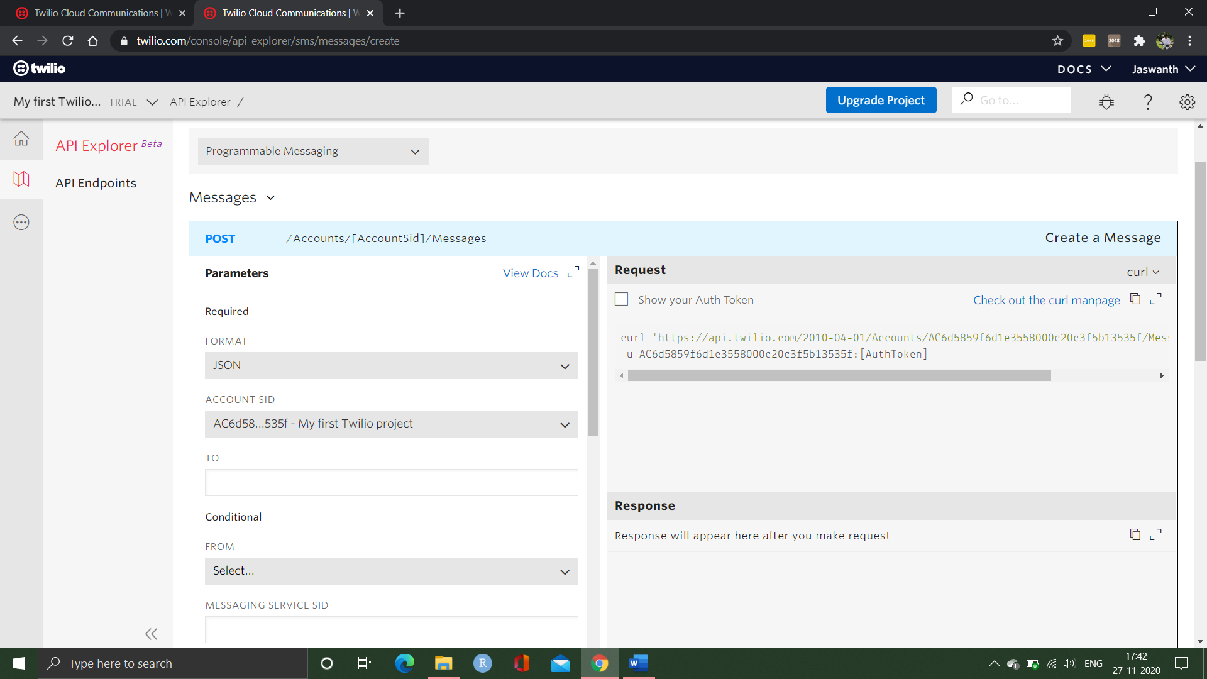

Step 6- After selecting the create message

* Enter the mobile number of participant to whom you are sending the message
* Click on from drop box and select the trail number which we have created in step 2
* In the body dialogue box enter the message you are willing to convey
* Click on make request.

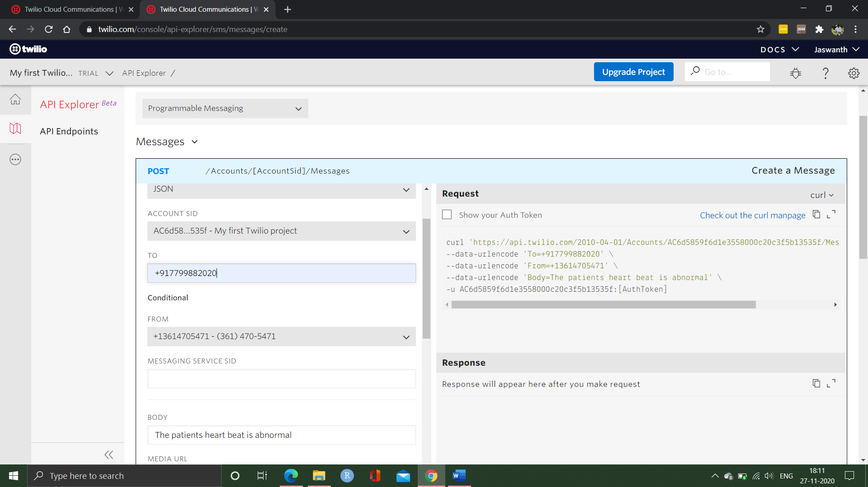

Step 7- After clicking on make request it will send the message to particular participant and will generate an account sid and auth token.

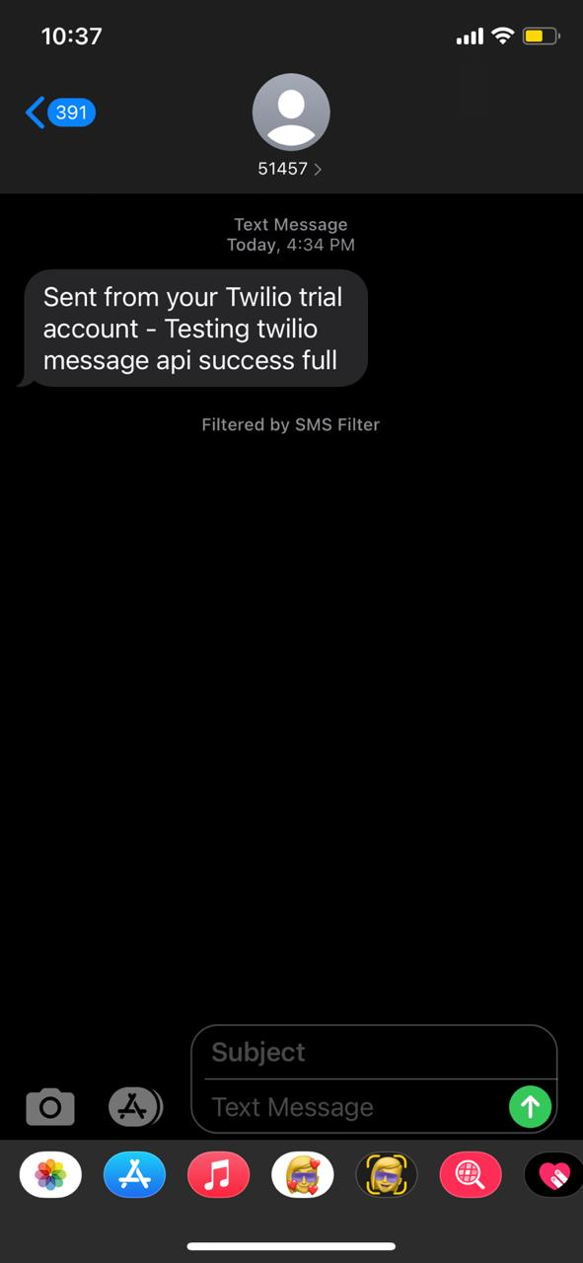

**We should save the account sid and auth token**

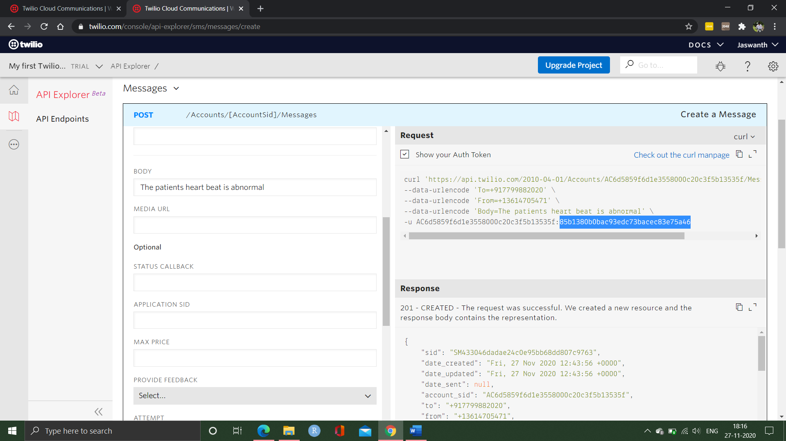

Step 8- Now we have to send this saved data to the AWS console.