sudo apt update -y
sudo apt-get install -y apt-transport-https ca-certificates curl gnupg lsb-release git unzip python3-pip
Docker (Ubuntu)
sudo apt-get install ca-certificates curl
sudo install -m 0755 -d /etc/apt/keyrings
sudo curl -fsSL https://download.docker.com/linux/ubuntu/gpg -o /etc/apt/keyrings/docker.asc
sudo chmod a+r /etc/apt/keyrings/docker.asc
echo \
"deb [arch=$(dpkg --print-architecture) signed-by=/etc/apt/keyrings/docker.asc] https://download.docker.com/linux/ubuntu \
$(. /etc/os-release && echo "${UBUNTU_CODENAME:-$VERSION_CODENAME}") stable" | \
sudo tee /etc/apt/sources.list.d/docker.list > /dev/null
sudo apt-get update
sudo apt-get install docker-ce docker-ce-cli containerd.io docker-buildx-plugin docker-compose-plugin
sudo groupadd docker
sudo usermod -aG docker $USER
sudo systemctl enable --now docker
logout and login

Jenkins
sudo apt-get install -y openjdk-17-jdk
sudo wget -O /etc/apt/keyrings/jenkins-keyring.asc \
https://pkg.jenkins.io/debian/jenkins.io-2023.key
echo "deb [signed-by=/etc/apt/keyrings/jenkins-keyring.asc]" \
https://pkg.jenkins.io/debian binary/ | sudo tee \
/etc/apt/sources.list.d/jenkins.list > /dev/null
sudo apt update
sudo apt install Jenkins
sudo systemctl status Jenkins
modify sg inboud to allow http on 8080
sudo cat /var/lib/jenkins/secrets/initialAdminPassword

aws-cli
curl "https://awscli.amazonaws.com/awscli-exe-linux-x86_64.zip" -o "awscliv2.zip"
unzip awscliv2.zip
sudo ./aws/install

kubectl
curl -LO "https://dl.k8s.io/release/$(curl -L -s https://dl.k8s.io/release/stable.txt)/bin/linux/amd64/kubectl"
sudo install -o root -g root -m 0755 kubectl /usr/local/bin/kubectl
kubectl version –client

helm
curl -fsSL https://raw.githubusercontent.com/helm/helm/master/scripts/get-helm-3 | bash
check “helm version”

repo structure
sample-app/
├── app/
│ └── index.js
Package.json
├── Dockerfile
└── Jenkinsfile

Index.js
const http = require('http');
const PORT = 3000;
const server = http.createServer((req, res) => {
res.end(`Hello from EKS CI/CD demo! Time: ${new Date()}\n`);
});
server.listen(PORT, () => console.log(`Server running on port ${PORT}`));
package.json
{
"name": "sample-app",
"version": "1.0.0",
"main": "app/index.js",
"scripts": { "start": "node app/index.js" }
}

Dockerfile
FROM node:18-alpine
WORKDIR /app
COPY package*.json ./
RUN npm install
COPY . .
EXPOSE 3000
CMD ["npm","start"]

Jenkinsfile
pipeline {
agent any

environment {
DOCKERHUB_USER = 'your-dockerhub-username'
IMAGE = "${DOCKERHUB_USER}/sample-app"
TAG = "build-${env.BUILD_NUMBER}"
}

triggers {
pollSCM('* * * * *') // optional if webhook not yet configured
}

stages {
stage('Checkout') {
steps { checkout scm }
}

stage('Build Docker Image') {
steps {
sh 'docker build -t $IMAGE:$TAG .'
}
}

stage('Push to Docker Hub') {
steps {
withCredentials([usernamePassword(credentialsId: 'dockerhub-creds',
usernameVariable: 'USER',
passwordVariable: 'PASS')]) {
sh '''
echo "$PASS" | docker login -u "$USER" --password-stdin
docker push $IMAGE:$TAG
docker logout
'''
}
}
}
}
stage('Deploy to EKS') {
steps {
sh '''
echo "Deploying to EKS..."

# Apply manifests (for first-time deployment)
kubectl apply -f k8s/deployment.yaml
kubectl apply -f k8s/service.yaml
kubectl apply -f k8s/ingress.yaml

# Update deployment image to latest build tag
kubectl set image deployment/sample-app-deployment sample-app=$IMAGE:$TAG --record

# Wait for rollout to complete
kubectl rollout status deployment/sample-app-deployment
'''
}
}
}
post {
success { echo "✅ Image pushed: $IMAGE:$TAG" }
failure { echo "❌ Build failed" }
}
}

Add Docker hub credentials in Jenkins
Create Jenkins pipeline job
sudo usermod -aG docker Jenkins – to allow Jenkins user to run docker
Added a github webhook
Create a EKS Cluster
Create EKS Node group
aws eks update-kubeconfig --name sample-eks --region ap-south-1
aws eks create-access-entry --cluster-name sample-eks --principal-arn arn:aws:iam::635465244346:role/JenkinsEKSRole --type STANDARD
aws eks associate-access-policy --cluster-name sample-eks --principal-arn arn:aws:iam::635465244346:role/JenkinsEKSRole --policy-arn arn:aws:eks::aws:cluster-access-policy/AmazonEKSClusterAdminPolicy --access-scope type=cluster
eks sg was not allowing ec2 server to get worker node details, so updated eks sg as below
aws ec2 authorize-security-group-ingress \
--group-id <eks-sg-id \
--protocol tcp \
--port 443 \
--source-group <ec2-sg-id> \
--region ap-south-1

create IAM policy for ALB controller
curl -o iam-policy.json \
https://raw.githubusercontent.com/kubernetes-sigs/aws-load-balancer-controller/main/docs/install/iam_policy.json
aws iam create-policy \
--policy-name AWSLoadBalancerControllerIAMPolicy \
--policy-document file://iam-policy.json

Install eksctl to create IRSA
curl -sLO "https://github.com/eksctl-io/eksctl/releases/latest/download/eksctl_$(uname -s)_amd64.tar.gz"
sudo tar -xzf eksctl_$(uname -s)_amd64.tar.gz -C /usr/local/bin
eksctl version
Associate the IAM OIDC Provider
eksctl utils associate-iam-oidc-provider \
--region ap-south-1 \
--cluster sample-eks \
--approve
Create the service account for controller IAM
eksctl create iamserviceaccount \
--cluster eks-cluster133 \
--region ap-south-1 \
--namespace kube-system \
--name aws-load-balancer-controller \
--attach-policy-arn arn:aws:iam::635465244346:policy/AWSLoadBalancerControllerIAMPolicy \
--approve \
--override-existing-serviceaccounts
(IAM role created with the help of cloud formation stack, service account created)

Install Helm chart on ec2 server
helm repo add eks https://aws.github.io/eks-charts
helm repo update

helm install aws-load-balancer-controller eks/aws-load-balancer-controller \
-n kube-system \
--set clusterName=sample-eks \
--set serviceAccount.create=false \
--set serviceAccount.name=aws-load-balancer-controller \
--set region=ap-south-1 \
--set vpcId=<your-vpc-id>

Service account for deployment
cat <<EOF | kubectl apply -f -
apiVersion: v1
kind: ServiceAccount
metadata:
name: jenkins-deployer
namespace: default
---
apiVersion: rbac.authorization.k8s.io/v1
kind: ClusterRole
metadata:
name: jenkins-deployer-role
rules:
- apiGroups: ["", "apps", "extensions", "networking.k8s.io"]
resources: ["deployments", "services", "pods", "replicasets", "ingresses"]
verbs: ["get", "list", "watch", "create", "update", "patch", "delete"]
---
apiVersion: rbac.authorization.k8s.io/v1
kind: ClusterRoleBinding
metadata:
name: jenkins-deployer-binding
roleRef:
apiGroup: rbac.authorization.k8s.io
kind: ClusterRole
name: jenkins-deployer-role
subjects:
- kind: ServiceAccount
name: jenkins-deployer
namespace: default
EOF
Generate the Kube Config for Jenkins role (optional, if Jenkins is not able to deploy)
aws eks update-kubeconfig \
--name eks-cluster133 \
--region ap-south-1 \
--role-arn arn:aws:iam::635465244346:role/JenkinsEKSRole
sudo mkdir -p /var/lib/jenkins/.kube
sudo cp ~/.kube/config /var/lib/jenkins/.kube/config
sudo chown -R jenkins:jenkins /var/lib/jenkins/.kube

Deployment.yaml
apiVersion: apps/v1
kind: Deployment
metadata:
name: sample-app-deployment
labels:
app: sample-app
spec:
replicas: 2
selector:
matchLabels:
app: sample-app
template:
metadata:
labels:
app: sample-app
spec:
containers:
- name: sample-app
image: harikiranmp/sample-app:latest
ports:
- containerPort: 3000
imagePullPolicy: Always

ingress.yaml
apiVersion: networking.k8s.io/v1
kind: Ingress
metadata:
name: sample-app-ingress
annotations:
kubernetes.io/ingress.class: alb
alb.ingress.kubernetes.io/scheme: internet-facing
alb.ingress.kubernetes.io/target-type: ip
spec:
rules:
- http:
paths:
- path: /
pathType: Prefix
backend:
service:
name: sample-app-svc
port:
number: 80

service.yaml
apiVersion: v1
kind: Service
metadata:
name: sample-app-svc
labels:
app: sample-app
spec:
type: LoadBalancer
selector:
app: sample-app
ports:
- port: 80
targetPort: 3000

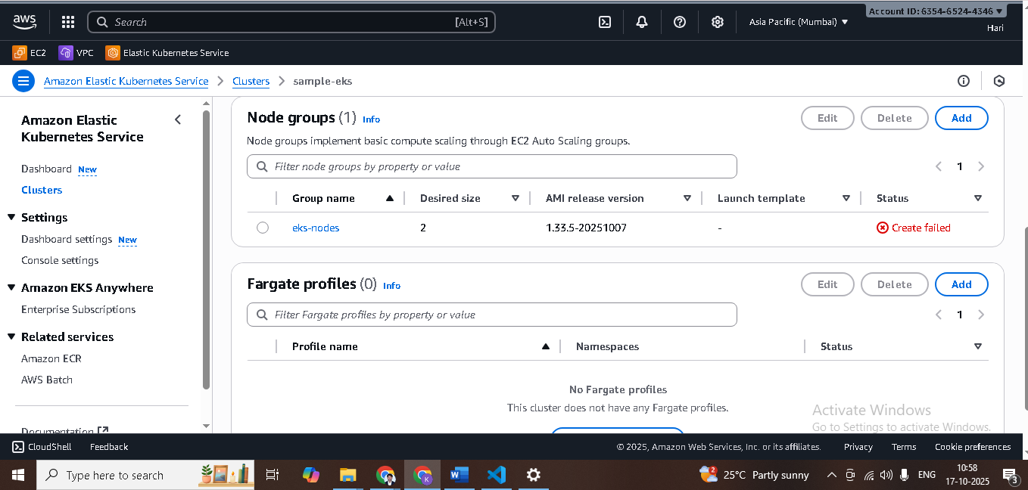
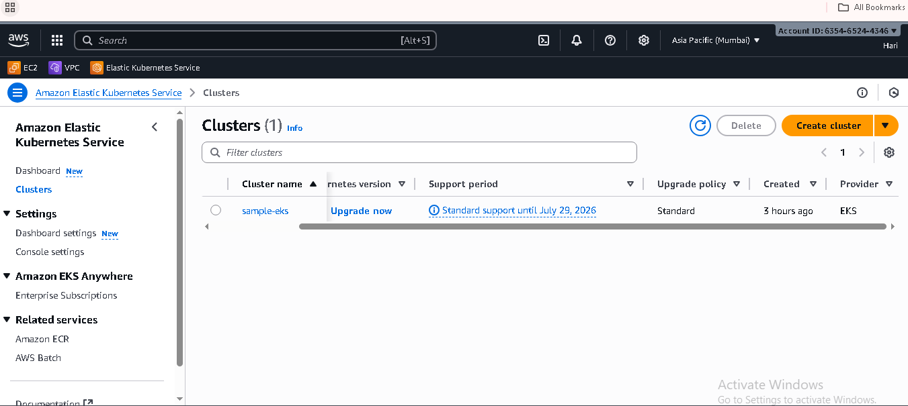
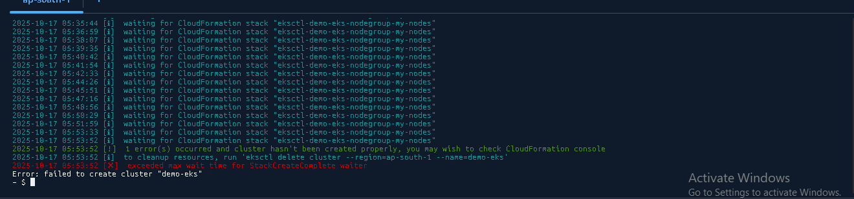

aws eks describe-nodegroup \
--cluster-name sample-eks \
--nodegroup-name my-nodes \
--region ap-south-1 \
--query "nodegroup.status,nodegroup.health"

