Design and Development of a MANET (Mobile Ad-Hoc Network) waveform for Software Defined Radios (SDRs)

Key Features
- Self-organizing and self-healing IP network
- Multi Hop Multicast and Broadcast communication
- Dynamic adaptation for changes of network topology
- Network routing using AODV/OLSR
- QoS: Traffic classifying and priority queues (8 queues)
- Network Synchronization across the neighboring nodes
- Network time distribution via Air Interface
- Operation without GPS
- Dynamic resource allocation, on-demand slot allocation
- Addressing for 128 users in a single network
- Wideband/Narrowband Mode.
- Fixed Frequency Mode and Frequency Hopping Mode (up to 2000 hops/s)
- Data Rate from 64kbps up to 16 Mbps in Frequency Hopping Mode; Up to 32 Mbps in Fixed Frequency Mode
- Dynamic Relaying Function (Up to 5 RF hop) for unicast and 4 hops for Multicast
- AAA with Radius support
- Support for SNMP v3
- Simultaneous voice and data communications
- Broadcast voice support in a single network 25 voice groups can be defined
- Group and random waypoint mobility
- Platform mobility 3.5Mach for Airborne, 120kmph for terrestrial
- Low latency: Voice < 100ms, Data < 1s, C2 message < 300 ms.
- Fast join and merge: Network Formation time < 5s; Node joining time < 1s; Node leaving time ~1s

Application running on Test PC
- Applications needed for testing
- Custom App for Message, Call, Voice, File Transfer
- Custom App for M&C (Monitoring and Control):
  - Control – Configuration of network parameters, SDR parameters, waveform parameters, Network Planning
  - Monitoring – Network Monitoring and Management, SDR Diagnostics, Health parameters
- Standard 3rd party apps such as jperf/iperf, VLC, Ostinato, NMS
- Deliverables
- Source code and Documentation

Application Layer – SDR
- Requirements:
- Software Apps running on SDR (embedded platform) for interfacing with PC in custom board for external interface (on A53 and/or R5)
- IP Gateway
- VoIP Gateway
- NMS
- Deliverables:
- Source code and Documentation including Message formats

MANET Stack – SDR
- Requirements:
- Software Stack running on SDR (embedded platform) for interfacing with PC in custom board for external interface (on A53 and/or R5)
- Transport Layer: Standard TCP/UDP/TCP reno/custom design
- Network Layer: AODV, OLSR and/or other secure and relevant variants, QoS
- MAC Layer: Network Time Synchronization, USAP or similar dynamic TDMA slot allocation, Fragmentation, CSMA, Frequency Hopping
- Logging: Diagnostics and Critical message log
- Deliverables:
- Source code and Documentation including any custom message formats
- Network Throughput vs Payload Data rate table
- Testing and Pass Criteria
- Real-time voice check
  - Voice PESQ ≥ 4 with 1st hop and 3rd hop
  - Latency < 100ms
  - Voice PESQ ≥ 4
- Data Check
- Run iperf/jperf on PC
- Measure Network Throughput at each hop and 5th hop
- Packet Reception ≥ 95%
- Repeat check for different number of nodes and different data rates
- Latency < 1s
- QoS and latency Check
- Run latency checks for voice < 100ms
- Run latency checks for critical message < 300ms
- Run latency checks for data message < 1s
- Run different QoS Traffic (2 or 3 at a time) and show delivery of higher priority messages
- Check Network Management Messages
- Self-initiated messages for Topology update, Routing Table update, Network Health exchange
- User initiated (App on PC) for above messages
- Consolidated picture at App on PC for entire network (Provides consolidation of all above message formats)
- Check maximum network throughput at each node by forcing all TDMA slots for one node. Configure M&C via PC App
- Check Network Timing and Diagnostics
- Measure Network formation time – with all nodes from start-up.
- Show appropriate topology updates and NMS message updates
- Kill waveform execution at one node and reload waveform after 2-3minutes
- Measure Network Leaving time and Joining time
- Show appropriate topology updates and NMS message updates
- Showcase network statistics, per node statistics at each layer
- Dynamic TDMA slot allocation
- Run network with 2-3 nodes, showcase slots/frames of nodes
- Start new node and show changes in the slot size allocated
- Check for unicast, multicast and broadcast messages
- Configure unicast addresses; only addressed nodes should receive packet
- Configure multicast mode and destination addresses; only addressed nodes should receive packet
- Configure broadcast mode and destination addresses; all addressed nodes should receive packet
- Topology and Routing Update check
- Configure network on PC App. Send different classes of packets like unicast, multicast, broadcast.
- Change the network configuration by disabling a route forcibly (allowing for a direct hop to become a 3rd hop or 4th hop); show updates to topology and routing in the network monitoring message.
- Voice message should not be delivered after 3 hops while data should still be received at 4th hop.
- IP services
- Run standard IP services from test PCs connected to different nodes – Ping, FTP, HTTP, VoIP.
- Run video streaming using VLC server/client from test PC on one node to test PC on another chosen node
- Logging
- All critical information and diagnostic logs of all layers are stored in local memory retrievable on request from external PC on authentication.

Security and Physical Layer – SDR
- Requirements:
- Software Layer running on SDR (embedded platform) for interfacing with PC in custom board for Security Layer (on A53 and/or R5 and FPGA)
- APIs for invoking AES256 encryption, decryption in FPGA
- APIs for changing keys from external PC
- APIs for loading waveforms to the node
- APIs for configuring node parameters and waveform selection
- APIs for generating frequency hop sets using crypto
- APIs for loading frequency hop sets and rate from external PC
- APIs for configuring Physical layer for frequency hops, frame size and other parameters
- Deliverables:
- Source code and Documentation including any custom message formats
- Testing and Pass Criteria
- Checking APIs with Physical Layer with prints and logs

Introduction
- Nodes turn on at different times; all nodes are expected to be within same TOD reference.
- All nodes generate index for FH using TOD
  - Hopsets are preloaded to radio during mission planning
  - GPS Mode: Wait for 1PPS to fetch first TOD and generates index for reading hopsets.
  - Non-GPS Mode: TOD is loaded during mission planning; uses internal SW clock for further calculations of TOD
- Initial Synchronization phase

- Data traffic phase
  - Data Rate: ; bandwidth
  - FH: 500 hops/second; 2ms hop rate.
  - Guard Time: 200us
  - Effective Data Time: 1.8ms (1800us)
  - Channel Data Rate:
  - Per Hop data bits:
  - Pre FEC per hop data bits:
  - Frame:

Hopset generation
- GPS Mode:
  - Wait for 1PPS from on-radio GPS
  - Use TODL as a seed to generate index for hopset array
  - PRBS15 to be used for generating index for hopset array
  - The seed changes every 100ms elapsed counted using SW Counter.
  - Reset SW Counter on every 1PPS
- Non-GPS Mode:
  - If 1PPS is not received from on-radio GPS
    - If 1PPS from external interface is received, then the waveform uses this for reference
    - Else the waveform assumes to be in non-GPS mode
  - Use of RTC based time for TOD
  - Uses TODH as seed to generate index for hopset array
  - PRBS15 to be used for generating index for hopset array
  - The seed changes every 100ms elapsed.
  - Exchange of TOD of Tx as master; all Rx synchs to this TOD irrespective of time at other node and irrespective of other node having GPS.

Message formats
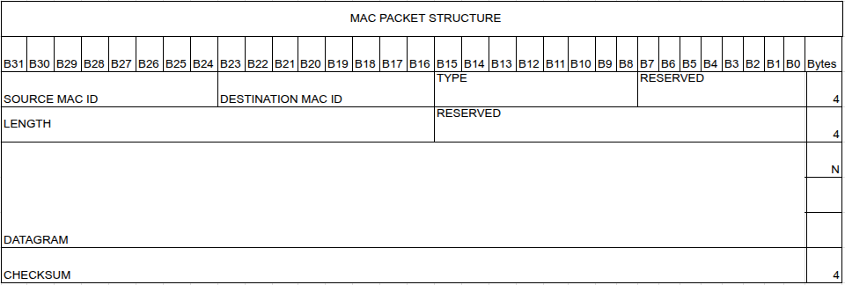
MAC ID - 8 bits are allocated for Source and Destination MAC ID. Unicast, Multicast and Broadcast are distinguished respectively.
0x00 – Reserved
0x01 to 0x7F – Unicast ID
0x80 to 0xFE – Multicast Group ID
0xFF – Broadcast ID

Waveform operation Tx Mode

Waveform operation Rx Mode

Waveform Design:

Application Layer
Network Layer
Link Layer/MAC
PHY Layer

Application Layer: Responsible for formatting and getting user data from User application. This layer is also responsible for segmentation and reassembly if needed.
Voice Compression – Use Opensource Voice coders to support 2.4Kbps and 8Kbps Voice

Voice -> Audio Codec (8Ksps/1 byte (160bytes for every 20msec) -> Collect for 1 Full TDMA Frame (100msec) (800 bytes) -> (SoftwareBased Vocoder – 2.4Kbps/8Kbps) -> Send in 1 TDMA Time Slot of 10msec
For 8Kbps Vocoder - 100 bytes of voice to be sent every 100msec
For 2.4Kbps Vocoder – 30 bytes of Voice to be sent every 100 msec

Network Layer
This layer has no role to play in Point To Point Waveform (PTP)
This layer must broadly achieve two function case of MANET waveform
- Routing – Find 1-hop/2-hop neighborhood, track topology changes, nominate MPR based on the neighborhood information – eg – OLSR (3a)
- Store and Forwarding – As relay nodes, store and forward the relayed data towards the destination (3b)

Network Layer Header:

Hello Packet Format: These are internally generated messages for network picture

Network Control Slot allocation:

Network Entry:

Network Exit:

Network Late Entry:

FH Synchronization:

LLC/MAC Layer

User Traffic:

Real Time – Voice –
Data – Digital Voice, SMS, Files, Streaming Audio/Video, Positional Data, IP Data

PTT Voice must have reserved Channel and establish LLC to LLC connection. User application should have option to select unicast/multicast/broadcast.
All traffic must be queued between layers and picked up from queues based on the traffic priority.

Unicast, Multicast and Broadcast data must be supported.
Broadcast data will be to 1 hop neighbours only.

Reservation and Contention can be followed same as described in NATO papers
Voice – Always Reservation
Data – Both Reservation and Contention

MAC Packet Format (Indicative):

Mac_pkt
{
Mac_hdr; <> Bytes
Mac_payload;
Mac_fcs; 4 Bytes // checksum
}

Mac_frame_ctrl
{
Frame_type; 1 Byte – Traffic Type
currSlotNum; 1 Byte
currFrameNum; 1 Byte
currCycleNum; 1 Byte
remainingLifeTime; 4 bytes
}
Mac_hdr
{
Mac_frame_ctrl;
Mac_LLC_SAP; 1 Byte
Mac_destaddr; 1 Byte
Mac_srcaddr; 1 Byte
Use Arq; 1 Byte
atTime; double
}

TDMA Slotting based on Waveform
- NB/WB: Wideband
- Data Rate: 2 Mbps
- Nodes Supported: 40
The below TDMA slot designs are given for PTP and MANET based waveforms.
PTP Waveform TDMA Slots
 | 100ms
 | 10ms (S1) | 10ms (S2) | 10ms (S3) | 10ms (S4) | 10ms (S5) | 10ms (S6) | 10ms (S7) | 10ms (S8) | 10ms (S9) | 10ms (S10)
F-1 | Voice-G1 | Voice-G2 | GU | GU | GU | GU | GU | GU | NC1 | NC2 |  | C-1  1s | SF  2s
F-2 | Voice-G1 | Voice-G2 | GU | GU | GU | GU | GU | GU | NC3 | NC4 |  | C-1  1s | SF  2s
.  .  . |  |  |  |  |  |  |  |  |  |  |  | C-1  1s | SF  2s
F-10 | Voice-G1 | Voice-G2 | GU | GU | GU | GU | GU | GU | NC19 |  | NC20 | C-1  1s | SF  2s
F-1 | Voice-G1 | Voice-G2 | GU | GU | GU | GU | GU | GU | NC21 |  | NC22 | C-2  1s | SF  2s
F-2 | Voice-G1 | Voice-G2 | GU | GU | GU | GU | GU | GU | NC23 |  | NC24 | C-2  1s | SF  2s
.  .  . |  |  |  |  |  |  |  |  |  |  |  | C-2  1s | SF  2s
F-10 | Voice-G1 | Voice-G2 | DU - V/D | DU - V/D | GU | GU | GU | GU | NC39 |  | NC40 | C-2  1s | SF  2s

F – Frame; S – Slots; C – Cycle; SF – Super Frame
Slotting Mechanism
- When PTT is pressed, voice packets must be sent after encoding in the voice slot.
- Until the next voice slot, the audio is buffered and compressed. This compressed data is transmitted in the next Frame (2).
- Two Voice Slots are allocated so 2 Groups can simultaneously use Voice slots.
- The remaining slots (3-9) in a frame are used for transmitting data packets (C2/SA/SMS/File). Depending on the user requirements, we can fix n slots (eg 4 slots) for a single type and the remaining can be contention based.
- The network control messages are transmitted during the NC slots based on the Node ID.
References:
MANET Waveform TDMA Slots
 | 100ms
 | 10ms (S1) | 10ms (S2) | 10ms (S3) | 10ms (S4) | 10ms (S5) | 10ms (S6) | 10ms (S7) | 10ms (S8) | 10ms (S9) | 10ms (S10)
F-1 | Voice | DU - V/D | DU - V/D | DU - V/D | GU | GU | GU | GU | NC1 | NC2 |  | C-1  1sec | SF  2sec
F-2 | Voice | DU - V/D | DU - V/D | DU - V/D | GU | GU | GU | GU | NC3 | NC4 |  | C-1  1sec | SF  2sec
.  .  . |  |  |  |  |  |  |  |  |  |  |  | C-1  1sec | SF  2sec
F-10 | Voice | DU - V/D | DU - V/D | DU - V/D | GU | GU | GU | GU | NC19 |  | NC20 | C-1  1sec | SF  2sec
F-1 | Voice | DU - V/D | DU - V/D | DU - V/D | GU | GU | GU | GU | NC21 |  | NC22 | C-2  1sec | SF  2sec
F-2 | Voice | DU - V/D | DU - V/D | DU - V/D | GU | GU | GU | GU | NC23 |  | NC24 | C-2  1sec | SF  2sec
.  .  . |  |  |  |  |  |  |  |  |  |  |  | C-2  1sec | SF  2sec
F-10 | Voice | DU - V/D | DU - V/D | DU - V/D | GU | GU | GU | GU | NC39 |  | NC40 | C-2  1sec | SF  2sec

Slotting Mechanism
- When PTT is pressed, a Communication Request (CR) packet is sent by the node to all the 1 hop neighbours. It also selects the Multipoint Relay Nodes (MPR), these relay the CR to 2 hop neighbours.
- The node in which PTT is pressed wait for Control Confirm (CC) from the MPRs.
- Post the reception of CC, the node starts transmitting the voice data.
- The same slots that were used for voice communication can be used to transmit other data packets (say packet type 1) when no audio data is available.
- The remaining slots are used for other data packet types.
- The network control messages are transmitted during the NC slots based on the Node ID.

Slot Usage in MANET WF:

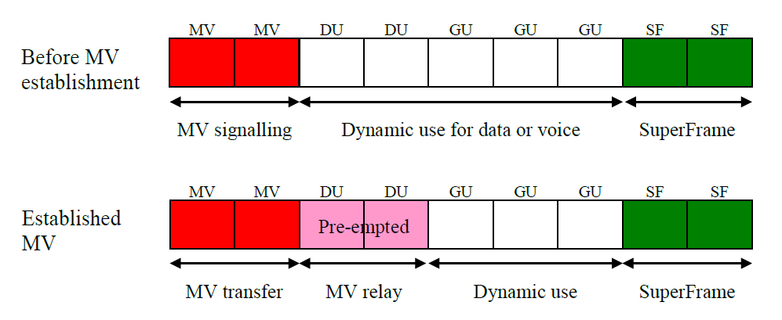

Usable Data per Time Slot:
Each Time Slot Usable Data Size (10msec slot) – 450bytes (per 2msec) x 5 = 2250 Bytes
= 18000 bits every 10msec

Network Time Synchronization:
The TDMA slot information can be used to synchronize either the time offset or time clock source. Time stamp must be marked in every Network Control slot by the sending Node.

A master must be designated for getting time from. All nodes which hear from Master must also be marked as “Master Heard (HM)” nodes. The receiving node must adjust local offset based on the time received from either Master or from HM nodes. If received from multiple HM nodes then averaging can be done.
Local Network Time Source: In case GNSS/GPS is present, then GPS 1PPS must be used for starting of every cycle. Each TDMA cycle must fir in 1sec.
In case of absence of GPS, the 1PPS can be generated locally by PL section. Provision to offset this local 1PPS must be available.

PHY Layer

