END-TO-END MLOPS
Heart Disease
Classification
A reproducible data-to-deployment workflow
BITS Pilani Work Integrated Learning Programmes
M.Tech — Artificial Intelligence and Machine Learning
AIMLCZG523 — Machine Learning Operations | Assignment 1
Student: Harikishor M G
Student ID: 2025AE05963
Project repository
https://github.com/harikishormg1993-art/heart-disease-mlops.git
SCOPE AND SAFETY
Educational demonstration on a small public dataset only. This is not a clinically validated diagnostic system. Predictions and probabilities must not be used for medical decisions.

Executive Summary
This assignment implements an end-to-end machine-learning operations (MLOps) workflow for binary classification using the processed Cleveland heart-disease dataset. The repository includes data ingestion and validation, exploratory data analysis (EDA), reusable preprocessing/model pipelines, model comparison, MLflow tracking, automated tests, linting, GitHub Actions continuous integration, a FastAPI inference service, Docker packaging, Kubernetes manifests, and basic monitoring through logs and Prometheus-compatible metrics.
Two candidate estimators were compared: Logistic Regression and Random Forest. Model selection was defined before evaluation as the highest mean ROC-AUC across stratified five-fold cross-validation on the training split. Logistic Regression therefore became the selected serving model (mean CV ROC-AUC 0.8963), while Random Forest achieved stronger metrics on the single holdout set. This difference is reported transparently rather than selecting a model after looking at holdout performance.

Project objectives
- Build a repeatable ingestion and preprocessing path, including target mapping and missing-value handling.
- Compare two classifiers using cross-validation and a stratified holdout split.
- Track experiment parameters, metrics and evaluation artifacts with MLflow.
- Automate linting, unit/API tests and training smoke steps with GitHub Actions.
- Package and serve the selected pipeline through FastAPI and Docker.
- Demonstrate local Kubernetes deployment, health checks, request logs and metrics.

Implementation at a glance
Area | Implemented approach | Evidence in repository
Data | UCI processed Cleveland CSV; schema validation; binary target mapping | src/data.py; evidence/metrics/metadata.json
EDA | Target balance, feature histograms, correlation heatmap, summary statistics | src/eda.py; evidence/figures/
Modelling | Logistic Regression vs Random Forest; 5-fold stratified CV | src/pipeline.py; src/train.py; artifacts/training_summary.json
Tracking | MLflow runs, metrics and evaluation plots | evidence/07*.png; MLflow run IDs in summary
Quality | Pytest, Ruff and GitHub Actions | tests/; .github/workflows/ci.yml; evidence/lab/
Serving | FastAPI /, /health, /predict and /metrics | api/main.py; evidence/lab/
Deployment | Docker image and local Kubernetes Deployment/Service | Dockerfile; deployment/k8s/; evidence/kubernetes/; evidence/lab/

1. Architecture and Workflow
The implementation separates data processing, model development, inference, and deployment concerns. The training workflow produces a serialized scikit-learn pipeline, while the API loads the saved artifact and validates incoming JSON before inference. The same container image can be run directly with Docker or referenced by the local Kubernetes manifest.
DATA SOURCE
UCI Cleveland CSV
↓
INGEST + EDA
Validation • summaries • plots
↓
TRAIN + EVALUATE
Imputation • scaling • CV • holdout
↓
MLFLOW + ARTIFACTS
Runs • metrics • plots • model.joblib
↓
FASTAPI SERVICE
/predict • /health • /metrics
↓
CONTAINER + DEPLOY
Docker • Kubernetes Deployment/Service

Repository structure
Path | Purpose
src/data.py, src/eda.py | Data download/validation, binary target mapping, EDA outputs
src/pipeline.py, src/train.py | Preprocessing pipelines, candidate models, evaluation and model selection
artifacts/ | Serialized selected pipeline, summary JSON, confusion matrices and ROC curves
api/main.py | FastAPI app, request validation, predictions and metrics
tests/ | Data, pipeline and API unit tests
.github/workflows/ci.yml | CI: install, lint, test, train and upload evidence
deployment/k8s/deployment.yaml | Kubernetes Deployment and ClusterIP Service
evidence/ | Screenshots, text logs, EDA summaries and deployment verification

The repository is the authoritative source for implementation details and repeatable commands. Evidence screenshots document selected execution outcomes; local and BITS lab environments are distinguished in the deployment section.

2. Data Acquisition and Exploratory Analysis
The project uses the processed Cleveland heart-disease data distributed through the UCI Machine Learning Repository. The recorded source is https://archive.ics.uci.edu/ml/machine-learning-databases/heart-disease/processed.cleveland.data. The ingestion script normalizes the expected schema and maps the original outcome to a binary target: original value 0 becomes class 0, and original values greater than 0 become class 1.
Dataset characteristic | Observed value
Rows | 303
Predictor features | 13
Target classes | 2
Class 0 records | 164 (54.1%)
Class 1 records | 139 (45.9%)
Missing values: ca | 4
Missing values: thal | 2
Other listed columns | 0 missing values in recorded EDA summary

EDA figures
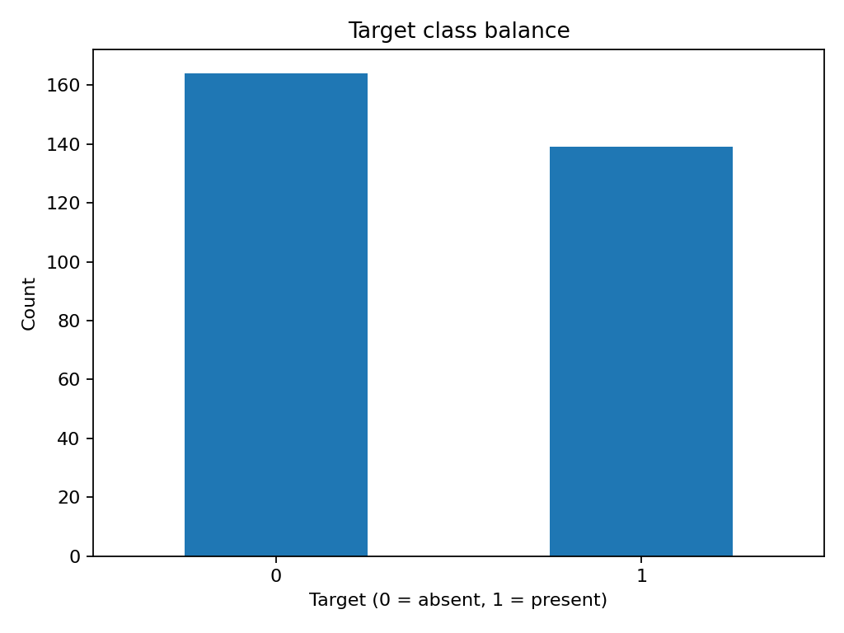
Figure 1. Target class distribution in the processed Cleveland dataset.
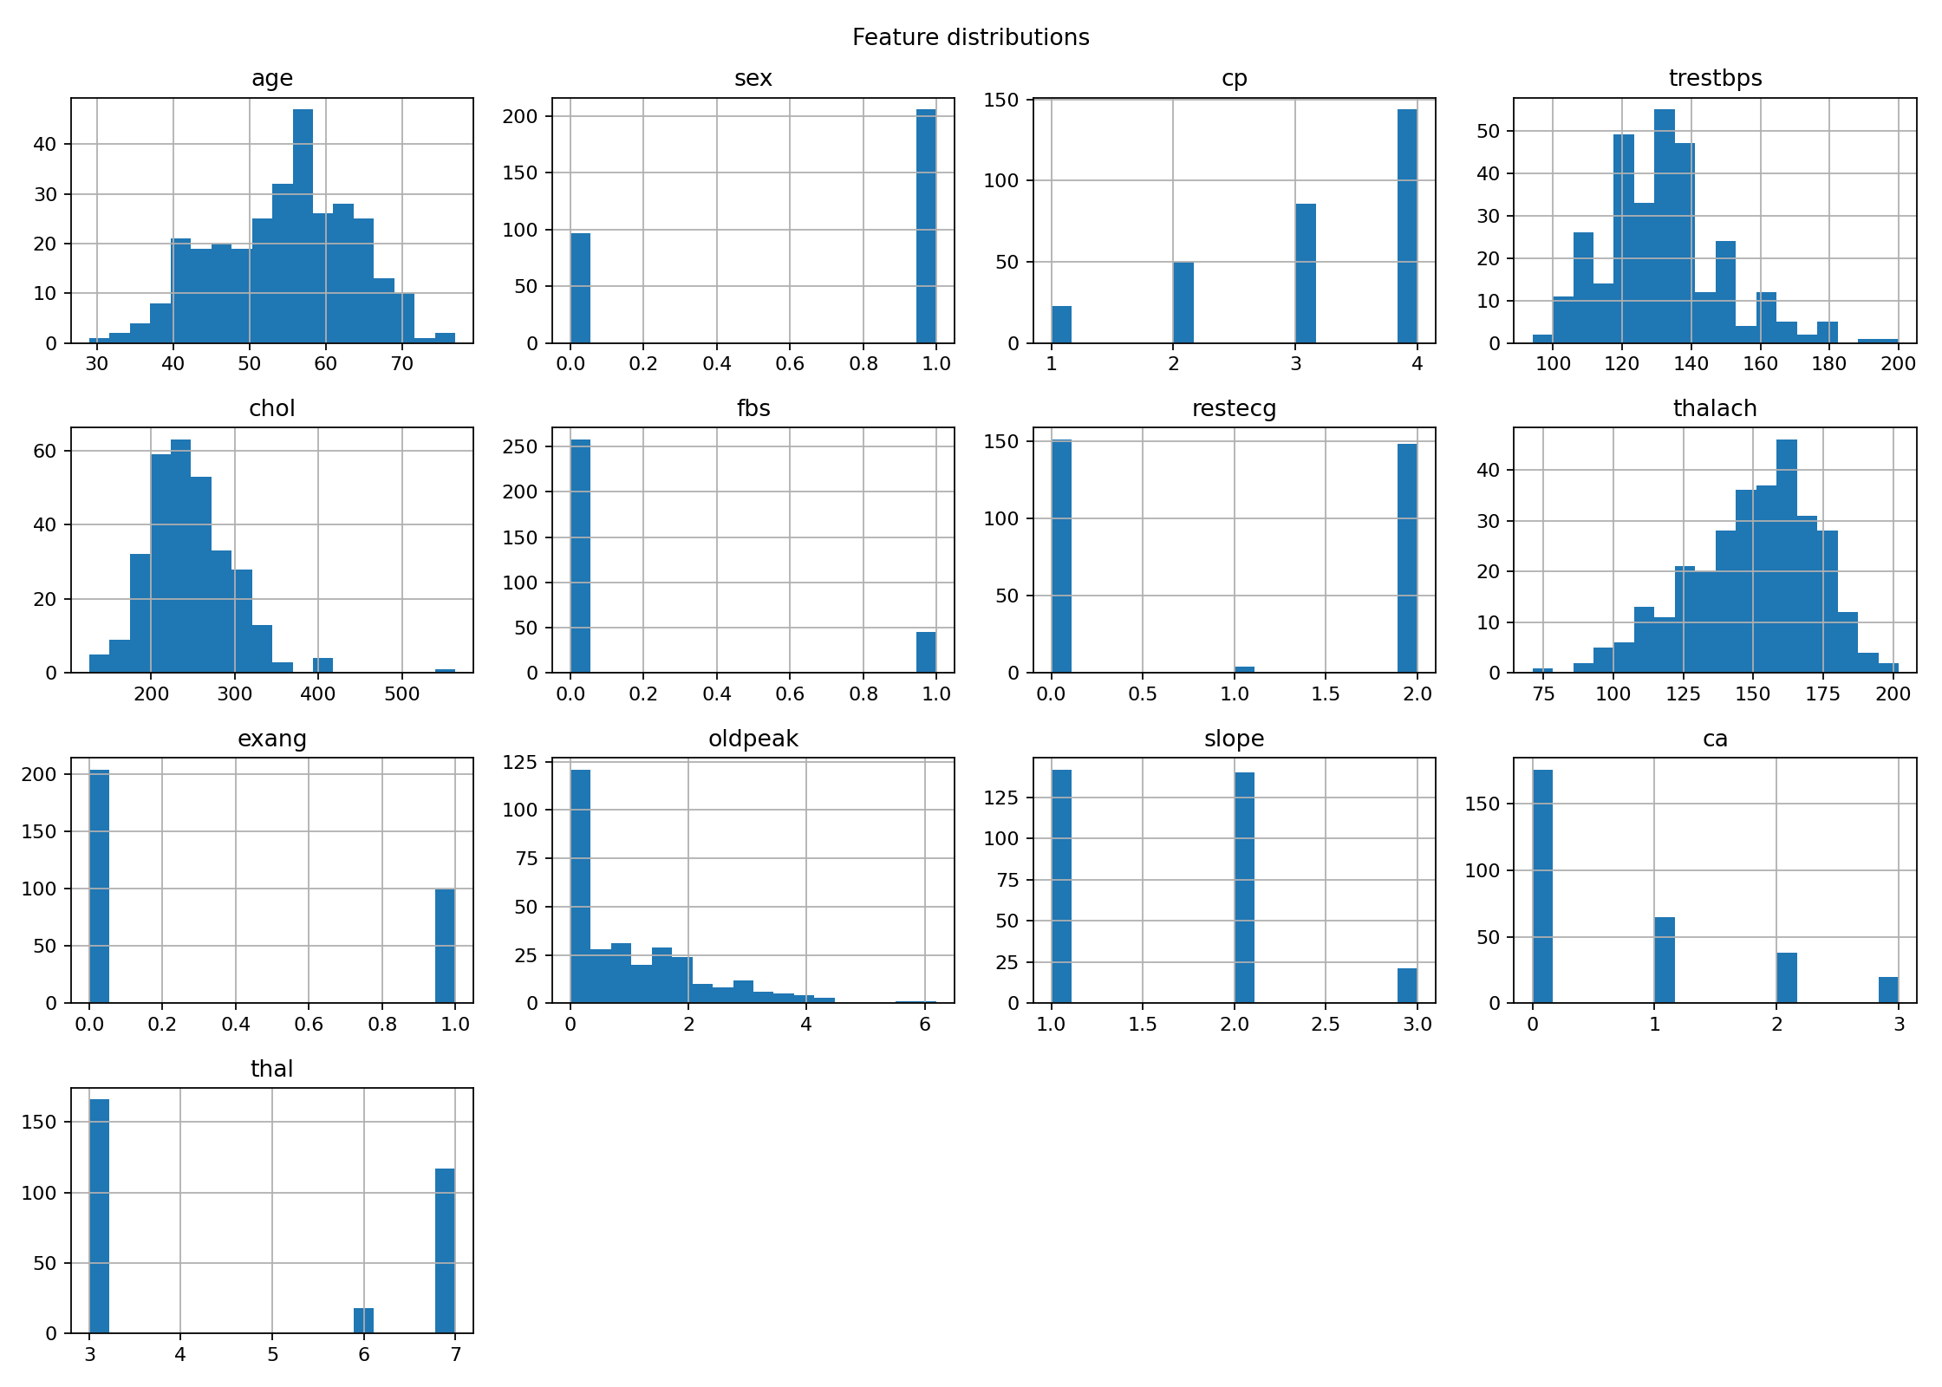
Figure 2. Distributions of selected predictor features. These plots are descriptive, not causal.
The two classes are relatively balanced in this sample. Four missing values are recorded for ca and two for thal; these are handled inside the modelling pipeline rather than by imputing the full dataset before splitting. Descriptive statistics indicate a mean age of approximately 54.4 years, but these sample statistics do not establish population representativeness.

3. Feature Preparation and Model Development

Preprocessing and evaluation protocol
- The target column is excluded from the predictors; the modelling input contains 13 features.
- A scikit-learn pipeline uses SimpleImputer(strategy="median") followed by StandardScaler for numeric inputs.
- The train/test split uses test_size=0.20, stratify=y and random_state=42.
- Cross-validation uses StratifiedKFold with 5 splits, shuffle=True and random_state=42.
- The same split and CV protocol are applied to both candidate estimators.
- Model selection uses the highest mean cross-validation ROC-AUC; the selected pipeline is refit for serving.

Candidate estimators
Estimator | Configuration recorded in project | Rationale
Logistic Regression | class_weight="balanced"; max_iter=2000; median imputation and scaling in pipeline | Interpretable linear baseline with scaled inputs and balanced class weighting.
Random Forest | 300 trees; min_samples_leaf=2; class_weight="balanced"; random_state=42; n_jobs=-1 | Non-linear tree ensemble to compare against the linear baseline.

Correlation and ROC analysis
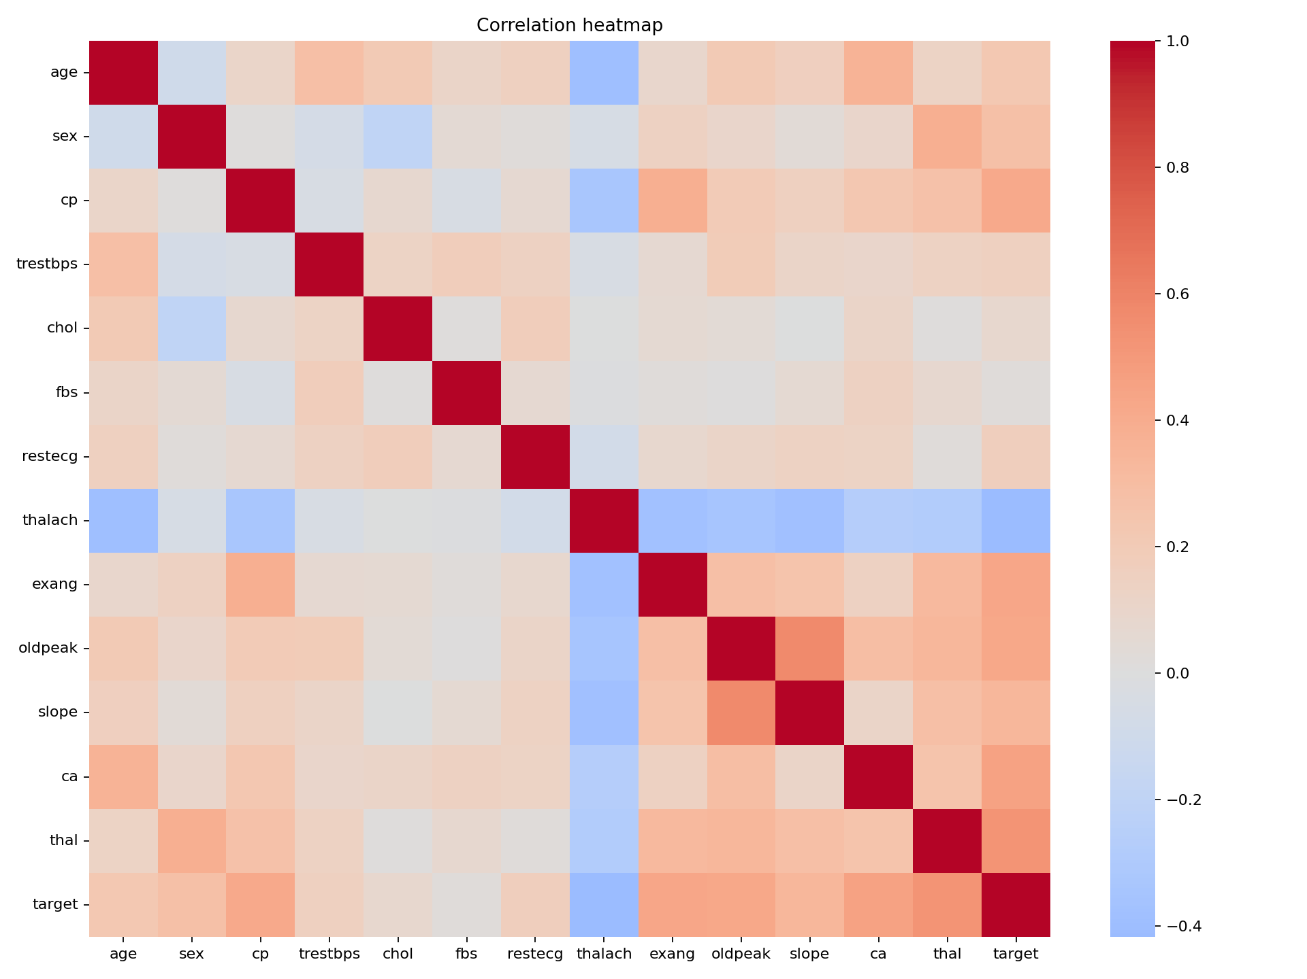
Figure 3. Correlation heatmap for the numeric-coded columns. Correlation is not evidence of causality.
Some source variables are categorical concepts represented as integers. The current pipeline treats these encoded values as numeric and scales them. This is a known modelling limitation; domain-aware categorical encoding should be assessed in a future iteration. The small dataset and fixed split also make the estimates sensitive to sampling variation.

4. Evaluation Results and Model Selection
Cross-validation metrics below are means across five folds on the training split. Test metrics are from the single stratified holdout split. Precision and recall refer to the positive class as implemented in the project.
Model | CV Acc. | CV Prec. | CV Recall | CV ROC-AUC | Test Acc. | Test ROC-AUC
Logistic Regression | 0.8139 | 0.8154 | 0.7739 | 0.8963 | 0.8689 | 0.9502
Random Forest | 0.7930 | 0.7895 | 0.7557 | 0.8828 | 0.9180 | 0.9545

Cross-validation variability
Model | Accuracy SD | Precision SD | Recall SD | ROC-AUC SD
Logistic Regression | 0.0263 | 0.0496 | 0.0738 | 0.0158
Random Forest | 0.0433 | 0.0665 | 0.0845 | 0.0351

Selection decision
Logistic Regression was selected because its mean CV ROC-AUC was 0.8963, compared with 0.8828 for Random Forest. Random Forest performed better on this particular holdout split: accuracy 0.9180 versus 0.8689, recall 0.9643 versus 0.9286, and ROC-AUC 0.9545 versus 0.9502. The model-selection rule is based on cross-validation and was not changed after inspecting holdout results.
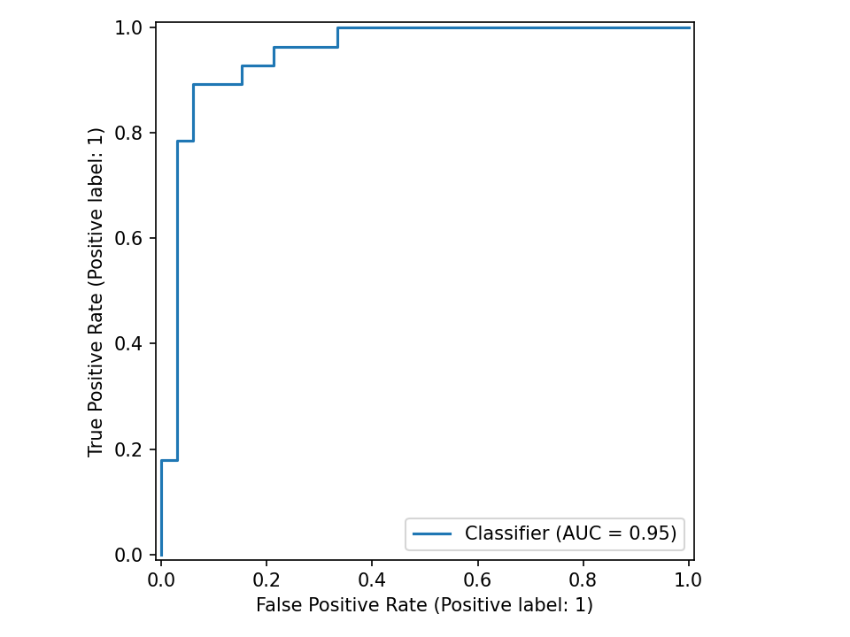
Figure 4. Logistic Regression ROC curve on the holdout split.
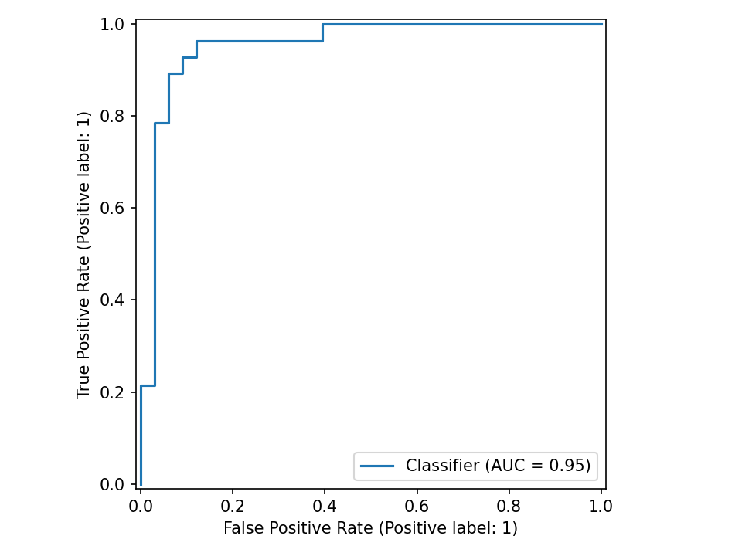
Figure 5. Random Forest ROC curve on the holdout split.
These scores are educational benchmark estimates from 303 records. They do not establish clinical validity, calibration, fairness across subgroups, or generalization to other institutions.

5. Confusion Matrices and Error Analysis
ROC-AUC summarizes ranking discrimination over thresholds, while a confusion matrix describes classification errors at the selected operating threshold. The following saved plots are included as evidence of the evaluation pipeline. The report does not interpret these results as clinical utility.
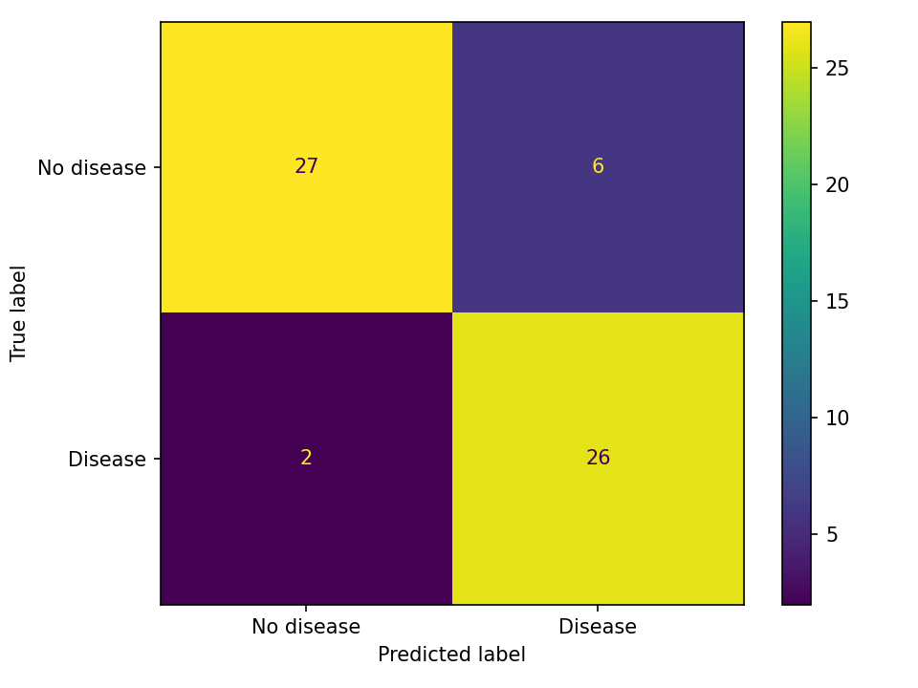
Figure 6. Logistic Regression holdout confusion matrix.
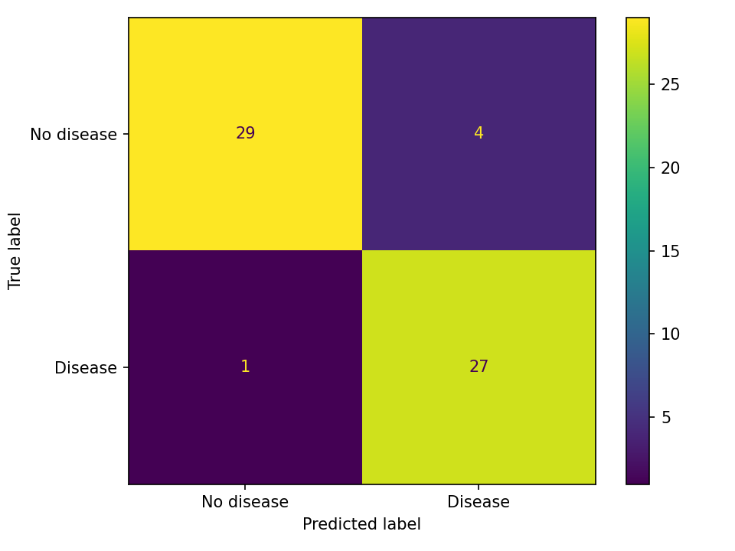
Figure 7. Random Forest holdout confusion matrix.

Interpretation and future evaluation
- The Logistic Regression model has holdout recall of 0.9286; Random Forest has holdout recall of 0.9643 on this split.
- The Random Forest result should not automatically override the predefined cross-validation selection rule. A new, untouched external test set would be needed for a stronger comparison.
- Future evaluation should report confidence intervals, subgroup metrics, calibration curves, threshold sensitivity, and external validation.
- Because the underlying data are small and historical, no deployment to a clinical workflow is appropriate.

6. Experiment Tracking with MLflow
The project logs candidate-model runs under the experiment heart-disease-classification. Recorded fields include model and split/CV configuration, mean and standard deviation of CV metrics, holdout metrics, and evaluation artifacts such as ROC curves and confusion matrices. The selected model is serialized to artifacts/model.joblib, and the summary is saved to artifacts/training_summary.json.
Model run | Run ID from saved training summary | Mean CV ROC-AUC | Holdout ROC-AUC
Logistic Regression | b208e2af9b9445dfa719e60163114e2d | 0.8963 | 0.9502
Random Forest | 91824f94c1634c529785987ab4b945b0 | 0.8828 | 0.9545

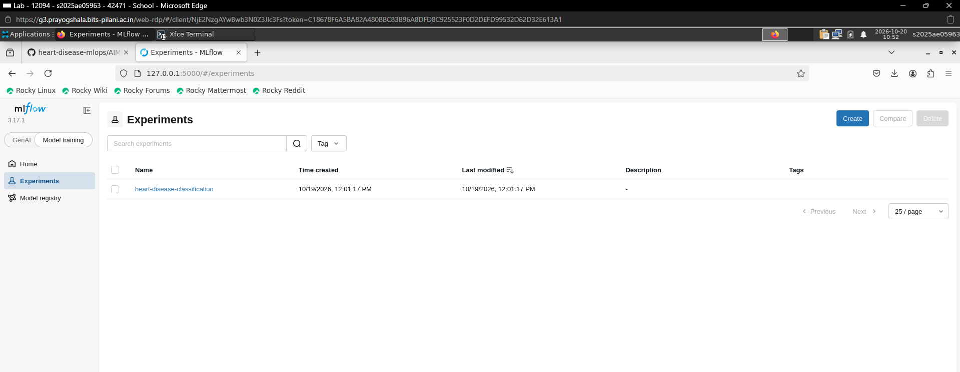
Figure 8. MLflow experiment overview screenshot included in the repository evidence.
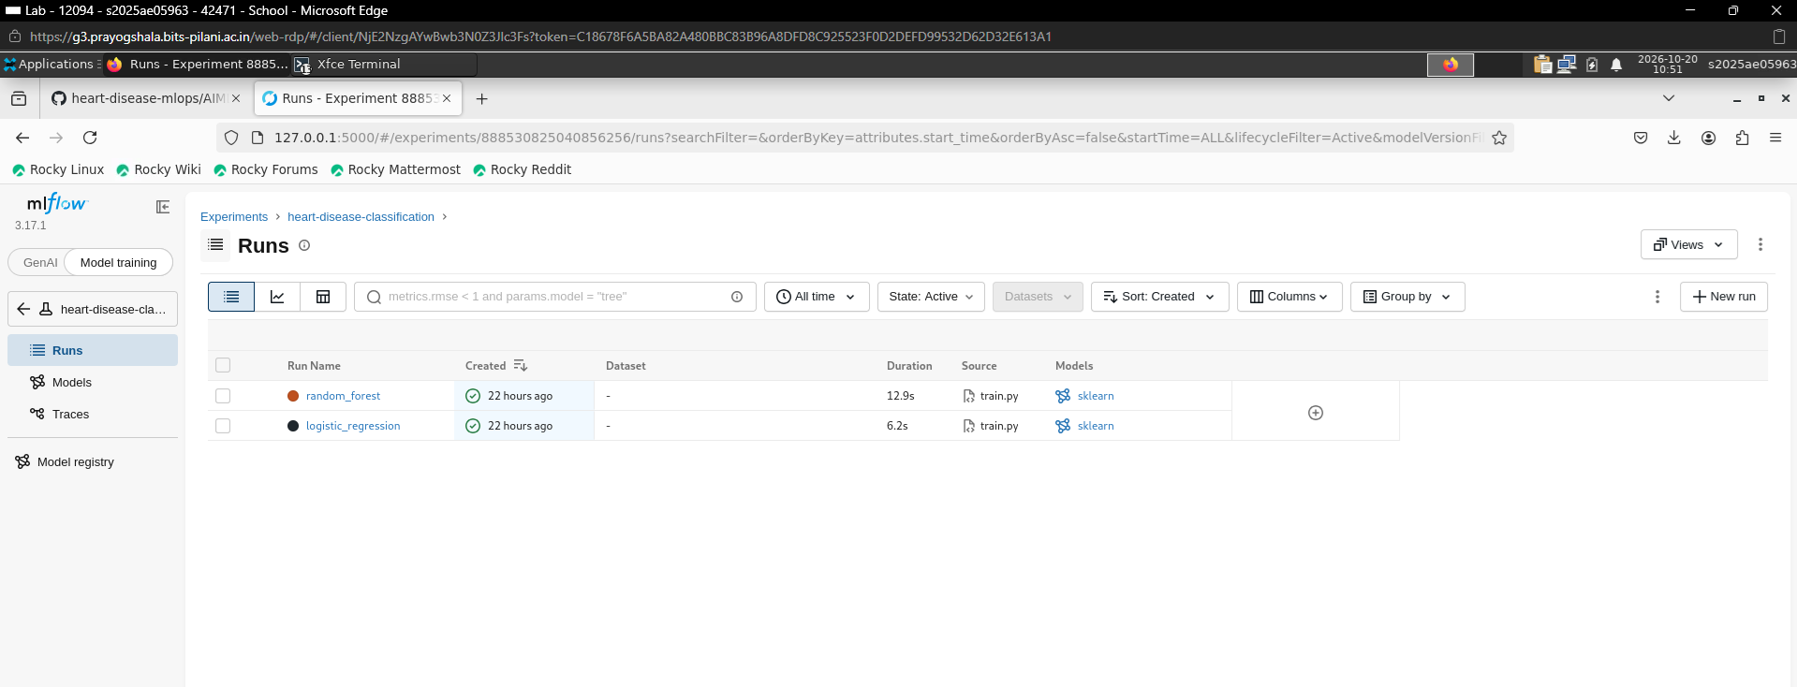
Figure 9. Comparison of tracked model runs.
The screenshots demonstrate that the experiment and model runs were recorded. The project requirements pin MLflow 2.17.2, while the supplied BITS lab screenshots show MLflow UI version 3.17.1. This is an environment/version difference; the report does not claim the UI screenshot was produced under the pinned local dependency. For a clean reproduction, install the repository requirements and rerun the training script.

7. Reproducibility, Testing and Continuous Integration

Reproduction environment
The project recommends Python 3.11 and pins dependencies in requirements.txt. The BITS lab evidence records Python 3.11.17, a successful pip check, six passing tests and a successful Ruff check. The local environment previously recorded Python 3.11.9; small environment differences should be resolved by installing the pinned requirements in a fresh environment.

Setup and execution
py -3.11 -m venv .venv
.\.venv\Scripts\Activate.ps1
python -m pip install --upgrade pip
pip install -r requirements.txt
python -m src.data
python -m src.eda
python -m src.train
ruff check .
pytest -v

Automated checks
Check | Recorded outcome | Scope
Pytest | 6 passed, 2 warnings | API root/health, invalid payload, metrics endpoint, target mapping, invalid column count, fit/predict for both models.
Ruff | All checks passed | Static linting; deprecation warning relates to Ruff configuration format.
pip check | No broken requirements found | Installed package dependency consistency in BITS lab environment.
GitHub Actions | Successful workflow run screenshot included | Workflow installs dependencies, runs Ruff, pytest, trains models and uploads model evidence.

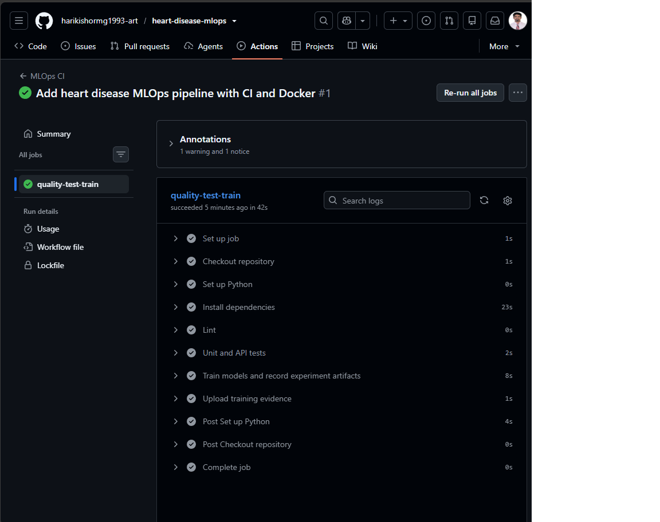
Figure 10. GitHub Actions CI success evidence from the repository.
The CI workflow is configured for push, pull_request and manual workflow_dispatch triggers. The saved screenshot documents a successful run; the workflow YAML is the reproducible definition. The report does not claim that every future commit will pass without execution.

8. FastAPI Inference Service
The FastAPI application loads artifacts/model.joblib and exposes a small inference interface. Request validation checks the expected feature payload; malformed payloads are rejected. The prediction response contains the predicted class, a label, estimated class probabilities and an educational-use disclaimer.
Endpoint | Purpose | Verification
GET / | Basic service information | Covered by API tests
GET /health | Health status and model-loaded flag | Verified in BITS lab evidence after model load
POST /predict | Accept 13 feature values and return class/probabilities | HTTP 200 captured in screenshot and JSON evidence
GET /metrics | Prometheus-compatible request and latency metrics | Metrics text files included in evidence

Run locally
uvicorn api.main:app --host 127.0.0.1 --port 8000
# Interactive API documentation: http://127.0.0.1:8000/docs
A synthetic test payload used age=58, sex=1, cp=0, trestbps=140, chol=240, fbs=0, restecg=1, thalach=150, exang=0, oldpeak=1.0, slope=1, ca=0 and thal=2. This is a software test fixture, not a real patient record. The saved BITS lab Docker prediction returned class 0 and estimated probability 0.9690 for class 0; this output is only a demonstration of the API contract.
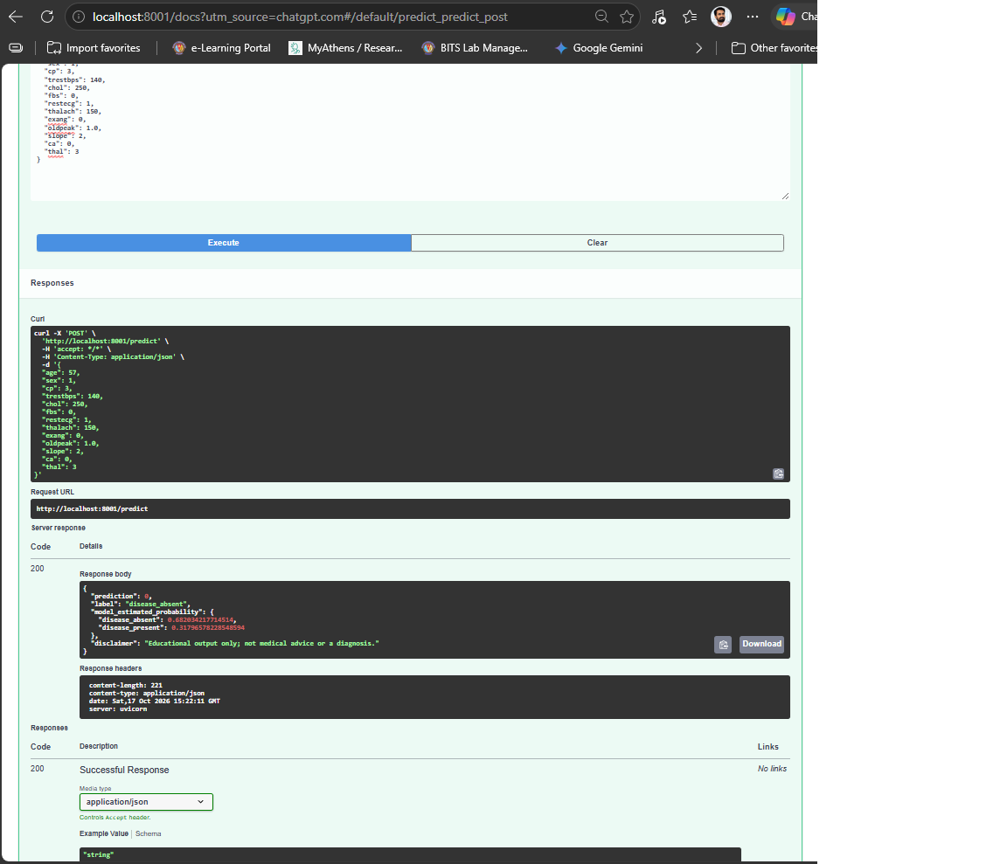
Figure 11. FastAPI prediction endpoint returning HTTP 200.
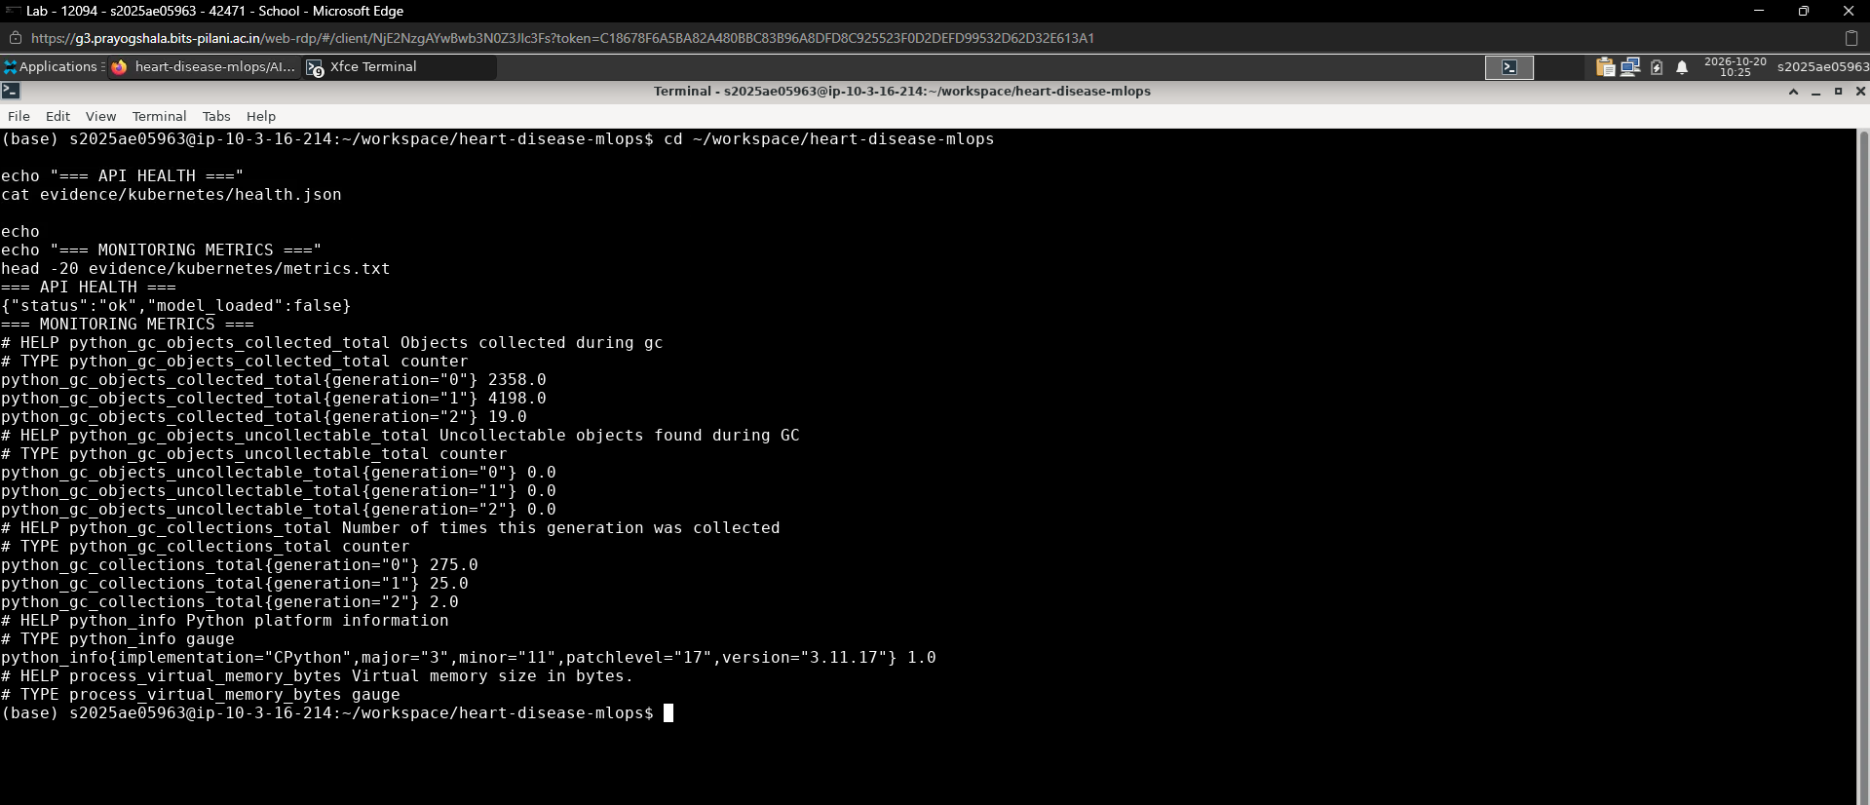
Figure 12. API health and metrics evidence from local Kubernetes verification.

9. Containerization and Deployment Verification

Docker
The Dockerfile packages the API and its runtime dependencies. In the BITS lab, the image heart-disease-mlops:lab was built at approximately 976 MB and the container was run with host port 8001 mapped to container port 8000. Evidence files record the image, container status, logs, health response, prediction response and metrics. The container responded to /predict and /health successfully.
docker build -t heart-disease-mlops:local .
docker run --rm -p 8000:8000 heart-disease-mlops:local

Kubernetes
The repository manifest defines a Deployment named heart-disease-api with one replica and a ClusterIP Service. Readiness and liveness probes call /health; CPU and memory requests/limits are configured. The supplied local Kubernetes evidence shows a successful rollout and a running pod. The service was accessed locally through port-forwarding rather than a public cloud endpoint.
Setting | Manifest value
Deployment replicas | 1
Container port | 8000
Service type | ClusterIP
Readiness probe | GET /health
Liveness probe | GET /health
Resource requests | 100m CPU; 256Mi memory
Resource limits | 500m CPU; 512Mi memory

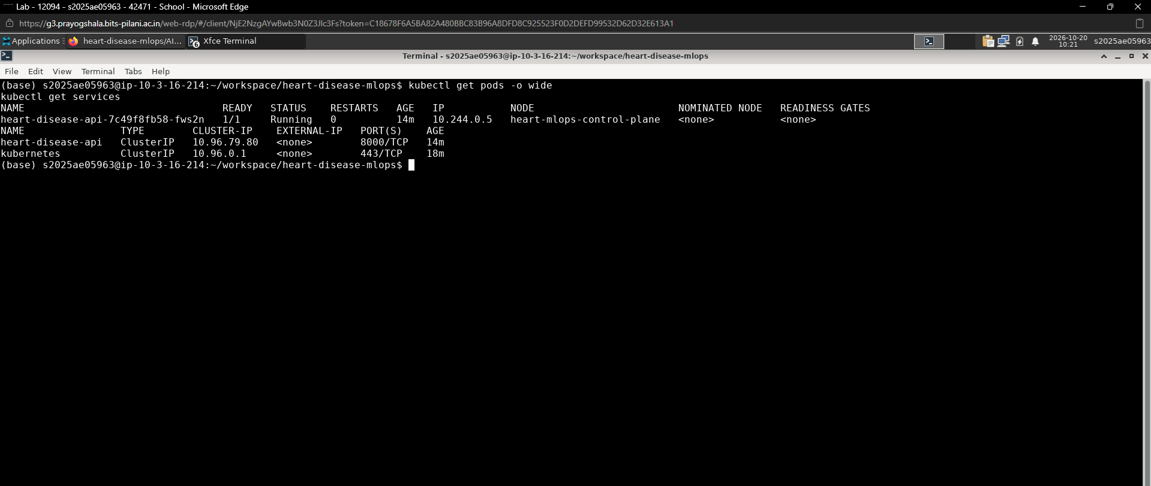
Figure 13. Local Kubernetes pods and services evidence.
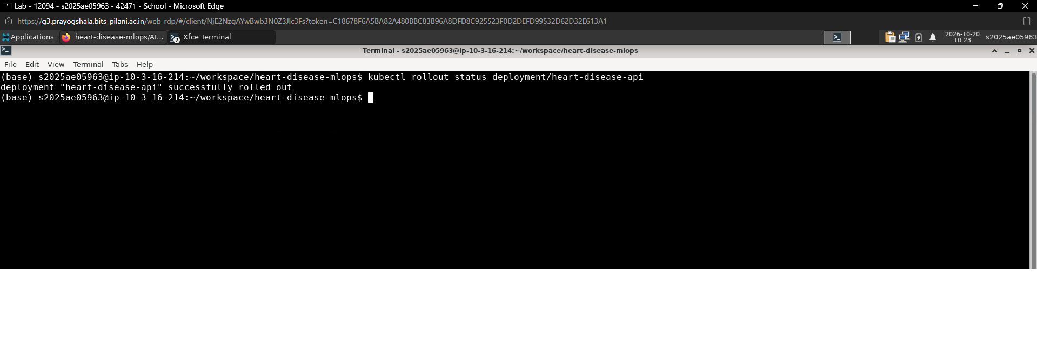
Figure 14. Successful Deployment rollout evidence.
Two environments are represented in the evidence: Docker Desktop Kubernetes on the local development machine and a Docker verification run in the BITS lab. The BITS lab checkpoint initially stated Kubernetes was not verified there; therefore, this report claims Kubernetes verification only for the local Docker Desktop environment and Docker container verification for BITS lab. No public-cloud deployment or externally reachable API URL is claimed.

10. Monitoring, Logging and Operational Considerations
The API exposes Prometheus-compatible metrics through /metrics, including request counters and latency histogram observations. Text evidence and logs are stored under evidence/kubernetes/, evidence/lab/ and evidence/logs/. These outputs demonstrate endpoint instrumentation and request activity, not a production monitoring service or an SLA.

Evidence captured
- Health responses showing service status and model load state.
- Synthetic prediction response with predicted label, estimated class probabilities and disclaimer.
- Request and latency metrics after test requests.
- API logs and Docker container logs.
- Kubernetes node, pod, service, resource, rollout and endpoint screenshots.
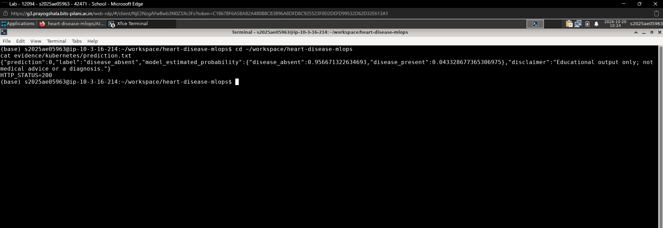
Figure 15. Prediction request through the local Kubernetes service.

Operational gaps before production
- No public ingress/load balancer or public endpoint is provided; access is local only.
- Authentication, authorization, TLS, secrets management and rate limiting are not demonstrated.
- No Prometheus server/Grafana dashboard, alert rules, persistent log aggregation or incident response process is evidenced.
- The one-replica deployment is a local demonstration, not a high-availability configuration.
- Resource requests/limits and health probes are present, but autoscaling and load testing are not demonstrated.

11. Limitations, Ethics and Conclusion

Limitations
- Dataset size is 303 rows and is insufficient to establish reliable performance across populations, sites or time periods.
- The dataset is historical; public mirrors may change. The source URL, schema, target mapping and missing-value counts should be rechecked on every fresh run.
- Categorical concepts encoded as integers are currently treated as numeric. Alternative encoding and domain review are future work.
- Evaluation uses one stratified holdout split and five-fold cross-validation on the same small dataset; no external validation or confidence intervals are reported.
- Probability calibration and subgroup performance have not been evaluated.
- The output probabilities are model estimates, not validated estimates of an individual’s clinical risk.

Ethical and safety statement
This project is an educational demonstration of software engineering and MLOps concepts. It must not be used for screening, diagnosis, triage, treatment selection, or patient-level decisions. Any future clinical research would require appropriate governance, representative data, independent validation, calibration, fairness assessment, clinical expertise and regulatory review.

Conclusion
The assignment demonstrates a coherent MLOps lifecycle from data ingestion and EDA through model comparison, experiment tracking, automated checks, API packaging, local deployment and basic monitoring. Logistic Regression is the selected serving model because it had the highest mean CV ROC-AUC under the stated rule, even though Random Forest scored better on the holdout split. The project is suitable as an educational prototype; production readiness and clinical suitability have not been established.

Appendix A. Reproduction and Access Instructions

Repository
GitHub: https://github.com/harikishormg1993-art/heart-disease-mlops.git

Windows PowerShell
git clone https://github.com/harikishormg1993-art/heart-disease-mlops.git
cd heart-disease-mlops
py -3.11 -m venv .venv
.\.venv\Scripts\Activate.ps1
pip install -r requirements.txt
python -m src.data
python -m src.eda
python -m src.train
pytest -v
ruff check .
uvicorn api.main:app --host 127.0.0.1 --port 8000

MLflow UI
mlflow ui --backend-store-uri ./mlruns --host 127.0.0.1 --port 5000
# Open http://127.0.0.1:5000
MLflow uses a local tracking store for this demonstration. The report includes MLflow screenshots and run identifiers from the saved training summary. A clean reproduction should install the repository’s pinned requirements and regenerate the runs rather than assume a prior local tracking directory exists.

Docker and Kubernetes
docker build -t heart-disease-mlops:local .
docker run --rm -p 8000:8000 heart-disease-mlops:local
# For an already configured local Kubernetes context:
kubectl apply -f deployment/k8s/deployment.yaml
kubectl rollout status deployment/heart-disease-api --timeout=120s
kubectl port-forward service/heart-disease-api 8001:8000
# Check http://127.0.0.1:8001/health and /metrics
For Kubernetes, the image must be available to the selected cluster. The manifest uses image heart-disease-mlops:local with imagePullPolicy IfNotPresent; image-loading steps vary by cluster. The submitted evidence demonstrates local verification only.

Evidence inventory
Folder | Contents
evidence/figures/ | EDA figures, ROC curves and confusion matrices
evidence/07*.png | MLflow experiment and run screenshots
evidence/08*.png | GitHub Actions CI success screenshot
evidence/09*.png | FastAPI prediction screenshot
evidence/kubernetes/ | Local Kubernetes status, rollout, prediction, health, metrics and logs
evidence/lab/ | BITS lab Docker, health, prediction, metrics, tests, lint and dependency checks
evidence/metrics/ | EDA summary, source metadata and training summary JSON

