Work Acceptance Letter

From: Harikrishnan KB

MRA 27, Mandiram road,

Ayyappankavu,kochi-18

To: Altos Technologies,

Carnival Infopark Phase I, First Floor,

Infopark Campus, Kakkanad, Kochi, Kerala 682042

Work List: Purchase order by vendor, Purchase order details, Recurring bill details.

Work Assigned: 1-12-2023

Start Date: 1-12-2023

End Date: 4-12-2023

Sir,

I do accept the above-mentioned work and I will submit that on or before the deadline without any corrections or errors. In the future, if any error occurs in my work, it is my responsibility to solve that. I do hereby solemnly affirm and declare that all information and particulars furnished here by me are true and correct to the best of my knowledge.

Date: 1-12-2023 Yours Faithfully,

Place: Kochi 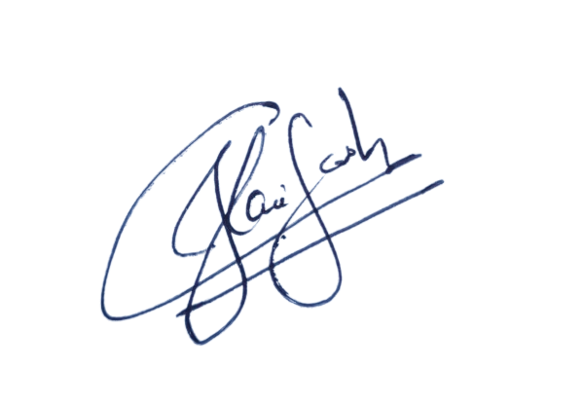 Harikrishnan KB