Creation of table product:

create table product(pid int(10),pname varchar(10),price int(10),unitOfMeasurement int(5));

insert into product values(1,'iphone',100000,1);

insert into product values(2,'samsung',80000,1);

insert into product values(3,'moto',15000,1);

insert into product values(4,'lg',15000,1);

insert into product values(5,'nokia',1000,1);

select *from product;

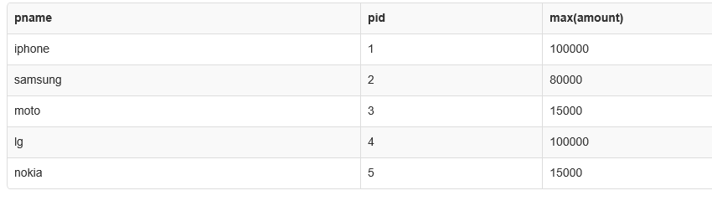

Creation of table customer:

create table customer(cid int(10),cname varchar(10),city varchar(10));

insert into customer values(101,'ram','trichy')

insert into customer values(102,'praveen','annanagar');

insert into customer values(103,'hari','madavakkam');

select *from customer;

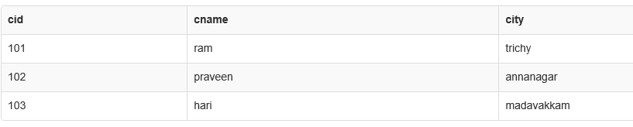

Creation of table sales:

create table sales(tid int(5),cid int(10),pid int(10),amount int(20));

insert into sales values(1001,101,1,100000);

insert into sales values(1001,101,3,15000);

insert into sales values(1002,102,2,80000);

insert into sales values(1002,102,1,100000);

insert into sales values(1003,101,5,15000);

insert into sales values(1004,103,1,80000);

insert into sales values(1004,103,4,100000);

select * from sales;

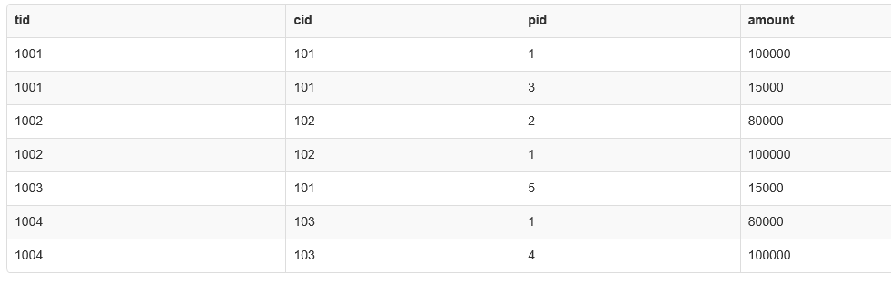

1.No. of times each product is sold?

Select pid,count(pid) as noOfProducts from sales group by pid order by pid;

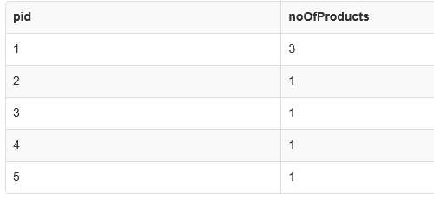

2. Which product is highly sold?

select pid,count(pid) as noOfProducts from sales group by pid order by pid)as t1;

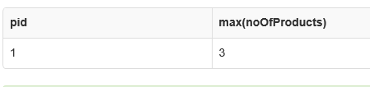

3. customer details who have done transactions above 80000?

select c.cid,c.cname,c.city,s.tid,sum(amount) from sales s join customer c on c.cid=s.cid Group by tid,cid Having sum(amount)>80000;

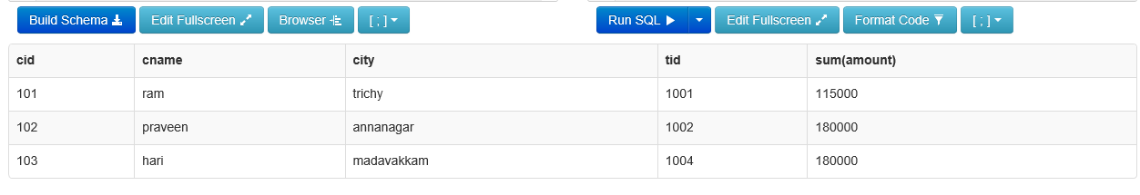

|  |
| --- |
| 4. Which ph brand has highest individual transactions?  select pname,s.pid,tid,max(amount) from sales s inner join product p on s.pid=s.pid group by tid;  C:\Users\dhivya.kavidasan\AppData\Local\Microsoft\Windows\INetCache\Content.Word\f.png  5. Which branch is giving the best sales?  select max(total),cid,city from(select c.city,sum(amount) as total,s.cid from sales s join customer c on c.cid=s.cid group by pid)as t2;  C:\Users\dhivya.kavidasan\AppData\Local\Microsoft\Windows\INetCache\Content.Word\new 5.png |