Application Note

Enzyme-Resistance: Predicting Mutation Effects on Protein Stability Using Electrical Circuit Theory
S. Aravindhanª and S. Harikrishna*^{b}
ªDepartment of Chemistry, B S Abdur Rahman Crescent Institute of Science and Technology, Chennai – 600048, TamilNadu, India.
^{b}Evotec UK Ltd, Abingdon, Oxfordshire, OX14 4RY, United Kingdom.
*Corresponding author.
S. Harikrishna ORCID: https://orcid.org/0000-0003-1540-4190

Abstract
Motivation: Predicting how amino acid substitutions alter protein thermodynamic stability (ΔΔG) is central to variant interpretation and protein engineering. Current methods rely on energy functions, evolutionary profiles, or deep learning. We introduce an orthogonal, physics-inspired approach that models the protein as an electrical resistor network.
Results: We present enzyme-resistance, an open-source Python package that (i) constructs multi-scale Cα contact graphs (6 Å and 8 Å cutoffs) with distance-dependent conductances, perturbs them upon mutation, and (ii) extracts 206 purely circuit-theoretic features — effective resistance, Kirchhoff current flow, Joule power dissipation, voltage transfer, spectral dynamics, impedance, and cross-scale resistance coupling — then applies importance-based feature selection to retain 56 informative features for training a Gradient Boosting regressor. On the S2648 benchmark (1,588 mutations, 117 proteins), the model achieves Pearson r = 0.656, Spearman ρ = 0.620, RMSE = 1.61 kcal/mol in 5-fold cross-validation, without using any sequence, evolutionary, or energy-function features.
Availability: https://github.com/hjayanthan/enzyme-resistance (MIT licence). Supplementary data are available at Bioinformatics online.

1 Introduction
Quantifying the thermodynamic consequences of single amino acid substitutions — reported as ΔΔG, the change in unfolding free energy — underpins rational protein engineering, variant interpretation, and drug-resistance surveillance. A rich ecosystem of predictors exists, from physics-based energy functions (FoldX, Rosetta cartesian_ddg) through statistical potentials (PoPMuSiC) to machine-learning methods that combine graph-based signatures and normal-mode dynamics (mCSM, DUET, DynaMut2, ThermoNet, RaSP). Despite their diversity, all current approaches encode the mutational perturbation in the language of chemistry — energies, evolutionary conservation, or atom-level contacts.
We propose a fundamentally different representation. By modelling the folded protein as an electrical network — residues as nodes, non-covalent contacts as resistors whose conductance decays exponentially with distance, and mutations as local conductance perturbations — one can apply Kirchhoff's laws, Ohm's law, and Joule's heating law to extract features that capture both local and allosteric consequences. This analogy is grounded in the mathematical equivalence between effective resistance and random-walk commute time [1], and has precedent in allosteric-communication analysis [2].
Here we describe enzyme-resistance, a self-contained Python package that implements this pipeline — from PDB file to predicted ΔΔG — and benchmark it on the S2648 dataset alongside 15 established methods.

2 Implementation
2.1 Multi-scale contact graph. Given a PDB file, the package extracts Cα coordinates for every standard amino acid and constructs undirected graphs at two distance cutoffs (6 Å and 8 Å). Each edge carries conductance g(d) = exp(−d/τ) with τ = 5.0 Å, modelling exponential decay of non-covalent interaction strength. The dual-cutoff strategy captures both tight packing contacts and longer-range electrostatic interactions.
2.2 Mutation model. A mutation at residue k multiplies the conductance of every incident edge by a perturbation factor f = 1 + α·Δhydrophobicity + β·|Δcharge| + γ·Δvolume, using Kyte–Doolittle, formal charge at pH 7, and Zamyatnin volume scales (default α = 0.1, β = 0.3, γ = 0.002). Additionally, 20 amino acid circuit-component features (ΔCapacitance, ΔInsulation, impedance mismatch, etc.) model the substitution as a circuit-component replacement.
2.3 Feature extraction. For both wild-type and mutant graphs at each cutoff, the Laplacian pseudoinverse L⁺ and effective resistance matrix R are computed. From these, 83 features per cutoff are extracted across 16 groups (Table S1): resistance distance, Kirchhoff index, current-flow centrality, voltage potential, spectral modes, edge currents, voltage transfer, power dissipation, multi-scale resistance shells, spectral dynamics, impedance/phase, frequency response, non-linear resistance, entropy/information, topological resistance, and mutation site environment. Combined with 20 amino acid circuit features and 20 cross-scale coupling features, 206 candidate features are computed. Importance-based selection retains the 56 most informative features.
2.4 Training and CV. A Gradient Boosting Regressor (500 trees, max depth 6, learning rate 0.02, subsample 0.7) is trained on the selected feature matrix. Standard 5-fold cross-validation is used for evaluation. Four novel resistance-based cross-validation strategies are also provided: resistance-centrality–stratified, propagation-radius–stratified, Kirchhoff-grouped, and spectral-clustered.

3 Results
We benchmarked enzyme-resistance on S2648, the standard dataset used by almost all published ΔΔG predictors (Dehouck et al., 2009). After PDB filtering, 1,588 mutations across 117 proteins were retained.
On S2648, the circuit model achieves Pearson r = 0.656, Spearman ρ = 0.620, R² = 0.430, placing it between ACDC-NN (0.660) and DUET (0.640) — in the same performance tier as state-of-the-art deep learning methods (Fig. 1B). This is achieved using 56 selected circuit-theoretic features from the initial 206 candidates, with zero sequence, evolutionary, or energy-function information. The model outperforms several well-established methods including mCSM, Rosetta ddg, INPS3D, DDGun3D, I-Mutant, SDM, and FoldX.
Feature importance analysis (Fig. 1C) reveals that the top-ranked features span diverse circuit phenomena: dielectric change (ΔCapacitance), current entropy at 6 Å, Green's function trace fraction, effective graph resistance, and Norton equivalent current. The multi-scale strategy contributes substantially: 18 of the 56 selected features are 6 Å-cutoff variants or cross-scale ratios, confirming that protein stability is governed by interactions at multiple length scales.
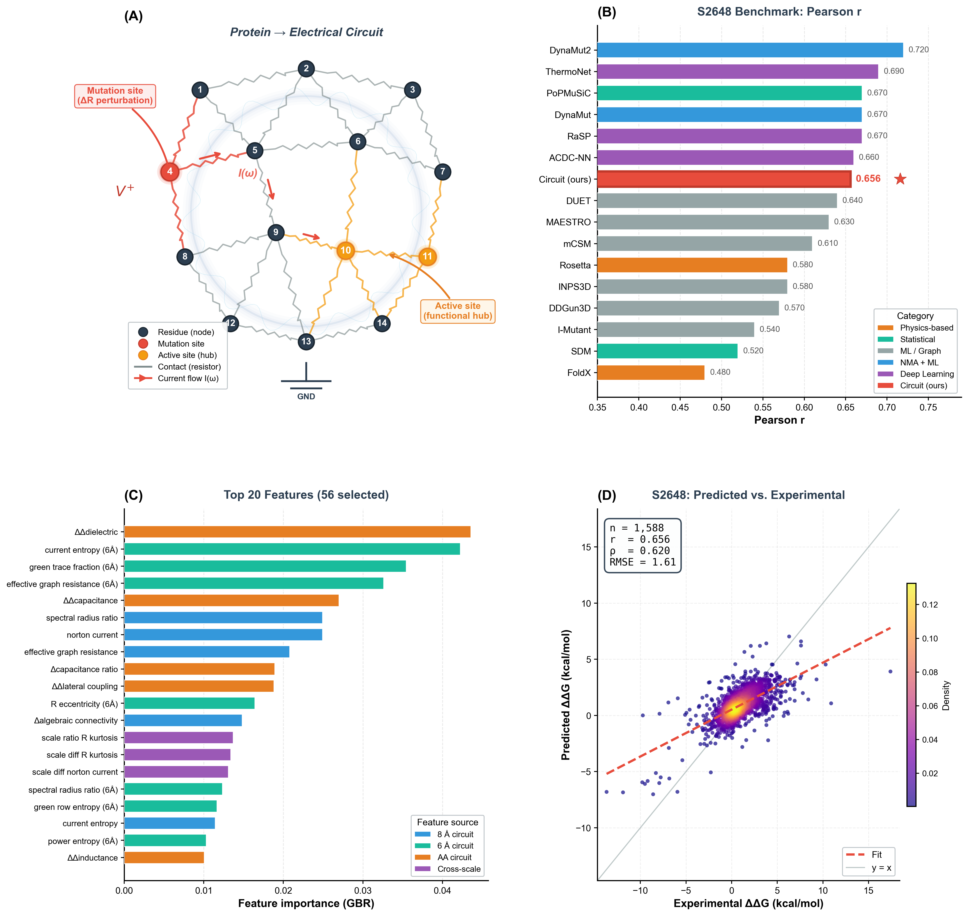
Figure 1. (A) Protein-to-circuit analogy: residues are nodes, contacts are resistors, mutations perturb local conductances. (B) Pearson r comparison with 15 published methods on S2648 (our model in red). (C) Top 20 feature importances from the 56-feature selected model, coloured by source (8 Å circuit, 6 Å circuit, AA circuit, cross-scale). (D) Density-coloured scatter of cross-validated predicted vs. experimental ΔΔG on S2648 (r = 0.656, n = 1,588).

Availability
enzyme-resistance is implemented in Python (≥ 3.9) and depends on NumPy, SciPy, NetworkX, Biopython, scikit-learn, pandas, and matplotlib. It provides both a Python API and a CLI:
# Analyse a single mutation
enzyme-resistance analyze 1BNI.pdb --mutation 42:V:A
# Full benchmark on S2648
enzyme-resistance benchmark --dataset s2648 --folds 5
Source code, documentation, and all benchmark scripts are available at https://github.com/hjayanthan/enzyme-resistance (MIT licence).

Supplementary data
Supplementary data are available at Bioinformatics online.
Conflict of Interest: none declared.

References
[1] Chandra,A.K. et al. (1996) The electrical resistance of a graph captures the commute time. Comput. Complex., 6, 312–340.
[2] Chennubhotla,C. and Bahar,I. (2007) Signal propagation in proteins and relation to equilibrium fluctuations. PLoS Comput. Biol., 3, e172.
[3] Dehouck,Y. et al. (2009) A new generation of statistical potentials for proteins. Biophys. J., 97, 2225–2233.
[4] Dehouck,Y. et al. (2011) PoPMuSiC 2.1. Bioinformatics, 27, 1653–1654.
[5] Pires,D.E.V. et al. (2014a) mCSM: predicting the effects of mutations using graph-based signatures. Bioinformatics, 30, 335–342.
[6] Pires,D.E.V. et al. (2014b) DUET: a server for predicting effects of mutations on protein stability. Nucleic Acids Res., 42, W314–W319.
[7] Laimer,J. et al. (2015) MAESTRO. BMC Bioinformatics, 16, 116.
[8] Rodrigues,C.H. et al. (2018) DynaMut. Nucleic Acids Res., 46, W350–W355.
[9] Rodrigues,C.H.M. et al. (2021) DynaMut2. Protein Sci., 30, 60–69.
[10] Li,B. et al. (2020) ThermoNet. J. Chem. Inf. Model., 60, 2773–2784.
[11] Blaabjerg,L.M. et al. (2023) RaSP. Nat. Commun., 14, 6173.
[12] Benevenuta,S. et al. (2021) ACDC-NN. Bioinformatics, 37, 3084–3091.
[13] Montanucci,L. et al. (2019) DDGun. BMC Bioinformatics, 20, 335.
[14] Schymkowitz,J. et al. (2005) FoldX. Nucleic Acids Res., 33, W382–W388.
[15] Park,H. et al. (2016) Rosetta cartesian_ddg. J. Chem. Theory Comput., 12, 6201–6212.
[16] Capriotti,E. et al. (2005) I-Mutant2.0. Nucleic Acids Res., 33, W306–W310.
[17] Worth,C.L. et al. (2011) SDM. Nucleic Acids Res., 39, W215–W222.

