**ACCT 6321 Database Applications for Business Analytics in Accounting**

**Fall 2022**

**Instructor: Dr. James Scott**

**Assignment #1 – Intro SQL and Oracle**

**General Instructions**

* Students may study together for the assignment and review each other’s completed work
* Students must each complete the assignment by their own hand
* Please use the provided word document template
* Please save the completed word document into PDF format before uploading
* Please submit the PDF file electronically through eLearning before the due date and time
* Do not include output – only the SQL
* **Use table aliases for all tables in all queries (unless otherwise specified)**
* Column aliases are required for all derived columns including aggregate columns (unless otherwise specified)
* Do not use column aliases unless required as stated previously
* If a problem does not ask for a specific sort order, use your best judgement to add a sort order

**Chapter 1 Problems – Database Systems**

Run the “Ch1_Problems_ORA.sql” script found in the elearning Assignment folder from the Oracle LiveSQL session. This will create the three following tables (Prob_1_01, Prob_1_05, Prob_1_09) needed to answer the following problems from the book.

Problems 1-4 page 32.

Q1

-- Count of records in file is 7.

1. Select count(1) from PROB_1_01;

-- Number of fields in file is 5

1. select * from PROB_1_01;

-- Q2

The problem is field city is part of the manager_address. For E.g., for the record with project code '21-5Z’, the address is '3334 Lee Rd., Gainesville, FL 37123', which is present in the city 'Gainesville'.

Dividing the field 'Manager address' into 'Address_line_No_1','Address_line_No_2', 'City', 'State' and 'ZipCode' would be the best option.

Another alternative is getting the ZIP to City mapping and joining it with right(trim(Manager_address,5)) would give us the city of each address, because zip code is unique to each city

--Q3

I would make the following changes to the file

'PROJECT_MANAGER' - ‘FIRST_NAME','MIDDLE_NAME','LAST_NAME’ -- Also would ensure the table is more than 100 characters to ensure no loss of data in name

'MANAGER_PHONE' - 'AREA_CODE','PREFIX_NUMBER','LINE_NUMBER' -- The columns must be INT variables

'MANAGER_ADDRESS' - 'Address_line_No_1','Address_line_No_2','City','State','ZipCode'

--Q4

We see that Holly B. Parker and George F. Dorts have 3 and 2 separate projects respectively. So, their manager information is repeated in the dataset. The solutions for this are to have two tables: One with the Manager info and one with the project info (which includes Manager ID or Manager Name).

Another would be Manager Name could be entered wrongly which might result in duplicates.

Problems 5-6 page 32 and 33.

--Q5

The table has `PROJ_NAME`, `EMP_NAME`, `JOB_CH0_HOUR` and `EMP_PHONE` have repeated multiple times in the given table as there could have been other foreign keys from different tables such as ‘PROJ_NUM’,’ EMP_NUM’ and ‘JOB_CODE’.

--Q6

EMP_NAME: Could be divided into `FIRST_NAME`, `MIDDLE_NAME` and `LAST_NAME`.

EMP_PHONE: Could be divided into `AREA_CODE`, `EXCHANGE_NUMBER` and `LINE_NUMBER`.

Problem 9 page 33.

-- Q9

`TEACHER_FNAME`, `TEACHER_LNAME` AND `TEACHER_INITIAL` repeats every time with repeating teachers time slot. Adding a column called `TEACHER_EMP_CODE` to simplify the table and add another table with Teacher info with the mapping information.

**Chapter 2 Problems – Database Models**

Do Problems 1-5 on pages 63-64 of our textbook using the data provided in the book figures.

**To make the ERD diagrams, keep it simple. Just draw the ERD diagrams with pen and paper then simply take a camera shot (.jpg) and include the camera shot of the ERD here in the homework assignment.**

-- Q1

`AGENT_CODE` is a foreign key in the CUSTOMER table which gives us the agent information for each transaction on insurance details. It is a 1:M relationship between AGENT and CUSTOMER.

--Q2

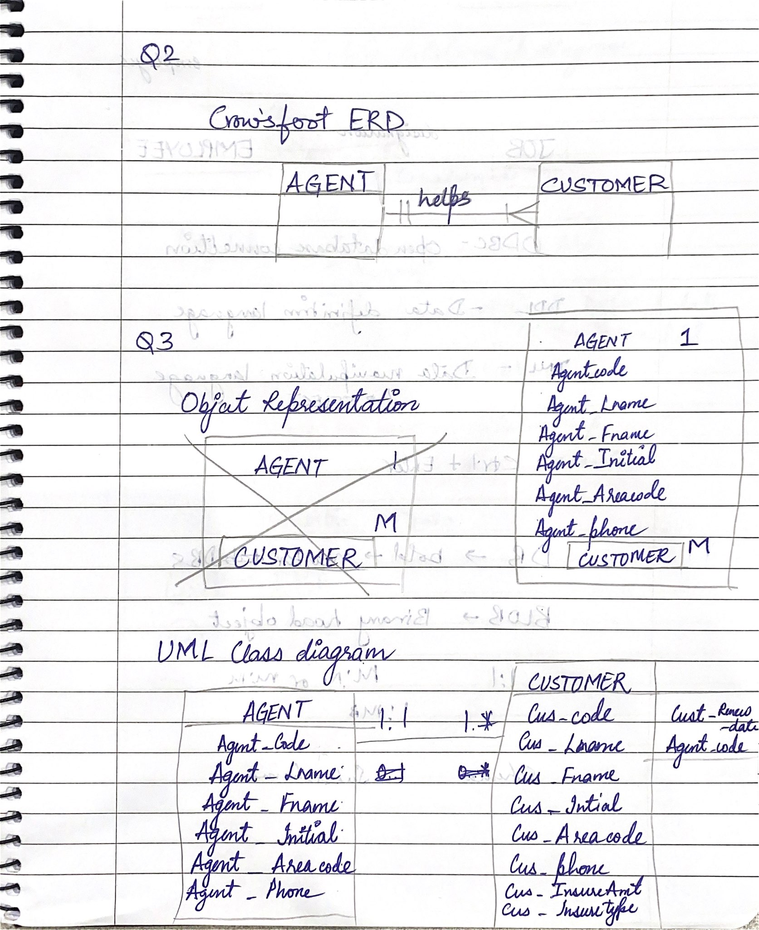

--Q4

One Store can only have one region but there could be multiple stores in one region. Therefore, the relationship between REGION and STORE is 1: M.

One Store can have multiple employees but usually one employee can only be in one store. Therefore, the relationship between STORE and EMPLOYEE is 1: M.

JOB_CODE refers to Job info and can be specific to a specific role in the store assigned to an employee. For example, there can be more than one janitor in a store. Therefore, the relationship between JOB and EMPLOYEE is 1: M. (Note: Assuming each employee has an only one role to attend to at the store)

-- Q5

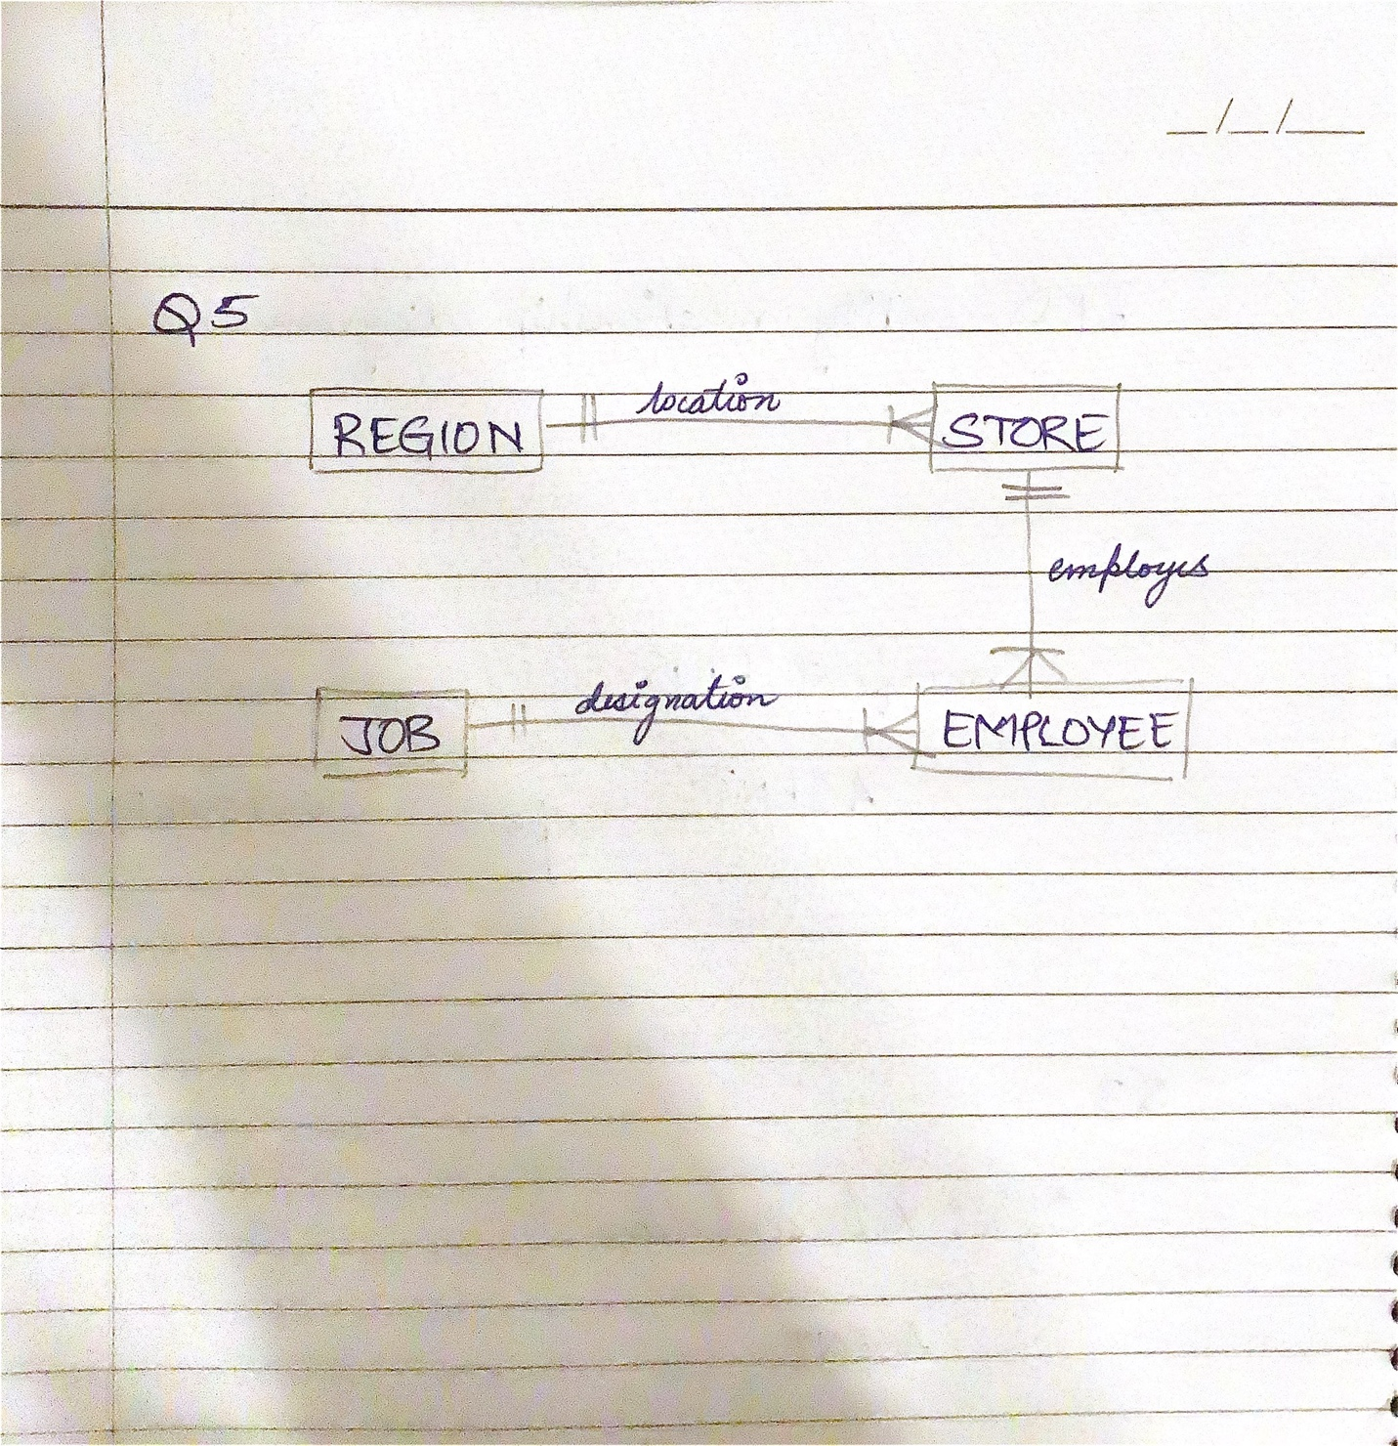

**For the following SQL coding problems use the “University_DDL.sql” script found in elearning to create your tables in Oracle Liesl session.**

**Problem #1 – Retrieving all rows and all columns from a table**

For each of our tables, retrieve all rows and all columns.

Tables are Student, Faculty, Offering, Course, and Enrollment

(no need to sort at this point)

1. -- Faculty table
2. SELECT * FROM Faculty;
3. -- Course table
4. SELECT * FROM Course;
5. -- Offering table
6. SELECT * FROM Offering;
7. -- Student table
8. SELECT * FROM Student;
9. -- Enrollment table
10. SELECT * FROM Enrollment;

**Problem #2 – Retrieving a subset of columns from a table and sorting them**

**both with and without the ASC keyword**

Retrieve the student number, student first name, and student last name for all students

Sort the results by student last name then by student first name

Use the ASC keyword on the query

Repeat the query omitting ASC

1. -- PART 1
2. SELECT StdNo,StdFirstName, StdLastName
3. FROM Student
4. ORDER BY StdLastName ASC , StdFirstName ASC;
5. -- PART 2
6. SELECT StdNo,StdFirstName, StdLastName
7. FROM Student
8. ORDER BY StdLastName , StdFirstName;

**Problem #3 – Retrieving a subset of columns from a table and sorting them on multiple columns mixing ascending and descending order, using both named and positional notation**

Retrieve the student last name, student first name, and GPA for all students

Sort the results by GPA highest first, then by student last name, then by student first name

Use column names to sort (omit ASC)

Repeat the query using positional notation

1. – PART 1
2. SELECT StdLastName,StdFirstName,StdGPA
3. FROM Student
4. ORDER BY StdGPA DESC, StdLastName , StdFirstName;
5. -- PART 2
6. SELECT StdLastName,StdFirstName,StdGPA
7. FROM Student
8. ORDER BY ORDER BY 3 DESC, 1,2;

**Problem #4 – Retrieving columns from a table both with and without duplicates**

Retrieve the student city and class for all students with duplicates

Repeat query without duplicates

1. --PART 1
2. SELECT StdCity,StdState
3. FROM Student;
4. --PART 2
5. SELECT DISTINCT StdCity,StdState
6. FROM Student;

**Problem #5 – Retrieving a subset of rows with a single Boolean expression**

Retrieve the student’s last name, student first name, and GPA for all students with a GPA greater than 3.2

1. SELECT StdLastName,StdFirstName, StdGPA
2. FROM Student
3. WHERE StdGPA > 3.2;

**Problem #6 – Retrieving a subset of rows with multiple complex Boolean expressions**

Retrieve the student last name, student first name, and GPA for all students with a GPA

(more than 2.2 and less than 2.7) OR (more than 3.2 and less than 3.8)

1. SELECT StdLastName,StdFirstName, StdGPA
2. FROM Student
3. WHERE (StdGPA > 2.2 AND StdGPA < 2.7) OR (StdGPA > 3.2 AND StdGPA < 3.8);

**Problem #7 – Retrieving a subset of rows with the BETWEEN operator**

Retrieve the student last name, student first name, and GPA for all students with a GPA that is between 2.7 and 3.2 inclusive

1. SELECT StdLastName,StdFirstName, StdGPA
2. FROM Student
3. WHERE StdGPA BETWEEN 2.7 AND 3.2;

**Problem #8 – Retrieving a subset of rows with testing for NULLs**

Retrieve the offer number, course number, year, and faculty number from all course offerings that has not yet been assigned a Faculty

Repeat query for course offerings that have been assigned a Faculty

1. SELECT OfferNo, CourseNo, OffYear, FacNo
2. FROM Offering
3. WHERE FacNo IS NULL;
4. SELECT OfferNo, CourseNo, OffYear, FacNo
5. FROM Offering
6. WHERE FacNo IS NOT NULL;