PoliceGIS

(Android Application)



Intern Program

B.Tech GeoInformatics (7th Semester)

**Submitted By:**

Hari Krishna Gadi

([gadiharikrishna@gmail.com](mailto:gadiharikrishna@gmail.com))

**Supervised By:**



**Acknowledgments**

I take this opportunity to express my profound gratitude and deep regards to Prof G. Jai Shankar(Head of the Dept., Geo Informatics, Andhra University College Of Engineering) for his exemplary guidance, monitoring and constant encouragement throughout the course of this project. The blessing, help and guidance given by him time to time shall carry me a long way in the journey of life on which I am about to embark. I also take this opportunity to express a deep sense of gratitude to Prof P. Jagadeshwar Rao (Geo Informatics Dept., Andhra University College of Engineering) for his cordial support, valuable information and guidance which helped me in completing this task through various stages. I am obliged to staff members of AUCE College, for the valuable information provided by them in their respective fields. I am grateful for their cooperation during the period of my assignment.

**Abstract**

The era of mobile technology opens the windows to the android app. The websites are vanishing and the mobile phones are emerging. With the launch of Apples’ I phone in the year 2007 by the then CEO, Steve Jobs everything has changed in the world of mobile phones and its usage. The new concept of mobile Apps and a store has come into the picture. Then the real power of internet spread like a wild fire. With the introduction of the concept of App store and apps has revolutionised the Information Technology Industry. Then everyone slowly started to feel that It’s the time to change from conventional websites to apps, which has become the part of our daily routine. And then came Android into the market as an alternative for IOS devices. Android is equally comparative to the IOS. It’s fast, smooth and reliable. Within no time the number of android devices has grown to a nearly half a million because of its open source principle. We would look for an App in our play store for an sort of digital requirement and being an enthusiast in technology I have made up my mind and decided to work on an android project and as the result of my work I am introducing „PoliceGIS ‟ the android application software which would be very helpful for the citizens of the Krishna District. The common citizen and the person new to an area would always be confused or rather in the state of no knowledge of the judicial boundaries of an area. Sometimes we may face the situation where we need to know the judicial boundaries and the respective Police Station location. During emergencies this situations would panic us. So I have developed this Android application which basically all the GIS information regarding the police Department and their corresponding boundaries.

**Table of Contents**

**1. Introduction**

**1.1 Definition**

**1.2 Types of Mobile Apps**

**1.3 Distribution**

**2. Development Environment**

**2.1 Client Server Architecture**

**2.2 Available Technologies**

**2.2.1 Back End Technologies**

**2.2.2 Front End Technologies for Android**

**2.3 Database**

**2.4 Choosing Technologies**

**3. Environment**

**3.1 Installing Software**

**3.2 Data and Node Server**

**3.3 React Native and Frontend**

**4. Working**

**5. Conclusion and References**

**Chapter 1**

**Introduction**

The era of mobile technology opens the windows to the android app. The websites are vanishing and the mobile phones are emerging. With the launch of Apples’ I phone in the year 2007 by the then CEO, Steve Jobs everything has changed in the world of mobile phones and its usage. The new concept of mobile Apps and a store has come into the picture.

Then the real power of internet spread like a wild fire. With the introduction of the concept of App store and apps has revolutionised the Information Technology Industry. Then everyone slowly started to feel that it’s the time to change from conventional websites to apps, which has become the part of our daily routine.

Then came Android into the market as an alternative for IOS devices. Android is equally comparative to the IOS. Within no time the number of android devices has grown to a nearly half a million because of its open source principle. Me being an enthusiast in technology I have made up my mind and decided to work on an android project and as the result of my work I am introducing „PoliceGIS ‟ the android application software

This Android application would be very helpful for the citizens of the Krishna District. The common citizen and the person new to an area would always be confused or rather in the state of no knowledge of the judicial boundaries of an area. Sometimes we may face the situation where we need to know the judicial boundaries and the respective Police Station location. During emergencies this situations would panic us. So I have developed this Android application which basically all the GIS information regarding the police Department and their corresponding boundaries.

* 1. **Definition:**

A mobile application, most commonly referred to as an app, is a type of application software designed to run on a mobile device, such as a Smartphone or tablet computer. Mobile applications frequently serve to provide users with similar services to those accessed on PCs. Apps are generally small, individual software units with limited function. This use of app software was originally popularized by Apple Inc. and its App Store, which offers thousands of applications for the I Phone, I Pad and I Pod Touch. A mobile application also may be known as an app, web app, online app, I Phone app or Smartphone app. Mobile applications are a move away from the integrated software systems generally found on PCs. Instead, each app provides limited and isolated functionality such as a game, calculator or mobile web browsing.

Although applications may have avoided multitasking because ofthe limited hardware resources of the early mobile devices, their specificity is now part of their desirability because they allow consumers to hand-pick what their devices are able to do. The simplest mobile apps take PC-based applications and port them to a mobile device. As mobile apps become more robust, this technique is somewhat lacking. A more sophisticated approach involves developing specifically for the mobile environment, taking advantage of both its limitations and advantages. For example, apps that use location-based features are inherently built from the ground up with an eye to mobile given that the user does not have the same concept of location on a PC.

* 1. **Types Of Mobile Apps:**

There are many different reasons to create an app maybe you see a need for a business app, maybe you just have a great idea. But regardless of the reason, you still have to start at the beginning. What are your options when it comes to mobile app development technology? First you have to decide what type of app works best for you: native, hybrid or web.

## Native mobile apps

Native mobile apps are likely what come to mind when you think of apps. A native app is one that is developed to be ‘native’ to a specific platform: Apple’s iOS, Google’s Android, Windows Phone or (decreasingly) BlackBerry OS. The principal advantage of a native app is that it optimizes the user experience; the app will operate more quickly because it’s been designed specifically for that platform. The principal disadvantage? If you wish to build and launch your app on more than one platform (e.g. a chat messenger) you almost need to start each one from scratch. Let’s look at each platform more closely.

If building for **Apple’s iOS**, your developer will need to use the Objective-C language—one of the hardest programming languages to master, even for professionals with experience. The good news is that Apple provides its developer community with very good tools. The main one, Xcode, is the tool your developer will use to create your native app.

Building for **Android** requires Java. Java is a more common language than Objective-C and has less of a learning curve, so it’s not as challenging to find proven developers. However, the tools available to create apps for Android—including the most popular tool, Eclipse—aren’t as good as Xcode; but a new tool called Android Studio could eventually deliver the same quality of development support as Apple’s tool.

**Windows Phone**, while still more popular than BlackBerry, is back in third place. However, it’s strongly supported by Microsoft and is particularly worth considering if building an enterprise app. Apps for Windows Phone are made using the C# or VB.NET languages. Microsoft’s Visual Studio is a great tool for building an app—it’s probably the most developer-friendly of the three main platforms.

**Hybrid mobile apps**

What makes an app a hybrid? A hybrid app can be installed on a device like a native app can, but it runs via a web browser. These apps are built using a language called HTML5. In 2012, HTML5 appeared to be the future of mobile; leading companies like Facebook, LinkedIn and Xero had jumped in and it was getting a lot of attention. The last year, however, has seen many of these companies ditch their existing HTML5 apps and start again with native apps. The reasons for this are simple—these hybrid apps are not as fast, reliable or smooth as native apps. Despite these challenges, the debate continues. The potential for HTML5 is certainly enormous as there’s a definite benefit in not having to build and maintain apps for separate native platforms, an endeavour that involves significantly more time and resources. Facebook, for example, employs 300 designers and developers on its iOS team and 300 on its Android team.

So when is hybrid still a good option? If your app will primarily deliver content, and if it’s important to the business outcome for the app to be cross-platform, you should still consider it.

## Web apps

There are actually three types of web apps: traditional, responsive and adaptive. Traditional web apps include any website. But what are responsive and adaptive web apps? A **responsive web app** takes on a different design when it’s opened on a mobile device (i.e. phone or tablet), altering its design to suit the device it is viewed on. A ready example of a responsive web app is the Up work blog. Below, you can see the tablet view on the left and the mobile view on the right.

**1.3 Distribution:**

### Google Play android.png

Google Play (formerly known as the Android Market) is an international online software store developed by Google for Android devices. It opened in October 2008.In July 2013, the number of apps downloaded via the Google Play Store surpassed 50 billion, of the over 1 million apps available. As of September 2016, according to Statistics the number of apps available exceeded 2.4 million. The store generated revenue of 6 billion U.S. dollars in 2015.

App Store **android.png**

Apple’s App Store for IOS was not the first app distribution service, but it ignited the mobile revolution and was opened on July 10, 2008, and as of September 2016, reported over 140 billion downloads. The original App store was first demonstrated to Steve Jobs in 1993 by

Jesse Tayler at Next World ExpoAs of June 6, 2011, there were 425,000 apps available, which had been downloaded by 200 million iOS users.  During Apple's 2012 Worldwide Developers Conference, CEO Tim Cook announced that the App Store has 650,000 available apps to download as well as 30 billion apps downloaded from the app store until that date. From an alternative perspective, figures seen in July 2013 by the BBC from tracking service Adeven indicate over two-thirds of apps in the store are "zombies", barely ever installed by consumers.

Microsoft Store android.png

Microsoft Store (formerly known as the Windows Store) was introduced by Microsoft in 2012 for its Windows 8 and Windows RT platforms. While it can also carry listings for traditional desktop programs certified for compatibility with Windows 8, it is primarily used to distribute "Windows Store apps"—which are primarily built for use on tablets and other touch-based devices (but can still be used with a keyboard and mouse, and on desktop computers and laptops).

### Others

### Amazon Appstore is an alternative application store for the Android operating system. It was opened in March 2011 and as of June 2015, the app store has nearly 334,000 apps.The Amazon Appstore's Android Apps can also be installed and run on BlackBerry 10 devices. BlackBerry World is the application store for BlackBerry 10 and BlackBerry OS devices. It opened in April 2009 as BlackBerry App World. Ovi (Nokia) for Nokia phones was launched internationally in May 2009. In May 2011, Nokia announced plans to rebrand its Ovi product line under the Nokia brandand Ovi Store was renamed Nokia Store in October 2011.  Nokia Store will no longer allow developers to publish new apps or app updates for its legacy Symbian and MeeGo operating systems from January 2014. Windows Phone Store was introduced by Microsoft for its Windows Phone platform, which was launched in October 2010. As of October 2012, it has over 120,000 apps available. The Electronic AppWrapper was the first electronic distribution service to collectively provide encryption and purchasing electronically. Opera Mobile Store is a platform independent app store for iOS, Java, BlackBerry OS, Symbian, iOS, and Windows Mobile, and Android based mobile phones. It was launched internationally in March, 2011. There are numerous other independent app stores for Android devices.

**Chapter 2**

**Development Environment**

**2.1. Client Server Architecture:**

A Client-Server Architecture consists of two types of components: clients and servers. A server component perpetually listens for requests from client components. When a request is received, the server processes the request, and then sends a response back to the client. Servers may be further classified as stateless or stateful. Clients of a stateful server may make composite requests that consist of multiple atomic requests. This enables a more conversational or transactional interactions between client and server. To accomplish this, a stateful server keeps a record of the requests from each current client. This record is called a session.

In order to simultaneously process requests from multiple clients, a server often uses the Master-Slave Pattern. In this case the Master perpetually listens for client requests. When a request is received, the master creates a slave to processes the request, and then resumes listening. Meanwhile, the slave performs all subsequent communication with the client.

Here is a simple component diagram showing a server component that implements operations specified in a Services interface, and a client component that depends on these services.

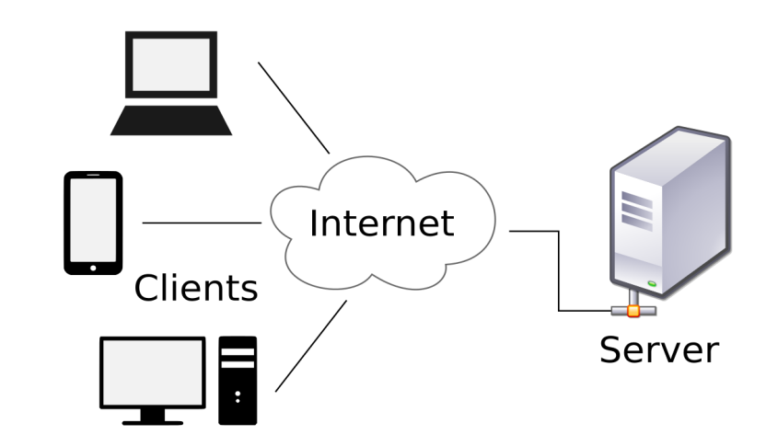

**2.2. Available Technologies:**

So, following the server client architecture we have our project divided into two parts, a front end and a back end. A front end here is represented by a client and the backend is represented by a server. So let’s see what are the available technologies to develop individual frontend and backend piece of software.

**2.2.1 Backend Technologies:**

The backend or the script-side of a dynamic application that works on request-response architecture comprises of API’s, databases, frameworks, service workers and an operating system. These days, developers have access to services such as Docker, Vagrant and BAAS that provide sophisticated systems to automatically deploy the backend scripts to any server or cloud.

**PHP Frameworks**

PHP is perhaps the most popular scripting language for web projects. It has been around for almost three decades now and has several important backend frameworks in its inventory.

**Symfony**

Symfony is a set of PHP components, a web application framework, a philosophy, and a community, all working together in harmony. Symfony provides a standard foundation on which developers could build powerful PHP applications that are strengthen by the standalone Symfony components.

The framework has a very active community of developers and enthusiasts who maintain and contribute to the framework. The bundle architecture of the framework provides plug-n-play capability for all external libraries. The latest version, Symfony 4 removes many dependencies and is the most lightweight version to date.

**Laravel**

Laravel is a relatively new framework that simplifies the production process and takes much of the pain out of web app project. It is well known for clean and elegant PHP code and simplifying tasks such as authentication, routing, containerization and queues. Laravel has its own migration system for manipulating database queries. This framework is best suited for developing small to large applications with complex backend requirements.

**Zend**

Zend is the popular choice for developing large enterprise level applications such as CRM and financial systems. Developers get the benefit of a high performing MVC architecture, robust codebases combined with extensible components. Zend supports full OOP concepts and the developers could create and deploy classes as and when needed. Like Symfony, Zend also has a long list of components for every requirement of the projects.

**CodeIgniter**

CodeIgniter is an application development framework — a toolkit for PHP website development projects. The goal is to make sure that developers do not need to write code from scratch. This is made possible the rich set of libraries for common tasks and a simple interface (with very logical structure) for accessing these libraries. There are no straight rules so the developers are free to experiment with the framework components to discover what works for their projects. Using CodeIgniter, developers can creatively focus on the project and minimize the code writing requirements for a given task.

**Yii2**

Yii is the fast and secure PHP framework, ideal for high performance web 2.0 applications. It comes with rich features including MVC, DAO/Active Record, caching, authentication and role-based access control, scaffolding, testing. Yii ensures clean and reusable code that follows MVC pattern and a clear separation of logic and presentation.

Honorable mentions include CakePHP, Slim, FuelPHP, Phalcon. These frameworks are often used to develop small scale applications’ backend.

**Node.js**

Node.js is a JavaScript runtime built on Chrome’s V8 JavaScript engine. It uses an event-driven, non-blocking I/O model resulting in a lightweight and efficient platform for app backend. The package ecosystem, npm, is the largest available ecosystem of open source libraries. Because of the limitations of PHP (an example is async processes), Node.js is rapidly eating into the PHP’s market share. In addition, the Node community is well known for adding tools, components and libraries that make the platform very competitive for backend development.

**Ruby on Rails**

Railsis a server-side fully MVC framework written in Ruby. It provides a default database structure, web services and web pages. Data transfer is handled by JSON and XML and frontend pages are rendered in HTML, CSS and JavaScript. Ruby on Rails offers seamless database table creation, migrations, and scaffolding of views to enable rapid application development.

**Python**

Python is an interpreted high level language built for general purpose programming. However, the language is better known for data science projects and machine learning applications. The elegant syntax allows developers to express more in fewer lines of codes. According to the Stack Overflow developers survey, Python has now become more popular than PHP with a skyrocketing adoption rate. Software developers are now able to analyze and create the complex data systems and designs using Python. In addition, Python based frameworks such as Django and Flask streamline the process of developing web apps. Deploy Your Backend Scripts When you are finished writing an application’s backend, the next challenge is to find the right hosting solution. I always recommend either dedicated or VPS servers. You can also use container solutions like Docker and create the automated deployment recipes. DigitalOcean, Linode, AWS, Google Cloud and Azure are also great choices. However, if you think server management is too much of a hassle, opt for PAAS solutions like Cloudways PHP web hosting.

**2.2.2 Front End Technologies for Android Platform:**

Cross-platform frameworks provide developers with a complete set of tools designed to increase productivity by resolving common issues. The question is which framework is the best for you. To help you answer this question, we’ve prepared this list of cross-platform frameworks for mobile development. With almost 3 million apps on Google Play, the Android operating system dominates the mobile landscape. Individuals, small businesses, and large enterprises work hard to establish a strong mobile presence and grab their share of the market. However, not everyone has the expertise and resources required to build an app from scratch using native tools.

**Corona SDK**

Corona SDK promises up to 10-times faster game and mobile development. How is that even possible? Because the Corona app backend framework relies entirely on Lua, a lightweight multi-paradigm programming language with a focus on speed, portability, extensibility, and ease-of-use. The official website hosts guides intended to turn complete beginners into seasoned pros. The guides go over everything from the basics of mobile development to more advanced topics. Corona SDK is 100 percent free, works both on Windows and Mac OS X, and supports real-time testing.

**Xamarin**

The framework was founded by the same people who have created Mono, an Ecma standard-compliant, .NET Framework-compatible set of tools. Xamarin offers developers a single C# codebase that can be used to produce native apps for all major mobile operating systems. Unlike many other frameworks, Xamarin has already been used by over 1.4 million developers from around the world. Thanks to Xamarin for Visual Studio, developers can take advantage of the power of Microsoft Visual Studio and all its advanced features, including code completion, IntelliSense, and debugging of apps on a simulator or a device. Xamarin Test Cloud makes it possible to instantly test apps on 2,000 real devices in the cloud. This is by far the best way how to deal with the heavy fragmentation of the Android ecosystem and released bug-free apps that work without any major issues.

**React Native**

React Native is developed by Facebook and used by Instagram, Airbnb, Walmart, Tesla, Baidu, and many other Fortune 500 companies. It is an open-source version of Facebook’s React JavaScript framework. Because React Native uses the same UI building blocks as regular iOS and Android apps, it’s impossible to distinguish a React Native app from an app built using Objective-C or Java. As soon as you update the source code, you can see the changes instantly manifest in an app preview window. Should you ever feel the urge to manually optimize certain parts of your application, React Native lets you combine native code with components written in Objective-C, Java, or Swift.

**2.3 Database :**

**MySQL**

One of the most influential and widely spread open source database applications that manipulates large databases and can be accessed over the Web is MySQL database server. **MySQL** runs as a service providing multiple user access to several databases. MySQL is popular for web applications and operates with the database elements for the platforms (Linux/BSD/Mac/Windows).  MySQL popularity for use with web applications is closely associated to the popularity of PHP programming language which is often used along with MySQL. Many high-traffic web sites use MySQL as the backend for its data warehouse. MySQL is very popular with start up companies, small or medium businesses and projects because it can be easy to use at a low cost. In case when high speed reads are applied for web, gaming and medium or small data storages MySQL surpasses all the other database management systems.

## Microsoft SQL Server

**Microsoft SQL Server** designed to create web, enterprise, and desktop database systems. It is used with various goals and at different levels.  MS SQL Server allows you to store large amount of data which handles components like video, photographs, numbers, text, and much more. Microsoft SQL Server is developed to manage terra bytes of data in comparison with Microsoft Access that can handle only 1 gigabyte of data. 

**Oracle**

**Oracle** is one of the leading commercial SQL relational database management systems. It is available in a variety of configurations from small personal versions to fail-safe, enterprise-class versions.  Oracle offers lots of feature and functionality for solving complicated problems that's why it excels in Fortune 100, medium and large enterprise business applications and warehouses. This powerful system requires lots of deep knowledge and skill to handle large environments.

## PostgreSQL

**PostgreSQL** is a relational DBMS that many web application developers prefer as the back-end data management component. It's principally used by many distinguished organizations applying it for mission critical or wide-ranging applications. The .info and .org domain name registries use it as their primary data store, so do many financial institutions and large companies.  Although PostgreSQL is not the right choice for every project but its advanced feature set and key advantages such as open source community support, very low deployment cost, and easy administration make it the great choice for those who use it for database driven website development.

As we are going to deal with GIS data in our application. The support for the GIS data is very available in PostgreSQL. They have a dedicated plug-in called POSTGIS for the handling of GIS data. So I choose PostgreSQL is the database I need for fulfilling my requirements.

**2.4 Choosing Technologies:**

With considering and deep study about all the available technologies I choose the React native as the frontend to create my app and using Node JS I will create my local server on my machine and I will make use of PostgreSQL database for handling my GIS data

1. **REACT NATIVE**
2. **NODEJS**
3. **EXPRESS FRAMEWORK**
4. **PostgreSQL**

**Chapter 3**

**Development**

**3.1 Installing Software :**

As a part of setting up the environment for the development we need to install various software. The first thing to install is a Text Editor. I use **ATOM** regularly and I am very comfortable with that and you can use anything of your choice such as sublime text or visual code studio. The Text Editor helps you organise things for your and makes thing easy for you. And if you’re interested in ATOM get your latest version form this website <https://atom.io/>

Though we are up for developing our App in React Native we need **Android Studio** for configuring our application and some of the third party applications require the sdk platforms and sdk tools through which you can install and configure your React Native App.

So, we will grab our latest Android Studio from the <https://developer.android.com/studio/> website choose your platform and install the android studio on your development system.

Now we need to install a Database on our local machine. As I have already chose PostgreSQL to be my local Database . I’ll head up to the website <https://www.postgresql.org/> and grab my database for my 64 bit windows system and also install POSTGIS extension after installation of this Local Database.

Then you will need NodeJS to be installed on your system for the Backend part of the project along with npm. You can find the node js at the website <https://nodejs.org/en/> . and also install npm and yarn on your system for installing all the javascript packages we may need in the part of our app development

**3.2 Data and Node Server:**

The data, this is what we need to serve as the part of our idea to provide the GIS services to the requested clients. So I need to have the GIS data to start off my project. My sincere regards to ANDHRA PRADESH SPACE APPLICATION CENTER. They have provided me with required shape files to make my things easy. This shape files consist of all the GIS data related to the Police department of the Krishna District. So my things are easier now I’ll just upload this shape files into my PostgreSQL where I have created a new database on the Pg Admin server. So the part of uploading data into the database is done and now I need to check if the data is reliable and normalised and any changes need to be done for our requirements also we need to show our SQL skills to manipulate our data and create any Functions or views as the part of our queries. Also E-R diagrams are to be drawn in this part of the Application development. Now we need to go into writing our server side code

We will start off this with ATOM editor and installing EXPRESS js framework which and then the logger npm package to create the logs and also a npm package named “Winston”

And all the dependencies required for this project are shown in the screenshot below

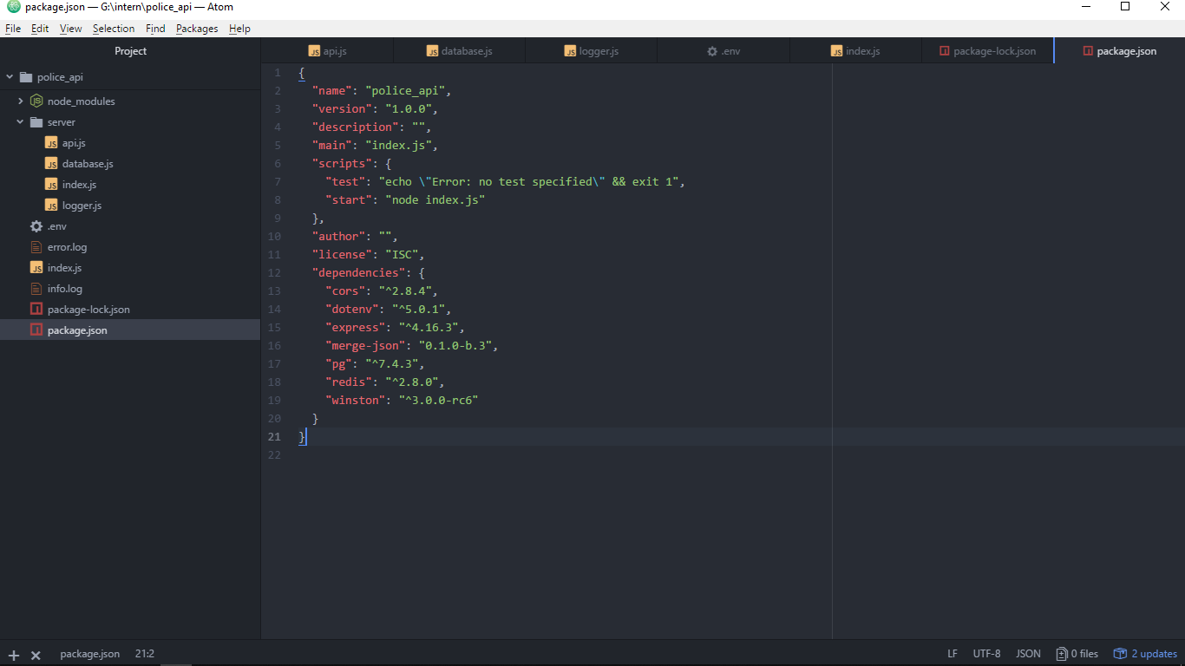

Using these dependencies we create a local server which runs on our local server at your requested port and handles the requests when we request from the local browser and from any browser which requests with the Ip address to which the system is connected to and followed by the port number and the url link. And then we handles the clients requests with the help of express framework which makes our routing very easy and then we connect to the PostgreSQL database installed on our system with the required credentials for the sign and those credentials are stored in the .env of the project and can be accessed later in the program and for this purpose we need a node package named “env” for this purpose and we have installed that also as part of our dependencies and now we are finally done with the routing and now we have to redirect the request form the server program to the database with the client object which can be created by importing the package “pg” which is also a node package.

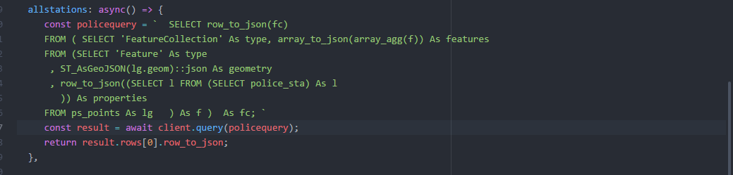

An example query function which we redirect to the database looks like this and then if a connection is setup successfully you get a response generated from the database and sent to our server program which in turn responds to the request of the client and the response generated is in the form of GeoJson a file format supporting the geographical data and basically is a json object and finally we are done with our backend and we have our urls ready for use. Finally we are done developing our REST API

**3.3 React Native and Front End:**

For the front end to start off we need to install npm package called create-react-native-app globally on our local machine which can be done either with node package manager or the yarn. And you can refer a lot about the React Native at the link and is being constantly developed by Facebook INC , <https://facebook.github.io/react-native/> .

This project is by default installed with the Expo support but to develop and add more features we need to eject out of the epxo environment and start building our native code with the help of the different node packages and the git hub libraries and all the dependencies for our project are shown in the screenshot below and also we need the other packges such as react-native-ui-lib for the ui components and the react native maps package to be able to incorporate the google maps in our applcation and also to render the geoJson what we reciever from the REST API what we have developed earlier . Also we need an android device for constant debugging and debugging on react native is so deveoloper friendly and easy.

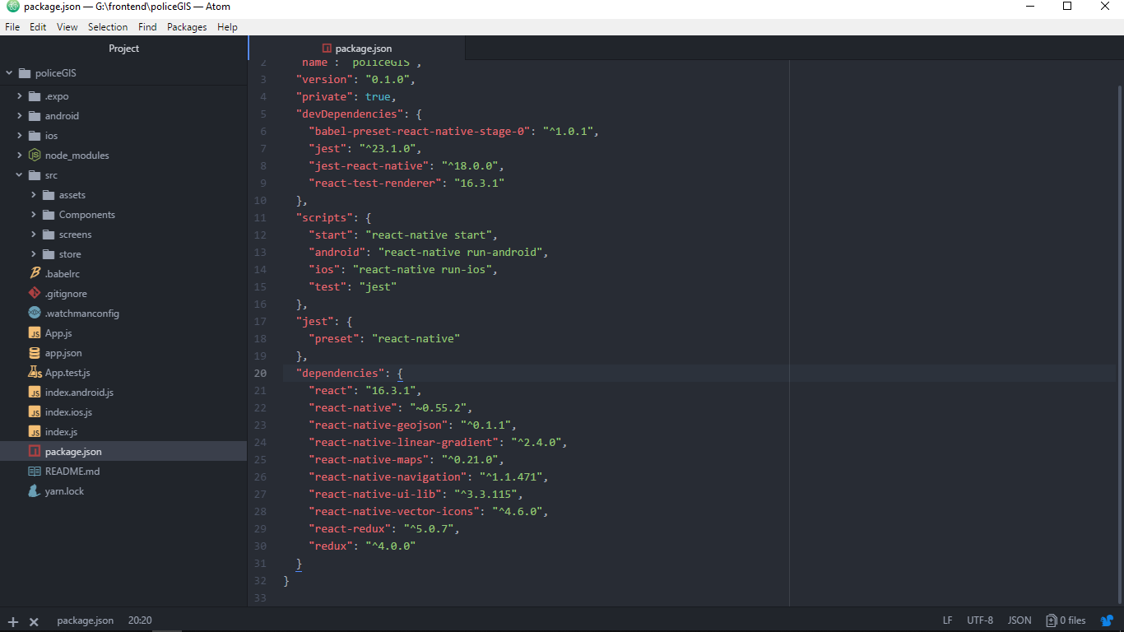

As we make use of the packages such as react-native-GeoJson to be able to render the layers we get from the api request and also the packages such as react native vector icons to embed the icons into our app and the react native navigation package to navigate between the screens and also the react redux and redux for the state management of the application. And the folder structure in the screenshot shows how the project is structured and the clean bode base helps us in developing or making changes in the future. And the command on the languages on JavaScript and the knowledge of react is a must.

**Chapter 4**

**Working**

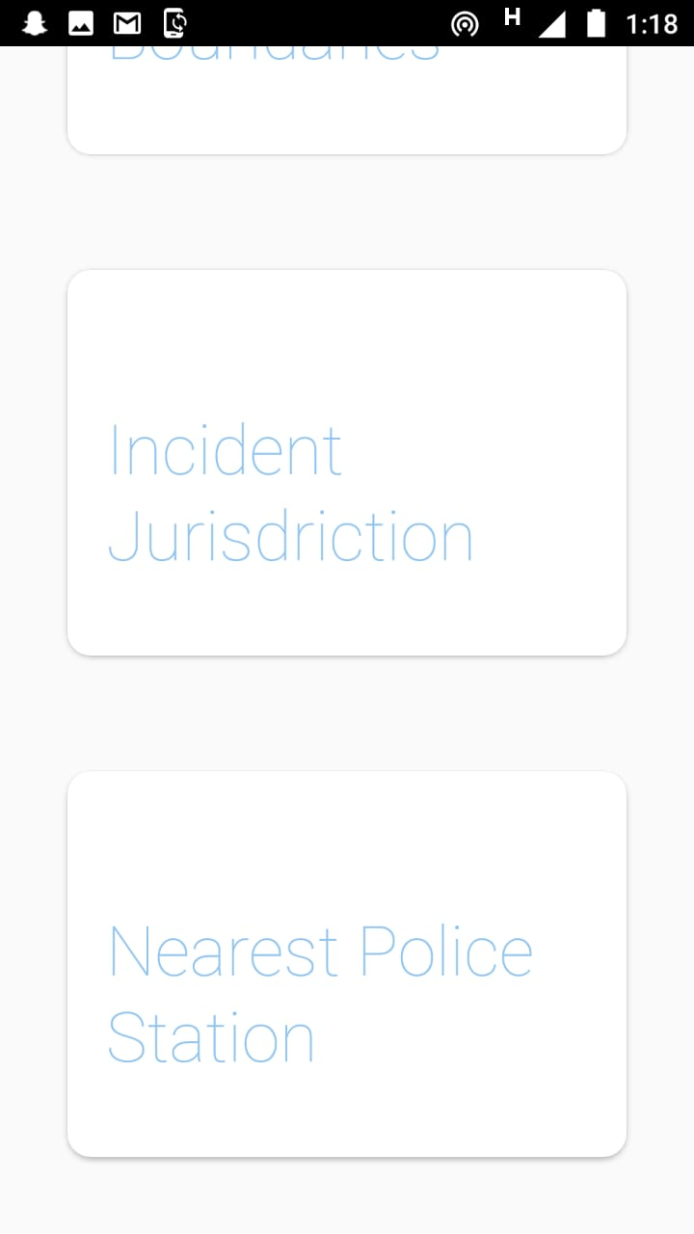 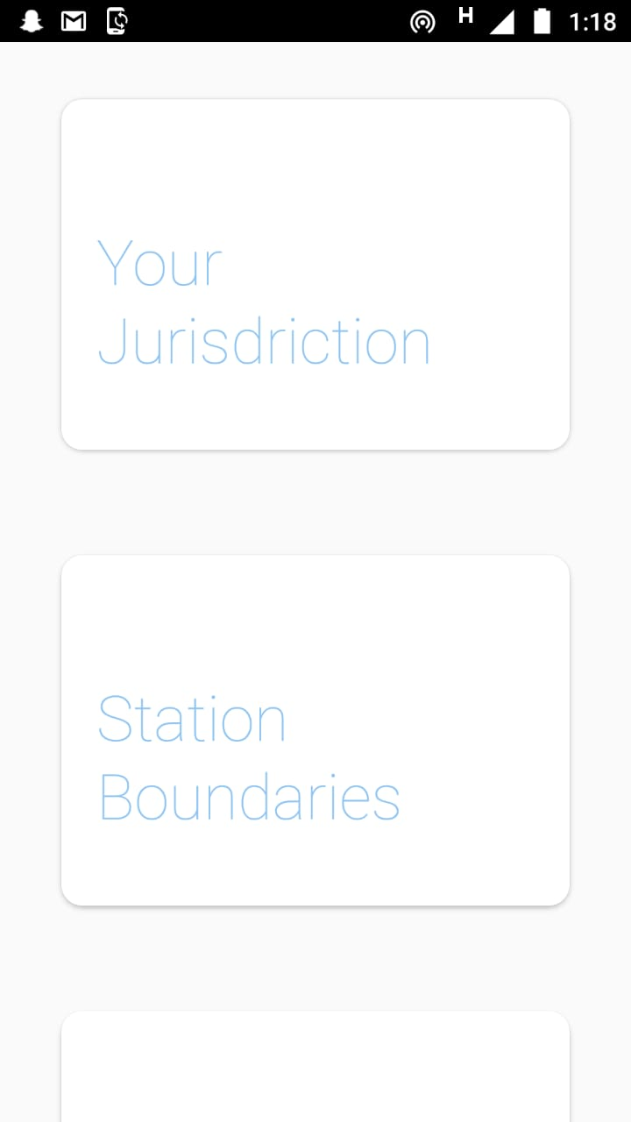

These two screenshots show you the launching screen of the application asking you for the four open among the four displayed. These are basically cards and are very commonly used and on selecting the first option where you can see your current jurisdiction from your current location

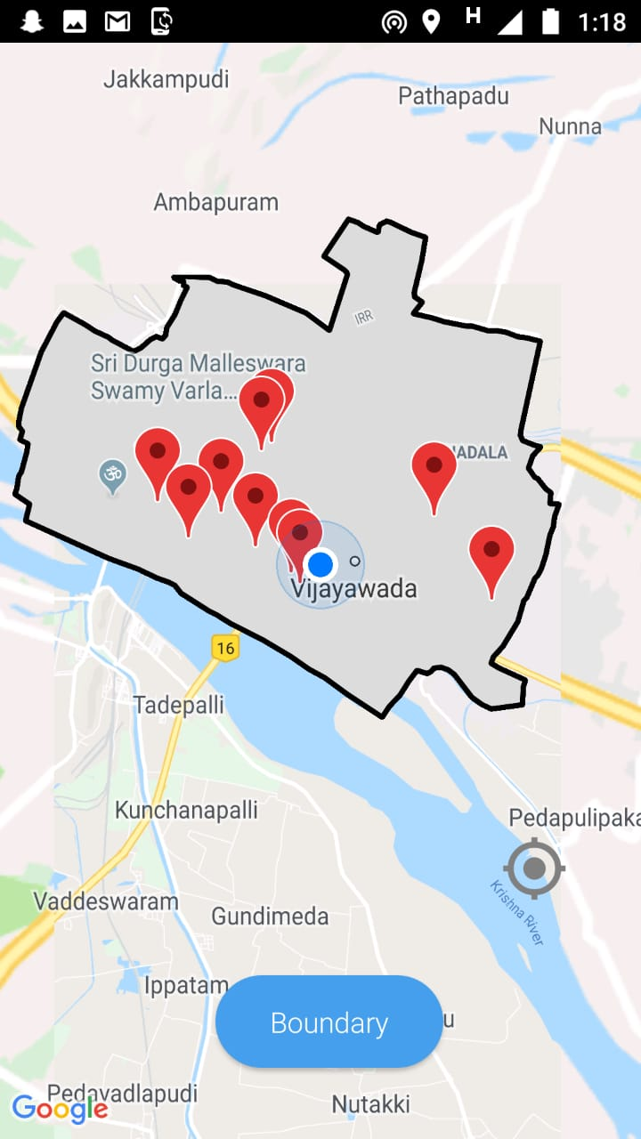 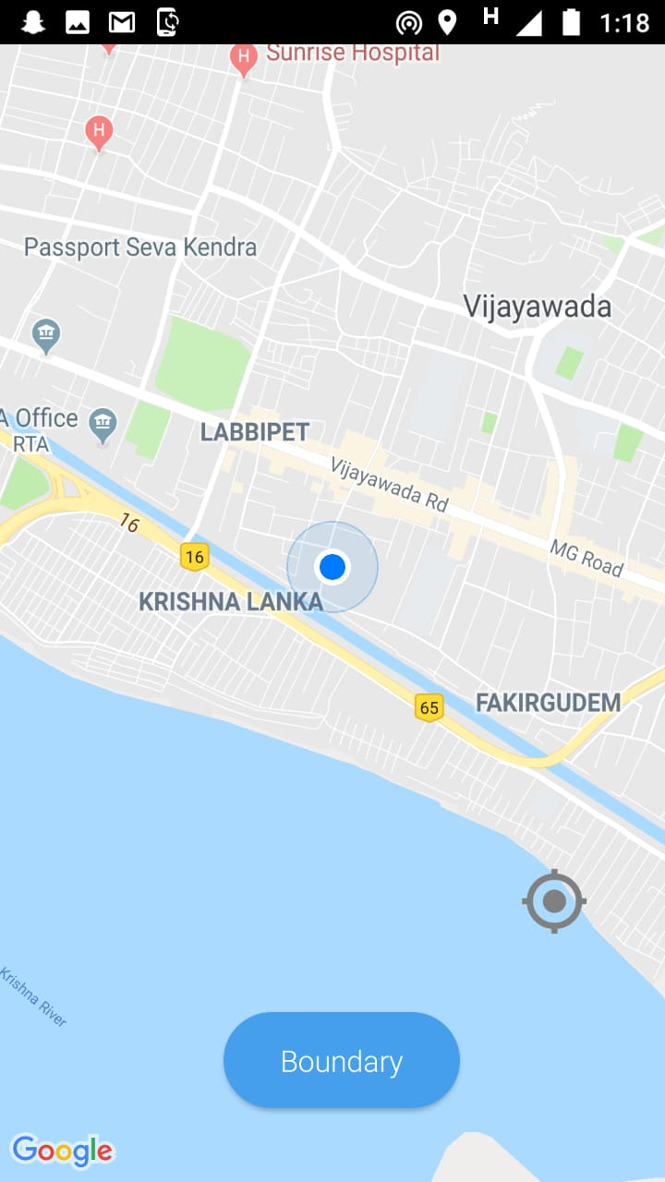

The screen on the right side shows the screen state after enerting into the your jurisdiction option a location marker indicating your current location and the boundary button to request for the jurisdiction you are in and the screen on the left side shows your the jurisdiction and all athe police stations in that jurisdiction.

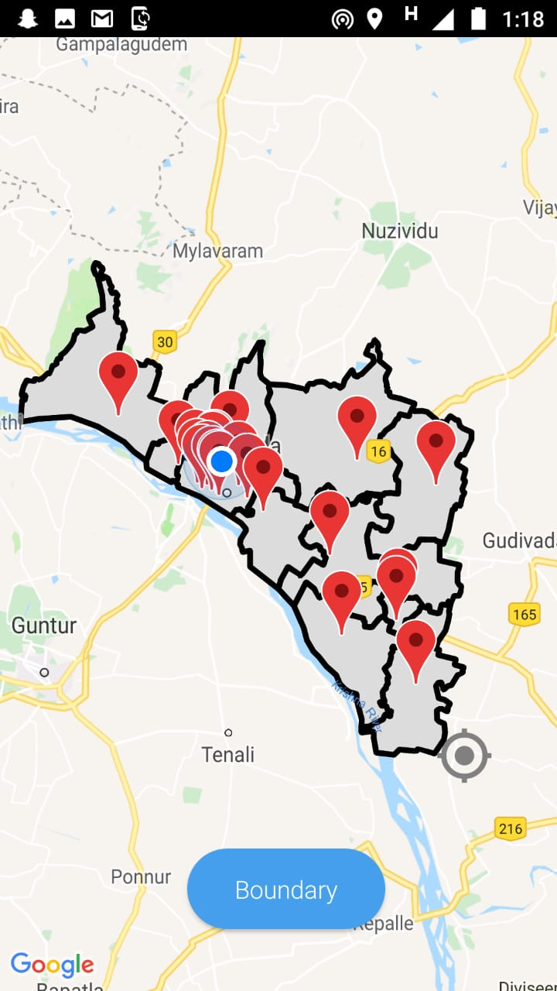 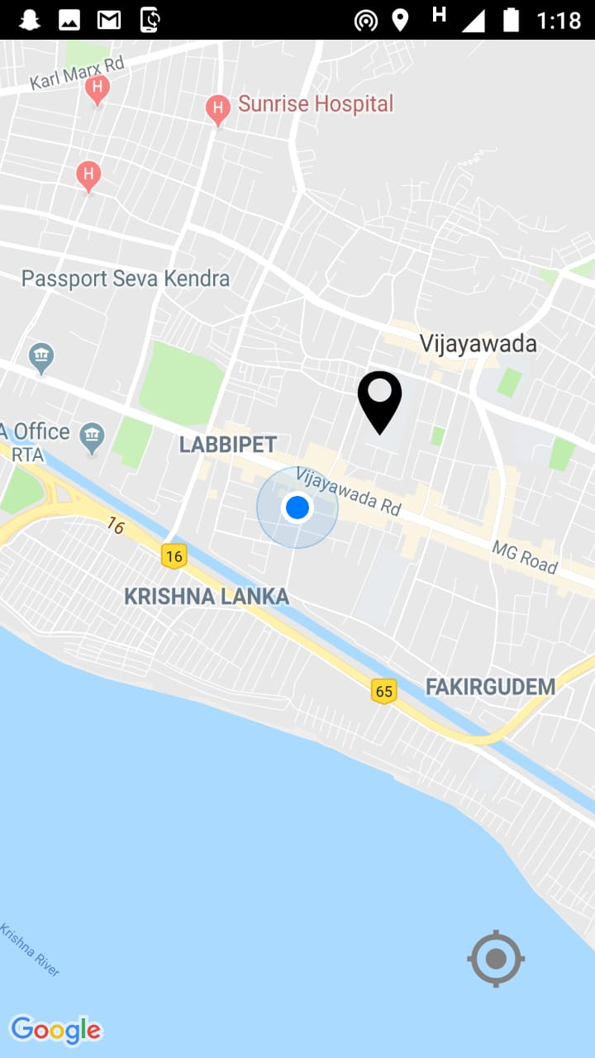

The screen on the left shows the result on the button pressed boundary when entered into the station boundaries option. In this screen you can actually see all the police stations and their boundaries in the district of Krishna and the screenshot on the right shows you the screen of Incident jurisdiction and here you can see the black marker which is draggable and you can drag the pin around the map and its an intelligent marker.

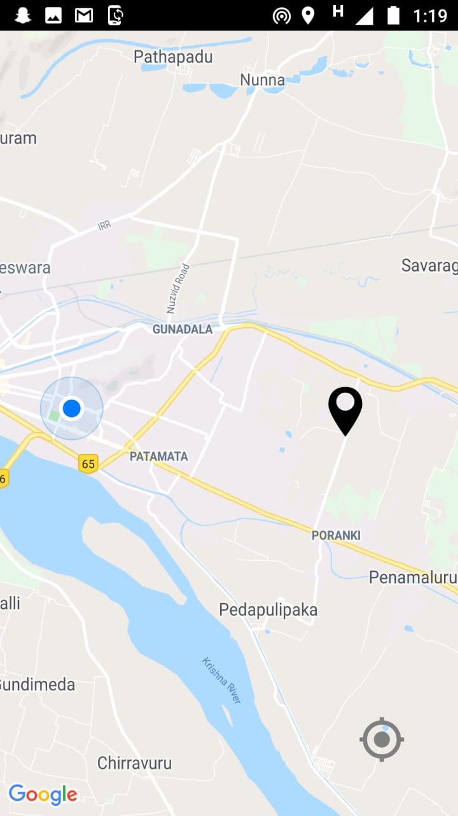 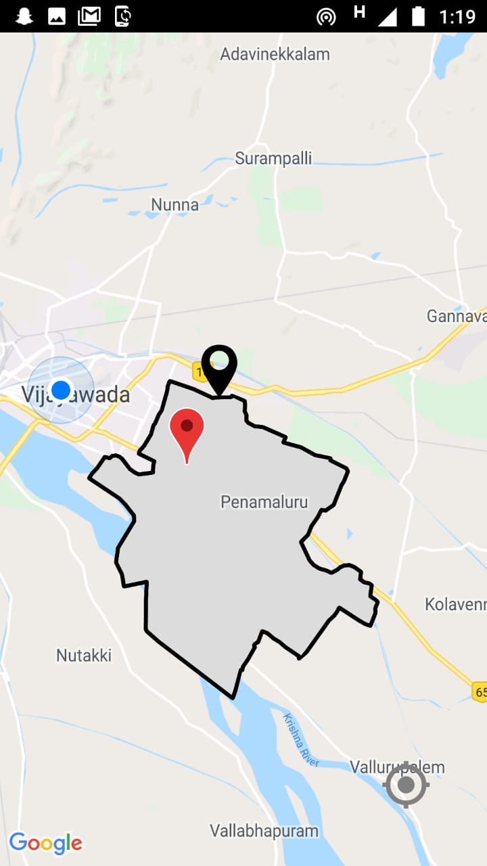

The screen on the right shows the draggable marker’s new position in order to drag the marker you need to long press the marker and then you can drag and the screen on the right is the boundary and police station of the jurisdiction of the incident location i.e the location of the black draggable marker.

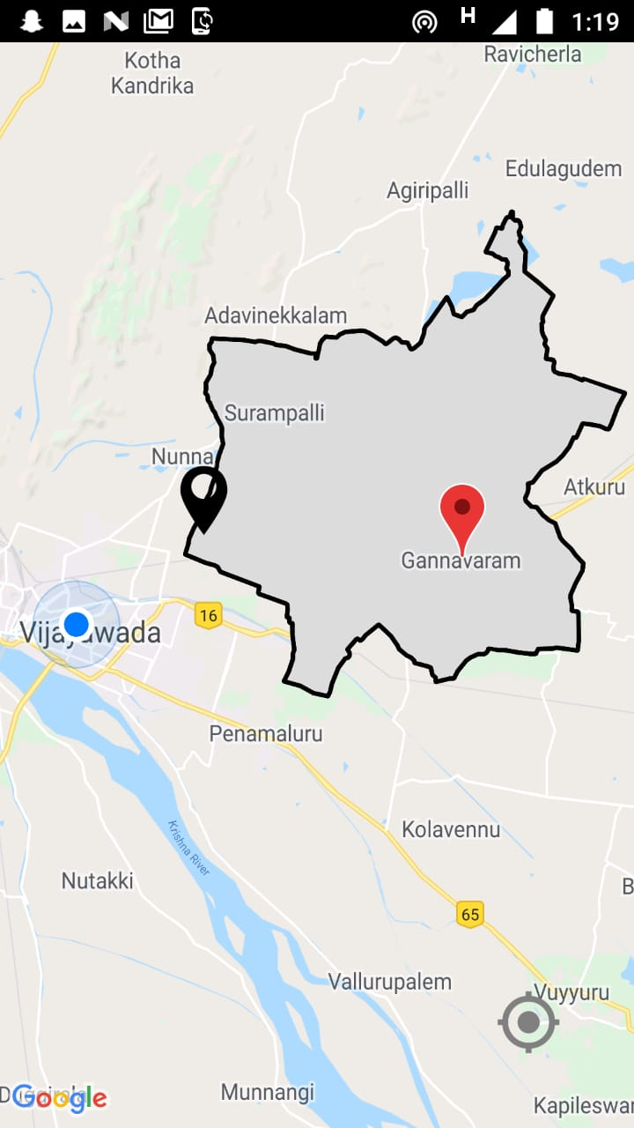 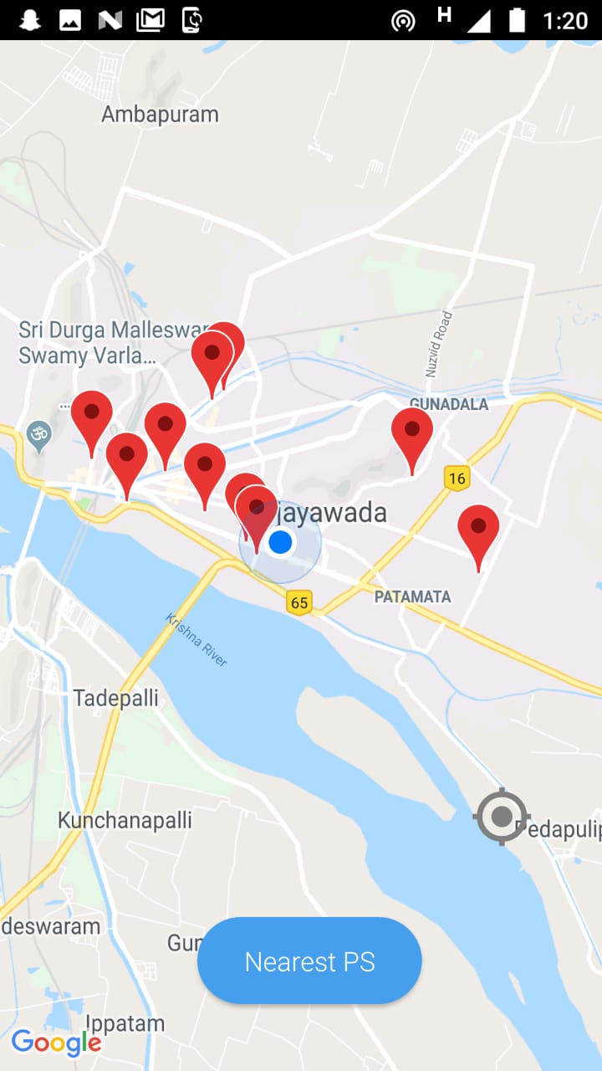

The screen on the left is the new incident area selected by the user and display of new boundary and the new police station re rendering the whole map where the React Native is very good for. The screen on the right is the nearest police stations options in the main screen where the police stations nearby you can serve you. These are all the police stations you can contact for any issues in the Vijayawada municipality.

**Chapter 5**

**Conclusion**

A simple android application which follows the basic of android app development and using basic client server architecture and the java script skills can be help us in developing an android application development. Also this is a bare basic form of the work I have displayed in this documentation for clear code and total source you can refer to the git hub link I will provide at the end of the conclusion. Also there are many suggestions and more features recommended for this project features such as routes to the police stations and the extension of this idea and prototype to the whole state and also the facilitating the other information about the police department is to be added in this project .

**References:**

1. [*https://facebook.github.io/react-native/*](https://facebook.github.io/react-native/)
2. [*https://nodejs.org/en/*](https://nodejs.org/en/)
3. [*https://www.postgresql.org/*](https://www.postgresql.org/)
4. [*https://www.npmjs.com/package/express*](https://www.npmjs.com/package/express)
5. [*https://github.com/react-community/react-native-maps*](https://github.com/react-community/react-native-maps)
6. [*https://www.npmjs.com/package/react-native-ui-lib*](https://www.npmjs.com/package/react-native-ui-lib)
7. [*https://github.com/harikrishnagadi/PoliceGIS*](https://github.com/harikrishnagadi/PoliceGIS)
8. [*https://github.com/harikrishnagadi/policeapi*](https://github.com/harikrishnagadi/policeapi)
9. [*https://atom.io/*](https://atom.io/)
10. [*https://www.npmjs.com/*](https://www.npmjs.com/)
11. [*https://facebook.github.io/react-native/docs/getting-started.html*](https://facebook.github.io/react-native/docs/getting-started.html)