CAMPUSFIX
Smart Campus Maintenance Complaint Management System
ACADEMIC PROJECT REPORT
Submitted by: ARUN YOGESH D
Register Number: 922525205013
Department: INFORMATION TECHNOLOGY
Institution: V.S.B ENGINEERING COLLEGE KARUR
Academic Year: 2 ND YEAR
Project Repository: https://github.com/Arun-Yogesh/CAMPUSFIXPROJECT

1. Project Overview / Abstract
CampusFix is a full-stack web application designed to digitize campus maintenance complaint management. Students can submit and track maintenance complaints, while administrators can review complaints, assign maintenance staff, manage staff records, update complaint status, and view analytics. Maintenance staff can access assigned complaints and update their progress. The system implements CRUD operations through a React frontend, Django REST Framework backend, and SQLite database.
The application also includes role-based access, input validation, search and filtering, emergency-priority heuristics, duplicate complaint detection, a visual complaint timeline, and automated testing.

2. Problem Statement
Campus maintenance issues are often reported through informal channels such as verbal communication, paper registers, or messaging applications. These methods make it difficult to track complaints, identify urgent issues, assign responsibility, avoid duplicate reports, and verify resolution.
- Lack of centralized complaint tracking.
- Delayed response to urgent maintenance and safety problems.
- Duplicate complaints for the same location or issue.
- Limited accountability and difficulty tracking assigned technicians.
- Poor visibility into complaint progress and resolution.

3. Objectives
- Provide a centralized digital platform for campus maintenance complaints.
- Implement role-based workflows for Students, Administrators, and Maintenance Staff.
- Implement Create, Read, Update, and Delete operations with database persistence.
- Provide validation and meaningful error messages on the client and server.
- Provide search, filtering, analytics, and complaint progress tracking.
- Detect potential emergency hazards and possible duplicate complaints.
- Provide a maintainable separation between frontend, backend, REST API, and database layers.

4. Scope
The system is intended for educational institutions, campus facilities, and student hostels.
Area | Coverage
Users | Students, Administrators, Maintenance Staff
Complaint categories | Electrical, Furniture, Classroom, Wi-Fi/Network, Plumbing, Cleaning, Projector, Fan/AC, Other
Complaint workflow | Submitted → Under Review → Assigned → In Progress → Resolved / Rejected
Management | Complaint CRUD, staff CRUD, assignment, status updates
Supporting features | Search, filters, analytics, validation, duplicate detection, priority detection

5. Existing System
The existing/manual approach may rely on paper complaint registers, verbal reports, or informal messages. Such methods do not provide reliable centralized records or systematic status tracking.

6. Proposed System
CampusFix replaces fragmented reporting with a centralized web application. The React interface communicates with Django REST APIs, which apply validation, authorization, business rules, and ORM-based persistence in SQLite.

7. Technology Stack
Layer | Technology | Purpose
Frontend | React, JavaScript, CSS | Responsive single-page user interface
Build Tool | Vite | Frontend development and production build
Backend | Python, Django, Django REST Framework | Business logic and REST APIs
Database | SQLite | Relational persistent storage
Authentication | Django authentication + DRF Token Authentication | User authentication and API protection
API Testing | Postman | Manual REST API verification
Automated Testing | Django tests + Python API test runner | Automated verification
Version Control | Git / GitHub | Source-code management

8. System Architecture
The implemented architecture is:
User
↓
React Frontend
↓
HTTP / JSON REST API
↓
Django REST Framework
↓
Django ORM
↓
SQLite Database
The backend is divided into users, staff, and complaints Django applications. The frontend contains pages, reusable components, API clients, and authentication context.

9. Functional Modules
Module | Functionality
Authentication | Registration, login, logout, current-user profile, and role handling.
Student Complaint Management | Create, view, search/filter, edit permitted complaints, and delete/cancel permitted complaints.
Administration | Campus-wide complaint queue, filtering, staff assignment, status management, and analytics.
Maintenance Staff Management | Add, view, update, and delete maintenance staff records.
Technician Workbench | View assigned complaints and update complaint status.
Smart Assistance | Hazard keyword priority suggestion and potential duplicate complaint detection.

10. Database Design
The project uses SQLite with Django ORM models. The main application entities are User, MaintenanceStaff, and Complaint.

10.1 User Entity
Field | Type / Constraint | Purpose
id | BigAutoField, PK | Unique identifier
username | Django authentication field | Login identity
email | EmailField, unique | User email
name | CharField | Display name
role | Choice: STUDENT / ADMIN / STAFF | Authorization role
department | CharField, optional | Department
phone | CharField, optional | Contact number
created_at | DateTimeField | Account creation time

10.2 MaintenanceStaff Entity
Field | Type / Constraint | Purpose
id | BigAutoField, PK | Unique staff identifier
name | CharField | Technician name
email | EmailField, unique | Staff email
phone | CharField | Contact number
department | CharField | Maintenance department
specialization | CharField | Technical specialty
availability | Available / Busy / On Leave | Current availability
created_at | DateTimeField | Record creation time

10.3 Complaint Entity
Field | Type / Constraint | Purpose
id | BigAutoField, PK | Complaint ticket ID
complaint_title | CharField(200) | Complaint title
description | TextField | Detailed issue description
category | Choice field | Issue category
location | CharField(255) | Campus location
priority | Low / Medium / High / Critical | Urgency
status | 6-state choice field | Complaint lifecycle
student | FK → User, CASCADE | Submitting student
assigned_staff | FK → MaintenanceStaff, SET_NULL | Assigned technician
image | ImageField, optional | Complaint photo
resolution_notes | TextField, optional | Resolution information
created_at / updated_at | DateTimeField | Record timestamps
resolved_at | DateTimeField, nullable | Resolution timestamp

11. ER Diagram
The implemented relationships are one-to-many. One User can submit multiple Complaints. One MaintenanceStaff record can be assigned to multiple Complaints. Deleting a User cascades to their complaints, while deleting MaintenanceStaff sets assigned_staff to NULL so complaint history is retained.
USER (1) ───────────< COMPLAINT >─────────── (1) MAINTENANCE STAFF
N N
For the final printed report, insert a graphical ER diagram generated from these relationships.

12. Frontend Design
- React single-page application using reusable pages and components.
- Responsive CSS layout supporting desktop and mobile views.
- Dedicated dashboards for Student, Admin, and Staff roles.
- Modal-based complaint creation, editing, details, deletion confirmation, and staff management.
- Status and priority badges, visual complaint timeline, search, filtering, analytics, and toast messages.
- Client-side validation and API error display.

13. Backend Design
- Django project with separate users, staff, and complaints applications.
- Django REST Framework ModelViewSet/APIView-based endpoints.
- Django ORM used for database operations.
- Serializer-level validation for complaint title, description, location, email, password confirmation, phone, and role-based update restrictions.
- Role-based permissions for administrative operations and staff workflows.
- Automatic resolution timestamp and automatic assignment status behavior in the Complaint model.

14. REST API Documentation
Method | Endpoint | Purpose | Access
POST | /api/auth/register/ | Register user | Public
POST | /api/auth/login/ | Authenticate user and obtain token | Public
GET | /api/auth/me/ | Get current user profile | Authenticated
GET | /api/complaints/ | List complaints with filters/search | Authenticated
POST | /api/complaints/ | Create complaint | Authenticated
GET | /api/complaints/{id}/ | Get complaint details | Authenticated / role restricted
PATCH | /api/complaints/{id}/ | Update complaint | Owner/admin rules
DELETE | /api/complaints/{id}/ | Delete complaint | Owner/admin rules
PATCH | /api/complaints/{id}/assign_staff/ | Assign technician | Admin
PATCH | /api/complaints/{id}/update_status/ | Update workflow status | Admin/Staff
GET | /api/complaints/analytics/ | Dashboard statistics | Authenticated
GET | /api/complaints/check_duplicate/ | Potential duplicate check | Authenticated
POST | /api/complaints/detect_priority/ | Priority suggestion | Authenticated
GET | /api/staff/ | List staff | Authenticated
POST | /api/staff/ | Create staff | Admin
PATCH | /api/staff/{id}/ | Update staff | Admin
DELETE | /api/staff/{id}/ | Delete staff | Admin

15. CRUD Implementation
Operation | Implementation | Expected Result
Create | POST complaint/staff endpoints and frontend forms | New record is persisted and displayed
Read | GET collection/detail endpoints | Records and details are displayed
Update | PATCH endpoints and edit/status controls | Existing record is changed and persisted
Delete | DELETE endpoints with confirmation UI | Record is removed from database and UI

16. Validation and Error Handling
- Complaint title must contain at least 4 characters.
- Complaint description must contain at least 10 characters.
- Location must contain at least 3 characters.
- Email addresses are validated and duplicate user emails are rejected.
- Passwords must satisfy the configured minimum length and password confirmation must match.
- Staff phone numbers are validated for numeric content and minimum length.
- Students cannot modify complaints after the complaint becomes In Progress or Resolved.
- Students cannot directly change status or assign maintenance staff.
- Invalid record IDs and invalid status values return appropriate API errors.

17. Authentication, Authorization and Security
The application uses Django authentication and Django REST Framework TokenAuthentication/SessionAuthentication. API permissions require authentication by default, while selected registration/login endpoints are public. Role checks restrict administrative operations such as staff management and complaint assignment.
Important submission note: the current development configuration has DEBUG enabled, allows all hosts, and includes a fallback SECRET_KEY value. Before production deployment, these settings should be moved to environment variables and restricted appropriately. CORS should also be limited to the actual frontend origin. Do not publish real credentials, tokens, or secret keys in GitHub.

18. Testing Methodology
- Django automated test suite: project documentation records 10 unit tests.
- Standalone REST API integration test runner: project documentation records 13 end-to-end API tests.
- Postman collection for manual API verification.
- Manual browser testing for CRUD workflows, role-based screens, validation, search/filter behavior, and responsiveness.

19. Test Results
The supplied project documentation records a 100% pass rate for the automated tests: 10/10 Django tests and 13/13 end-to-end API tests. The supplied TEST_CASES.md also records successful authentication, CRUD, smart-feature, analytics, staff-management, and mobile-responsiveness cases.
Category | Coverage | Recorded Result
Authentication | Valid login, invalid login, registration, duplicate email | PASS
Create | Valid and invalid complaint creation | PASS
Read | Complaint list and detail | PASS
Update | Complaint edit, staff assignment, status update | PASS
Delete | Valid and invalid complaint deletion | PASS
Smart features | Priority detection and duplicate warning | PASS
Analytics | Analytics endpoint | PASS
Staff CRUD | Create, update, delete staff | PASS
Responsiveness | 375px mobile viewport | PASS

20. Results and Discussion
The completed application demonstrates end-to-end communication between the React frontend, REST API, Django backend, and SQLite database. The project implements the required CRUD lifecycle and extends it with role-based workflows, search/filtering, analytics, and smart assistance.

21. Challenges and Solutions
Challenge | Solution
Console encoding during automated testing | Adjusted output handling and used ASCII-safe test result markers.
Restricting student edits after work begins | Implemented is_editable_by_student and serializer validation.
Complaint lifecycle automation | Implemented model save logic for assignment and resolved_at timestamp handling.
Duplicate and emergency issue detection | Implemented dedicated utility/API logic and frontend feedback.

22. Future Enhancements
- Email, SMS, or push notifications for complaint status changes.
- AI-assisted analysis of uploaded maintenance photographs.
- Campus map/GIS integration for complaint locations.
- Production deployment with PostgreSQL and secure environment-based configuration.
- More advanced dashboards for response time and recurring fault analysis.

23. Installation and Execution
Prerequisites: Python, Node.js/npm, and Git.
Backend:
cd backend
python -m venv venv
venv\Scripts\activate (Windows)
pip install -r requirements.txt
python manage.py migrate
python manage.py runserver 8000
Frontend:
cd frontend
npm install
npm run dev
Open the frontend URL shown by Vite (normally http://localhost:5173) and ensure the backend is running on port 8000.

24. Version Control and Repository
The supplied project contains a Git repository and a root .gitignore covering Python cache files, virtual environments, Node dependencies, build output, SQLite database files, media, editor files, and environment files. Meaningful commits should describe individual development changes, for example: "Implemented complaint CRUD", "Added staff assignment workflow", or "Added API validation tests".
GitHub Repository URL: https://github.com/Arun-Yogesh/CAMPUSFIXPROJECT

Website link:
https://campusfixproject-dun.vercel.app/

25. Screenshots and Demonstration Evidence
1. Login / authentication page
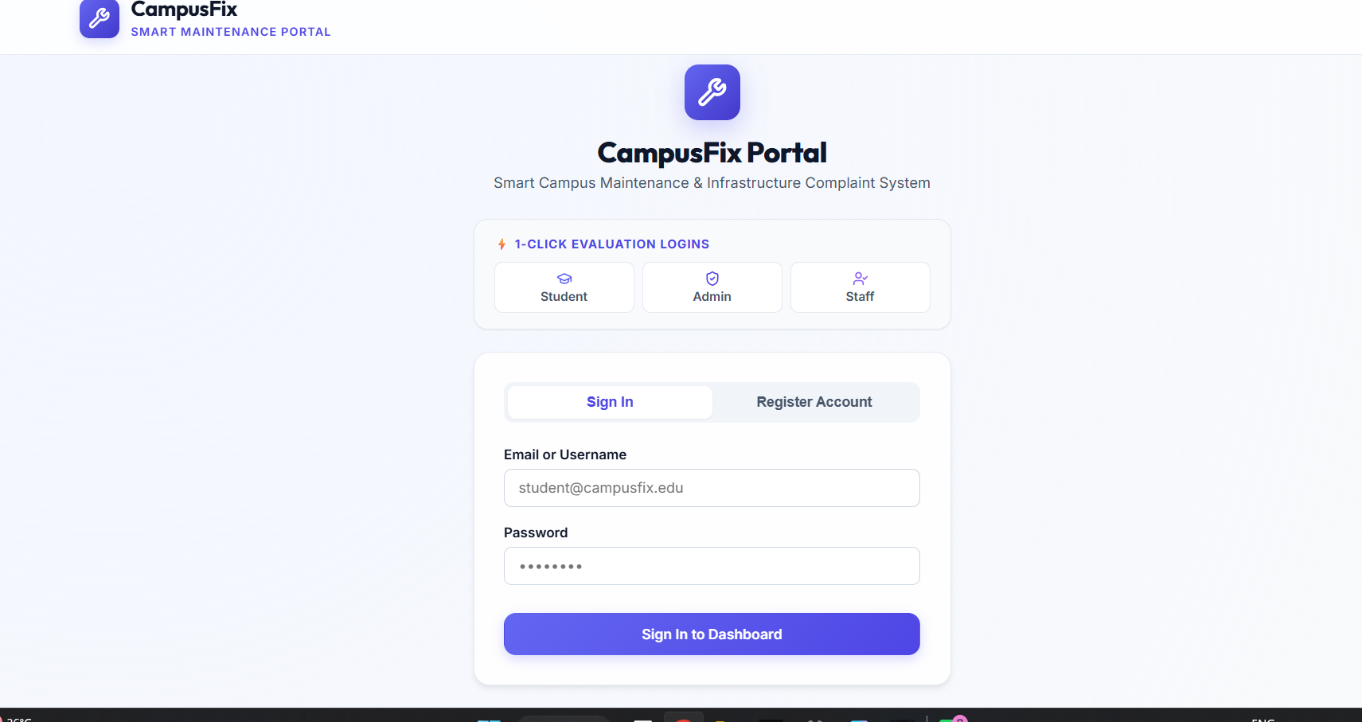
2. Student dashboard
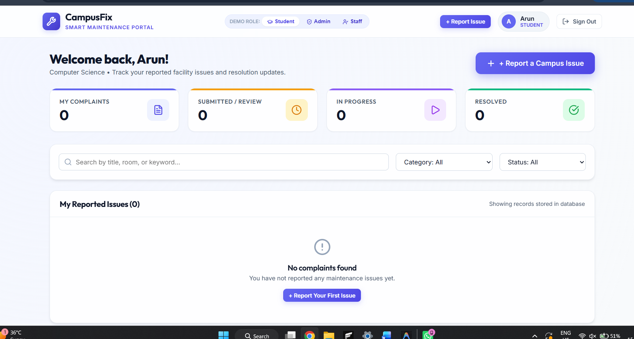
3. Create complaint form
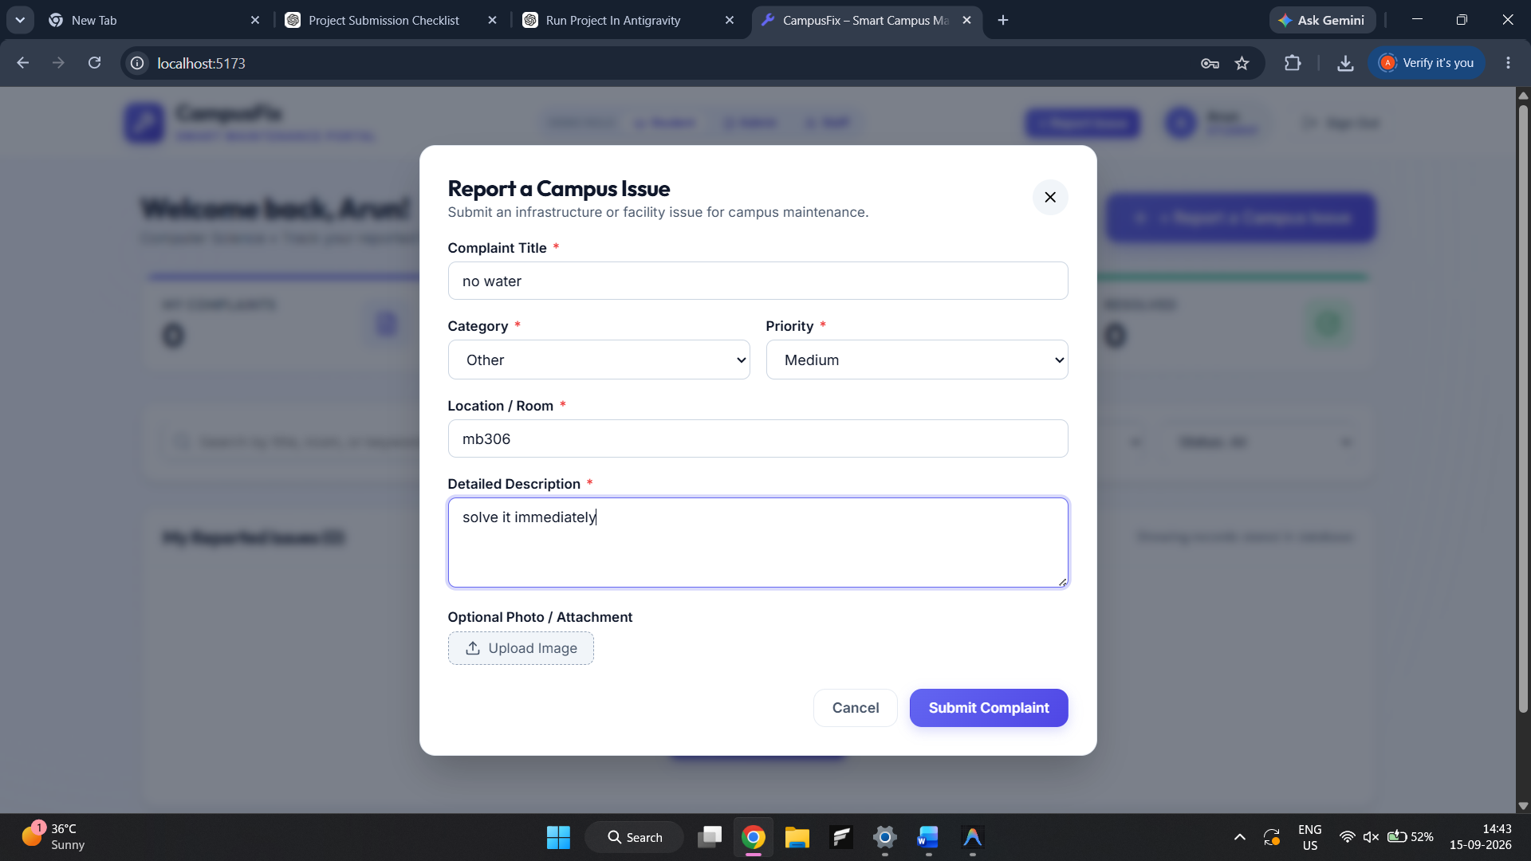
4. Validation/error message
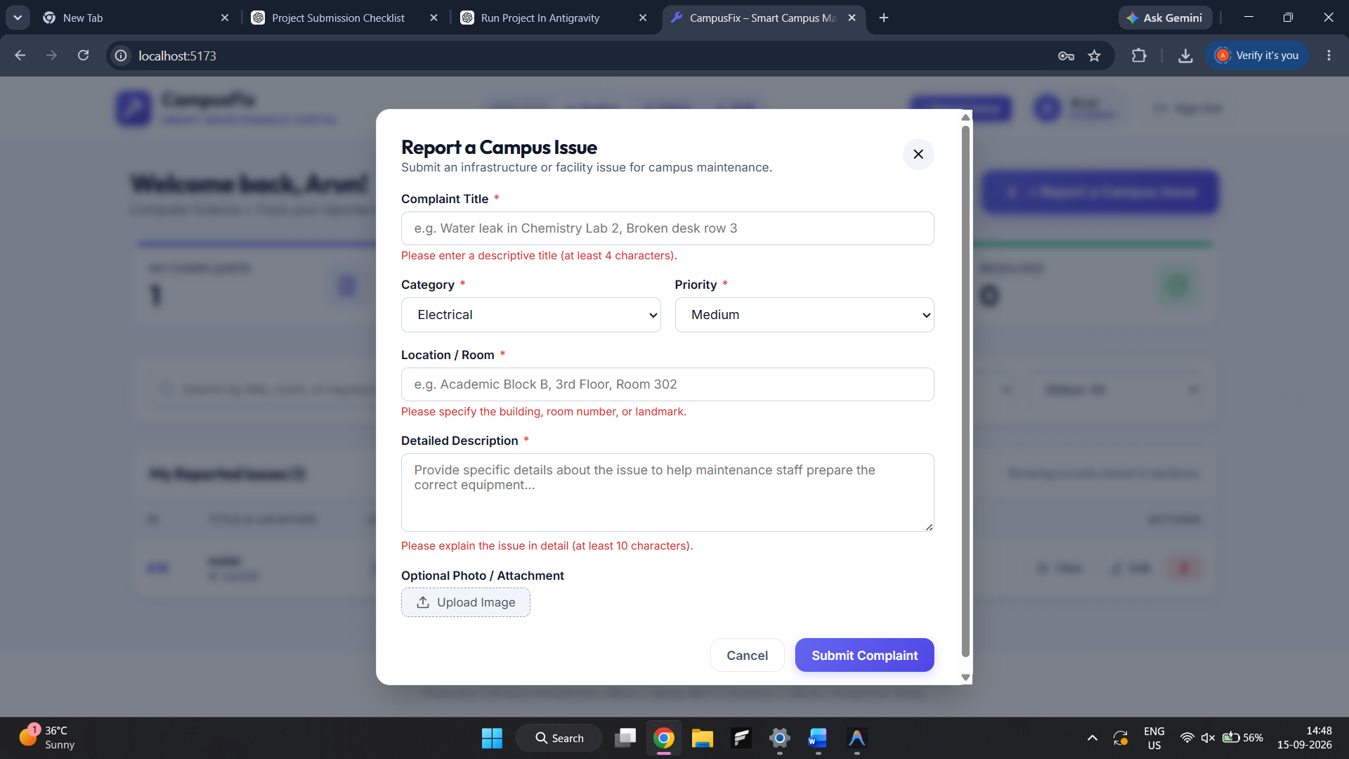
5. Complaint list with search/filter
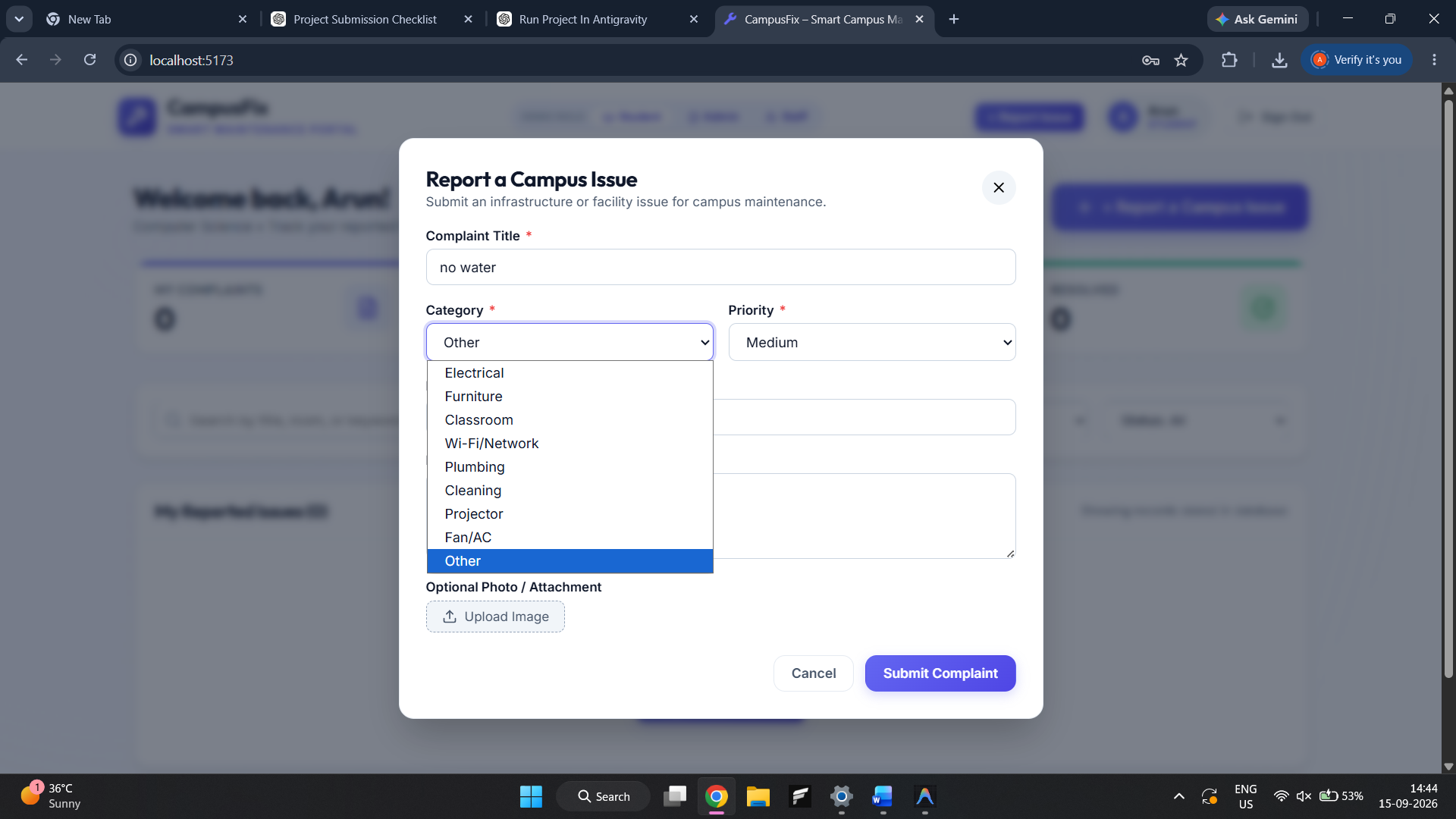
6. Complaint detail and visual timeline
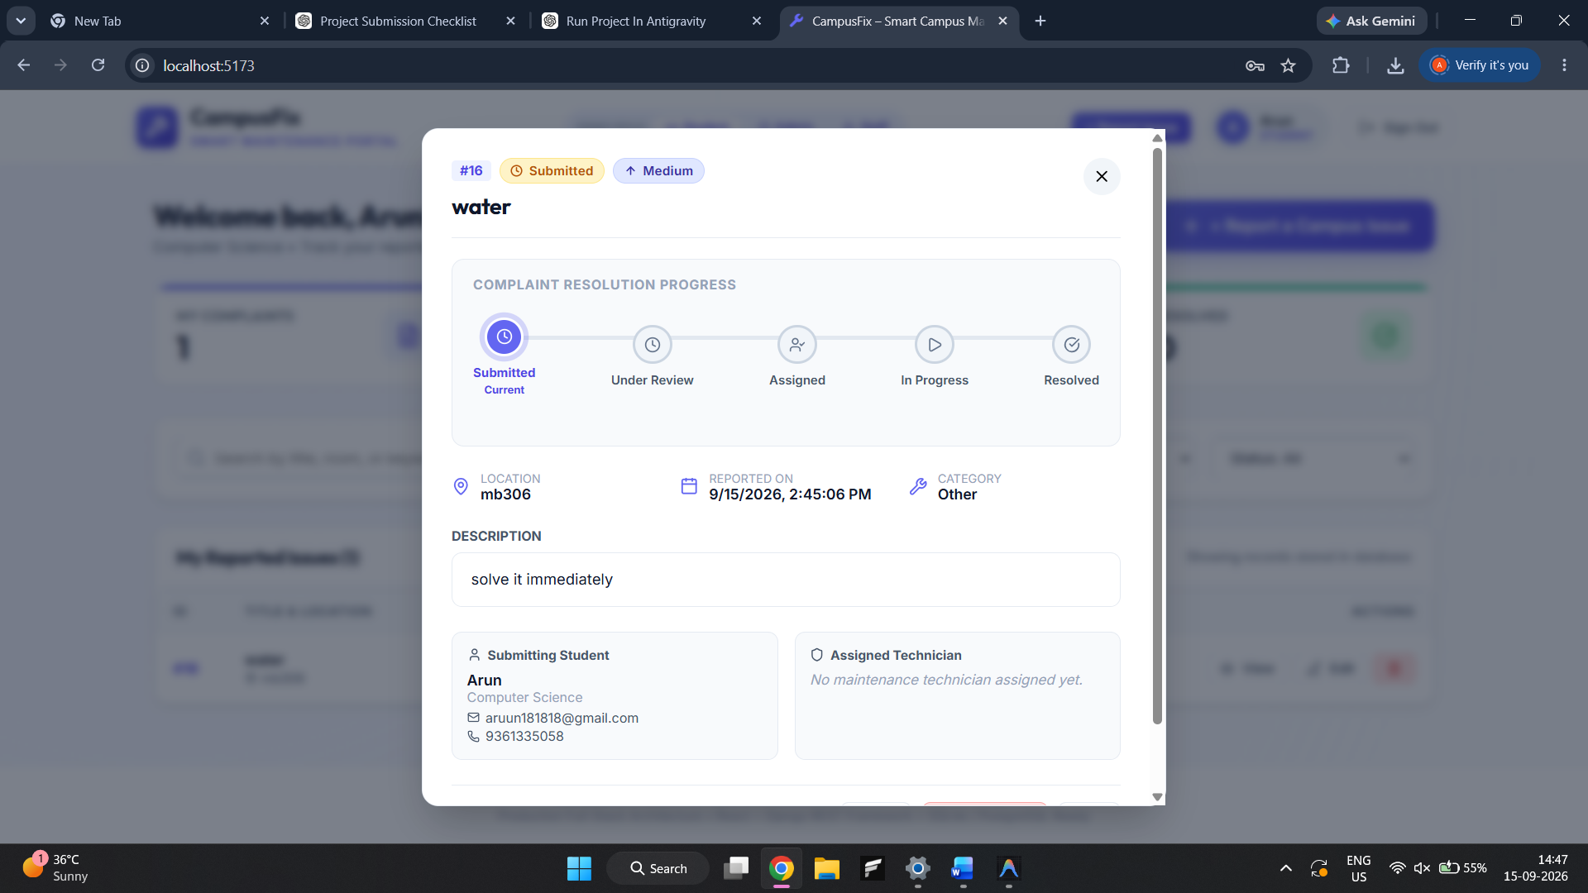
7. Edit complaint result
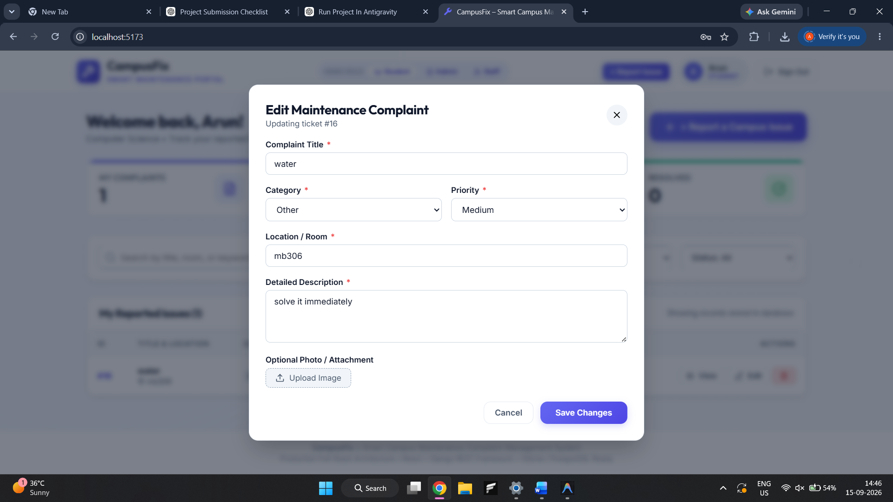
8. Admin dashboard and analytics
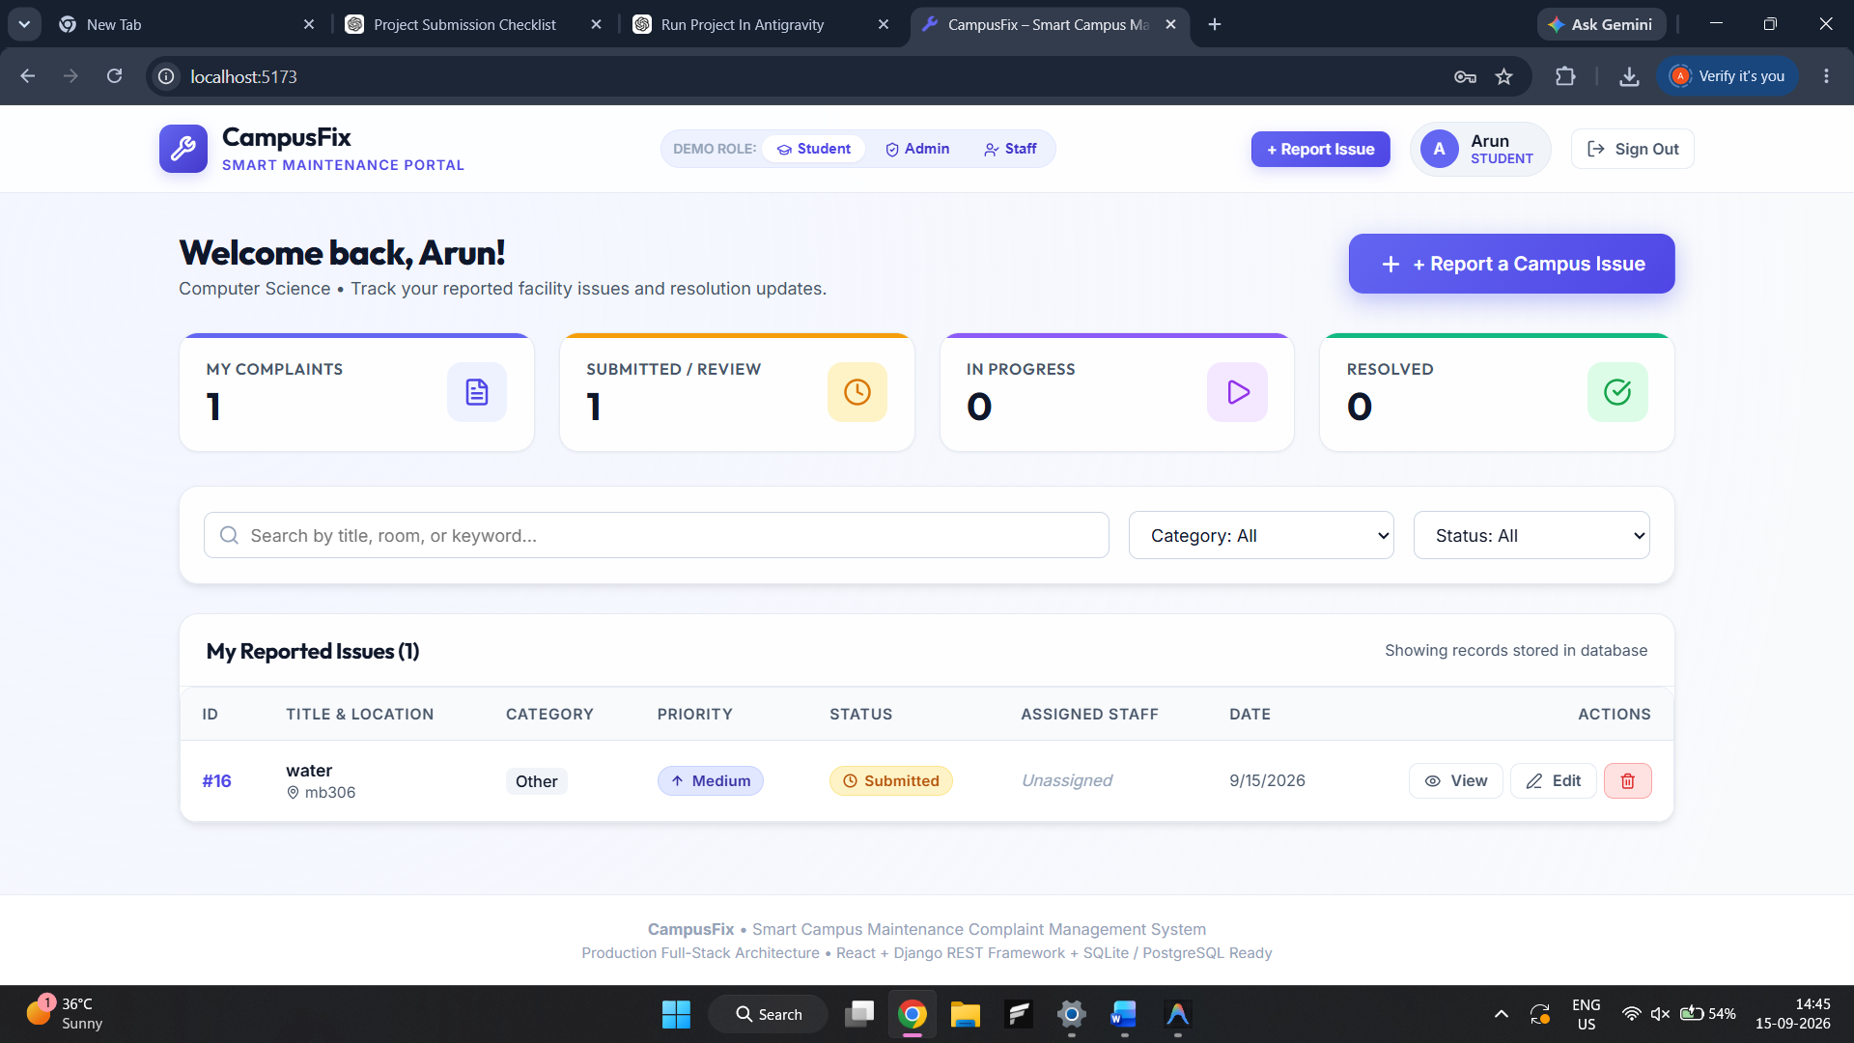
9. Staff assignment
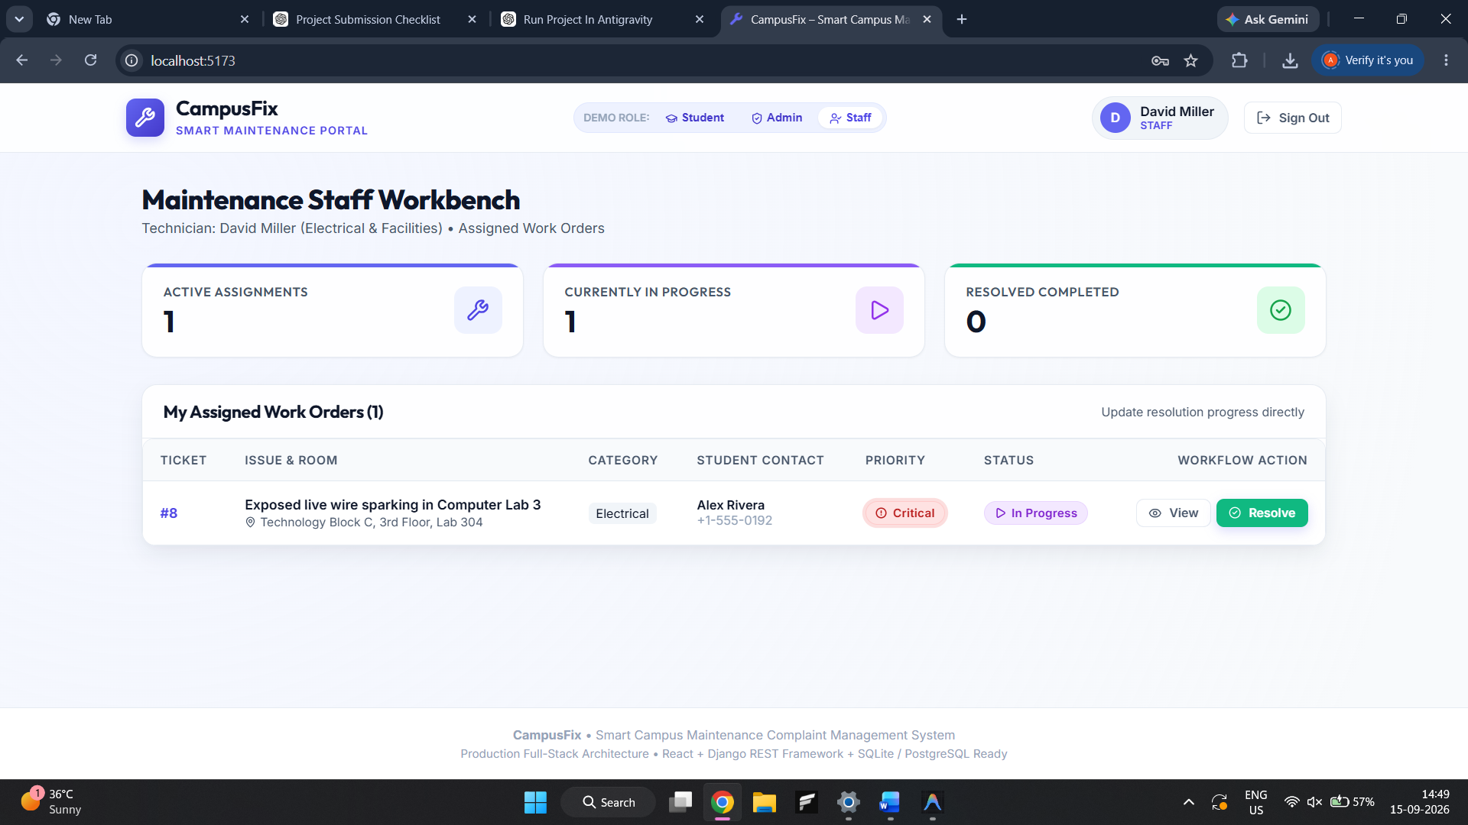
10. Staff Directory CRUD
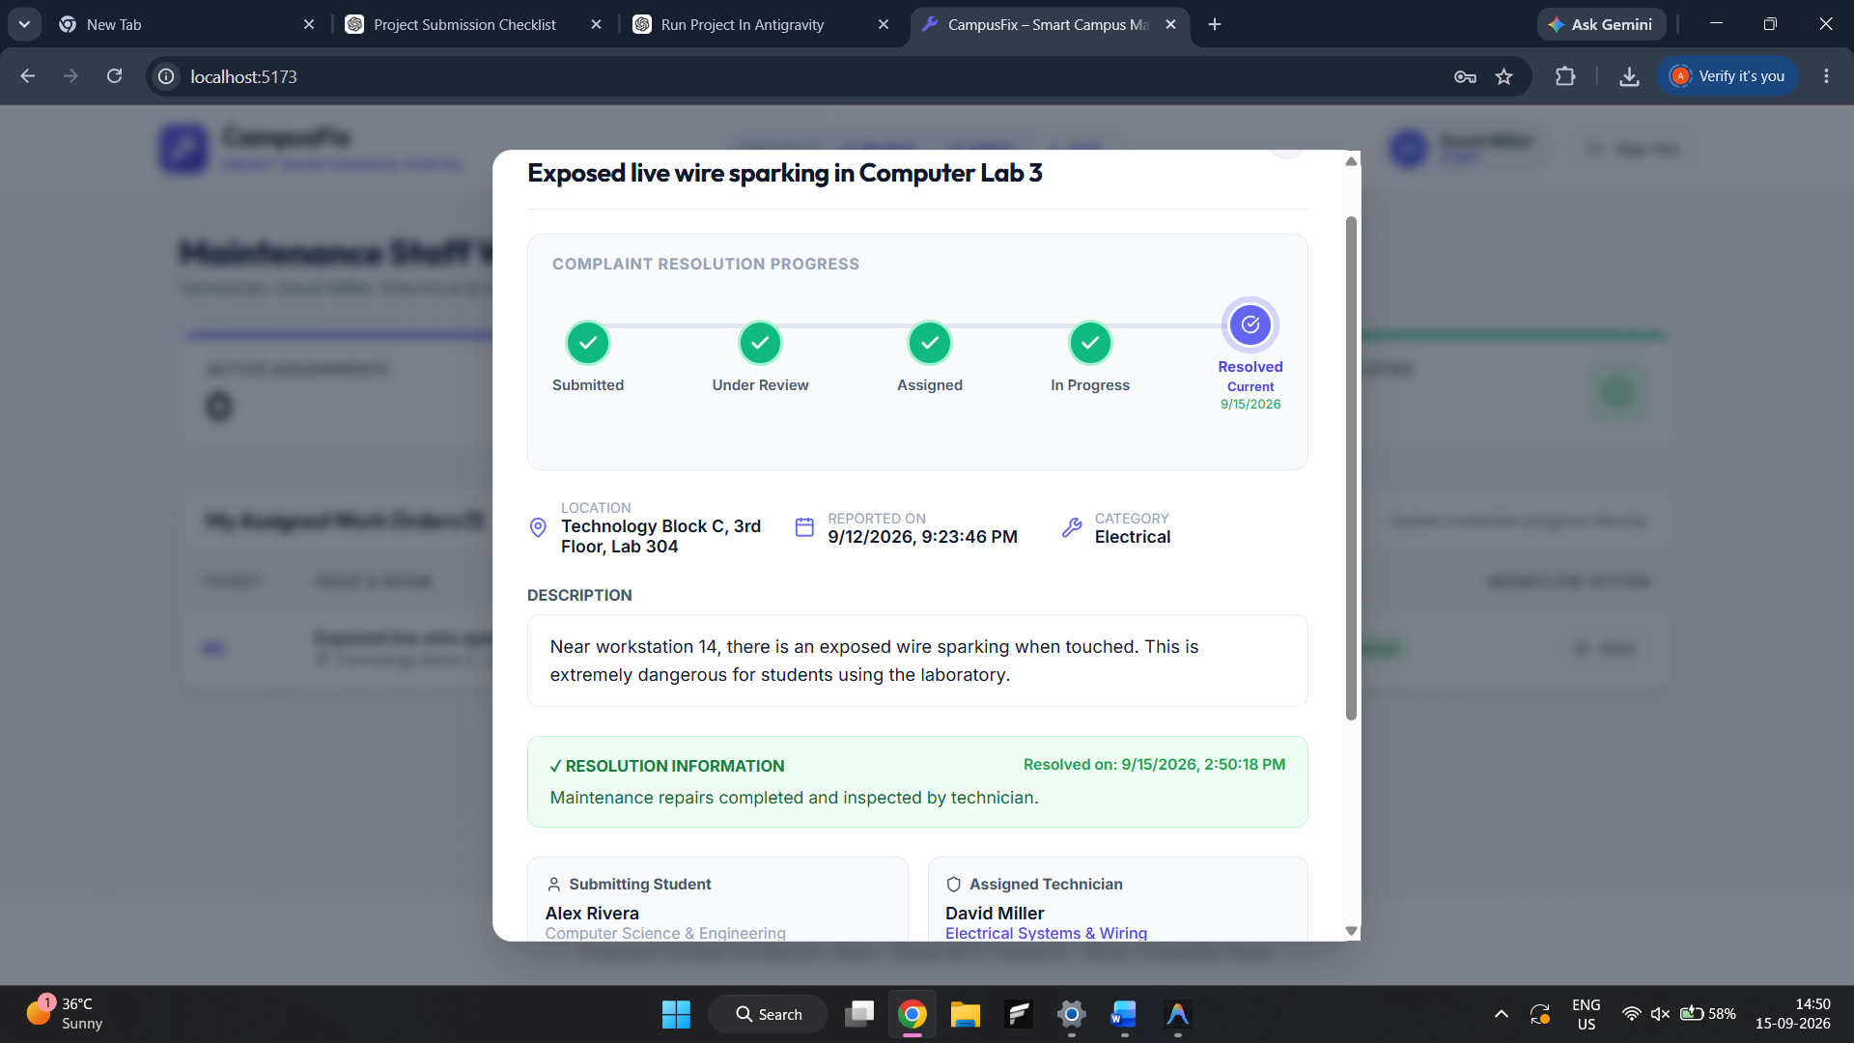
11. Staff dashboard / assigned complaints
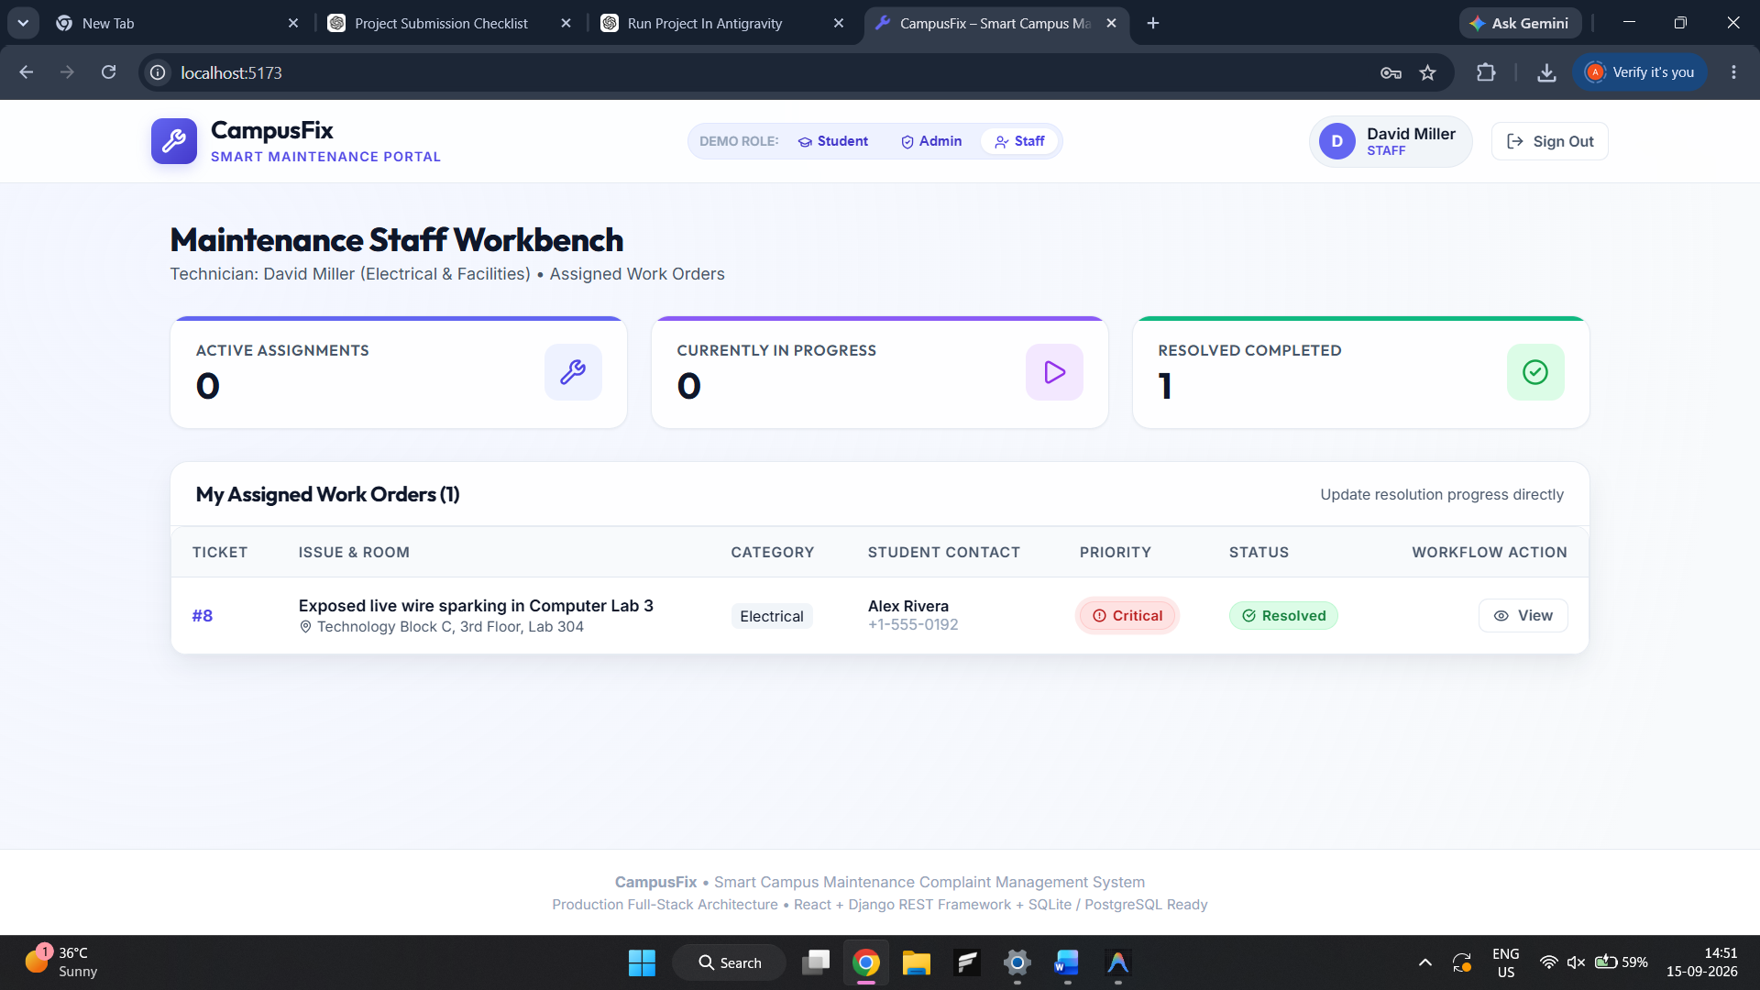
12. Delete confirmation and deletion result
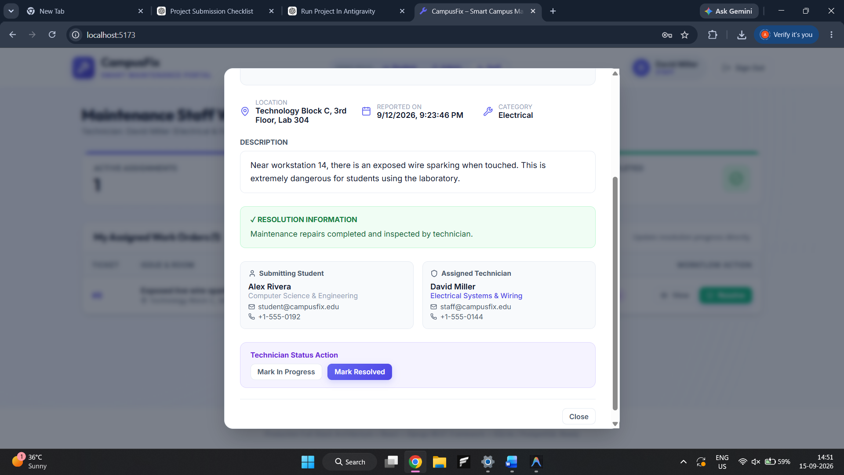
13. Postman POST/GET/PATCH/DELETE responses
[Insert actual screenshot here]
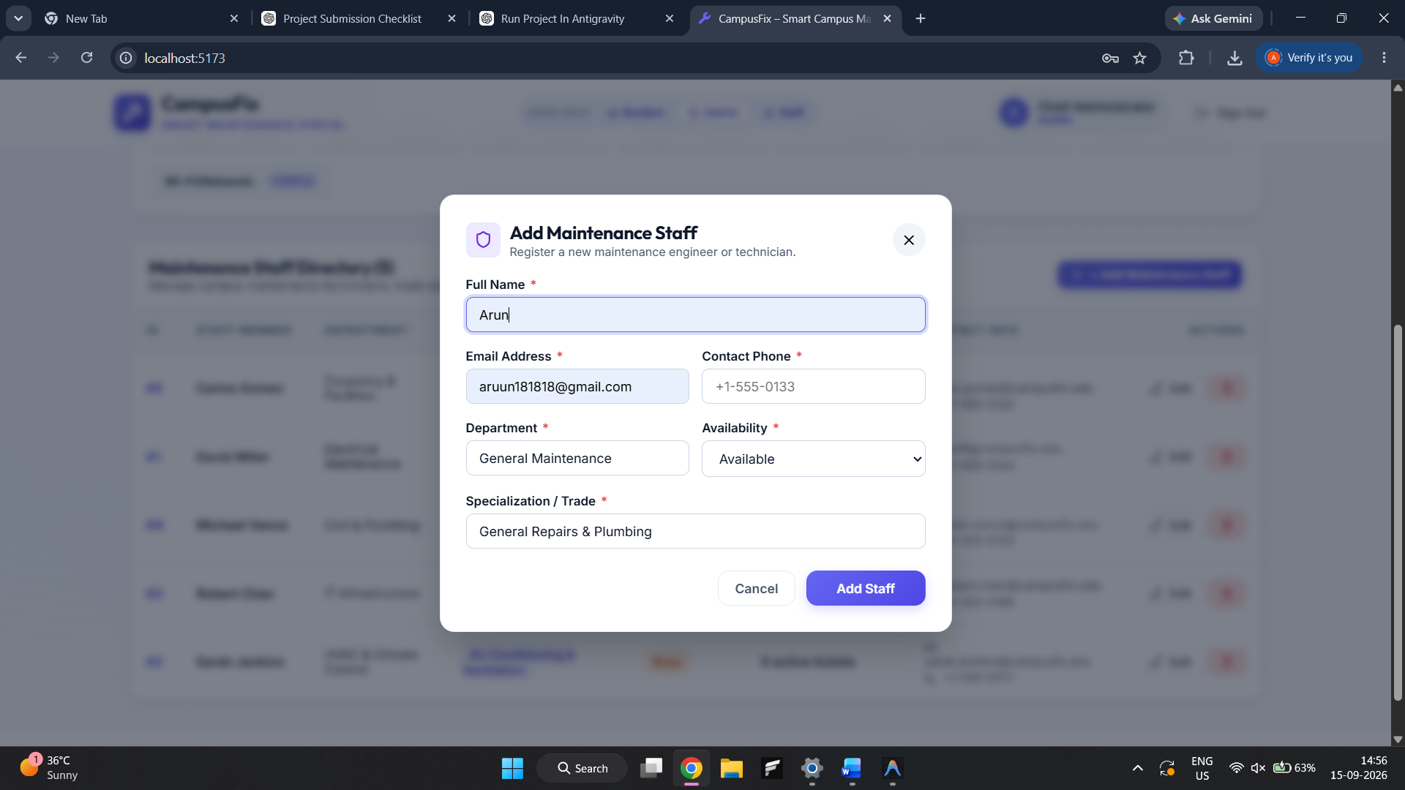

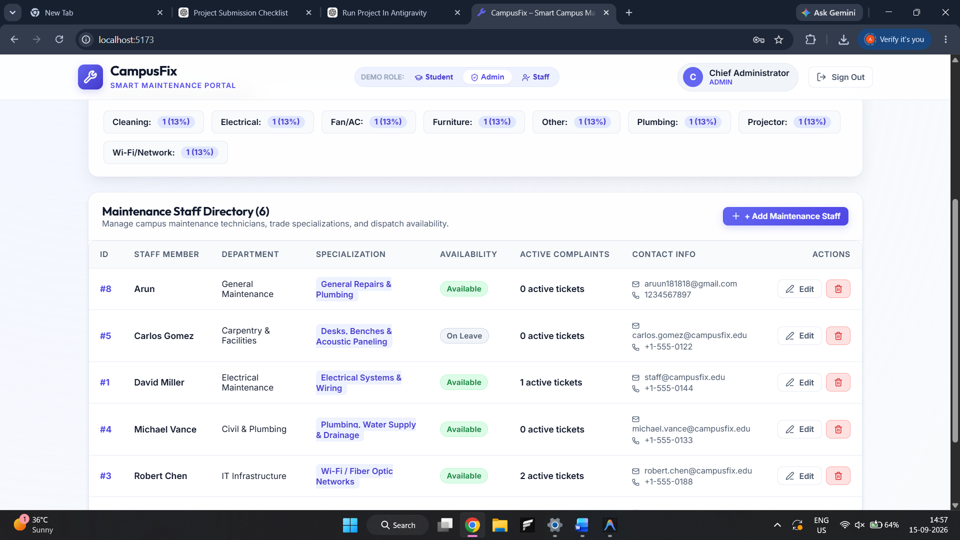

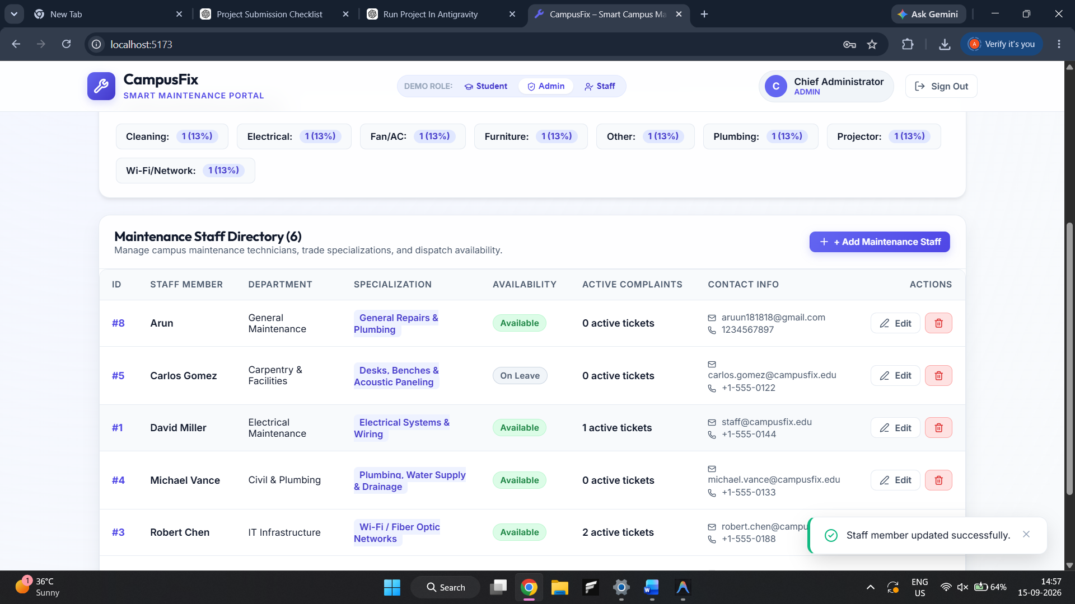

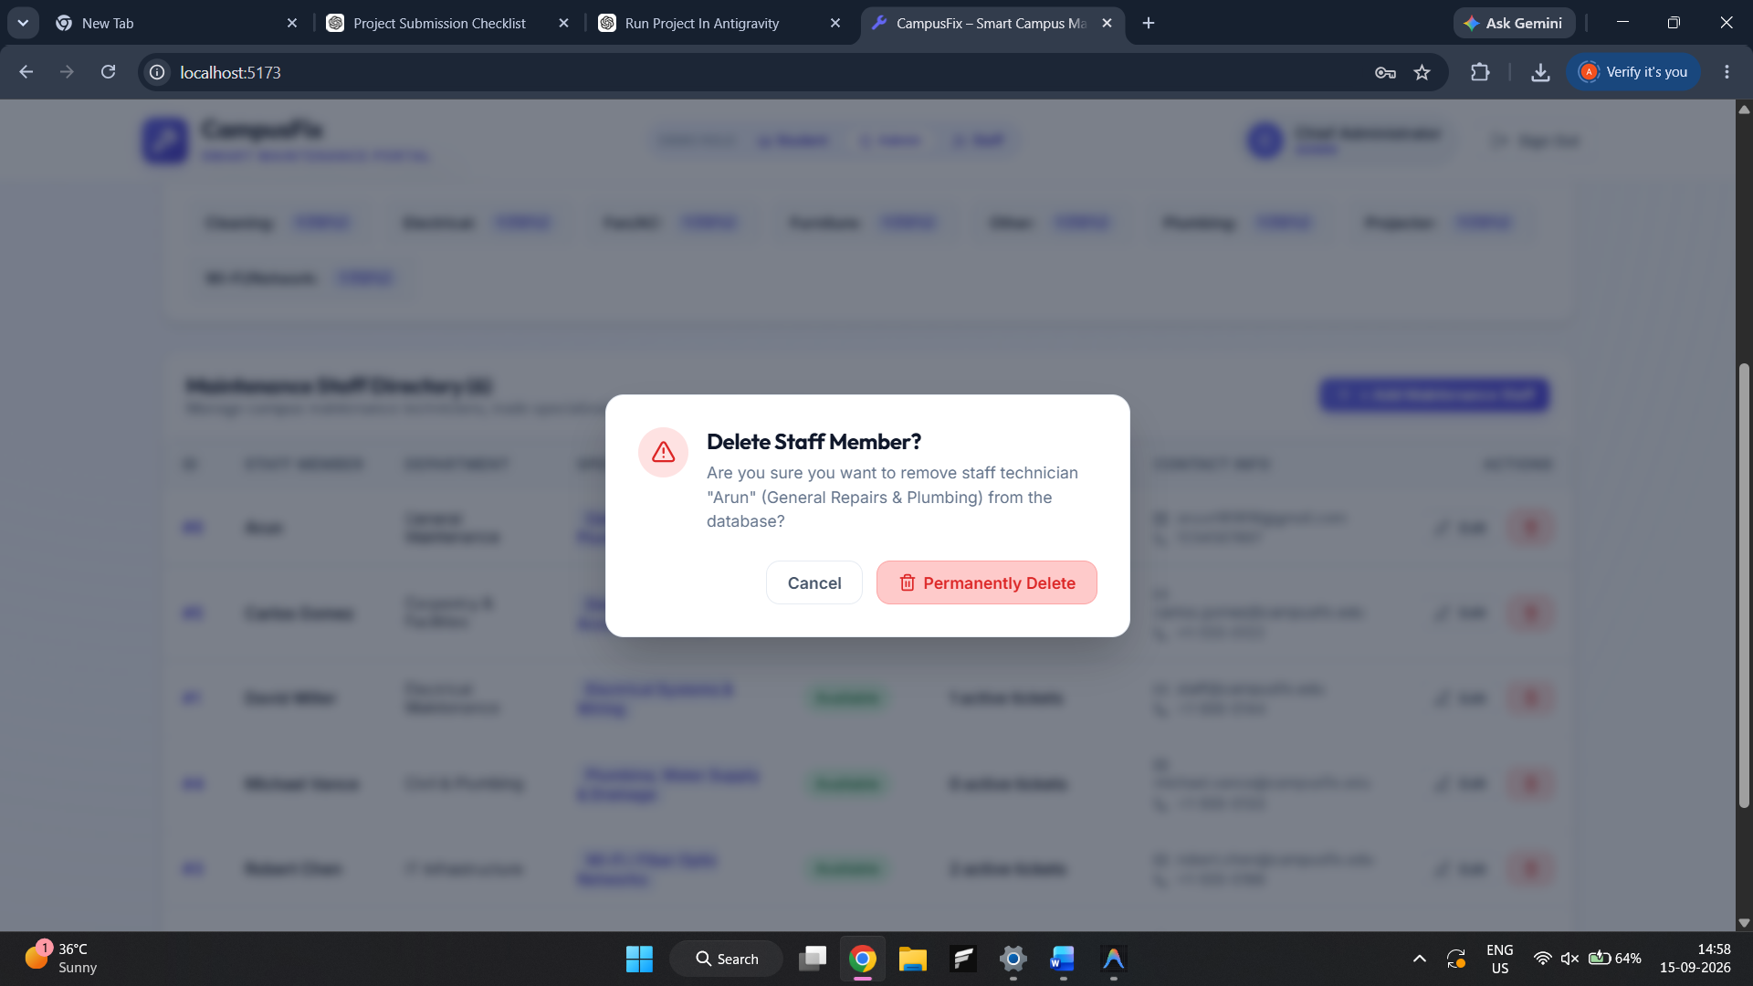
14. Database record verification
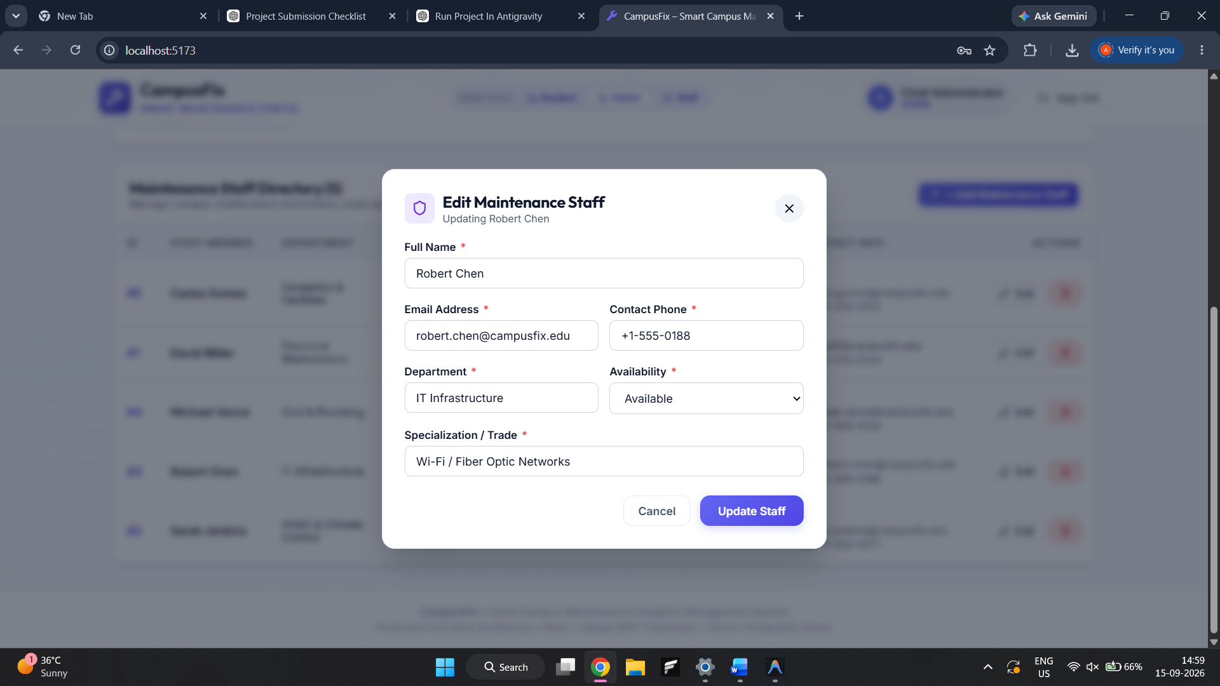
15. Mobile responsive view
[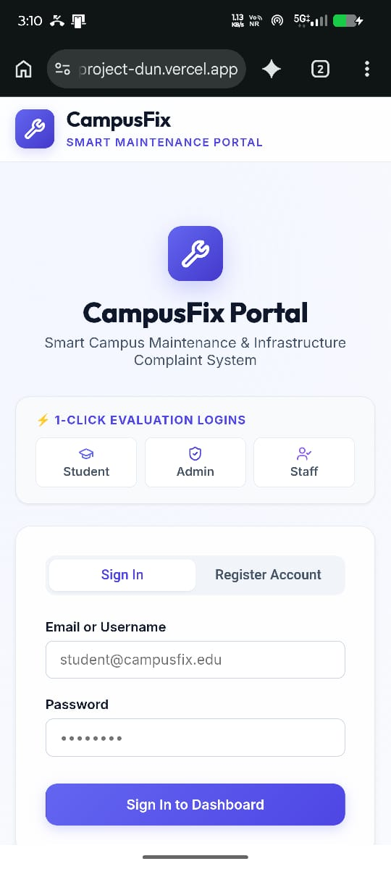

26. SOP Compliance Checklist
SOP Area | Status | Evidence
Requirement & design | Covered | Architecture, problem, objectives, scope, database design
Frontend | Covered | React UI, forms, validation, responsive design
Backend/API | Covered | Django REST Framework and REST endpoints
CRUD functionality | Covered | Complaint and staff CRUD
Database | Covered | SQLite + Django ORM + migrations
Testing | Covered | Automated tests, API tests, Postman, manual checks
Documentation | Covered | This report + README + test documentation
Demonstration | Ready after screenshots | Use the actual running application and Postman collection

27. Conclusion
CampusFix provides a complete CRUD-based full-stack solution for campus maintenance complaint management. The project demonstrates frontend-backend integration, relational database persistence, REST API development, validation, authorization, testing, and practical workflow automation. With the addition of final screenshots, repository details, and institution-specific cover-page information, the report is suitable for academic submission.

Appendix A – Submission Files
- Frontend source code
- Backend source code
- Database migrations/schema
- README.md
- Postman/CampusFix_API_Collection.json
- docs/TEST_CASES.md
- Project report
- Final screenshots
- GitHub repository link

