**Session 1: How to Solve Big Data Problem**

**Assignment 1.5**

Student Name: Harikrishnan D

Course: Big Data Hadoop & Spark Training

Start Date:  2018-05-06

End Date:  2018-06-02

**Assignment 1.5 Question** – List the Components of Hadoop 2.x and explain each component in detail.

Contents

I. Hadoop 2.x Architecture: 2

II. Hadoop 2.x Major Components: 2

**HDFS:** 3

**YARN (Yet Another Resource Negotiator)** 4

**MapReduce** 5

# Hadoop 2.x Architecture:

Hadoop 2.x Architecture is designed completely different. It has added one new component: YARN and also updated HDFS and MapReduce component’s Responsibilities.

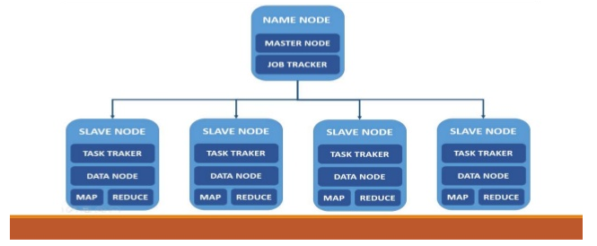Fig1.1 - Hadoop master/Slave Architecture

## Hadoop 2.x Major Components:

Hadoop 2.x has the following three Major Components:

1. HDFS
2. YARN
3. MapReduce

The above 3 are major components of Hadoop 2.x version.

### **HDFS:**

**The Hadoop Distributed File System (HDFS)** is the primary storage system used by Hadoop applications. HDFS is a distributed file system that provides high-performance access to data across Hadoop clusters.

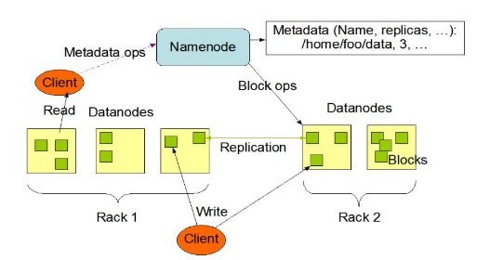

Fig 1.2 – HDFS Architecture

* The file store in HDFS provides scalable, fault-tolerant storage at low cost.
* The HDFS software detects and compensates for hardware issues, including disk problems and server failure.
* HDFS stores file across the collection of servers in a cluster.
* Files are decomposed into the blocks and each block is written to more than one of the servers.
* The replication provides both fault-tolerance and performance.

### **YARN (Yet Another Resource Negotiator)**

Apache **YARN** (**Yet another Resource Negotiator**) is Hadoop’s cluster resource managementSystem. YARN was introduced in Hadoop 2 to improve the MapReduce implementation,but it is general enough to support other distributed computing paradigmsas well.

YARN provides APIs for requesting and working with cluster resources, but these APIs are not typically used directly by user code. Instead, users write to higher-level APIs provided by distributed computing frameworks, which themselves are built on YARN and hide the resource management details from the user. The illustration shows some distributed computing frameworks (MapReduce, Spark,and so on) running as YARN applications on the cluster compute layer (YARN) and thecluster storage layer (HDFS and HBase).



Fig1.3 - Yarn Applications

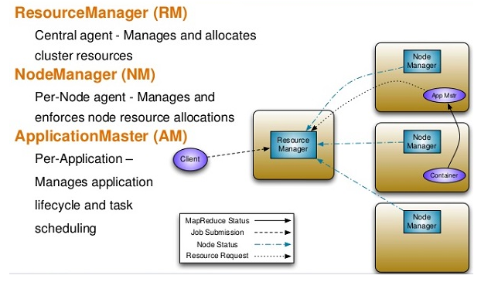

Fig1.4 – Yarn Architecture

### **MapReduce**

**MapReduce** is a programming model for data processing. The model is simple, yet nottoo simple to express useful programs in. Hadoop can run MapReduce programs writtenin various languages; in this chapter, we look at the same program expressed in **Java, Ruby, and Python**. Most importantly, MapReduce programs are inherently parallel, thusputting very large-scale data analysis into the hands of anyone with enough machinesat their disposal.

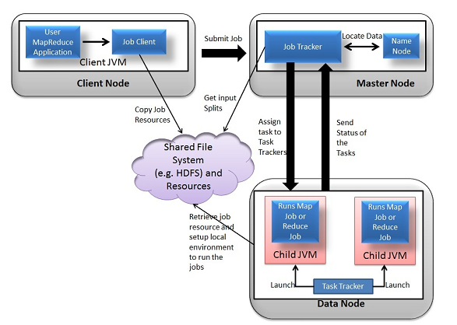

Fig 1.5 – MapReduce illustration

**THANK YOU**