STRYO TECHNOLOGIES Pvt Ltd

Full Stack Web Development Project

Name : Hari krishnan S

Reg.no : 510822104012

Degree / Dept : BE – CSE – 4th year

Course : Full Stack Web Development

College Name : Ganadipathy Tulsi's Jain Engineering College

Project Title | BBC News Website Simulation

- Abstract
A news website provides an online platform for delivering real-time information to users in a structured and accessible manner. This project focuses on developing a dynamic and user-friendly news portal that presents updated news articles across various categories such as politics, sports, entertainment, technology, and international affairs. The system is designed using modern web development technologies to ensure intuitive navigation, fast loading, and responsive design adaptable to different devices.
The platform integrates a content management approach, enabling administrators to add, update, and manage news articles efficiently. Users can browse news, search for specific topics, and explore trending updates. The website emphasizes readability, visual clarity, and secure access. Overall, this project demonstrates the implementation of a scalable and interactive digital news delivery system that enhances accessibility, improves user engagement, and supports the efficient dissemination of information.

Introduction
In the digital era, online news platforms have transformed the way people access and consume information. Traditional print media is increasingly being replaced by fast, interactive, and easily accessible web-based news systems. A news website serves as a centralized platform that delivers real-time updates on current events, enabling users to stay informed anytime and from anywhere. With the rapid growth of internet usage and mobile devices, the demand for reliable, user-friendly, and visually appealing news portals has significantly increased.
This project focuses on developing a modern news website that organizes and displays information across various categories such as national news, international affairs, sports, entertainment, business, technology, and lifestyle. The platform aims to provide quick navigation, responsive design, and seamless browsing to enhance user engagement. The system also supports effective content management, allowing administrators to upload, edit, and manage articles efficiently.
By combining essential web technologies with structured content presentation, this news website project demonstrates how digital platforms can be used to disseminate information effectively. It highlights the importance of accuracy, accessibility, and user experience in creating a trustworthy and functional online news service.

Objectives of the Project
- To provide a centralized platform for accessing real-time news across various categories such as politics, sports, entertainment, business, and technology.
- To design a user-friendly and responsive interface that ensures smooth navigation and accessibility across different devices, including mobiles, tablets, and desktops.
- To implement an efficient content management system (CMS) that allows administrators to add, edit, update, and delete news articles with ease.
- To ensure accuracy and reliability of information by organizing content in a structured and easily readable format.
- To enhance user engagement through features like search functionality, category filtering, trending news sections, and visually appealing layouts.
- To improve accessibility by ensuring fast loading times, optimized images, and clean design for all users.
- To demonstrate the use of modern web technologies (HTML, CSS, JavaScript, backend framework if applicable) in building a scalable and dynamic web platform.
- To create a secure and stable system that prevents unauthorized access and maintains the integrity of news data.

System Requirements

Hardware Requirements

Component | Minimum Requirement | Recommended Requirement
Processor | Intel Pentium 4 or equivalent | Intel Core i3 or higher
RAM | 2 GB | 4 GB or higher
Hard Disk | 80 GB | 120 GB or higher
Display | 1024×768 resolution | 1366×768 or higher
Network | Internet connectivity | Broadband/Wi-Fi

2. Software Requirements

Operating System
- Windows 10 or later / Linux / macOS

Web Development Tools
- Frontend: HTML5, CSS3, JavaScript
- Backend (if dynamic): PHP / Node.js / Python (Django/Flask)
- Database: MySQL / MongoDB / SQLite

Web Server
- Apache / XAMPP / WAMP / Nginx

Development Environment
- Code editor: VS Code / Sublime Text / Atom
- Browser: Google Chrome / Mozilla Firefox / Edge (for testing)

Other Tools
- Graphics: Adobe Photoshop / Canva (for images and banners)
- Version Control (optional but recommended): Git / GitHub

Methodology
The methodology describes the systematic approach used to design, develop, and implement the News Website. It outlines the steps and techniques used to ensure the project meets its objectives effectively.

1. Requirement Analysis
- Gathered requirements from users and stakeholders to understand the functionalities needed.
- Identified features like category-wise news display, search functionality, trending news, and admin content management.
- Analyzed existing news websites to determine best practices in user interface and usability.

2. System Design
- Created the overall architecture of the website including front-end and back-end design.
- Designed database schema to store news articles, categories, users, and admin data.
- Prepared Data Flow Diagrams (DFD) and Entity-Relationship Diagrams (ERD) to represent system workflow.

3. Technology Selection
- Frontend: HTML5, CSS3, JavaScript for responsive and interactive design.
- Backend: PHP / Node.js / Python Django for handling server-side logic.
- Database: MySQL / MongoDB to store and manage news data efficiently.
- Web Server: Apache/XAMPP for testing and deployment.

4. Implementation
- Developed the front-end pages including Home, Categories, News Detail, and Admin Panel.
- Implemented the backend logic for content management, user authentication, and dynamic news display.
- Integrated database operations for adding, updating, deleting, and fetching news articles.

5. Testing
- Performed unit testing on individual modules such as news upload, search, and user interface.
- Conducted integration testing to ensure seamless interaction between front-end, back-end, and database.
- Carried out user acceptance testing (UAT) to ensure the website is intuitive and meets user expectations.

6. Deployment
- Deployed the website on a local server or hosting platform.
- Ensured proper functionality across different browsers and devices.
- Applied security measures to prevent unauthorized access and data breaches.

7. Maintenance
- Periodically updated news content and added new features.
- Fixed bugs and optimized website performance.
- Monitored user feedback to improve usability and functionality.

- Programs
/* index.html */
<!DOCTYPE html>
<html lang="en">
<head>
<title>BBC News</title>
<style>
.design1
{
width: 350px;
height: auto;
color: black;
text-align: justify;
margin-left: 50px;
margin-top: 20px;
cursor: pointer;
}
.design2
{
width: 280px;
height: auto;
color: black;
text-align: justify;
margin-left: 50px;
cursor: pointer;
}
.design3
{
width: 600px;
height: auto;
margin-left: 450px;
margin-top: -680px;
text-align: justify;
color: black;
}
.design4
{
width: 400px;
height: auto;
margin-left: 1100px;
margin-top: -550px;
text-align: justify;
color: black;
}
.design5
{
width: 400px;
height: auto;
margin-left: 1100px;
}
.design6
{
width: 300px;
height: auto;
margin-left: 1100px;
}
</style>
</head>
<body>
<div style="text-align: center;">
<h1>B B C</h1>
</div><hr>
<div style="text-align: center">
<h2><u>Home</u> News Sport Business Innovation Culture Arts Travel Earth Audio Video Live</h2>
</div><hr>
<div class="design1">
<a href="one.html"><img width="350px" height="auto" src="images/1.png" alt="images"></a>
<h2>Taxas floods deadth toll climbs to more than 100</h2>
<p>Search and rescure teams have been wading through mud-piled riverbanks for a fourth day as more flash floods threaten the region.</p>
<h4>6 hrs | US & Canada</h4>
<hr>
</div>
</a>
<div class="design2">
<a href="two.html"><img width="350px" src="images/2.png" alt="images"></a>
<h2>Why Texas floods were so devastating</h2>
</div>
<div class="design3">
<a href="three.html"><img style="width: 600px; height: auto;" src="images/3.jpg" alt="images"></a>
<h2>Poisoned water and scarred hills: BBC visits worlds's rare earths captital in China</h2>
<p>China has paid a step price for minig the rare earth metals the world wants.</p>
</div>
</a>
<div class="design4">
<h2>Trump upbeat on Gaza ceasefire talks as he hosts Netanyahu</h2>
<p>The two leader's meeting came with no sign of a breakthrough yet in the latest round of Israel-Hamas negotiations in Qatar.
</p>
<h4>7 hrs ago | World</h4>
<hr>
</div>
<div class="design5">
<h2>Us delays higher tariffs but announces new taxes for some countries</h2>
<p>Trump says the US will impose a raft of levies after pausing his Liberation Day tariffs.</p>
<h4>4 hrs ago | Business</h4>
<hr>
</div>
<div class="design6">
<h2>How King Charles will help rebuild the shaken UK-France friendship during the state visit</h2>
</div>
</body></html>

/* one.html */
<!DOCTYPE html>
<html lang="en">
<head>
<title>First page</title>
<style>
.design
{
margin-left: 500px;
margin-top: 100px;
}
</style>
</head>
<body>
<div class="design">
<img width="600px" height="auto" src="images/1.png" alt="images">
<br>
<br>
<h2><a href="index.html">Index page</a></h2>
</div>
</body>
</html>

/* two.html */
<!DOCTYPE html>
<html lang="en">
<head>
<title>Second page</title>
<style>
.design
{
margin-left: 500px;
margin-top: 100px;
}
</style>
</head>
<body>
<div class="design">
<img width="600px" height="auto" src="images/2.png" alt="images">
<br>
<br>
<h2><a href="index.html">Index page</a></h2>
</div>
</body>
</html>

/* three.html */
<!DOCTYPE html>
<html lang="en">
<head>
<title>Three page</title>
<style>
.design
{
margin-left: 500px;
margin-top: 100px;
}
</style>
</head>
<body>
<div class="design">
<img width="600px" height="auto" src="images/3.jpg" alt="images">
<br><br>
<h2><a href="index.html">Index page</a></h2>
</div>
</body>
</html>

- Results & Screenshots

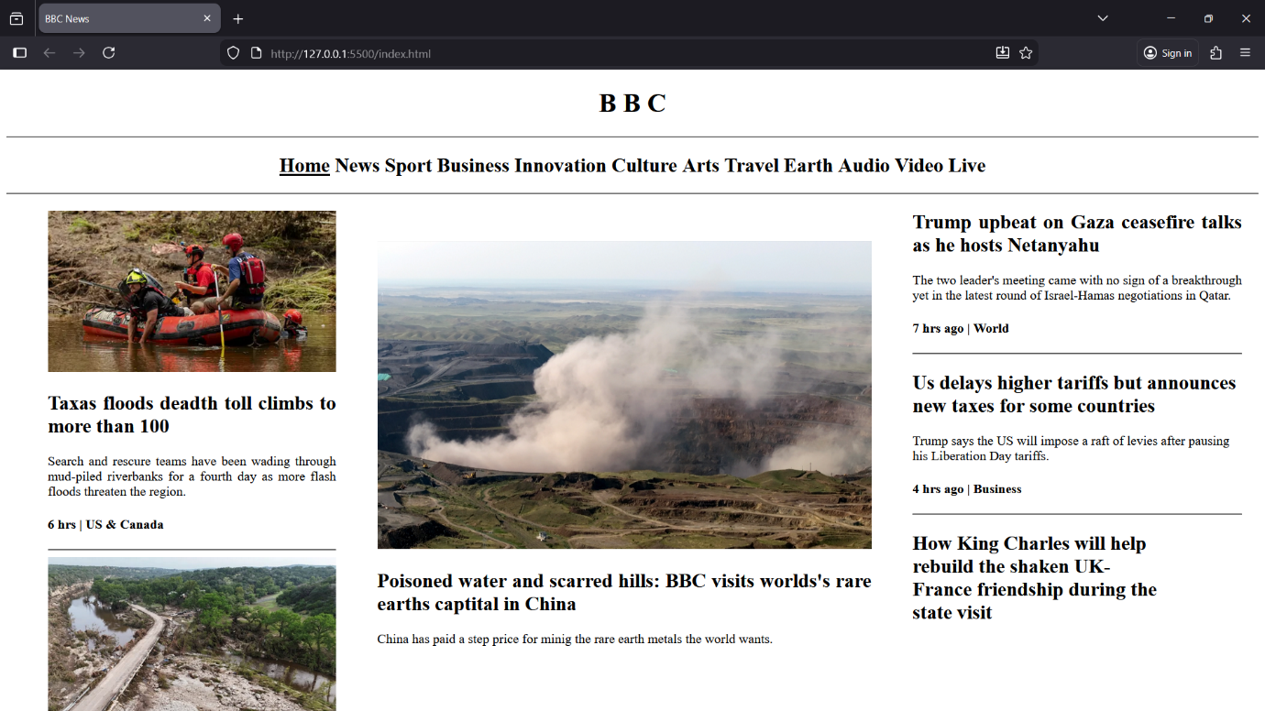

Advantages of the News Website
- Real-Time Access to Information
Users can access the latest news instantly from anywhere, without waiting for newspapers or TV broadcasts.
- Category-Wise Organization
News is organized into categories such as politics, sports, technology, entertainment, and business, making it easier for users to find relevant content.
- User-Friendly and Interactive
The website provides an intuitive interface, responsive design, and easy navigation, enhancing user experience.
- Efficient Content Management
Administrators can easily add, edit, or delete news articles, ensuring updated and accurate information is available at all times.
- Search Functionality
Users can search for specific news topics, articles, or events quickly and efficiently.
- Accessibility
The website can be accessed anytime, on any device (desktop, tablet, or mobile), increasing reach and convenience.
- Cost-Effective
Reduces dependency on printed newspapers or other physical media, saving both time and resources.
- Improved Engagement
Features like trending news, comments, and sharing options help keep users engaged and informed.
- Scalable and Upgradable
The platform can be expanded to include additional features such as multimedia content, notifications, and user accounts in the future.
- Environment-Friendly
Reduces paper usage by promoting digital consumption of news, contributing to environmental sustainability.

Limitations of the News Website
- Internet Dependency
Users need a stable internet connection to access the website; offline access is not available.
- Data Accuracy
The reliability of news depends on the sources and administrators; incorrect information may be displayed if not verified properly.
- Security Risks
Being an online platform, the website may be vulnerable to hacking, data breaches, or unauthorized access if security measures are not strong.
- Maintenance Requirement
Regular updates and maintenance are required to keep the website running smoothly and the content up-to-date.
- Limited User Interaction
Compared to social media platforms, user interaction (like commenting or sharing) may be limited unless additional features are implemented.
- Performance Issues
High traffic or multimedia-heavy content may slow down the website if server capacity or optimization is insufficient.
- Technical Knowledge Required for Admin
Administrators may need basic technical knowledge to manage content, perform updates, or troubleshoot minor issues.
- Browser Compatibility
Older browsers may not fully support modern web technologies, leading to display or functionality issues.

Conclusion
The News Website project successfully demonstrates the development of a modern, dynamic, and user-friendly online platform for accessing real-time news. By integrating various categories, search functionality, and a content management system, the website provides an efficient way for users to stay informed about current events.
The project highlights the importance of responsive design, easy navigation, and organized content presentation in enhancing user experience. It also emphasizes the role of web technologies in creating scalable and interactive platforms that can be maintained and updated efficiently.

References
- Duckett, J. (2014). HTML & CSS: Design and Build Websites. Wiley.
- Duckett, J. (2014). JavaScript and JQuery: Interactive Front-End Web Development. Wiley.
- Freeman, E., & Robson, E. (2017). Head First HTML and CSS. O’Reilly Media.
- W3Schools Web Tutorials – https://www.w3schools.com/
- CSS-Tricks – https://css-tricks.com/
- GeeksforGeeks – Web Development Tutorials – https://www.geeksforgeeks.org/web-development/
- “Importance of Online News Portals,” ResearchGate, https://www.researchgate.net/

