GRASPIN
Where understanding begins
BUILD PACK · VOLUME 1
Module 1: Xora Operations
Complete instructions for building the Xora Operations console exactly as designed: every screen, rule, message, role restriction, email, test and the ordered prompts for the team’s Claude.
Xora AI Research Labs Private Limited
Chennai, Tamil Nadu | November 2026
For the development team and their Claude coding assistant

What is in this volume
Part | Contents | Use
1 | Purpose, users and scope of the module | Orientation
2 | Screen inventory and where each lives in the prototype | Map
3 | The application shell and navigation | Build first
4 | Sign-in screen | Build first
5 | Roles and capabilities | Build first
6 | Screen-by-screen specifications (10 screens plus 4 sub-views) | The core
7 | Business rules, validation messages and statuses (OPS-BR) | Rules
8 | Email templates, word for word | Mail
9 | Data, API and realtime contract | Backend
10 | What the prototype simulates and what production must use instead | Backend, QA
11 | Prototype defects not to copy | Reviewers
12 | Acceptance tests (AC-OPS) | QA
13 | Prompt sequence P1.0 to P1.14 | The team’s Claude
14 | Parity checklist and sign-off | Reviewers

Before you start
Read Volume 0 first. Everything here assumes its fidelity rules (F1 to F12), design system, data model and shared services. Prototype file for this module: reference/prototype/1_Xora_Operations.html. Shared test logins are in Volume 0 Part 13.

Final decisions that apply to this volume
Every item here is decided
The product owner has delegated all open choices, and they are now final. Each item below overrides any wording elsewhere in this volume that says DECISION, open, recommended, “the business may” or “the product owner confirms”. Build exactly what it says. Do not ask for these answers and do not put them in docs/questions. Reasons are in Volume 00 (Master Decision Record). A later change goes through change control (Volume 0 Part 14).
ID | Final decision | What to build in this volume
D0-1 Video, calls and recordings | LiveKit (open source), run by Xora in an India region with its own relay servers. No third-party video vendor, no Jitsi. Live-class recordings are kept 12 months from the class date and then deleted. Messenger calls are never recorded. Exam video is not stored in release 1.0. | Settings, video for live classes: production offers one provider, “LiveKit — Xora video (India)”, with the server text read-only. “Simulated classroom (demo, no camera)” is offered only in local, preview and staging. “Jitsi Meet” and the public meet.jit.si server are never offered, and the explanatory note under the drop-down is not shown in production.
D0-2 Exam fee basis | Per registered student. Every student registered for an exam is billed, whether or not they sit it. The amount is set aside when the exam is authorised, charged per starter when it starts, and the absentees are charged when it closes. | The exam-start charge and the close-of-exam charge stay as in Volume 1: in total registered students × exam fee.
D0-3 Unused wallet on exit | Yes, on request. The balance is never refunded automatically. After an institute is switched off and has asked in writing, Finance refunds the available balance (balance minus amounts held) to the original payment source within 14 days, less any payment-gateway charge that the gateway does not return. The Director and Finance both approve. The plan fee and setup fee are not refunded. | No new screen. The refund is made with the ledger adjustment command of Volume 10 (REL-BR-140), which writes one entry “Adjustment — Refund on exit”, needs two approvers, records the reason and the gateway reference, and leaves the balance at zero. The institute’s record shows the entry in the existing ledger list.
D0-5 GST | All prices and amounts are tax-inclusive at 18 percent GST. Screens show the same figures as the prototype. Invoices and receipts (PDF and email) add the split: taxable value = round(total ÷ 1.18); GST = total − taxable value. For an institute in Tamil Nadu the GST is shown as CGST 9 percent and SGST 9 percent; for any other state as IGST 18 percent. The state is read from the first two digits of the institute’s GST number when it was entered, otherwise from its PIN code. Xora’s own GST number is configuration, not a screen. A separate field for the institute’s tax invoice details is a release 1.1 item. | The invoice, the reminder and the payment receipt (Part 8) gain, below the amounts, the lines “Taxable value”, “CGST 9%” and “SGST 9%” (or “IGST 18%”) and “Total (including GST)”, and Xora’s GST number. On-screen figures and the existing lines do not change. The only existing wording that changes is “(taxes as applicable)”, which becomes “(including GST)”.
D0-6 Invoice numbers across years | The year in the number is the calendar year of the invoice date in IST. The four-digit sequence restarts at 0001 on 1 January. A number is never reused. OB- numbers (onboarding requests) are a single sequence that never restarts. | The invoice list and the invoice documents use the numbers of BR-007.
D0-7 Payment gateway and reminders | Razorpay Orders and webhooks, in test mode until gate G6, live after it. The invoice due reminder is sent two days before the due date, once, by email to the owner and as a notification to the Xora finance role. | Wallet top-ups and invoice payments created in production go through Razorpay Orders; the confirmation arrives by signed webhook and is applied once (REL-BR-040). The reminder job of Volume 0 Part 10 sends the reminder 2 days before the due date.
D0-8 Retention of data | See the retention table in Volume 00 (Master Decision Record), Part 3. In short: messages 24 months; live-class recordings 12 months; Quest uploads and drafts 30 days; removed library items 30 days; results and attempts while the institute is active plus 24 months; audit log 7 years; ledger, invoices and payments 8 years; mail bodies 24 months; backups 35 days (monthly copy 12 months); logs 30 days. | Mail bodies are cleared after 24 months, keeping to, subject, time and status for 7 years. The audit log is never purged before 7 years.
D1-1 Owner phone on screen | Yes. It shows the first two digits, “xxx” and the last five digits (98xxx43210) to every role except Super Admin and Finance, who see all ten digits. | Implement in the one function that formats a phone for display (Part 6.2) and in the API response, not only in the screen: other roles never receive the full number.
D1-2 Editing an onboarding request | Only while the request is a draft. When an invoice exists, the details change only by cancelling the invoice and starting a new request. The prototype’s “reopen on step 2” is kept only while no invoice exists. | OPS-BR-002 is final as worded.
D1-3 Overpayment | The payment is recorded as entered; the wallet is credited with the recharge amount only; the difference is shown to Finance as an “Unapplied payment” line in the audit detail. Within 7 days Finance refunds it to the payer or, on the institute’s written request, adds it to the wallet by an adjusting entry (REL-BR-140). | OPS-BR-005 is final. The unapplied difference is written in the audit entry in the existing detail field; the Finance dashboard of Volume 1 lists unapplied payments older than 7 days in the existing audit filter (no new screen).
D1-4 Disconnected students | 20 seconds, kept as a setting (heartbeatTimeoutSeconds, default 20, allowed 10 to 60). The browser sends a heartbeat every 5 seconds. | OPS-BR-036 is final.
D1-5 Camera wall | In release 1.0 each tile shows the student’s initials on a coloured disc, the name and the status chip, in the same size and place as the prototype’s drawn faces. The browser is not asked for a camera and no picture is taken or stored. Real snapshots come with the proctored-exam mode of release 1.1. | Build the camera wall as described above. The tile layout, the number of tiles and the chips stay.
D10-10 Smoke-test institute | Yes. A small flag on the institute record, “Internal test”, with a grey chip in Boarded Centres. Internal institutes are excluded from all Business Dashboard figures, invoice reminders and exports. | Boarded Centres shows the grey chip “Internal test” for flagged institutes (the only screen addition of release 1.0).

Addendum acceptance tests
These tests are added to this volume’s own test list. They are numbered F01 and upward so the earlier numbering does not move. A screen or service they touch is finished only when they pass.
ID | Do | Expect
AC-OPS-F01 (D0-1) | Open Settings on production and on staging | Production lists only LiveKit; staging lists Simulated and LiveKit; no Jitsi anywhere
AC-OPS-F02 (D0-2) | Authorise an exam of 100 registered students at ₹80; 90 start; close it | The wallet shows 90 starter charges, then one charge for the 10 absentees; total ₹8,000; the held amount is released
AC-OPS-F03 (D0-3) | Run the command for an institute with ₹40,000 available and ₹10,000 held | Refused for the held amount; refund of ₹40,000 accepted with two approvers; the ledger equals the balance; one audit entry
AC-OPS-F04 (D0-5) | Generate the first invoice of a Tamil Nadu institute with total ₹1,62,000 | PDF and email show the taxable value, CGST and SGST above and the total ₹1,62,000
AC-OPS-F05 (D0-7) | An invoice due on 20 Oct; run the daily job on 18 Oct and again on 19 Oct | One reminder on 18 Oct; none on 19 Oct
AC-OPS-F06 (D0-8) | Run retention.purge with an email 25 months old | Body cleared; metadata kept
AC-OPS-F07 (D1-1) | Open an institute as Support and as Finance | Support: 98xxx43210 in the page and in the API response; Finance: 9876543210
AC-OPS-F08 (D1-2) | Try to change the owner’s email after the invoice was sent | Refused; the cancel-invoice path is offered
AC-OPS-F09 (D1-3) | Record a payment of ₹1,70,000 against an invoice of ₹1,62,000 | Recorded ₹1,70,000; wallet credited with the recharge amount; audit detail shows an unapplied ₹8,000
AC-OPS-F10 (D1-4) | Stop a student’s heartbeat for 19 seconds, then 21 seconds | Not disconnected, then Disconnected
AC-OPS-F11 (D1-5) | Open the camera wall during a live exam | Tiles show initials, name and status; the student browsers make no camera request

Part 1. Purpose, users and scope
Xora Operations is the console used by the Xora team to run the Graspin business day to day. It does five jobs: bring new institutes on by invoice, watch every live exam across all institutes at once, handle problems that institutes report, keep wallets funded, and administer the Xora team’s own access and rules. It is the first module to build because every other console depends on the institutes, users and wallets that it creates.

1.1 Who uses it
Role | Typical person | What they do here
Super Admin | Director (Anu Pradeep) | Everything, including users, settings and cut-off references; may preview other roles with the role switcher
Exam Controller | Karan P. | Watches live exams; pauses, resumes and extends them; reviews proctoring flags; handles incidents
Proctor | Suresh B. | Watches live exams and reviews proctoring flags; handles incidents
Support Agent | Meenal S. | Reads live exams; handles incidents; sees the exam schedule and boarded centres
Finance | Latha M. | Onboards institutes, records payments, sees centres, wallets and invoices

1.2 The business loop this module serves
1  Details  Finance enters institute, owner, Academic Head | → | 2  Invoice  Plan + setup + first recharge, emailed | → | 3  Payment  Finance records amount, date, reference | → | 4  Approval  Director or GM approves in Module 2

5  Logins  Admin and Head emailed | → | 6  Live  Institute appears in Centres, Wallet, Schedule and Monitor

1.3 In scope and out of scope
In scope (this volume) | Out of scope (other volumes)
All ten screens, sign-in, shell, capability checks | Approving or rejecting an institute (Volume 2)
Onboarding wizard, invoice, payment recording, resend, cancel, refund mark | Price list editing (Volume 2)
Live Monitor, proctoring review, pause, resume, extend, report download | Proctoring detection itself and the camera stream (Volume 7 and the proctoring service)
Incidents and support, exam calendar, centres, wallet and billing views | Wallet top-up payment by the institute (Volume 5)
Users and roles, audit log, settings, cut-off references, video setting | Messenger and calls (Volume 9; the chat bubble is only mounted here)

Part 2. Screen inventory
Navigation order and names are fixed. “Capability” is the permission needed to open the page; a role without it sees the lock icon in the menu and a no-access panel on the page. Prototype function names are given so the assistant can open the right code.
Page (menu name) | Route | Capability | Prototype function | Page subtitle (exact)
Dashboard | /dashboard | none (everyone) | rDash, dashBody | Every institute, every live exam, at a glance
Live Monitor | /monitor | monitor | rMon, rMonInst | Institutes running exams right now
Incidents & Support | /incidents | incidents | rInc, newIncident | Problems to attend to, by institute
Exam Schedule | /exams | exams | rExams | Exams across every institute, by date
Onboard Institute | /onboard | onboard | rOnboard, obWizard, obDrawer, payModal | Details, invoice, payment received, approval
Boarded Centres | /centres | centres | rCentres, rCenDetail | Every institute on Graspin
Wallet & Billing | /wallet | wallet | rWal | Wallets, reminders and invoices
Users & Roles | /users | users | rUsers | Xora team access
Audit Log | /audit | none (everyone) | rAud | Every significant action
Settings | /settings | users | rSet | Rules, reminders and invoice details

Menu groups, in order: Operations (Dashboard, Live Monitor, Incidents & Support); Exams (Exam Schedule); Network (Onboard Institute, Boarded Centres); Business (Wallet & Billing); Admin (Users & Roles, Audit Log, Settings). Browser tab title: “Xora Operations — <page name>”. Unknown route opens the Dashboard.
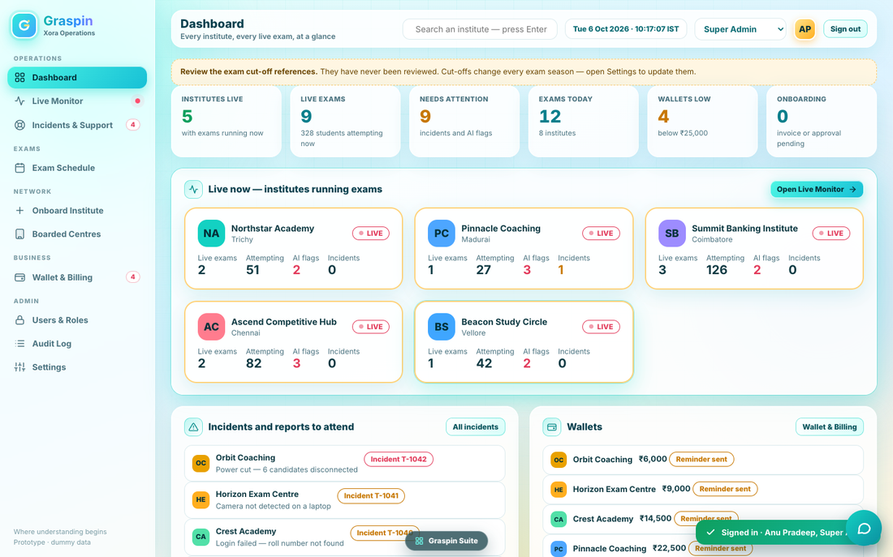
Figure 1. Dashboard (reference: reference/screens/module-1/dashboard.png)

Part 3. The application shell

3.1 Layout
- Left sidebar. Logo tile with a “G”, the word “Graspin” in turquoise, and the line “Xora Operations”. Below: the navigation groups with small-caps group labels (OPERATIONS, EXAMS, NETWORK, BUSINESS, ADMIN). At the bottom: “Where understanding begins” and “Prototype · dummy data” (in production replace the second line with the build version).
- Top bar. Page title and subtitle on the left. On the right: search box with placeholder “Search an institute — press Enter”; clock text “Tue 6 Oct 2026 · 10:17:07 IST” updating every second (production: current date and time in IST); the role switcher (a drop-down); the avatar with the user’s initials (tooltip: name · role); a “Sign out” button.
- Floating items. The “Graspin Suite” pill (link back to the launcher) at the bottom centre, and the round chat button at the bottom right (Volume 9). Toasts appear bottom right.

3.2 Navigation behaviour
- Active item is highlighted turquoise. Clicking an item clears any open institute view (Live Monitor institute, Centre detail) and opens the page.
- Badges: Incidents & Support shows the count of incidents that are not Resolved (red outlined number). Wallet & Billing shows the count of institutes whose available wallet is below the threshold. Live Monitor shows a pulsing red dot. A page the role cannot open shows a small lock instead of any badge, in muted colour.
- Icons per item: Dashboard grid, Live Monitor activity, Incidents lifebuoy, Exam Schedule calendar, Onboard plus, Boarded Centres building, Wallet wallet, Users lock, Audit Log list, Settings sliders. Use the prototype’s SVG paths.

3.3 Role switcher
Only a Super Admin sees the drop-down. Choosing another role changes what the screens show and enable, so the Director can check what each role sees. It never changes the server’s permissions or the signed-in identity. PROD: the preview is purely visual; every API call still carries the real user’s rights, and the audit log records the real user.

3.4 Global search
Typing a name fragment and pressing Enter opens the first boarded centre whose name contains it, on its Profile tab. If none matches, a warning toast says “No institute found”.

3.5 Shared dialogs
Dialog | Exact behaviour
Confirm with reason | Title, subtitle line, a field labelled “Reason (recorded in the audit log)” with placeholder “Why is this action needed?”, buttons Cancel and the action verb. Fewer than three characters shows a warning toast “Please add a reason” and keeps the dialog open.
Modal | Closes on Esc or on a click outside; an action that returns false keeps it open.
Drawer | Slides in from the right with a Close button; used for an institute’s onboarding details.
Toasts | Kinds: ok, warn, bad, info; auto-hide after 3.8 seconds.

Part 4. Sign-in screen
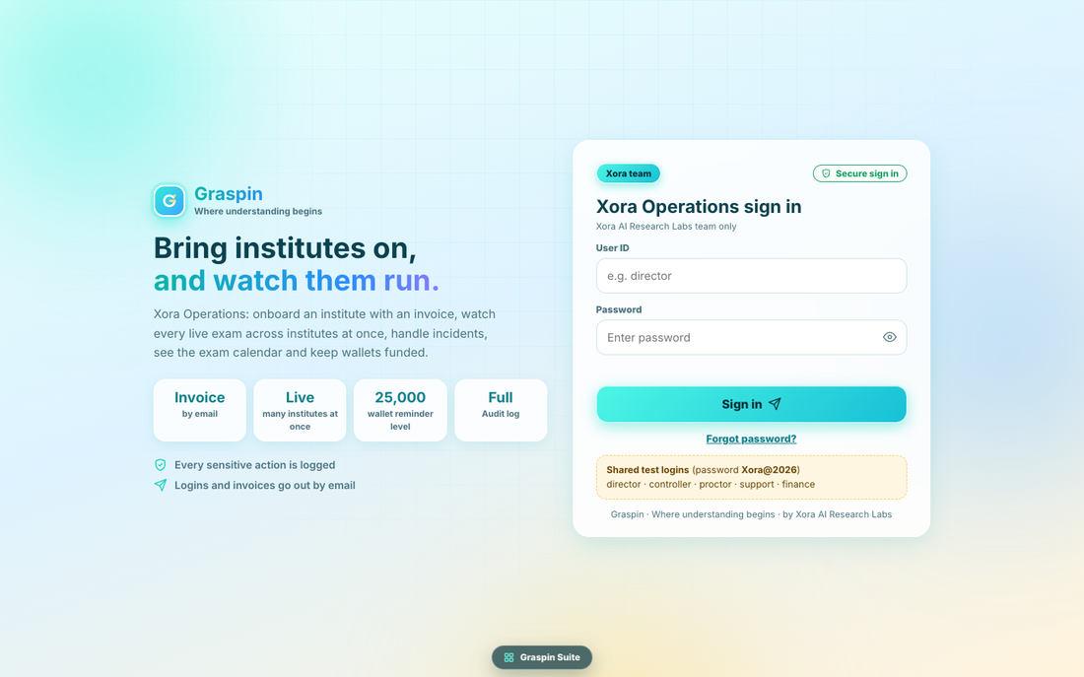
Figure 2. Xora Operations sign-in (reference: reference/screens/module-1/login.png)
A two-panel page. Left panel: logo block (“Graspin”, “Where understanding begins”), headline “Bring institutes on, and watch them run.” (second line in turquoise), the lead sentence, four fact tiles and two tips.
Element | Exact text
Headline | Bring institutes on, / and watch them run.
Lead | Xora Operations: onboard an institute with an invoice, watch every live exam across institutes at once, handle incidents, see the exam calendar and keep wallets funded.
Fact tiles | Invoice — by email | Live — many institutes at once | 25,000 — wallet reminder level | Full — Audit log
Tips | Every sensitive action is logged | Logins and invoices go out by email
Card badge and chip | Xora team | Secure sign in
Card heading and sub | Xora Operations sign in / Xora AI Research Labs team only
Fields | User ID (placeholder “e.g. director”) | Password (placeholder “Enter password”, with show/hide eye)
Button | Sign in
Link | Forgot password? → dialog “Forgot your password?” with “Ask a Super Admin to press Notify next to your name under Users & Roles. Your login is emailed to you again.” and an OK button
Test-login box (non-production only) | Shared test logins (password Xora@2026) / director · controller · proctor · support · finance
Footer | Graspin · Where understanding begins · by Xora AI Research Labs
Errors | Please enter your user ID and password. | User ID or password is incorrect.
The 25,000 fact tile shows the wallet reminder level; in production it reads the setting rather than a fixed number. Enter submits. After sign-in the toast reads “Signed in · <Name>, <Role>”, and the Dashboard opens. The sign-in IDs are lower-case; the ID field is trimmed and lower-cased before checking. Test-login box is shown only when the environment is not production.

Part 5. Roles and capabilities
Nine capabilities decide everything. A tick means allowed. These are the exact values in the prototype and must be enforced by the API.
Capability | Super Admin | Exam Controller | Proctor | Support Agent | Finance
monitor: Live monitor | ✓ | ✓ | ✓ | ✓ | —
control: Pause / extend exams | ✓ | ✓ | — | — | —
proctor: Proctoring | ✓ | ✓ | ✓ | — | —
incidents: Incidents & support | ✓ | ✓ | ✓ | ✓ | —
exams: Exam schedule | ✓ | ✓ | — | ✓ | —
onboard: Onboard institutes | ✓ | — | — | — | ✓
centres: Boarded centres | ✓ | ✓ | — | ✓ | ✓
wallet: Wallet & billing | ✓ | — | — | — | ✓
users: Users, roles, settings | ✓ | — | — | — | —

- Dashboard and Audit Log need no capability. Settings uses the users capability, so only the Super Admin opens it.
- Buttons the role cannot use are shown disabled where the prototype does so (Onboard an institute: title “Your role cannot onboard institutes”; Save settings; Save and mark as reviewed today; Pause, Resume, +10 min; Warn, Dismiss, Tell the institute). The API must also refuse them.
- PROD: the capability table is data (a roles table), not code, so the Super Admin could one day edit it. Until then it is seeded exactly as above. The permission grid on the Users & Roles page reads this table.

Part 6. Screen-by-screen specifications
Each screen below lists purpose, layout from top to bottom, what each element shows, every action and its result, and the tests that prove it. “Source” names the prototype function to read in full before building (rule F3).

6.1 Dashboard
Source: rDash, dashBody, instTile, instStats, bindTiles in 1_Xora_Operations.html. Tests: AC-OPS-020 to 027.
Purpose: one screen that tells the on-duty person whether anything needs them right now. It refreshes every two seconds while open, and immediately on realtime events (PROD: on events, with a 10-second safety refresh).
Block (top to bottom) | Content and rules
Cut-off banner | Amber callout “Review the exam cut-off references. They have never been reviewed / were last reviewed N days ago. Cut-offs change every exam season — open Settings to update them.” Shown only if never reviewed or reviewed more than 180 days ago. Clicking it opens Settings.
KPI row (six tiles) | Institutes live (number of institutes with at least one live exam; caption “with exams running now”; green when above zero). Live exams (count; caption “N students attempting now”). Needs attention (count of attention items; caption “incidents and AI flags”; amber when above zero, green at zero). Exams today (count; caption “N institutes”). Wallets low (count of institutes below the reminder level; caption “below ₹25,000”; amber when above zero). Onboarding (count of institutes in draft, invoice sent or awaiting approval; caption “invoice or approval pending”).
Live now card | Title “Live now — institutes running exams” with button “Open Live Monitor →”. A three-column grid of institute tiles (6.2.1). If none: “No exam is running right now.”
Incidents card (left of two) | Title “Incidents and reports to attend”, button “All incidents”. Up to seven items, most urgent first (red before amber). Each row: institute avatar, institute name, one-line text, and a chip (“Incident T-1042” or “Proctoring”). Click opens that incident, or the institute’s proctoring tab. If none: “Nothing needs attention.”
Wallets card (right) | Title “Wallets”, button “Wallet & Billing”. The six institutes with the lowest available wallet, each row: avatar, name, available amount in bold, chip “Reminder sent” (amber) if below the level, else “OK” (green). Footnote “Institutes are reminded automatically by email when their wallet falls below ₹25,000.”
Next 7 days card | Title “Next 7 days”, button “Exam Schedule”. Seven small day boxes starting today: weekday and day number, exam count in large type, institutes count beneath. Today’s box has a turquoise border and pale fill. Click opens the Exam Schedule on that date.
Onboarding and health blocks | Onboarding counts by stage and the system-health sparklines (connected students, latency in milliseconds, errors in percent; thirty points, one new point every two seconds). Read dashBody for the exact layout and the screenshot above. PROD: the three series come from real telemetry (Part 10).

Needs-attention rule (OPS-BR-020)
An item is created for every unresolved incident whose priority is High or Medium (High is red, Medium amber), and for every institute with at least one pending proctoring flag (red when more than three flags are pending, otherwise amber; text “N AI flag(s) waiting for a proctor”). Sort: red first, then amber. The KPI counts all items, the card shows seven.
6.2.1 Institute tile (used on the Dashboard and Live Monitor)
A clickable card with avatar, institute name (cut with an ellipsis), city, a red LIVE chip, and four small figures: Live exams, Attempting, AI flags (red), Incidents. The border is 2 pixels: red #FF8FA3 when the institute has an unresolved High incident or more than three pending flags; amber #FFD27A when it has any pending flag, any unresolved incident, or a paused exam; otherwise green #BDF2EA. Clicking opens that institute in the Live Monitor.

6.2 Live Monitor
Source: rMon, rMonInst (tabs live, proctor, inc, rep), instTile, cam, pendingFlags, liveOf, LT. Tests: AC-OPS-030 to 046. Capability: monitor (controls need control; flag buttons need proctor).
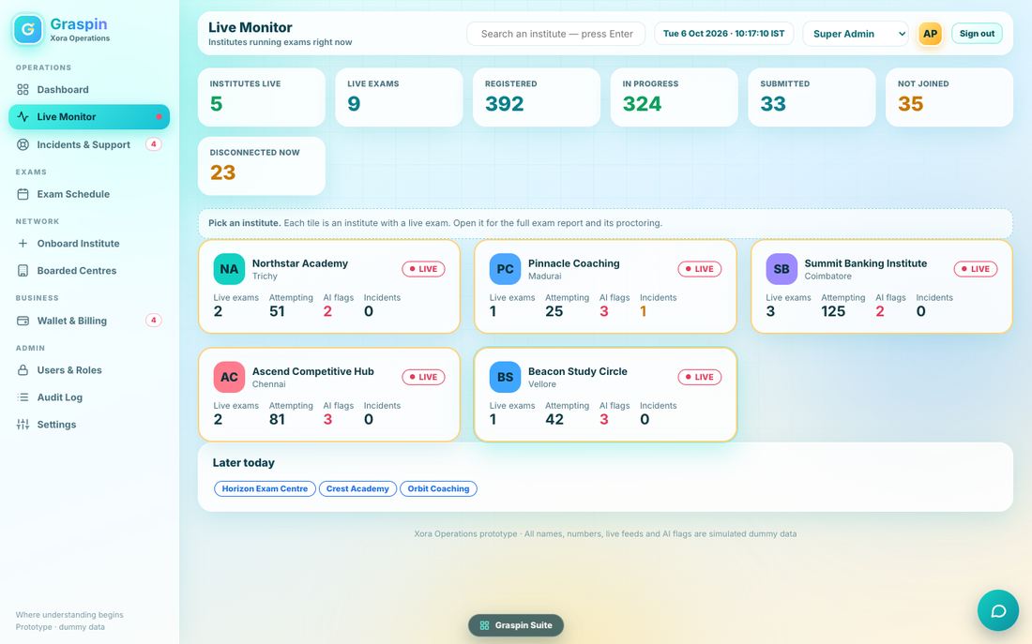
Figure 3. Live Monitor, all institutes
6.2.2 All-institutes view
Block | Content and rules
KPI row (seven) | Institutes live; Live exams; Registered (sum of registered students in live exams); In progress (green); Submitted; Not joined (amber); Disconnected now (amber, red above 25).
Callout | “Pick an institute. Each tile is an institute with a live exam. Open it for the full exam report and its proctoring.”
Tiles | Institute tiles (6.2.1) in a three-column grid. If none: card “No institute has an exam running right now.”
Later today | Card “Later today” listing, as blue chips, institutes that have an exam today still scheduled and none live. Hidden when there are none.
Live numbers: Registered = students registered for the exam. In progress = started minus submitted. Not joined = registered minus started. Disconnected = attempts that stopped sending a heartbeat (production definition, Part 10). Everything refreshes every two seconds.
6.2.3 One institute (after clicking a tile)
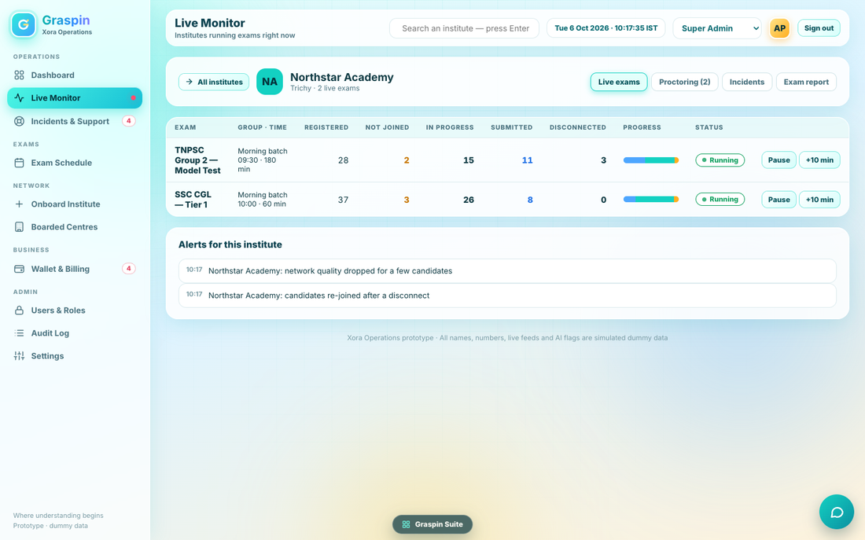
Figure 4. One institute, tab “Live exams”
Header card: button “← All institutes” (arrow icon; returns to the tile view), avatar, institute name, “City · N live exam(s)”, and four tabs: Live exams, Proctoring (N) with the pending flag count, Incidents, Exam report. The selected tab is remembered while the user stays on the page.
Tab | Content and rules
Live exams | Table with columns: Exam (name; a blue chip “Real exam from the institute” when it is a real exam), Group · time (batches, start time and total minutes including extensions), Registered, Not joined (amber), In progress, Submitted (blue), Disconnected (red above 8), Progress (stacked bar: submitted #4DA6FF, in progress #13D1C2, not joined #FFAE1F, each as a share of registered), Status (green “Running” with live dot; amber “Paused”; blue “+N min” when extended), and two buttons: Pause or Resume, and +10 min. Both buttons are disabled without the control capability. Below the table, a card “Alerts for this institute” listing time and text, or “No alerts.”
Proctoring | If no live exam: “No live exam to proctor.” Otherwise a callout “Proctoring for <name>. AI flags are always reviewed by a person. Flagged tiles are outlined in red.” Left card “Live wall — <exam name>”: a grid of up to 24 candidate tiles (camera preview, candidate name, candidate code such as TNQ-2200, and the flag type when flagged). Right card “AI flags waiting (N)”: one note per flag with candidate name, flag type, a confidence chip (red for high severity, amber otherwise) and three buttons Warn, Dismiss, Tell the institute (disabled without the proctor capability). If none: “No flag is waiting.” Clicking a tile opens a dialog with a larger camera view, the candidate name and “TNQ-… · <flag> (<confidence>%)” or “No flag”, and a Close button.
Incidents | Card “Incidents at <institute>” with a button “Log an incident” and a table of that institute’s incidents (title, id · category · time, priority chip, status chip). Clicking a row opens Incidents & Support with that incident selected. Empty: “No incidents.”
Exam report | One card per live exam: title, red LIVE chip, four KPI tiles (Registered; Joined with percentage; Submitted; Disconnected now), three bars (Admit cards sent %, System checks passed %, Slow-network candidates count), and the line “Group: … · starts HH:MM · N min”. A button “Download live report” saves a CSV named <institute>_live_report.csv with the header Exam,Group,Registered,Not joined,In progress,Submitted,Disconnected and one line per live exam. Audit: “Downloaded live exam report”.

Controls and their effects (OPS-BR-030 to 036)
Action | Effect | Message and audit
Pause / Resume | Toggles the exam’s paused flag. In production the Student App shows “Exam paused by the exam controller” and stops the timer; resuming restores it. No reason asked. | Toast “Exam paused” / “Exam resumed”. Audit “Paused exam” / “Resumed exam”, target institute.
+10 min | Opens the confirm dialog “Extend the exam by 10 minutes?” with subtitle “All candidates of this exam get 10 more minutes.” and the verb Extend; reason required. Adds 10 minutes to the end time for every candidate. May be repeated. | Toast “Extended by 10 minutes”. Audit “Extended exam by 10 min” with the reason.
Warn | Marks the flag warned; the candidate sees a warning (PROD). | Toast “Candidate warned”. Audit “AI flag warn”, target “<institute> · <flag type>”.
Dismiss | Marks the flag dismissed. | Toast “Dismissed”. Audit “AI flag dismiss”.
Tell the institute | Marks the flag escalated and emails the institute’s contact (Part 8, “Exam incident”). | Toast “The institute has been told”. Audit “AI flag escalate”.
PROTO/PROD note: in the prototype, Pause and +10 min are offered only for the simulated sample exams, not for real exams coming from the institute’s own console. In production they must work for every live exam, and the Student App must honour them (Volume 7).
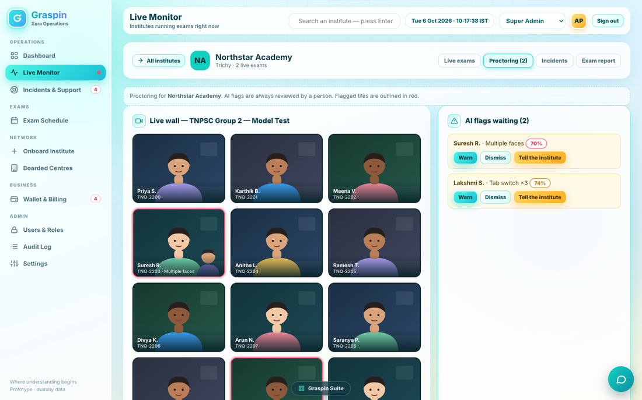
Figure 5. One institute, tab “Proctoring”

6.3 Incidents & Support
Source: rInc, newIncident. Tests: AC-OPS-050 to 059. Capability: incidents.
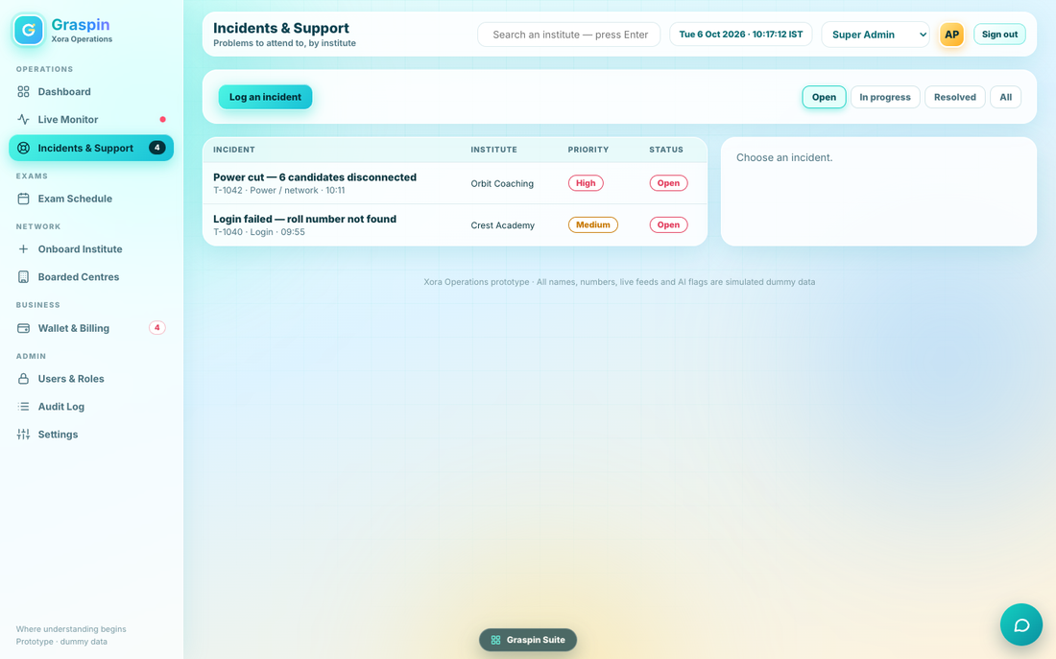
Figure 6. Incidents & Support
- Top card: button “Log an incident” and, on the right, a segmented filter: Open, In progress, Resolved, All. Default Open.
- Left card (list): table with Incident (title in bold; below: id · category · time), Institute, Priority chip (High red, Medium amber, Low grey), Status chip (Open red, In progress blue, Resolved green). The selected row is tinted #EFFFFC. Empty: “Nothing here.”
- Right card (detail): avatar, title, “id · institute · category”; rows Priority, Status, Assigned to, Reported; buttons by state. If nothing is selected: “Choose an incident.”
Status | Buttons | Result
Open | Take it; Email the institute; Resolve; Open the institute | Take it: status In progress, assigned to the signed-in user, toast “Assigned to you”.
In progress | Email the institute; Resolve; Open the institute | Resolve opens the confirm dialog “Resolve this incident?” / “Say what was done.” / verb Resolve; on confirm status Resolved, assignee kept or set to the user, toast “Resolved”.
Resolved | Re-open; Open the institute | Re-open: status In progress.

- Email the institute sends the “Support” email (Part 8) to the institute’s contact, logs “Emailed institute”, and shows toast “Email sent to <address>”.
- Open the institute opens that centre on its Incidents tab.
Log an incident dialog
Field | Rule
Institute | Drop-down of all boarded centres; pre-selected when opened from an institute
Priority | High, Medium (default), Low
What happened? | Text, at least five characters; otherwise the inline error “Describe the problem.”
Category | Power / network, Camera / audio, Login, Exam setup, Other
Buttons | Cancel, Log it. Result: a new incident at the top of the list, status Open, assigned “—”, time now; toast “Incident logged”; audit “Logged incident”.
Incident IDs run T-1043 and upward in creation order, never reused (OPS-BR-050).

6.4 Exam Schedule
Source: rExams, allExams. Tests: AC-OPS-060 to 066. Capability: exams.
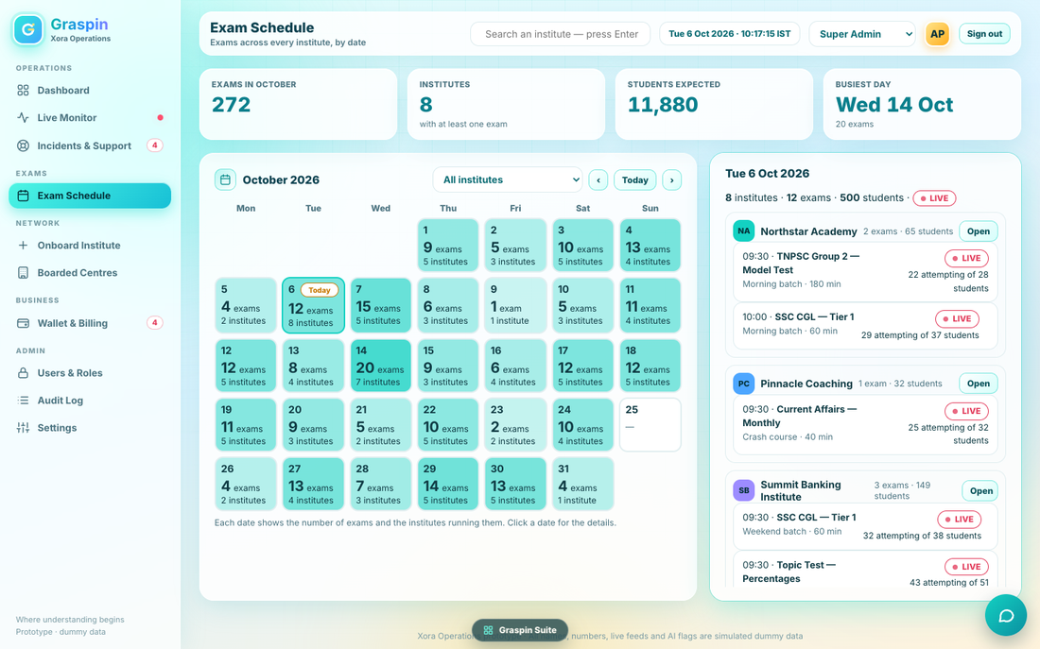
Figure 7. Exam Schedule
- KPI row: Exams in <Month> (count); Institutes (with at least one exam, caption “with at least one exam”); Students expected (sum of registered students); Busiest day (e.g. “25 Sep”, caption “N exams”).
- Calendar card (left): title “<Month> <Year>”; institute filter (All institutes or one centre); buttons ‹, Today, ›. A seven-column grid, weeks starting Monday (Mon to Sun headers). Each date box (minimum height 76 px) shows the date, a “Today” chip on today, and, when there are exams, the count in large type and “N institute(s)”; otherwise a dash. Fill colour rgba(19,209,194, a) with a = min(0.9, 0.18 + count ÷ busiest day × 0.6). Border: turquoise on the selected date, yellow #FFC93C on today, pale otherwise. Caption below: “Each date shows the number of exams and the institutes running them. Click a date for the details.”
- Day panel (right): title the full date; line “N institute(s) · N exam(s) · N students” plus a red LIVE chip when today has live exams. Scrollable list grouped by institute: avatar, name, “N exam(s) · N students”, button Open (opens that centre on its Exams tab). Under each institute its exams by time: time · exam name, group · duration · “real exam” marker, and on the right a status chip (red LIVE, green Done, blue Scheduled) and “N attempting of M students” for live ones. If none: “No exam on this date.”
Rules: exams come from every institute’s real exam records plus, in demo mode only, illustrative sample exams. Status is Done when completed, LIVE when inside its start window and authorised, otherwise Scheduled. Today button returns to the current month and date. Changing month keeps the institute filter.

6.5 Onboard Institute
Source: rOnboard, obWizard, obSteps, obPlanHTML, obPrice, obValidate, obSaveDraft, obSendInvoice, invoiceText, obDrawer, payModal, loginMail. Tests: AC-OPS-070 to 099. Capability: onboard.
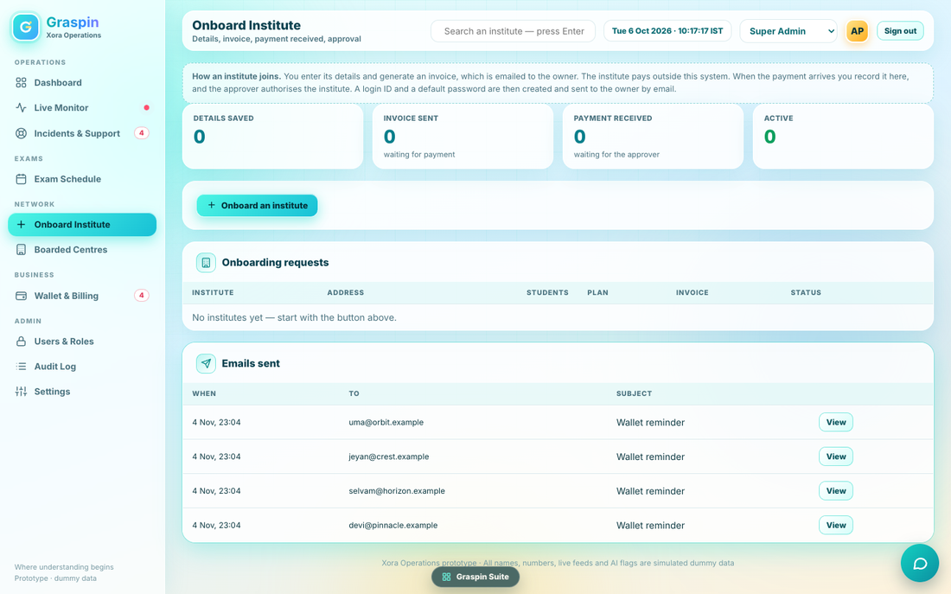
Figure 8. Onboard Institute list
6.5.1 List view
- Callout: “How an institute joins. You enter its details and generate an invoice, which is emailed to the owner. The institute pays outside this system. When the payment arrives you record it here, and the approver authorises the institute. A login ID and a default password are then created and sent to the owner by email.”
- KPI row: Details saved; Invoice sent (“waiting for payment”, amber when above zero); Payment received (“waiting for the approver”, amber when above zero); Active (green).
- Button: “+ Onboard an institute” (disabled for roles without onboard, with the tooltip “Your role cannot onboard institutes”).
- Table “Onboarding requests”: Institute (name bold; below: request id and institute code), Address (city), Students (right aligned), Plan, Invoice (number and total, or a dash), Status chip, Open button. Newest first. Empty: “No institutes yet — start with the button above.” Click a row opens the details drawer.
- Table “Emails sent”: When, To, Subject, View. The eight newest. View opens a dialog with the subject as title, “To: … · when”, and the full text. Empty: “No email sent yet.”
Status chips (exact): Details saved (grey); Invoice sent — awaiting payment (amber); Payment received — awaiting approval (blue); Active (green); Rejected (red); Cancelled (grey).
6.5.2 Wizard step 1: Institute details
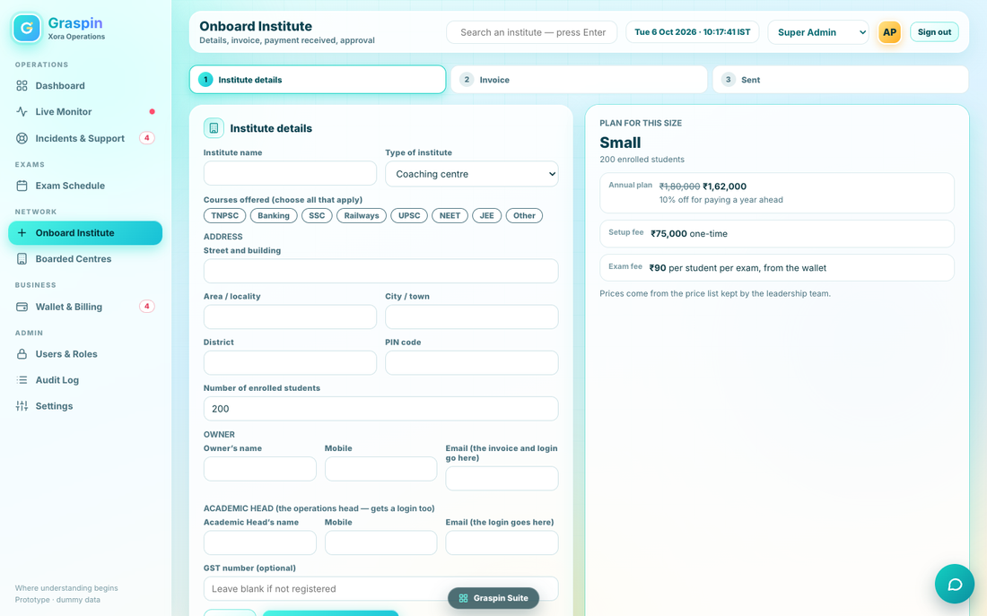
Figure 9. Onboarding wizard, step 1 (details on the left, plan for this size on the right)
A three-step header: 1 Institute details, 2 Invoice, 3 Sent; completed steps show a tick. Step 1 is a card on the left and the plan card on the right.
Section and field | Rule and exact text
Institute name | Text; at least 3 characters
Type of institute | Drop-down: Coaching centre (default), Training academy, College / university, Skill institute, Other
Courses offered (choose all that apply) | Toggle chips: TNPSC, Banking, SSC, Railways, UPSC, NEET, JEE, Other; green when chosen, grey otherwise; at least one required
ADDRESS | Street and building (at least 5 characters); Area / locality; City / town (at least 2); District (at least 2); PIN code (digits only, exactly 6)
Number of enrolled students | Number, minimum 1, default 200; changing it redraws the plan card at once
OWNER | Owner’s name (3+); Mobile (10 digits); Email (“the invoice and login go here”)
ACADEMIC HEAD (the operations head — gets a login too) | Academic Head’s name (3+); Mobile; Email (“the login goes here”). Must differ from the owner’s email.
GST number (optional) | Placeholder “Leave blank if not registered”
Buttons | Cancel (back to the list, discards the unsaved form); “Continue to the invoice ✈” (validates, saves the draft, goes to step 2)

Plan card (“PLAN FOR THIS SIZE”): plan name large, “N enrolled students”; for Small, Medium and Large: rows Annual plan (list price struck through, annual price bold, note “10% off for paying a year ahead”), Setup fee (“one-time”), Exam fee (“per student per exam, from the wallet”); footnote “Prices come from the price list kept by the leadership team.” For Enterprise: an amber callout “Above 1,000 students is an Enterprise plan. Enter the agreed amounts; the Director confirms them at approval.” and three number fields: Agreed annual fee (₹), Setup fee (₹), Exam fee per student (₹).
Validation, in this order (the first failure is shown in red under the form)
# | Message (exact)
1 | Please enter the institute’s name.
2 | Choose at least one course.
3 | Please enter the street and building.
4 | Please enter the city or town.
5 | Please enter the district.
6 | Enter a 6-digit PIN code.
7 | Enter the number of enrolled students.
8 | Please enter the owner’s name.
9 | Enter a valid 10-digit mobile number for the owner.
10 | Enter a valid email for the owner.
11 | Please enter the Academic Head’s name.
12 | Enter a valid 10-digit mobile number for the Academic Head.
13 | Enter a valid email for the Academic Head.
14 | The Academic Head needs an email of their own.
15 | Enter the agreed annual fee and exam fee for the Enterprise plan.

6.5.3 Wizard step 2: Invoice
Left card “Invoice for <institute>”: bill-to line (name, street, area, city, PIN, GST when given) and “Due in N days (by <date>)”; a table with Annual plan — <plan> (paid a year ahead, 10% off), One-time setup fee, First wallet recharge (exam fees at ₹X per student), and Total payable in larger type; note “Taxes are added as applicable.” followed by the payment instructions from Settings. A field “First wallet recharge (₹, minimum ₹25,000)” step 1,000; changing it recalculates. Buttons: Back; “Generate invoice and email it to the owner”. Below 25,000: “The first wallet recharge must be at least ₹25,000.” Right card “WHAT HAPPENS NEXT” with four lines: The invoice is emailed to <owner email>. / The institute pays outside this system and tells us. / You record the payment here; the approver authorises the institute. / The login ID and default password are emailed to the owner.
On generating: the invoice is saved (number INV-2026-NNNN, date today, due date today + due days), the institute status becomes invoice_sent, the history line “Invoice <no> (₹…) emailed to <owner email>” is added, the invoice email is sent (Part 8), audit entry “Invoice <no> sent to <institute>”, toast “Invoice emailed to <owner email>”, and step 3 opens.
6.5.4 Wizard step 3: Sent
A green tick circle, heading “Invoice sent”, text “Invoice <no> for ₹… has been emailed to <owner email>. When <institute> has paid, open this request and record the payment.” and a button “Back to onboarding requests”.
6.5.5 Details drawer (click a row)
Right-hand drawer: institute name; “type · request id · institute code”; status chip; rows Address, Courses, Students (“N enrolled · <plan> plan”), Institute Admin (owner) with mobile and email, Academic Head, Prices (“₹ a year · ₹ setup · ₹ per student”), Invoice (number, total, due), Payment (amount by mode, reference, date). Then, by status, a green callout “Logins created and emailed. Institute Admin <id> · Academic Head <id>” when active, or an amber callout “Not approved: <note>” with “Refunded: ref …” or “The payment has to be refunded outside this system.” when rejected. Then TIMELINE (time and text per history line, oldest first). Buttons by status:
Status | Buttons and effects
draft (Details saved) | Continue to the invoice: reopens the wizard on step 2 with the saved details.
invoice_sent | Record payment received (opens the payment dialog). Resend invoice email: sends the reminder variant, history “Invoice email resent”, toast “Invoice emailed again”. Cancel invoice: confirm dialog “Cancel this invoice?” / “The institute is told the invoice is cancelled.” / verb “Cancel invoice” (amber); on confirm status cancelled, history “Invoice cancelled: <reason>”, cancellation email, audit “Cancelled invoice”, toast “Cancelled”.
awaiting_approval | Text “Waiting for the approver (Director or GM) in the Business Dashboard.” No buttons.
active | Resend login email: emails each of the Owner and the Academic Head their login; toast “Login emails sent again to the Institute Admin and the Academic Head”.
rejected (no refund yet) | Mark refund done: dialog “Mark refund done” with “Refund reference” (at least 4 characters, else “Enter the refund reference.”) and Save; stores reference and time; history “Refund done, ref …”; audit “Refund recorded”; toast “Saved”.
any, with emails | View emails (N): dialog “Emails to <owner email>” listing each email with subject, time and text.

6.5.6 Record the payment dialog
Title “Record the payment received”. Subline “Invoice <no> · <institute> · total ₹…”. Fields: Amount received (₹) pre-filled with the total; Received on (date, not later than today, default today); Mode (NEFT, IMPS, UPI, Cheque, Bank transfer); Reference number. Buttons Cancel and “Record and send for approval”. Errors: “The amount is less than the invoice total of ₹….” / “Enter the payment reference (for example the UTR number).” / “Enter the date received.”
On success, in one transaction: payment stored (status Received, mode, reference, date, amount, total, recorded by); wallet opened with balance equal to the recharge and one ledger line Recharge “First recharge at onboarding (invoice <no>)” carrying the reference and mode; status awaiting_approval; history lines “Payment of ₹… recorded (ref …) by <name>” and “Sent to the approver”; “Payment received” email to the owner; institute audit “Payment recorded for <institute>”; Xora audit “Payment recorded” with “₹… ref …”; toast “Payment recorded — sent to the approver”. The approver’s queue in Volume 2 then shows the institute.

6.6 Boarded Centres
Source: rCentres, rCenDetail, syncCentres. Tests: AC-OPS-100 to 108. Capability: centres.
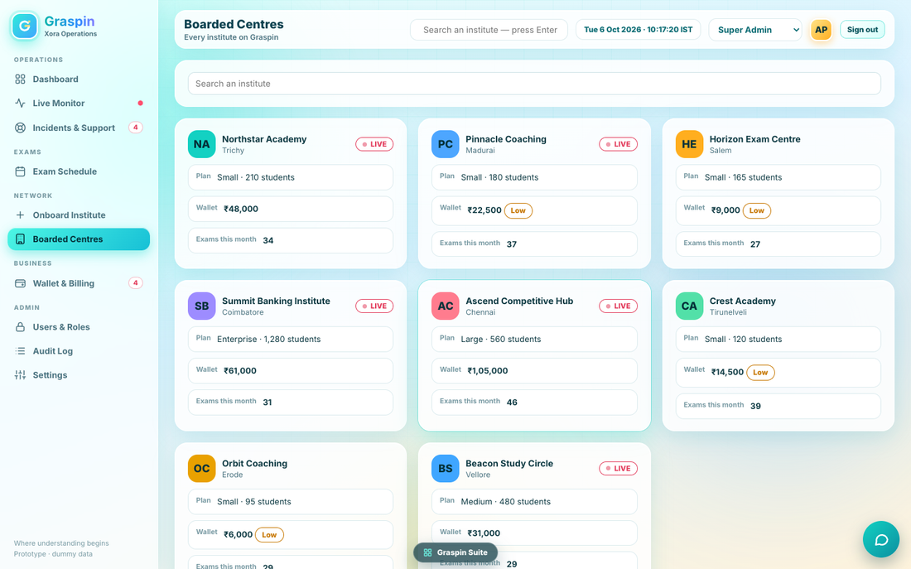
Figure 10. Boarded Centres
- Card with a search box “Search an institute” (matches name or city, live as you type), then a three-column grid of centre cards: avatar, name, city, red LIVE chip when a live exam is running; rows Plan (“Medium · 375 students”), Wallet (available amount bold plus an amber “Low” chip when below the reminder level), Exams this month (count).
- Plan name: fewer than 250 Small; 250 to 500 Medium; to 1,000 Large; above Enterprise.
- Click a card opens its detail page: header card with button “← All centres”, avatar, name, city, and tabs Profile, Wallet, Exams, Incidents, Billing.
Tab | Content
Profile | Rows: Address; Owner (name, email · phone, shown masked as “98xxx 12345”); Enrolled students (“N (Plan plan)”); On Graspin since; Prices charged (“₹ a year · ₹ setup · ₹ per student per exam”, note “Set by the leadership team in the Business Dashboard”; Enterprise shows only the exam fee if no annual fee); Institute ID when the centre is real.
Wallet | KPIs: Balance; Set aside for exams; Available (caption “below ₹25,000 — reminder sent” amber, or “above the reminder level” green). Table When, Entry (type and note), Amount (green with + for credits, red with − for charges). Hold entries are not shown. Empty: “No entries.”
Exams | Table (up to 40 newest first): Date and time, Exam (blue “real” chip when real), Group, Students, Status chip. Note “Student results and statistics are in the institute’s own dashboard.”
Incidents | Card “Incidents” with button “Log an incident” and the institute’s incidents; click opens Incidents & Support.
Billing | For a real institute: Onboarding invoice (number, total, issue date), Payment (amount, mode, reference, date), Annual plan renews (activation date plus 365 days). For others: “Onboarded in <month year>. The onboarding invoice was paid.”
PROD: owner phone is masked on screen (first two digits, “xxx”, last five digits) and shown in full only to Super Admin and Finance (D1-1, final). The masking is applied in the API response, not only on screen.

6.7 Wallet & Billing
Source: rWal, walletSweep, lowCentres. Tests: AC-OPS-110 to 119. Capability: wallet.
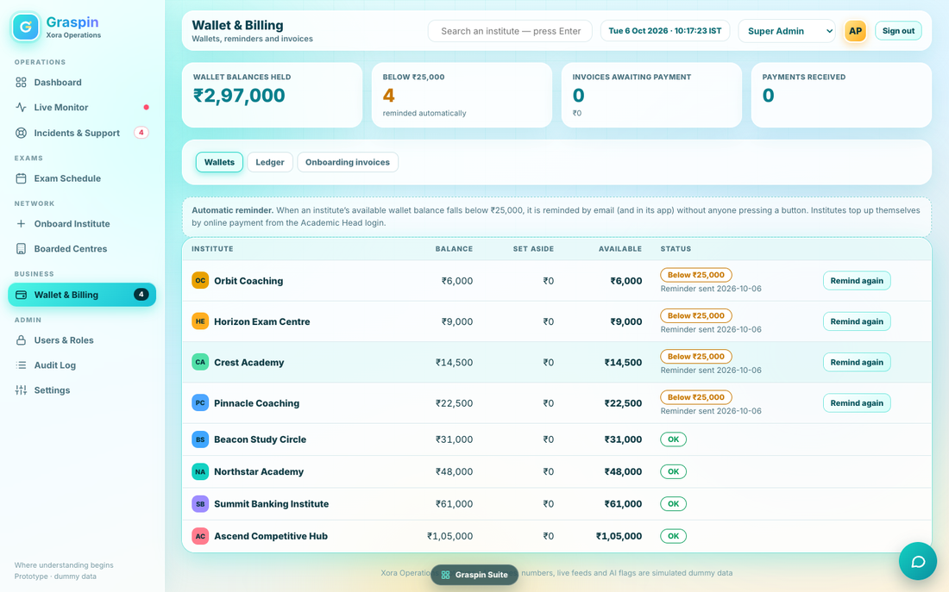
Figure 11. Wallet & Billing
- KPI row: Wallet balances held (sum of balances); Below ₹25,000 (count, “reminded automatically”, amber when above zero); Invoices awaiting payment (count and total value); Payments received (count).
- Tabs (segmented): Wallets, Ledger, Onboarding invoices.
- Wallets tab: callout “Automatic reminder. When an institute’s available wallet balance falls below ₹25,000, it is reminded by email (and in its app) without anyone pressing a button. Institutes top up themselves by online payment from the Academic Head login.” Table: Institute (avatar, name), Balance, Set aside, Available (bold), Status (green OK, or amber “Below ₹25,000” with “Reminder sent <date>”), and a “Remind again” button on low rows. Sorted by available amount, lowest first.
- Ledger tab: all wallet entries from every institute: When, Institute, Entry (type, note), Amount (+ green, − red). Types shown: Recharge as “Top-up”, Charge as “Exam usage”. Hold entries are hidden.
- Onboarding invoices tab: Invoice (number, “due <date>”), Institute, Total, Status chip. Click opens the Onboard page with that institute’s drawer.
Remind again sends the manual wallet reminder email (Part 8), logs “Wallet reminder sent — Manual”, and shows toast “Reminder emailed”.
Automatic reminder rule (OPS-BR-060)
For every centre: available = balance − set aside. If available is below the threshold in Settings and no reminder has been sent since it last dropped, send the automatic reminder email to the centre’s contact, send an in-app notification to the institute’s Academic Head and to the Owner (“Wallet below ₹25,000”), record the reminder date, and write the audit entry “Wallet reminder sent — Automatic — below ₹25,000”. If available is at or above the threshold, clear the reminder date so a later drop reminds again. The check runs when the console starts, when settings are saved, every 30 seconds while open, and on every wallet change event; production also runs it on the server every five minutes.

6.8 Users & Roles
Source: rUsers, admUser, ADM_USERS, CAPN. Tests: AC-OPS-120 to 129. Capability: users.
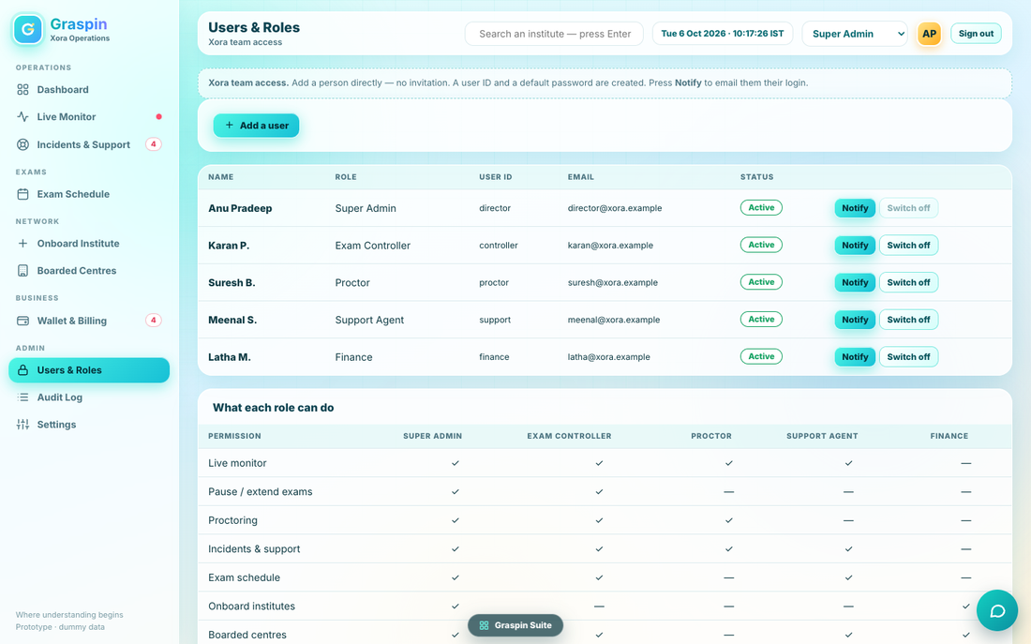
Figure 12. Users & Roles
- Callout: “Xora team access. Add a person directly — no invitation. A user ID and a default password are created. Press Notify to email them their login.”
- Button “+ Add a user”. Dialog “Add a user”: Full name (3+), Role (Super Admin, Exam Controller, Proctor, Support Agent, Finance), Email, Mobile. Errors: “Enter the full name.” / “Enter a valid email.” / “Enter a valid 10-digit mobile.” Note: “A user ID and default password are created now. They are emailed only when you press Notify.” Buttons Cancel and Add user.
- ID creation: the part of the email before “@”, lower-cased, keeping only letters, digits and dots; if taken, append 2, 3 and so on. Default password: Xora@ and four random digits. Toast “Added — press Notify to email the login”; audit “Added user” with “<name> · <role>”.
- Table: Name, Role, User ID, Email, Status (green Active or grey Switched off, and “login emailed” once notified), and buttons Notify and Switch off / Switch on. The Director’s row cannot be switched off. Notify sends the “Xora team login” email, toast “Login emailed to <address>”, audit “Notified user”. Switch on or off audits “Switched on user” or “Switched off user”.
- Card “What each role can do”: a grid of the nine capabilities against the five roles with ticks and dashes, read from the capability table.
PROD: the prototype shows the initial password in the email and stores it readable. Production stores only a hash, sends a one-time default password by email on Notify, and forces a change at first sign-in (DO NOT COPY the plain storage). A switched-off user cannot sign in and has all sessions ended at once.

6.9 Audit Log
Source: rAud, log. Tests: AC-OPS-130 to 133. Capability: none; every Xora role may read.
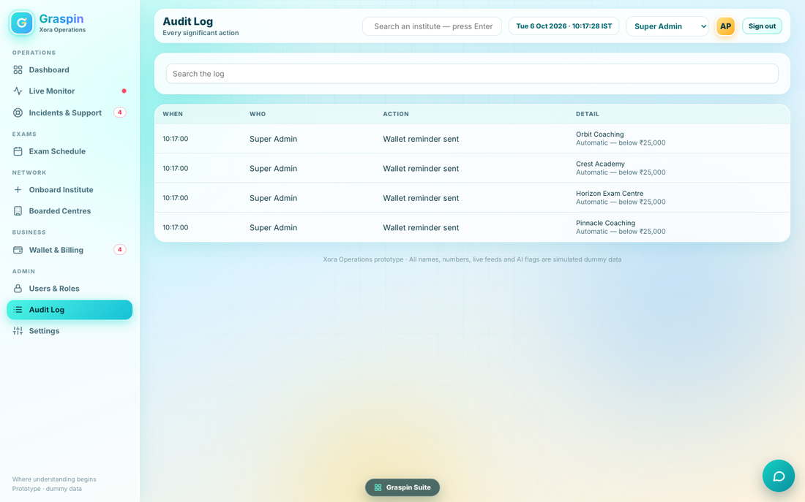
Figure 13. Audit Log
A card with a search box “Search the log” (matches person, action and detail as you type), and a table with columns When, Who, Action, Detail (the detail text and, beneath it in muted type, the reason). The newest 200 entries are listed; empty: “Nothing logged yet.” The list merges two sources: actions taken in this console (who is the role name in the prototype; production shows the person’s name and role) and actions taken inside institutes, which show “In an institute” as the reason when none was given.
Entries are written by every action marked “Audit” in this volume. The complete list of action names used by the prototype: Invoice sent, Payment recorded, Cancelled invoice, Refund recorded, Added user, Notified user, Switched on user, Switched off user, Saved settings, Reviewed exam cut-off references, Wallet reminder sent, Logged incident, Took incident, Resolved incident, Emailed institute, Paused exam, Resumed exam, Extended exam by 10 min, AI flag warn, AI flag dismiss, AI flag escalate, Downloaded live exam report, Changed own password. Production adds: Signed in, Signed out, Failed sign-in, Locked out, Switched role view.

6.10 Settings
Source: rSet. Tests: AC-OPS-140 to 152. Capability: users (Super Admin only).
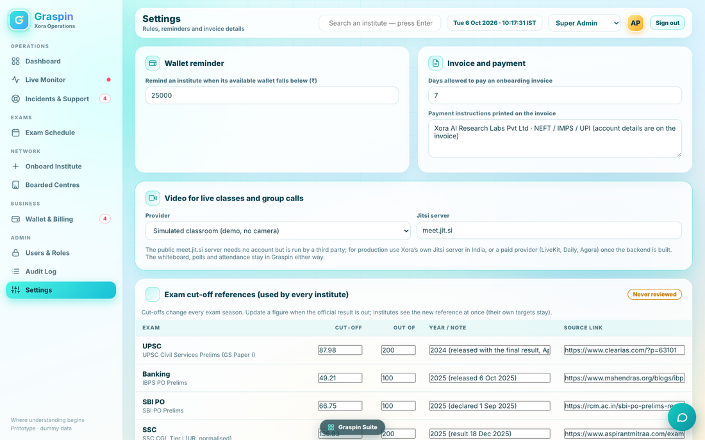
Figure 14. Settings (top of page)
Card | Fields and rules
Wallet reminder | “Remind an institute when its available wallet falls below (₹)”: number, minimum 1,000, step 1,000, default 25,000
Invoice and payment | “Days allowed to pay an onboarding invoice”: 1 to 60, default 7. “Payment instructions printed on the invoice”: text, default “Xora AI Research Labs Pvt Ltd · NEFT / IMPS / UPI (account details are on the invoice)”
Video for live classes and group calls | Provider drop-down: “Simulated classroom (demo, no camera)” or “Jitsi Meet — real video, opens full screen”; “Jitsi server” text, default meet.jit.si. Note: “The public meet.jit.si server needs no account but is run by a third party; for production use Xora’s own Jitsi server in India, or a paid provider (LiveKit, Daily, Agora) once the backend is built. The whiteboard, polls and attendance stay in Graspin either way.” PROD (D0-1, final): production offers one provider, “LiveKit — Xora video (India)”, with the server text read-only; “Simulated classroom (demo, no camera)” is offered only in local, preview and staging; Jitsi and the public meet.jit.si server are never offered, and this note is not shown.
Exam cut-off references (used by every institute) | Chip “Never reviewed” or “Reviewed N days ago” (amber when never or over 180 days, green otherwise). Note: “Cut-offs change every exam season. Update a figure when the official result is out; institutes see the new reference at once (their own targets stay).” Table, one row per exam type held in the reference list (UPSC, Banking, SBI PO and others): Exam (type and full name), Cut-off (number), Out of (number), Year / note, Source link. Button “Save and mark as reviewed today”: saves all rows, stamps the review time, audit “Reviewed exam cut-off references”, toast “Cut-off references saved and marked as reviewed”.
Proctoring rules | Seven switches with a bold name and a muted line: Multiple faces (Flag when more than one person is in view); Face not visible (Flag when no face is seen); Tab switching (Flag repeated switches away); Phone detected (Flag a phone in view); Voice detected (Flag speech); ID mismatch (Flag a face that does not match the ID); Looking away (Flag long glances away). Defaults: all on except Looking away.
Save and password | Button “Save settings” saves reminder level, due days, payment text and video settings, writes audit “Saved settings”, runs the wallet sweep, toast “Saved”; invalid numbers show warning “Check the numbers”. Card “My password” with Current, New, Again, button “Change my password” (messages in Volume 0 Part 6.3); audit “Changed own password”.
Proctoring switches apply immediately when toggled in the prototype and are saved with the page; in production each switch saves with “Save settings” and is read by the proctoring service. The seven switches map to flag types in Volume 0 Part 8.6.

Part 7. Module business rules (OPS-BR)
Rules BR-001 to BR-032 in Volume 0 also apply. These are specific to this console. Implement each in packages/core (or the ops service layer for those with database effects) with a unit test named after the ID.
ID | Rule | Where it shows
OPS-BR-001 | Onboarding status machine: draft → invoice_sent → awaiting_approval → active. From invoice_sent: → cancelled. From awaiting_approval: → rejected (by approver). No other move is allowed; the API refuses it. | Onboard list, drawer
OPS-BR-002 | Saving details creates the request (OB-NNNN) in draft with a history line “Details entered by <name>”. Details can be edited only while the request is in draft. Once an invoice exists, details change only by cancelling the invoice and starting a new request (D1-2, final: the prototype lets a draft reopen on step 2 only; production keeps that only while no invoice exists). | Wizard
OPS-BR-003 | The wallet of a new institute starts with balance 0 and no entries, and is credited only when the payment is recorded. | Wizard, payment
OPS-BR-004 | The invoice number is reused when the invoice is regenerated for the same request; a new number is issued only for a new request. | Invoice
OPS-BR-005 | Payment amount must be at least the invoice total. Overpayment is allowed and recorded as entered; the wallet is credited with the recharge amount only (the difference is reported to Finance in the audit detail) (D1-3, final: shown to Finance as an “Unapplied payment”, refunded or credited within 7 days). | Payment dialog
OPS-BR-006 | A payment reference must be unique across institutes in production; a duplicate reference shows “This reference is already recorded.” (PROD). | Payment dialog
OPS-BR-010 | Only the Super Admin may add users or change settings. Finance may onboard and record payments. Nobody but the Super Admin sees Settings. | Capabilities
OPS-BR-011 | The Director’s account (director) cannot be switched off. At least one active Super Admin must always exist. | Users
OPS-BR-020 | Needs-attention items: unresolved High or Medium incidents, and institutes with pending flags (red above three). | Dashboard
OPS-BR-030 | Pause and Resume toggle without a reason; +10 minutes needs a reason; all three are audited. | Live Monitor
OPS-BR-031 | A live exam may be extended many times; the end time moves by 10 minutes each time and the student timer follows (PROD). | Live Monitor
OPS-BR-032 | Only Exam Controller and Super Admin may pause, resume or extend. Proctors may decide on flags but not pause. | Capabilities
OPS-BR-033 | A flag decision is final for that flag; a second decision on the same flag is refused. Warned and escalated flags leave the waiting list; so do dismissed ones. | Proctoring
OPS-BR-034 | Tell the institute emails the centre contact and creates an in-app notification for the institute’s Academic Head (PROD). | Proctoring
OPS-BR-035 | Proctoring detection thresholds come from Settings: absent 10 seconds, tab switches 3. | Settings
OPS-BR-036 | Disconnected means no heartbeat for 20 seconds (D1-4, final: setting heartbeatTimeoutSeconds, default 20, allowed 10 to 60; the browser sends a heartbeat every 5 seconds; the prototype only simulates the number). | Live Monitor
OPS-BR-050 | Incident IDs are sequential from T-1043 and never reused. | Incidents
OPS-BR-051 | Take it moves Open to In progress and assigns the signed-in user. Resolve requires a reason. Re-open returns to In progress. | Incidents
OPS-BR-060 | Wallet reminder fires once per drop below the threshold and re-arms on recovery (see 6.7). | Wallet
OPS-BR-070 | Calendar weeks start on Monday; shading follows 0.18 + count ÷ busiest × 0.6 capped at 0.9. | Exam Schedule
OPS-BR-080 | Cut-off references are global; saving stamps the review time. The dashboard banner appears when never reviewed or older than 180 days. | Settings, Dashboard
OPS-BR-090 | Every email is written to the outbox before sending; the Emails sent table shows the eight newest. | Onboard

Part 8. Email templates (word for word)
Replace the words in angle brackets with the real values. Keep line breaks as shown. “₹…” is Indian grouping, e.g. ₹3,02,400. Dates read “6 Oct 2026”. These are the texts the prototype sends; PROD changes are noted underneath.
8.1 Invoice (also the reminder: subject adds “ (reminder)”)
Subject: Invoice <no> for Graspin onboarding

Invoice <no>
Date: <date> Due: <due date>

Bill to: <institute name>
<street>, <area>
<city>, <district> — <PIN>
GST: <GST number> (this line only when a GST number was entered)

• Annual plan — <plan> (paid a year ahead): <₹…>
• One-time setup fee: <₹…>
• First wallet recharge: <₹…>

Total payable: <₹…> (including GST)
Taxable value: <₹…>
CGST 9%: <₹…> SGST 9%: <₹…> (or, outside Tamil Nadu: IGST 18%: <₹…>)
Xora GST number: <Xora GST number>

How to pay: <payment instructions from Settings>
Please quote <no> as the reference and let us know once the payment is made.

Xora AI Research Labs Pvt Ltd, Chennai
[PROD] (D0-5, final): the tax lines and Xora’s GST number are added; “(taxes as applicable)” becomes “(including GST)”. Amounts: taxable = round(total ÷ 1.18), GST = total − taxable, see BR-016. The same lines are added to the payment receipt PDF and to the reminder.

8.2 Invoice cancelled
Subject: Invoice <no> cancelled

The invoice <no> has been cancelled. Reason: <reason>

8.3 Payment received
Subject: Payment received — <no>

We have received <₹…> (reference <ref>) against invoice <no>. Your onboarding is now with our approver. Your login ID and default password will be emailed to you once it is authorised.

8.4a Login for the Institute Admin (Owner)
Subject: Your Graspin login

Welcome to Graspin, <first name>!

<institute name> is now live. You are the Institute Admin: you see every dashboard of your institute.

User ID: <id>
Default password: <password>

Please sign in to Institute Admin and change your password. Your Academic Head has been sent a login of their own.

Xora AI Research Labs
[PROD] the password is a one-time default; the first sign-in forces a change.

8.4b Login for the Academic Head
Subject: Your Graspin login

Welcome to Graspin, <first name>!

You are the Academic Head of <institute name>: you run the institute day to day, create the coaches and batches, and keep in touch with the Institute Admin.

User ID: <id>
Default password: <password>

Please sign in to Institute Academic Head and change your password.

Xora AI Research Labs

8.5a Wallet reminder, automatic
Subject: Wallet reminder

Graspin reminder: the wallet of <institute name> has <₹…> available, below <₹ threshold>. Please top it up from the Academic Head login so that new exams can be approved.

8.5b Wallet reminder, Remind again
Subject: Wallet reminder

Graspin reminder: the wallet of <institute name> has <₹…> available. Please top it up from the Academic Head login.

8.6 Exam incident (Tell the institute)
Subject: Exam incident

Graspin: during the live exam, a candidate was flagged (<flag type>). Please check the centre.

8.7 Support update (Email the institute)
Subject: Support: <incident id>

Graspin support: we are looking into "<incident title>" and will keep you updated.

8.8 Xora team login (Notify)
Subject: Your Graspin admin login

Hello <name>,

You have been added to the Graspin Admin Console as <role>.

User ID: <id>
Password: <password>

Please sign in and change your password.

Xora AI Research Labs

Part 9. Data, API and realtime contract
REST with JSON, under /api/ops. Every route checks the signed-in user, the capability in brackets, and writes the audit entry named in this volume in the same transaction as the change. Errors return a short code and the exact user-facing message from this volume. All lists accept page and size and return a total.
Route | Purpose | Capability
POST /auth/login, /auth/logout, /auth/password | Sign in, sign out, change own password | —
GET /dashboard | All dashboard blocks in one payload | —
GET /monitor | Live institutes and totals | monitor
GET /monitor/:instituteId | Live exams, alerts, flags, incidents, report | monitor
POST /exams/:id/pause, /resume | Toggle pause | control
POST /exams/:id/extend {minutes:10, reason} | Extend | control
POST /flags/:id/decision {action: warn, dismiss, escalate} | Decide a flag | proctor
GET /monitor/:instituteId/report.csv | Live report download | monitor
GET /incidents?status= | List incidents | incidents
POST /incidents | Log an incident | incidents
POST /incidents/:id/take, /resolve {reason}, /reopen, /email | Incident actions | incidents
GET /exams/calendar?month=&institute= | Calendar counts and a day’s exams | exams
GET /onboarding, GET /onboarding/:id | List and drawer data (with history and emails) | onboard
POST /onboarding | Save details (draft) | onboard
PUT /onboarding/:id | Update draft | onboard
POST /onboarding/:id/invoice | Generate and email the invoice | onboard
POST /onboarding/:id/invoice/resend, /cancel {reason} | Resend or cancel | onboard
POST /onboarding/:id/payment | Record payment | onboard
POST /onboarding/:id/logins/resend | Resend login emails | onboard
POST /onboarding/:id/refund {reference} | Mark refund done | onboard
GET /mail?limit=8 | Emails sent list | onboard
GET /centres?q=, GET /centres/:id/(profile, wallet, exams, incidents, billing) | Centres | centres
GET /wallets, /ledger, /invoices | Wallet & Billing tabs | wallet
POST /wallets/:instituteId/remind | Remind again | wallet
GET/POST /users, POST /users/:id/notify, /toggle | Xora team | users
GET /audit?q= | Audit list | —
GET/PUT /settings, GET/PUT /cutoffs | Settings and cut-off references | users

Approval is not in this API: Volume 2 provides POST /api/biz/approvals/:id/approve and /reject. Approval creates the Owner and Academic Head users (default passwords), sets the institute code and activation date, sets status active, and sends the two login emails. Rejection stores the note and sets status rejected.
Realtime events published by this module’s services are listed in Volume 0 Part 10.4. A screen subscribes to: dashboard (all), monitor (exam.live, flag.*, incident.*), incidents (incident.*), schedule (exam.live, institute.status), onboard (institute.status, mail.sent), centres and wallet (wallet.changed, institute.status), users (user.changed).

Part 10. What the prototype simulates and what production uses
The prototype runs a small simulation so the screens look alive. Production must replace each simulated item with a real source. Do not ship the simulation. It may be kept for the demo environment only (GRASPIN_DEMO=1).
Simulated in the prototype | How it works there | Production source
Sample institutes (14 illustrative centres) and their wallets, incidents, exam calendar | Built by code at start-up | Real institute records. Demo data only when GRASPIN_DEMO=1.
Live exam counts (not joined, in progress, submitted, disconnected, slow) | A timer every 2 seconds nudges random numbers | Attempt records and heartbeat: not joined = registered − started; in progress = started − submitted; disconnected = no heartbeat for 20 seconds; slow = round-trip time above a set limit.
AI flags | A new flag appears every 8 seconds, up to 14 waiting | Proctoring service posts a flag {attemptId, type, confidence, snapshot, time}. Flags use the thresholds in Settings.
Camera wall | Drawn cartoon faces | Release 1.0 (D1-5, final): the student’s initials on a coloured disc, the name and the status chip, in the prototype’s tile layout. No camera or picture is requested or stored. Snapshots arrive with the proctored-exam mode of release 1.1.
System-health sparklines | Random walk | Metrics from the monitoring system: connected students, latency, error rate.
Alerts feed | Random messages every 20 seconds | Events from the platform: network quality drops, reconnect waves, autosave health.
Clock | Fixed to Tue 6 Oct 2026 and counting | Real time, IST.
Passwords and users | Plain text in browser storage | Hashed in the database.
Email | A record in a list | Mail provider with delivery status.
Pause, extend | Changes a number on sample exams only | Server-side exam state honoured by the Student App.

Why this matters
If the assistant copies the simulation, the console looks right but reports invented numbers to real operators during real exams. The production test AC-OPS-046 starts a real attempt in the Student App and confirms it appears in the Live Monitor within 2 seconds.

Part 11. Prototype defects not to copy
# | Prototype behaviour | Production behaviour
1 | Passwords stored and compared in plain text; default password shown in emails and the Users list logic | Hash; one-time default; forced change
2 | Incident ID built from list length: T-(1043 + count − 6) | Database sequence
3 | Role name stored as the actor in the Xora audit log | Person name and role
4 | Settings changes in proctoring switches apply in memory only | Saved to the database and read by the proctoring service
5 | Wallet figures copied between the store and a console cache | Single source: the wallet tables
6 | Home “Today” button jumps to October 2026 | Jumps to the current month and day
7 | Pause and extend on sample exams only | All live exams
8 | Duplicate key head in the drawer’s “Continue to the invoice” code | Not applicable; implement the intended behaviour
9 | Checks run in the browser only (for example payment amount) | The server re-checks every rule
10 | Test-login hint box on the sign-in page | Shown in non-production environments only

Part 12. Acceptance tests (AC-OPS)
Run with the seed data and the shared logins from Volume 0 Part 13. “Demo mode” means GRASPIN_DEMO=1. Each test must pass in the browser and, where it changes data, be confirmed in the database. Numbers inside a range not listed here are reserved for tests the assistant adds; add them to this table in the pull request.
Shell, sign-in and capabilities
ID | Do this | Expect
AC-OPS-001 | Open /dashboard signed out | Sign-in page shows; no data loads
AC-OPS-002 | Sign in as director / Xora@2026 | Toast “Signed in · Anu Pradeep, Super Admin”; Dashboard opens
AC-OPS-003 | Sign in with a wrong password; with empty fields | “User ID or password is incorrect.”; “Please enter your user ID and password.”
AC-OPS-004 | Click Forgot password? | Dialog text exactly as in Part 4
AC-OPS-005 | Sign in as each of the six Xora users | Menu shows lock icons exactly per the capability table
AC-OPS-006 | As finance open /monitor by typing the address | No-access panel; API call returns 403
AC-OPS-007 | As director choose role Proctor in the switcher | Screens behave as Proctor; server rights unchanged; audit records the director
AC-OPS-008 | Type “Pinnacle” in the search box and press Enter | Pinnacle Coaching opens on its Profile tab
AC-OPS-009 | Press Sign out | Signed out; back button does not show data
AC-OPS-010 | Navigation badges | Incidents shows unresolved count; Wallet shows low count; Live Monitor shows red dot
Dashboard
ID | Do this | Expect
AC-OPS-020 | Seed demo data and open Dashboard | Six KPI tiles with values equal to database counts
AC-OPS-021 | Cut-off banner | Shows when never reviewed; disappears after saving cut-offs; returns after 181 days
AC-OPS-022 | Click an institute tile | Opens that institute in Live Monitor
AC-OPS-023 | Needs attention ordering | Red items first; counts match incidents and flags
AC-OPS-024 | Click an attention row of type Incident, then of type Proctoring | Opens Incidents with it selected; opens the institute’s Proctoring tab
AC-OPS-025 | Wallets card | Six lowest available amounts; chip “Reminder sent” only below the level
AC-OPS-026 | Next 7 days | Seven boxes from today; counts match schedule; click opens that date
AC-OPS-027 | Record a payment in another tab | Onboarding KPI updates within 2 seconds without reload
Live Monitor
ID | Do this | Expect
AC-OPS-030 | Open Live Monitor with five live institutes | Seven KPI tiles; five tiles; border colours per rule
AC-OPS-031 | Open an institute | Header, four tabs, “← All institutes” returns
AC-OPS-032 | Live exams tab columns and stacked bar | Exactly as Part 6.2.3
AC-OPS-033 | Pause then Resume as Exam Controller | Status chip changes; toasts; audit entries; the exam clock in the Student App stops and resumes
AC-OPS-034 | +10 min with an empty reason | Warning toast “Please add a reason”; dialog stays open
AC-OPS-035 | +10 min with a reason | Chip “+10 min”; audit with the reason; end time moves 10 minutes
AC-OPS-036 | As Proctor press Pause | Button disabled; API refuses
AC-OPS-037 | Proctoring tab as Proctor | Wall of tiles; flagged tiles red; waiting list with three buttons
AC-OPS-038 | Warn, Dismiss, Tell the institute on three flags | Toasts as specified; flags leave the list; audit; one email in the outbox for Tell
AC-OPS-039 | Decide the same flag twice (two browsers) | Second is refused
AC-OPS-040 | Click a candidate tile | Dialog with larger view and caption
AC-OPS-041 | Incidents tab: Log an incident | Dialog opens with this institute selected
AC-OPS-042 | Exam report tab | Four KPIs and three bars per exam
AC-OPS-043 | Download live report | CSV with the exact header and one row per live exam; audit entry
AC-OPS-044 | Disconnect a student’s network for 25 seconds | Disconnected count rises, then falls on reconnect
AC-OPS-045 | Later today card | Lists institutes with exams still scheduled today and none live
AC-OPS-046 | Start a real attempt in the Student App | Appears in Live Monitor within 2 seconds as a “Real exam from the institute”
Incidents & Support
ID | Do this | Expect
AC-OPS-050 | Open with filter Open | Only Open incidents; default filter
AC-OPS-051 | Log an incident with fewer than 5 characters | “Describe the problem.”; dialog stays open
AC-OPS-052 | Log a valid incident | Appears at top; ID is next in sequence; toast; audit
AC-OPS-053 | Take it | Status In progress; assigned to the user; toast “Assigned to you”
AC-OPS-054 | Resolve without a reason | Blocked
AC-OPS-055 | Resolve with a reason | Status Resolved; toast; audit
AC-OPS-056 | Re-open a resolved incident | In progress
AC-OPS-057 | Email the institute | Outbox row with the support text; toast with the address
AC-OPS-058 | Open the institute | Centre opens on its Incidents tab
AC-OPS-059 | Support Agent and Proctor can log; Finance cannot see the page | As capabilities
Exam Schedule
ID | Do this | Expect
AC-OPS-060 | Open the current month | Weeks start Monday; today highlighted; counts per day
AC-OPS-061 | Click a date | Right panel groups by institute with times and chips
AC-OPS-062 | Filter by one institute | Counts and KPIs recalculate
AC-OPS-063 | Month arrows and Today | Navigate and return
AC-OPS-064 | Open on an institute in the day panel | Centre opens on Exams tab
AC-OPS-065 | Shading | Busiest day is darkest (alpha 0.78 cap rule)
AC-OPS-066 | Create a real exam in the institute console | It appears on its date within 2 seconds

Onboard Institute
ID | Do this | Expect
AC-OPS-070 | Open as Finance; as Support Agent | Finance sees an enabled button; Support Agent sees a lock
AC-OPS-071 | Open the wizard and submit empty | Message 1 of the list; each later message shows in order when the earlier ones are fixed
AC-OPS-072 | Use the same email for owner and Academic Head | “The Academic Head needs an email of their own.”
AC-OPS-073 | Enter 200, 375, 800, 1,200 students | Plan card shows Small, Medium, Large, Enterprise with BR-001 and BR-002 figures
AC-OPS-074 | Enterprise without fees | Message 15
AC-OPS-075 | Continue to the invoice | Request saved as draft with an OB- ID and history line
AC-OPS-076 | Enter recharge 20,000 | “The first wallet recharge must be at least ₹25,000.”
AC-OPS-077 | Generate the invoice | Status invoice_sent; INV- number; email in outbox with exact text; toast; step 3 shows
AC-OPS-078 | Open the drawer on that request | All rows and the timeline correct; buttons per status
AC-OPS-079 | Resend invoice | Reminder subject variant sent; toast
AC-OPS-080 | Cancel invoice without a reason, then with one | Blocked, then cancelled with email and audit
AC-OPS-081 | Record payment below the total | “The amount is less than the invoice total of ₹….”
AC-OPS-082 | Record payment with a 3-character reference | Reference message
AC-OPS-083 | Record a valid payment | Status awaiting_approval; wallet equals the recharge with one ledger line; email; two audits; toast
AC-OPS-084 | Approve in the Business Dashboard | Status active; two users created; two login emails; Centres, Wallet, Schedule show the institute
AC-OPS-085 | Resend login email on an active request | Two emails; toast text exact
AC-OPS-086 | Reject in the Business Dashboard then Mark refund done | Callout text; refund stored; history; audit
AC-OPS-087 | Emails sent table | Eight newest; View shows full text
AC-OPS-088 | Try to skip a status by API | Refused
Boarded Centres, Wallet & Billing
ID | Do this | Expect
AC-OPS-100 | Search “pinn” | Only matching centres; live while typing
AC-OPS-101 | Open a centre; check five tabs | Content per Part 6.6
AC-OPS-102 | Wallet tab entries | Credits green with +, charges red with −, holds hidden
AC-OPS-103 | Billing tab for a real institute | Invoice, payment, renewal = activation + 365 days
AC-OPS-110 | Wallet KPIs | Sum of balances, low count, awaiting invoices and value, payments received
AC-OPS-111 | Lower an institute’s available below 25,000 | One automatic email and one in-app notice to Head and Owner; chip shows; nav badge increments; audit
AC-OPS-112 | Stay below for several sweeps | No second email
AC-OPS-113 | Raise the balance above 25,000, then drop again | A new reminder is sent
AC-OPS-114 | Press Remind again | Manual email text; toast “Reminder emailed”; audit “Manual”
AC-OPS-115 | Change the level in Settings to 40,000 and save | Sweep runs; counts change
AC-OPS-116 | Ledger and Onboarding invoices tabs | Entries and statuses; invoice click opens the drawer
Users, Audit, Settings
ID | Do this | Expect
AC-OPS-120 | Add a user with a bad email, name, mobile | The three inline messages
AC-OPS-121 | Add “Priya Nair priya@xora.example” | ID priya; second “priya@…” becomes priya2; password Xora@ + 4 digits
AC-OPS-122 | Press Notify | Email text exact; “login emailed” marker; toast; audit
AC-OPS-123 | Switch a user off | Cannot sign in; sessions end; audit. The director’s switch is disabled
AC-OPS-124 | Role grid | Equals the capability table
AC-OPS-130 | Search the log | Filters live; reason shown under detail
AC-OPS-131 | Do three actions | Three entries, newest first, with person and role
AC-OPS-132 | Institute actions | Appear with “In an institute”
AC-OPS-133 | Try to edit or delete an entry via API | Refused
AC-OPS-140 | Save settings with 500 as level | Warning “Check the numbers”
AC-OPS-141 | Save valid settings | Toast “Saved”; audit; sweep runs
AC-OPS-142 | Save cut-offs | Toast; chip “Reviewed 0 days ago”; banner on Dashboard disappears
AC-OPS-143 | Change my password with wrong current / mismatch / weak | Three exact messages
AC-OPS-144 | Proctoring switches | Saved and read by the proctoring service (test with a flag that depends on a switch)
AC-OPS-150 | As Exam Controller open Settings | No-access panel; API 403

Part 13. Prompt sequence for Module 1
Run these in order after Volume 0 prompts P0.1 to P0.9 are merged. One prompt per session. Each ends with a report; do not start the next until the report is reviewed. Every prompt begins with the same read-first rule: open the prototype function before building.
PROMPT P1.0 Read, summarise and ask (no code)
ROLE: You are a senior engineer about to build the Xora Operations console. Follow
CLAUDE.md.
READ FIRST: docs/build-packs Volume 0 and Volume 1 in full;
reference/prototype/1_Xora_Operations.html (every function named in Volume 1 Part 2); every
PNG in reference/screens/module-1.
TASK:
1. Write docs/specs/ops.md: a screen-by-screen digest in your own words (one section per
screen) that lists every element, action, message and rule. It must be complete enough that
someone could rebuild the screen without the Word pack.
2. Write docs/specs/ops.screens.json: for each screen, route, prototype hash, steps to reach
each state, mask selectors for the parity harness.
3. List every place where the Word pack and the prototype disagree, and every place the pack
says PROD that needs a human answer, in docs/questions.md. DECISION items are final (Volume
00); do not list them.
CONSTRAINTS: write no application code in this step.
DONE WHEN: the digest covers all ten screens, the sign-in page and the four monitor tabs.
REPORT: docs/parity/p1-0.md with the list of questions. Stop and wait for answers.
FINAL DECISIONS: obey the section Final decisions of this volume and Volume 00. They are
decided; do not reopen them or ask for them.

PROMPT P1.1 Shell, routing, sign-in and capability gating
ROLE: You are a senior front-end and back-end engineer. Follow CLAUDE.md.
READ FIRST: Volume 1 Parts 3, 4, 5; prototype functions admLogin, admStart, renderNav,
route, go, noAccess, can, toast, openModal, openDrawer, confirmReason; screens m1_login.png
and m1_dashboard.png.
TASK:
1. In apps/ops build the shell exactly as Part 3: sidebar with groups, top bar with title,
subtitle, search, clock, role switcher (Super Admin only), avatar, Sign out; floating
Graspin Suite pill; toasts.
2. Build the sign-in page exactly as Part 4 with the exact copy and the Forgot password
dialog.
3. Implement routing for the ten routes, the tab titles, the unknown-route rule, and the
no-access panel.
4. Wire capabilities from packages/auth using the table in Part 5, in the menu (lock icon),
on pages and in every API route.
5. Implement the role switcher as a visual preview only.
CONSTRAINTS: use packages/ui components only; no new colours; the ten pages are placeholders
that show their title and subtitle.
DONE WHEN: AC-OPS-001 to 010 pass; pnpm parity ops reports the sign-in page within 2 percent
and zero text differences.
REPORT: docs/parity/p1-1.md.
FINAL DECISIONS: obey the section Final decisions of this volume and Volume 00. They are
decided; do not reopen them or ask for them.

PROMPT P1.2 Settings, Users & Roles and Audit Log
ROLE: You are a senior full-stack engineer. Follow CLAUDE.md.
READ FIRST: Volume 1 Parts 6.8, 6.9, 6.10, 7 (OPS-BR-010, 011, 080), 8.8, 9; prototype
functions rSet, rUsers, rAud, admUser, log; screens m1_settings.png, m1_users.png,
m1_audit.png.
TASK:
1. Build the three pages exactly as specified, including the exact texts, defaults,
validation and toasts.
2. Implement the APIs GET/PUT /settings, /cutoffs, GET/POST /users, POST /users/:id/notify,
/toggle, GET /audit.
3. Seed the cut-off reference list from the prototype’s GBUS.CUTS (all exam types with name,
cut, max, year, source link, note).
4. Implement my-password change with the three messages; hash storage; forced change at
first sign-in for new users.
5. Send the Xora team login email (Part 8.8) through the outbox.
6. Every action in these pages writes the audit entries named in Part 6.9.
CONSTRAINTS: the Director cannot be switched off; at least one active Super Admin must
exist; no plain-text passwords.
DONE WHEN: AC-OPS-120 to 152 pass; parity for the three pages is within 2 percent with zero
text differences.
REPORT: docs/parity/p1-2.md.
FINAL DECISIONS: obey the section Final decisions of this volume and Volume 00. They are
decided; do not reopen them or ask for them.

PROMPT P1.3 Onboard Institute: list, wizard, invoice
ROLE: You are a senior full-stack engineer. Follow CLAUDE.md.
READ FIRST: Volume 1 Parts 6.5.1 to 6.5.4, 7 (OPS-BR-001 to 005), 8.1, 9; prototype
functions rOnboard, obWizard, obSteps, obPlanHTML, obPrice, obValidate, obSaveDraft,
obSendInvoice, invoiceText; screens m1_onboard.png and m1_wizard.png.
TASK:
1. Build the list view with KPIs, callout, table of requests and Emails sent table.
2. Build the three-step wizard with the exact fields, labels, chips, plan card (including
the Enterprise variant and the live redraw on student count) and the fifteen validation
messages in order.
3. Use packages/core for price, validation, ID generation and the invoice text; build the
invoice email from the template in Part 8.1.
4. Build the APIs for create, update, generate invoice, resend and list mail. Each writes
history, audit and outbox rows in one transaction.
5. Enforce the status machine OPS-BR-001 on the server.
CONSTRAINTS: no payment recording and no drawer in this step. Do not change a single word of
copy.
DONE WHEN: AC-OPS-070 to 077 and 087, 088 pass; parity for the list, wizard step 1, step 2
and step 3 is within 2 percent with zero text differences.
REPORT: docs/parity/p1-3.md.
FINAL DECISIONS: obey the section Final decisions of this volume and Volume 00. They are
decided; do not reopen them or ask for them.

PROMPT P1.4 Onboard Institute: drawer, payment, cancel, refund, logins
ROLE: You are a senior full-stack engineer. Follow CLAUDE.md.
READ FIRST: Volume 1 Parts 6.5.5, 6.5.6, 7, 8.2 to 8.4, 9; prototype functions obDrawer,
payModal, loginMail; also Volume 2’s approval section if present.
TASK:
1. Build the details drawer with every row, callout, timeline and the buttons per status.
2. Build the payment dialog with its three messages and the single-transaction effect listed
in Part 6.5.6, including opening the wallet with the first recharge ledger line.
3. Build resend invoice, cancel invoice (confirm with reason), resend login emails, mark
refund done, and View emails.
4. Build the approval service hooks the Business Dashboard will call: approve (creates Owner
and Academic Head users with default passwords, assigns the institute code, sets
activatedAt, sends the two login emails) and reject (stores the note). Expose them in
packages/core and the API; Module 2 will add only the screens.
CONSTRAINTS: default passwords are one-time and hashed; the emails use the exact texts of
Part 8.
DONE WHEN: AC-OPS-078 to 086 pass.
REPORT: docs/parity/p1-4.md including a sequence diagram in text form of invoice to active.
FINAL DECISIONS: obey the section Final decisions of this volume and Volume 00. They are
decided; do not reopen them or ask for them.

PROMPT P1.5 Boarded Centres and Wallet & Billing, with the wallet sweep
ROLE: You are a senior full-stack engineer. Follow CLAUDE.md.
READ FIRST: Volume 1 Parts 6.6, 6.7, 7 (OPS-BR-060), 8.5; Volume 0 BR-010 to BR-014;
prototype functions rCentres, rCenDetail, syncCentres, rWal, walletSweep, lowCentres,
walletAvail, tierOf; screens m1_centres.png, m1_wallet.png.
TASK:
1. Build both screens exactly, including the five centre tabs and the three wallet tabs.
2. Implement the wallet sweep as a shared service with the fire-once and re-arm behaviour,
an in-app notification for the Academic Head and the Owner, the audit text, and a server job
every five minutes plus a trigger on every wallet change and settings save.
3. Implement Remind again.
4. Implement the plan name function and the masked owner phone.
CONSTRAINTS: the sweep must be idempotent and safe to run concurrently.
DONE WHEN: AC-OPS-100 to 116 pass and AC-FND-012 passes.
REPORT: docs/parity/p1-5.md.
FINAL DECISIONS: obey the section Final decisions of this volume and Volume 00. They are
decided; do not reopen them or ask for them.

PROMPT P1.6 Exam Schedule
ROLE: You are a senior full-stack engineer. Follow CLAUDE.md.
READ FIRST: Volume 1 Parts 6.4, 7 (OPS-BR-070); prototype functions rExams, allExams; screen
m1_exams.png.
TASK: build the calendar, KPIs and day panel exactly as specified, the institute filter, the
month navigation and the Today button; implement GET /exams/calendar from real exam records,
with status derived as in the pack.
CONSTRAINTS: week starts on Monday; use the shading formula and the border colours in Volume
0 Part 9.
DONE WHEN: AC-OPS-060 to 066 pass; parity within 2 percent with zero text differences when
the same data is seeded.
REPORT: docs/parity/p1-6.md.
FINAL DECISIONS: obey the section Final decisions of this volume and Volume 00. They are
decided; do not reopen them or ask for them.

PROMPT P1.7 Incidents & Support
ROLE: You are a senior full-stack engineer. Follow CLAUDE.md.
READ FIRST: Volume 1 Parts 6.3, 7 (OPS-BR-050, 051), 8.7; prototype functions rInc,
newIncident; screen m1_incidents.png.
TASK: build the list, filter, detail panel and the Log an incident dialog exactly; implement
the APIs and the sequential IDs from T-1043; implement the email to the institute; add the
Incidents tab on the centre page and on the monitor page; add the nav badge.
DONE WHEN: AC-OPS-050 to 059 pass; parity within 2 percent with zero text differences.
REPORT: docs/parity/p1-7.md.
FINAL DECISIONS: obey the section Final decisions of this volume and Volume 00. They are
decided; do not reopen them or ask for them.

PROMPT P1.8 Live Monitor (all institutes, one institute, proctoring, report)
ROLE: You are a senior full-stack engineer. Follow CLAUDE.md.
READ FIRST: Volume 1 Parts 6.2, 7 (OPS-BR-030 to 036), 8.6, 9, 10; prototype functions rMon,
rMonInst, instTile, instStats, cam, pendingFlags, liveOf, LT, FLAG_TYPES; screens
m1_monitor.png, m1_monitor_inst.png, m1_proctor.png.
TASK:
1. Build the all-institutes view, the tile with its border rule, and the four tabs of the
institute view exactly.
2. Implement the live numbers from real attempt data and heartbeat (Part 10), a realtime
feed to the page, and the “Later today” card.
3. Implement Pause, Resume, +10 min (with reason), and make the Student App contract:
publish exam.control events and expose the exam’s paused state and extended minutes through
the exam API so Volume 7 can honour them.
4. Implement proctoring flag ingestion (POST /proctor/flags, internal key only), the waiting
list, Warn, Dismiss, Tell the institute, and the CSV report.
5. Implement the camera wall tile as a snapshot component fed by the ingestion API; in demo
mode use the prototype’s drawn faces.
CONSTRAINTS: never invent counts in non-demo mode; flags are reviewed by a person and never
penalise a student automatically.
DONE WHEN: AC-OPS-030 to 046 pass.
REPORT: docs/parity/p1-8.md, including the event and API contract for the Student App and
proctoring service.
FINAL DECISIONS: obey the section Final decisions of this volume and Volume 00. They are
decided; do not reopen them or ask for them.

PROMPT P1.9 Dashboard
ROLE: You are a senior full-stack engineer. Follow CLAUDE.md.
READ FIRST: Volume 1 Parts 6.1, 7 (OPS-BR-020), 10; prototype functions rDash, dashBody,
instTile; screen m1_dashboard.png.
TASK: build the dashboard exactly, including the cut-off banner, six KPIs, Live now,
Incidents and reports to attend, Wallets, Next 7 days, the onboarding counts and the health
sparklines; implement GET /dashboard as a single payload; subscribe to realtime events with
a 10-second safety refresh.
DONE WHEN: AC-OPS-020 to 027 pass; parity within 2 percent with zero text differences.
REPORT: docs/parity/p1-9.md.
FINAL DECISIONS: obey the section Final decisions of this volume and Volume 00. They are
decided; do not reopen them or ask for them.

PROMPT P1.10 Realtime wiring, outbox views and cross-console checks
ROLE: You are a senior full-stack engineer. Follow CLAUDE.md.
TASK: connect every Operations page to the realtime events in Volume 1 Part 9, using the
focus-safe reload rule; verify that a payment recorded here is visible in the Business
Dashboard queue and that approval, wallet changes and exam events from the institute
consoles appear in Operations within 2 seconds. Write a Playwright test that opens two
browsers for each flow.
DONE WHEN: AC-OPS-027, 066, 084 pass with two browsers.
REPORT: docs/parity/p1-10.md.
FINAL DECISIONS: obey the section Final decisions of this volume and Volume 00. They are
decided; do not reopen them or ask for them.

PROMPT P1.11 Full parity pass
ROLE: You are a QA engineer. Follow CLAUDE.md.
TASK: run pnpm parity ops. For every screen and state, fix every text difference and every
picture difference above 2 percent by changing the application, never the prototype or the
pack. Where a difference is intentional (a PROD change), record it in docs/parity/p1-11.md
with the reason.
DONE WHEN: the report shows zero unexplained text differences and every picture within 2
percent.
REPORT: docs/parity/p1-11.md with before and after tables.
FINAL DECISIONS: obey the section Final decisions of this volume and Volume 00. They are
decided; do not reopen them or ask for them.

PROMPT P1.12 Acceptance run and defect list
ROLE: You are a QA engineer. Follow CLAUDE.md.
TASK: run all AC-OPS and AC-FND tests against a freshly seeded database. For every failing
or missing test, fix the cause or add it to docs/questions.md with evidence. Confirm the
eleven items of the Definition of Done (Volume 0 Part 11.3) for every screen.
DONE WHEN: all AC-OPS tests pass.
REPORT: docs/parity/p1-12.md with a table of test ID, result and evidence.
FINAL DECISIONS: obey the section Final decisions of this volume and Volume 00. They are
decided; do not reopen them or ask for them.

PROMPT P1.13 Hardening, performance and handover
ROLE: You are a senior engineer. Follow CLAUDE.md.
TASK: (1) review every Operations API route for the capability check, institute scoping and
rate limit; (2) add database indexes for the heaviest queries (live monitor, audit search,
wallet list); (3) load-test the Live Monitor with 100 institutes and 20,000 attempts and
record page and API timings (target under 1 second for page data); (4) write
docs/ops-runbook.md: how to start, seed, reset, rotate secrets, run the wallet sweep
manually, and what to do if the realtime gateway is down; (5) update the Volume 1 prompt
list in docs with anything you changed.
DONE WHEN: negative permission tests exist for every route; timings recorded.
REPORT: docs/parity/p1-13.md.
FINAL DECISIONS: obey the section Final decisions of this volume and Volume 00. They are
decided; do not reopen them or ask for them.

Part 14. Parity checklist and sign-off
The reviewer (not the author) ticks every line using the parity report and a manual click-through. Tick only what was seen working.
Check | Done | Reviewer’s note
Sign-in page: copy, layout, errors, forgot-password dialog
Shell: menu groups, badges, lock icons, search, clock, role switcher, sign-out
Dashboard: six KPIs, banner, live tiles, attention list, wallets, next 7 days
Live Monitor: seven KPIs, tile borders, four tabs, controls, flags, report CSV
Incidents: filters, detail, take, resolve with reason, email, log dialog
Exam Schedule: Monday start, shading, filter, day panel, Today
Onboard: list, 3-step wizard, 15 messages, invoice email, drawer, payment, cancel, refund, resend
Centres: search, five tabs, masked phone
Wallet: KPIs, three tabs, automatic reminder fire-once and re-arm, Remind again
Users: add, notify, switch, role grid; Director cannot be switched off
Audit: search, merged sources, append-only
Settings: all five cards, cut-off save, own password messages
All eight email texts match Part 8 word for word
Every role restriction enforced by the API (negative tests present)
No simulation code runs when GRASPIN_DEMO is not set
Text parity zero differences; picture parity 2 percent or less

Signed off by: ______________________ Date: ______________

End of Volume 1. Volume 2 (Business Dashboard) follows the same structure; it continues from the approval service created in prompt P1.4.

