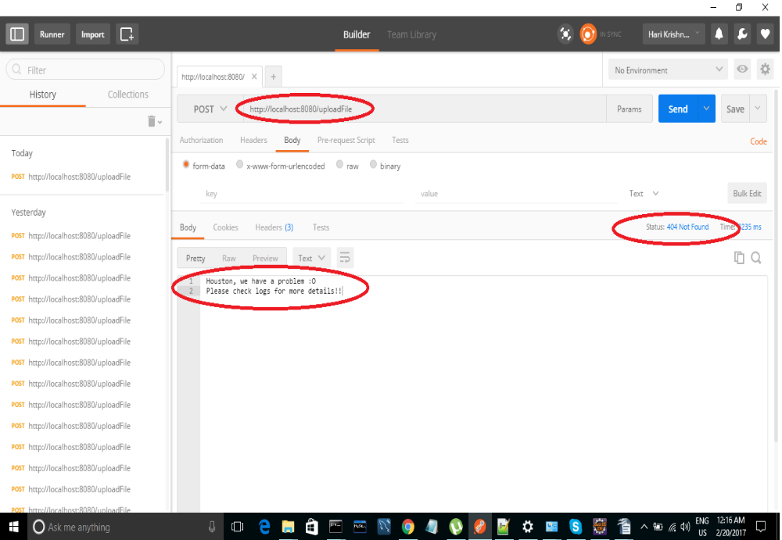
# Use-case 1: Perform API call without a file

#Use-case 2: Perform API call with valid file

