**Employee Management Service**

**Execute below insert script for role and user configuration**  
INSERT INTO roles (name) VALUES ('USER');

INSERT INTO roles (name) VALUES ('CREATOR');

INSERT INTO roles (name) VALUES ('EDITOR');

INSERT INTO roles (name) VALUES ('ADMIN');

INSERT INTO users (username, password, enabled) VALUES ('nilesh', '$2a$10$OlpVGGz1EXm.LQ/OcvmBQOFdAe3FQNYhOOXrKD6y9fhxOr2aBKwHu', '1');

INSERT INTO users (username, password, enabled) VALUES ('mahesh', '$2a$10$lv8PTtiNw7injglznpYeIehWW6knfFe/RnUW16TmGKtfSWRm/V2z2', '1');

INSERT INTO users (username, password, enabled) VALUES ('suresh', '$2a$10$flDL1ovH.7JEy1lSpBuuHuqagrXA8K3j3ELXQFV/KXhQK.WSnP8a.', '1');

INSERT INTO users (username, password, enabled) VALUES ('ramesh', '$2a$10$9k8/ODt16QFCmcmXLO2.oeVR8gHUtqpw9JeoEwEx/BKKAX9BZbbHK', '1');

INSERT INTO users (username, password, enabled) VALUES ('admin', '$2a$10$bN7OWEvi6rTqJEYbZfDOg.FHmG.xPTDxJR1k9LzsR4O6Nt8zuIKwq', '1');

INSERT INTO users_roles (user_id, role_id) VALUES (1, 1);

INSERT INTO users_roles (user_id, role_id) VALUES (2, 2);

INSERT INTO users_roles (user_id, role_id) VALUES (3, 3);

INSERT INTO users_roles (user_id, role_id) VALUES (4, 2);

INSERT INTO users_roles (user_id, role_id) VALUES (4, 3);

INSERT INTO users_roles (user_id, role_id) VALUES (5, 4);

**Login with username :”nilesh” and password :”nilesh”  
nilesh - is user role so read only access so just viewing the records  
Url : <http://localhost:8086/>**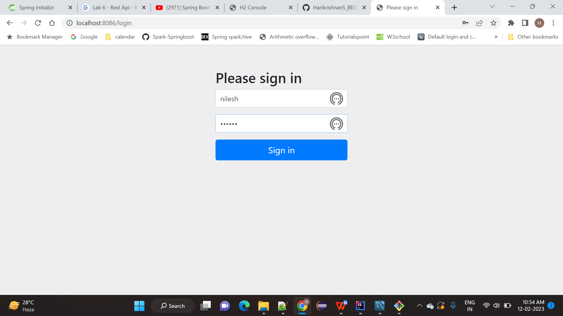

**List of Records**

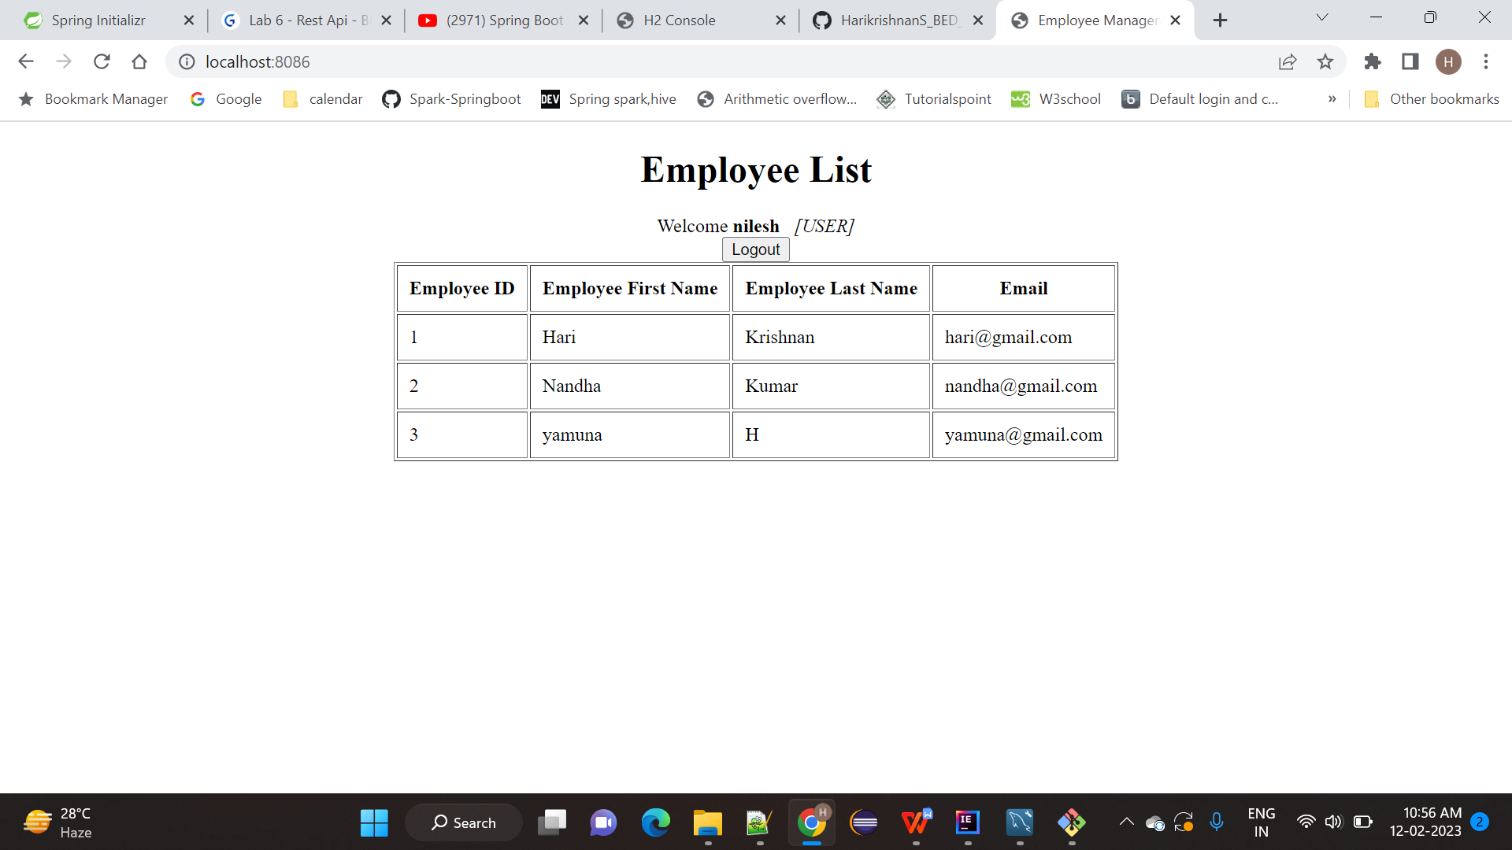

1. **Add User**

**Mahesh user has add employee access  
  
Click Add Employee Link**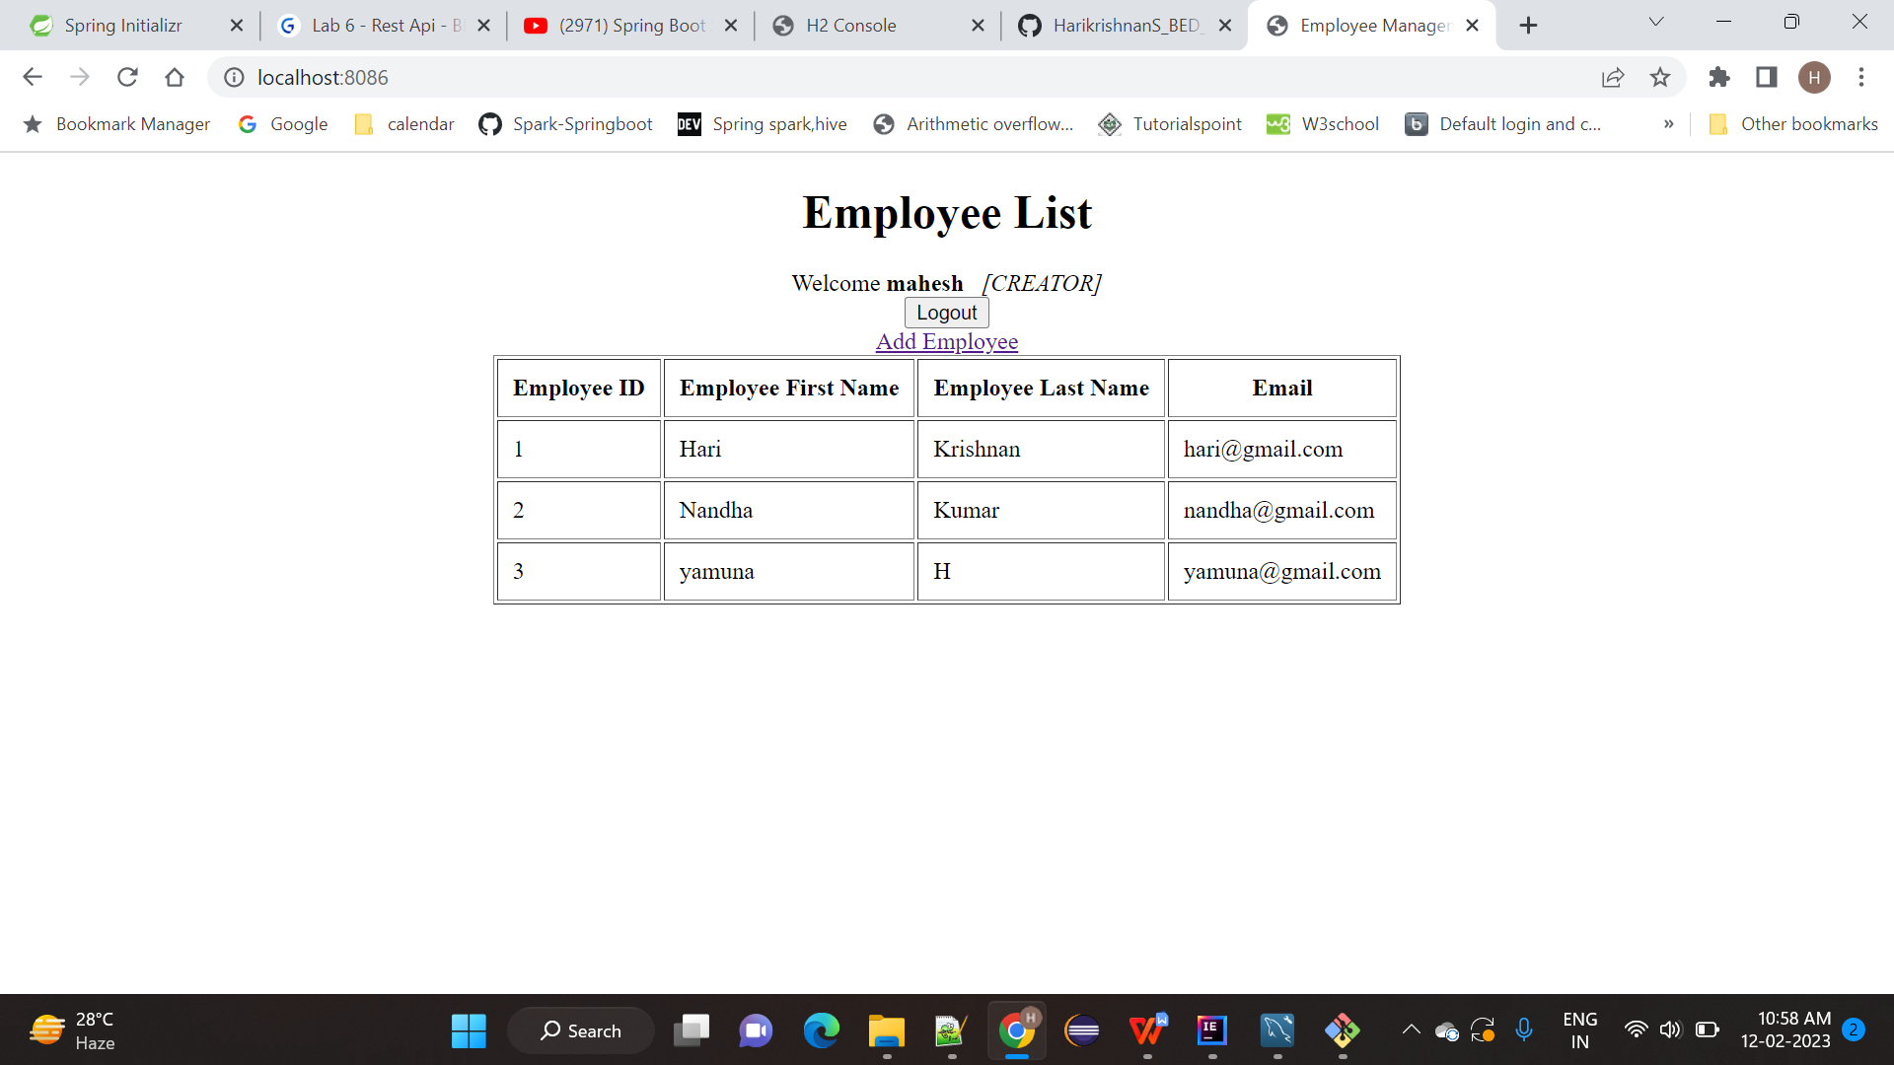

**Enter the Employee Details**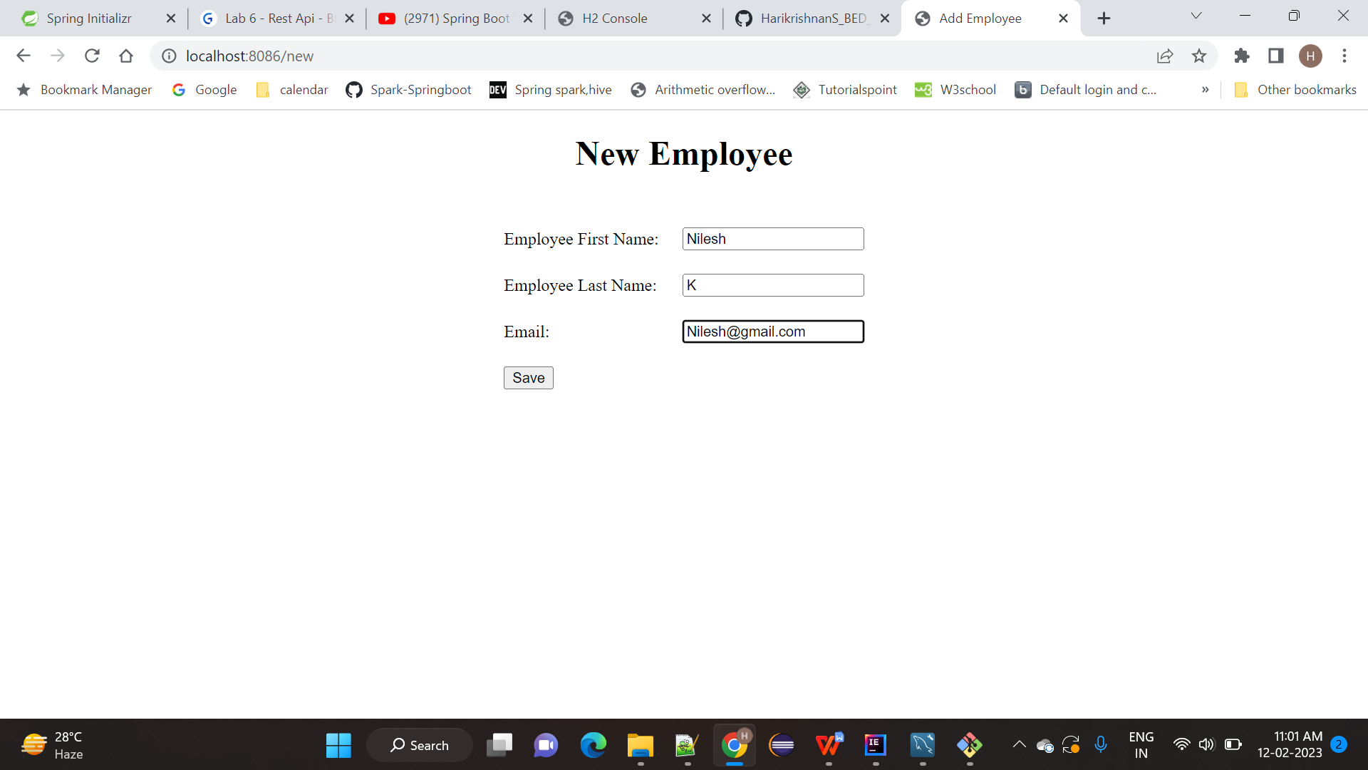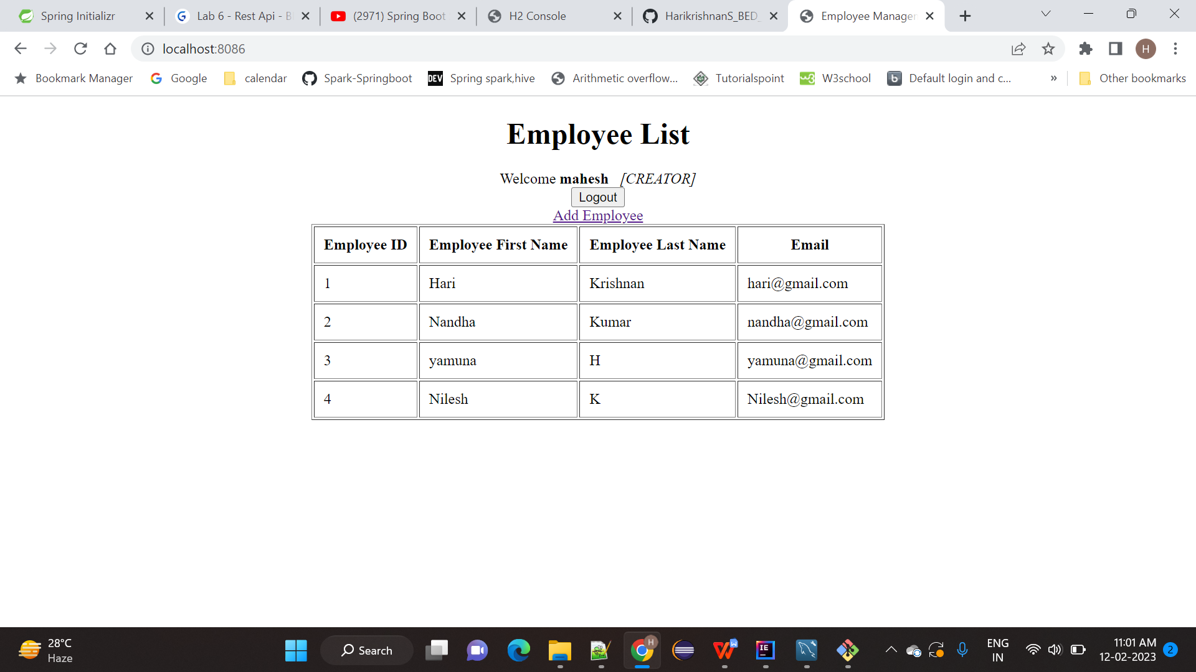  
  
**3) Edit Employee for details update  
  
suresh user has edit access  
  
click edit link**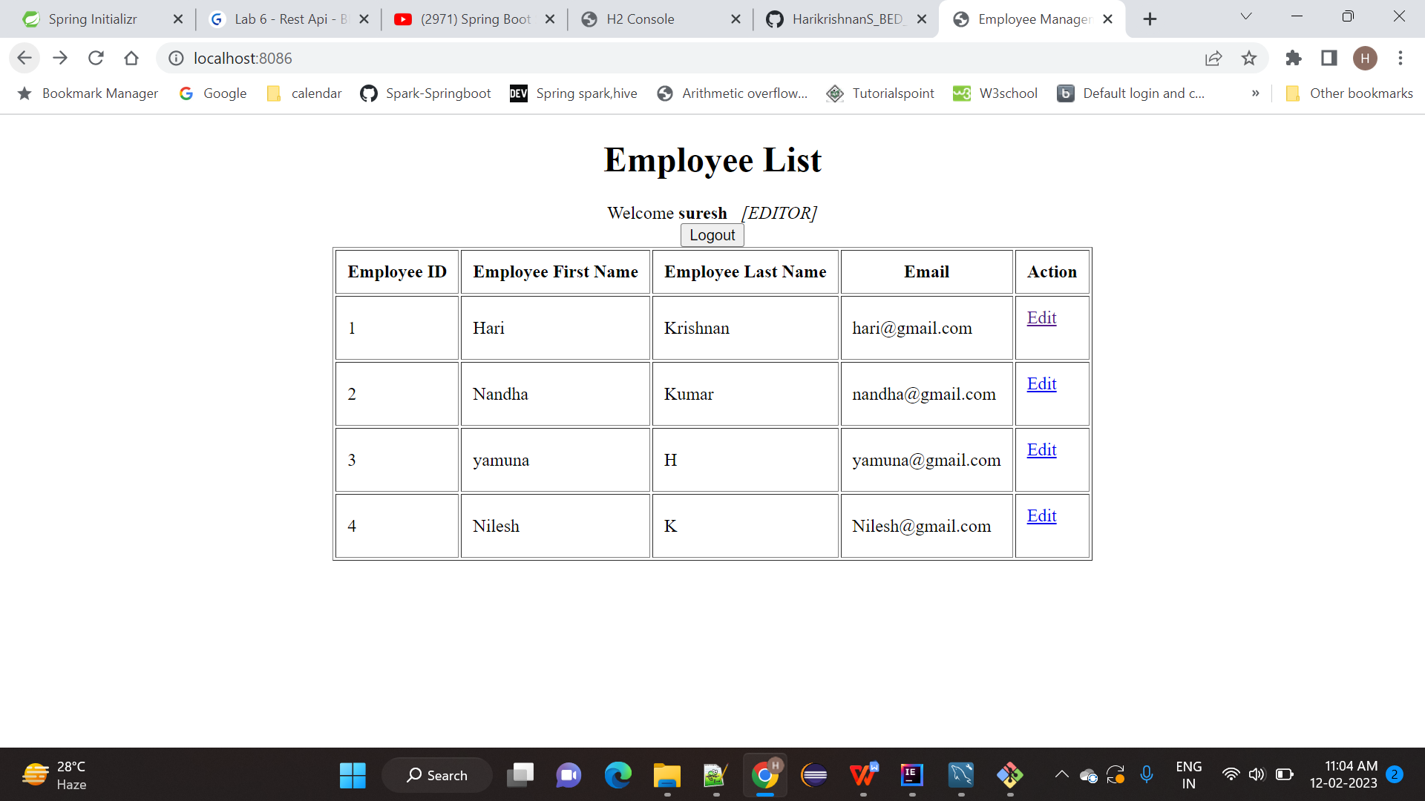

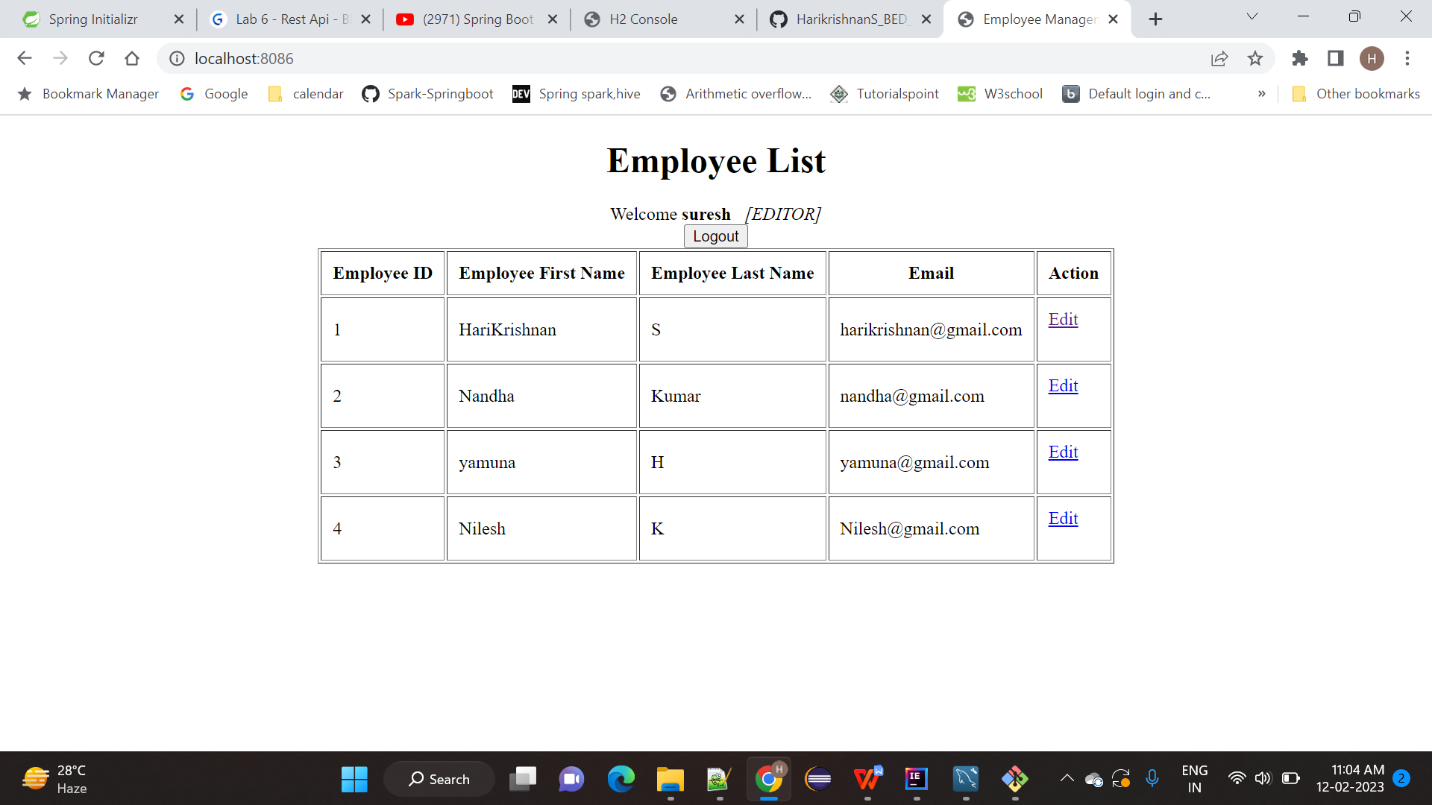

1. **Create and delete access for the employee  
     
   ramesh user has create and delete access  
     
   click the add employee for create new user and click edit link for update**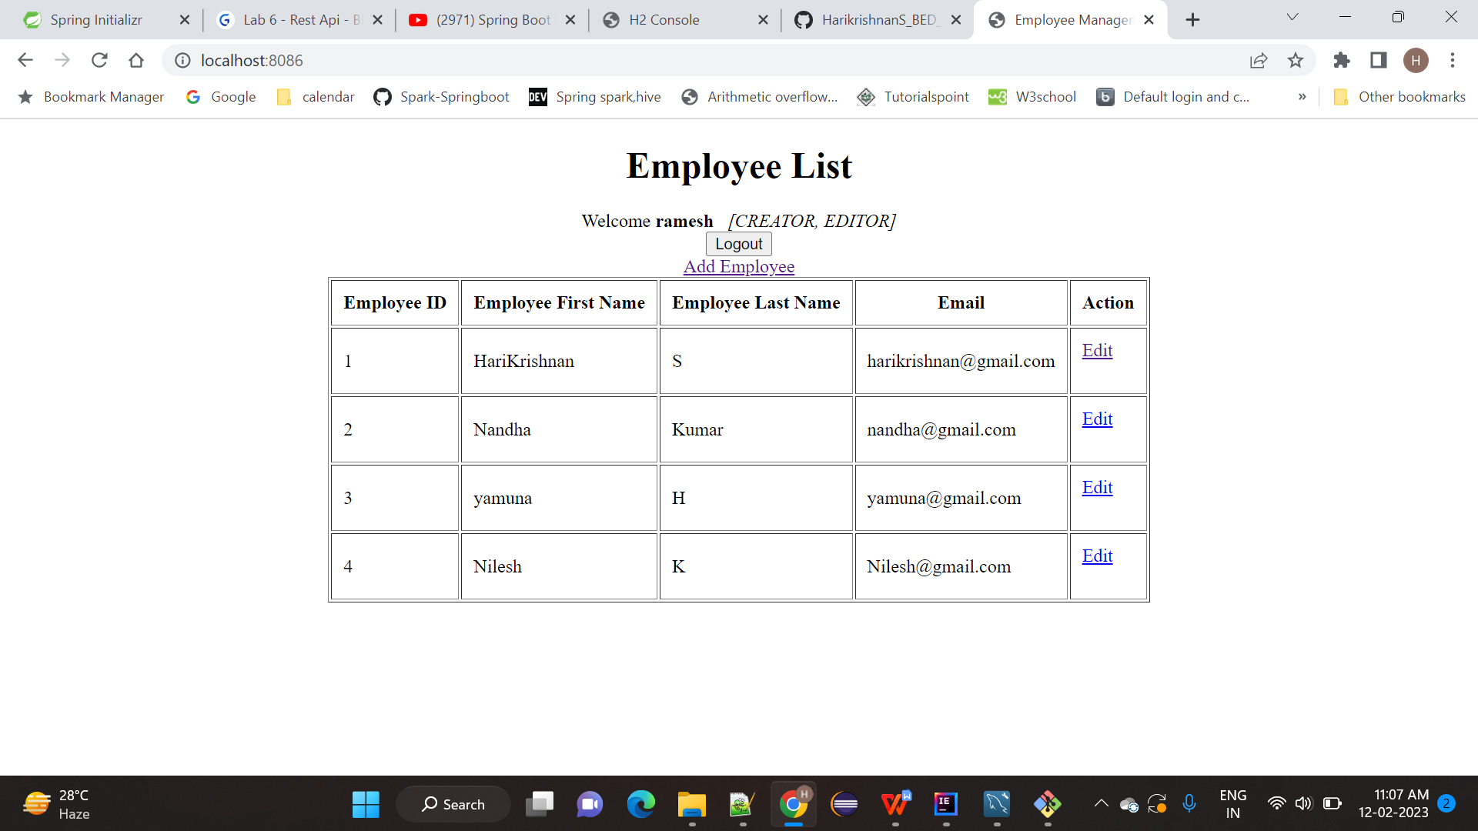

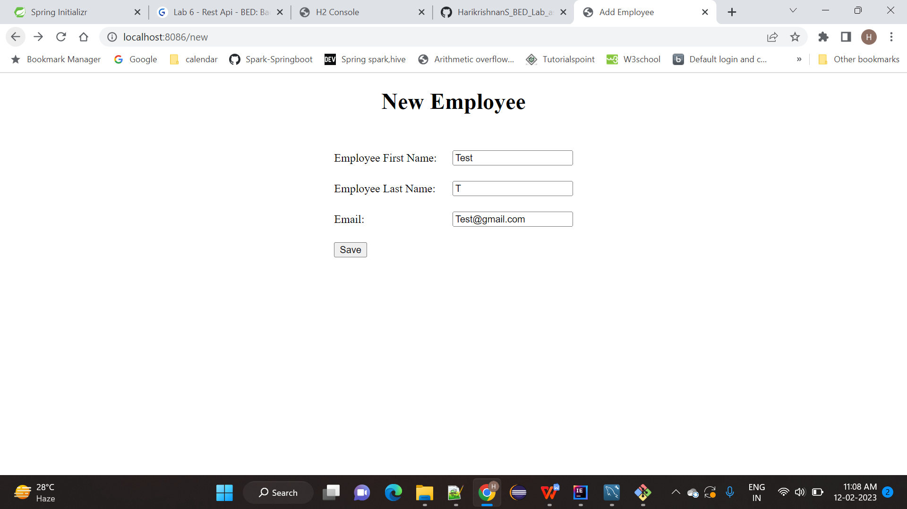

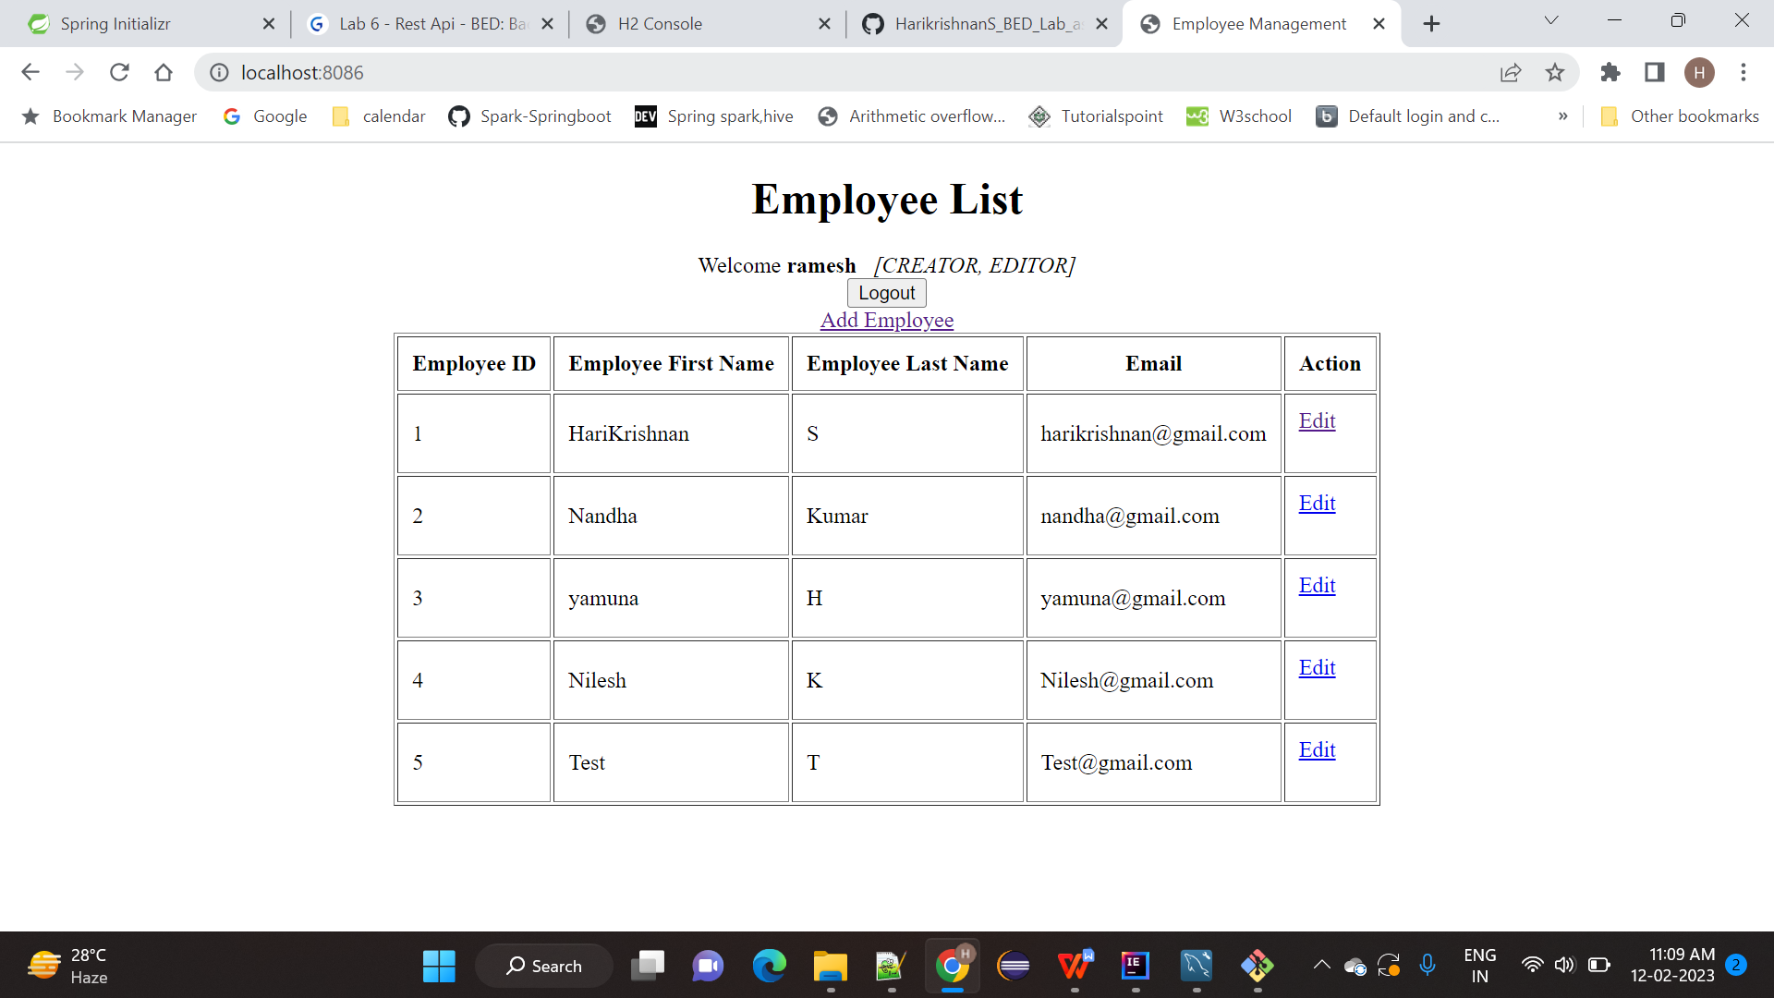

**Editted 5th record**

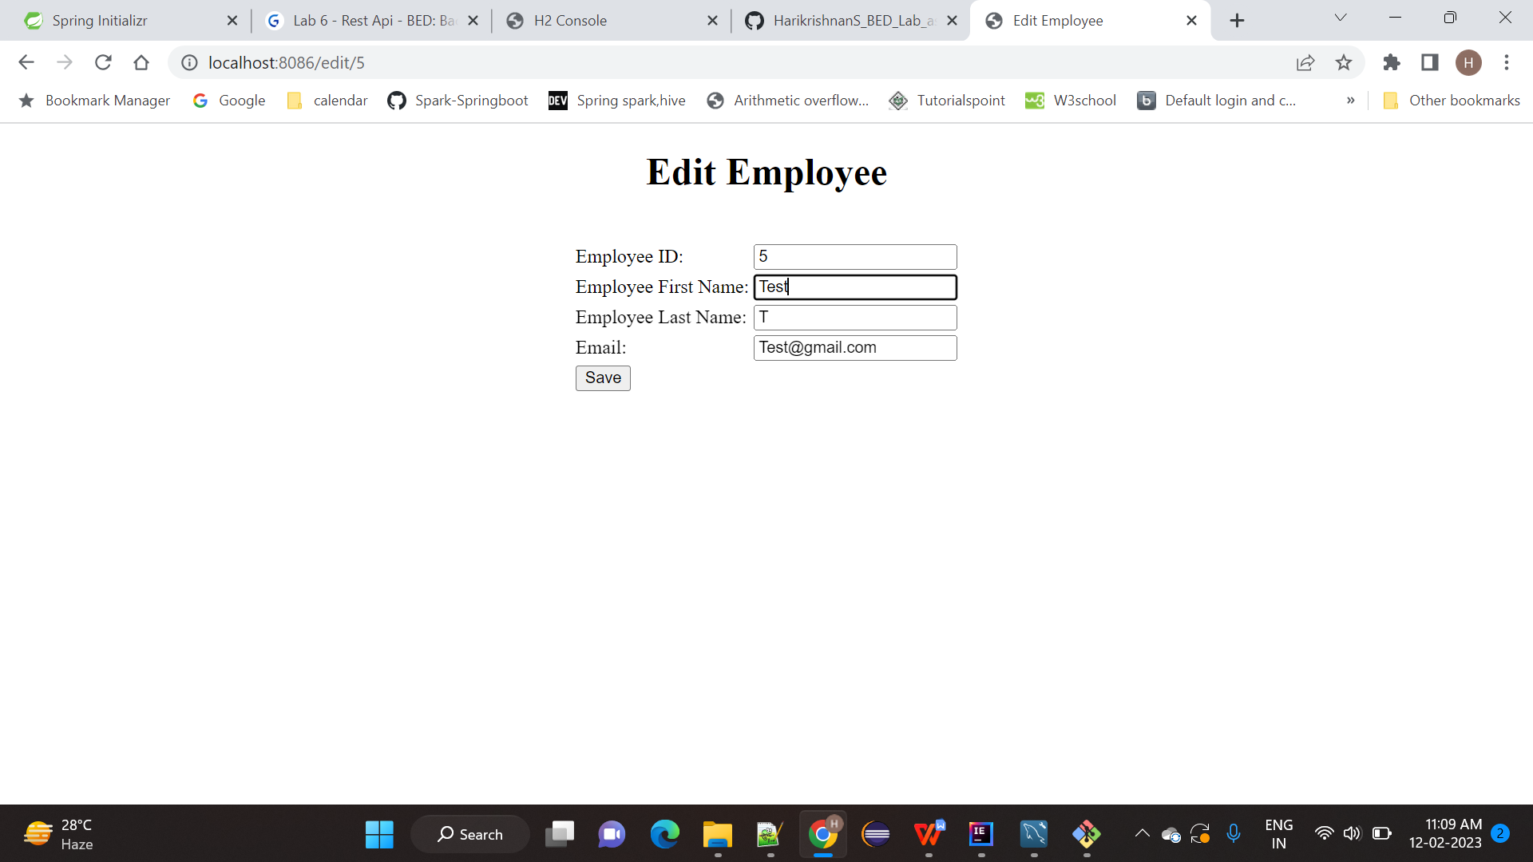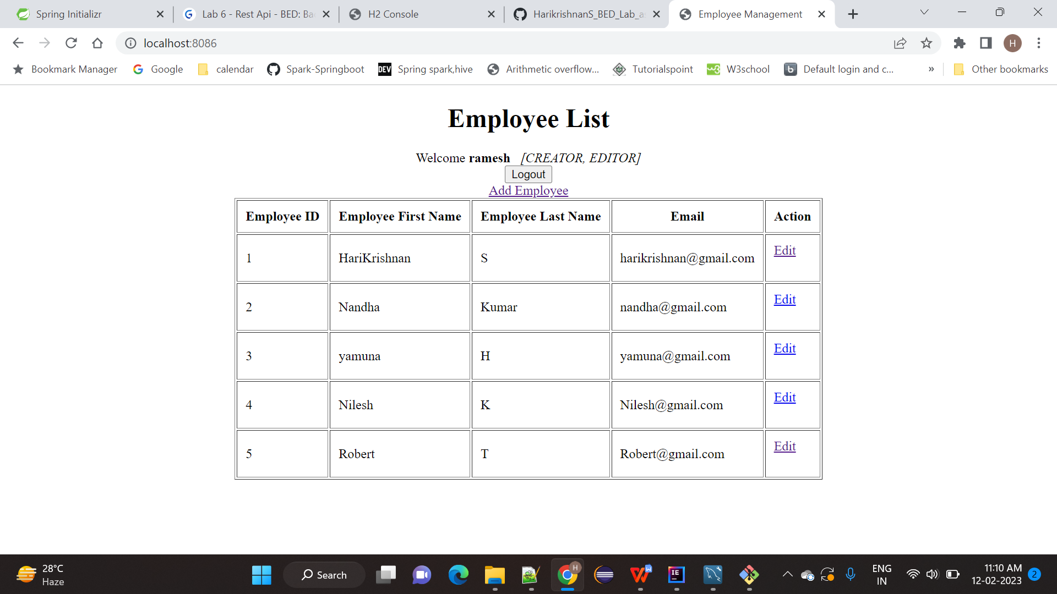

**Admin have all the access like create , Edit and Delete access:  
  
username : admin and password : admin**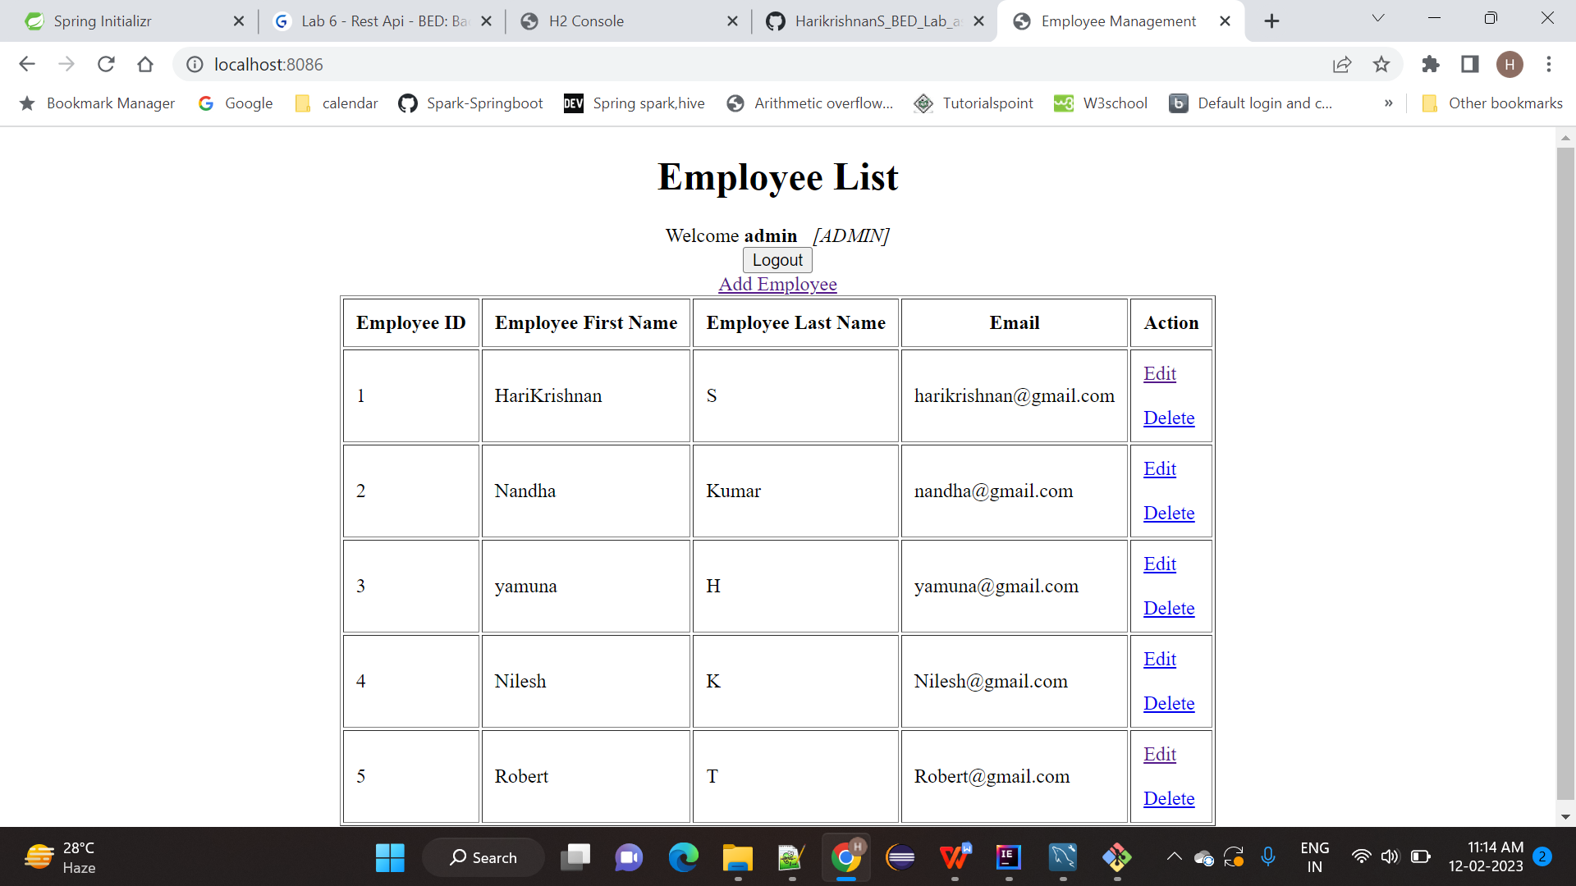  
  
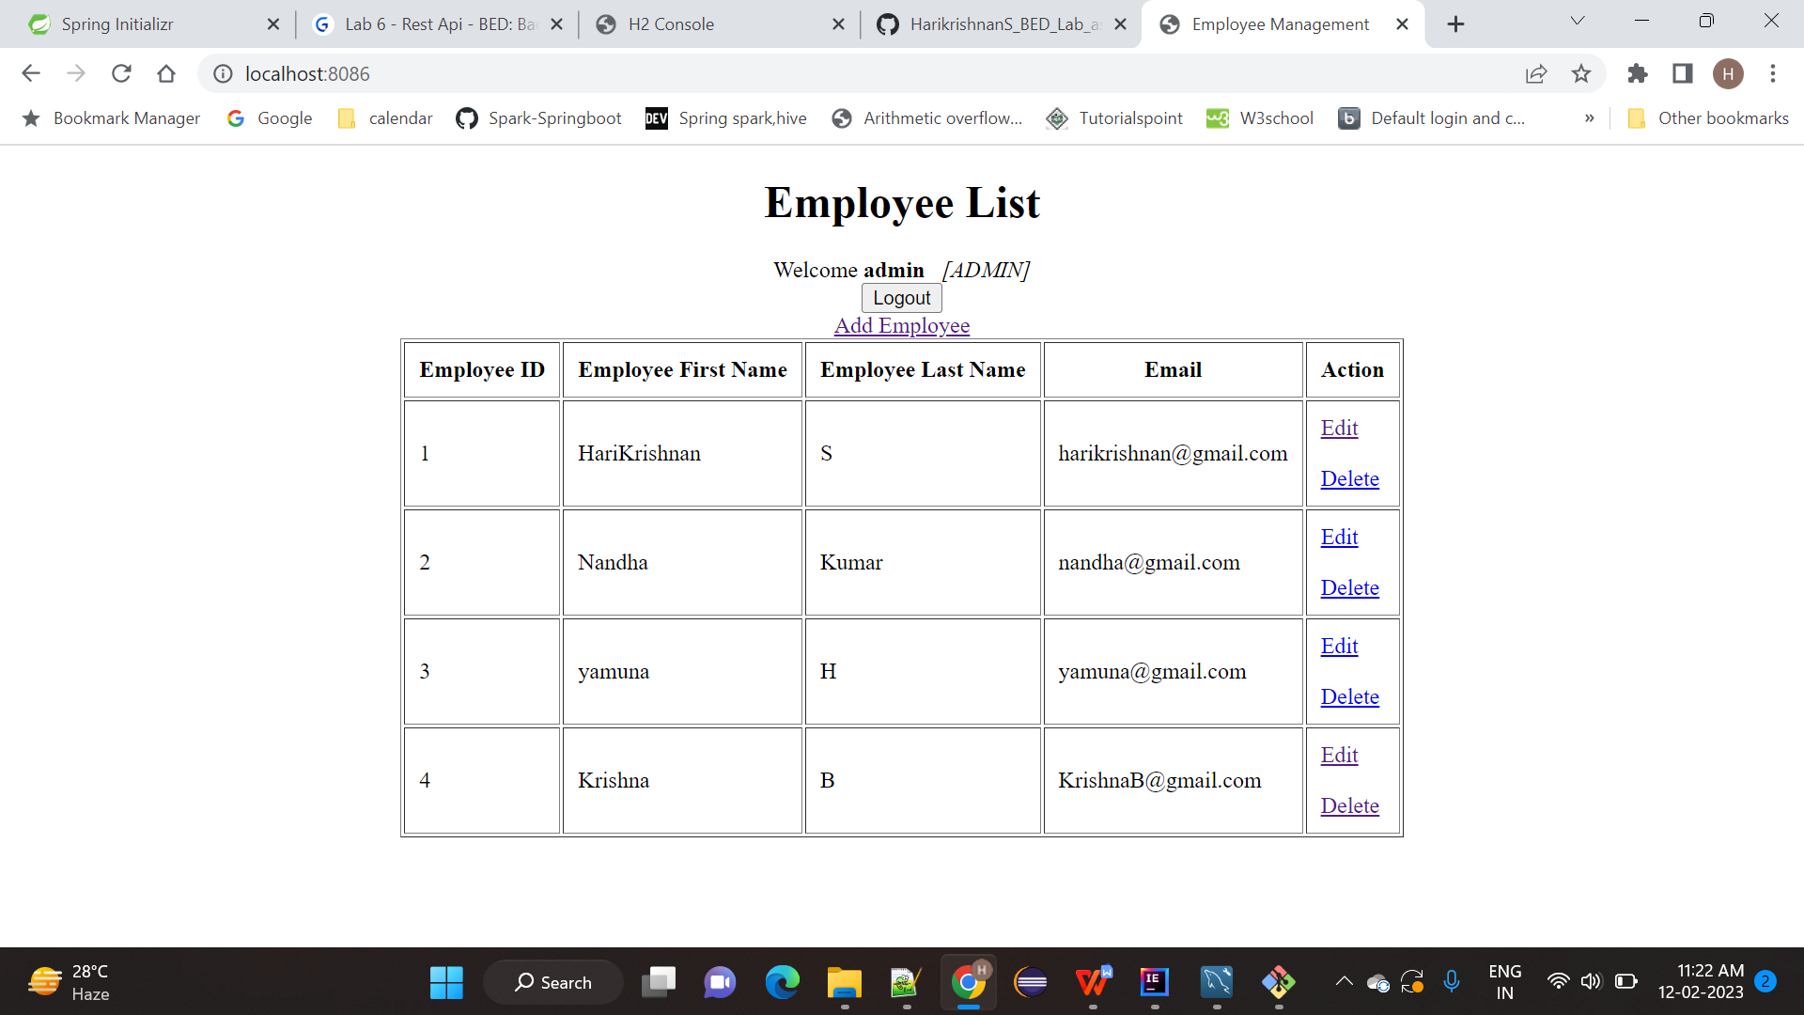  
  
Edit Record no 4 for firstname as Krishnan and Last name as B and Email as [KrishnaB@gmail.com](mailto:KrishnaB@gmail.com)  
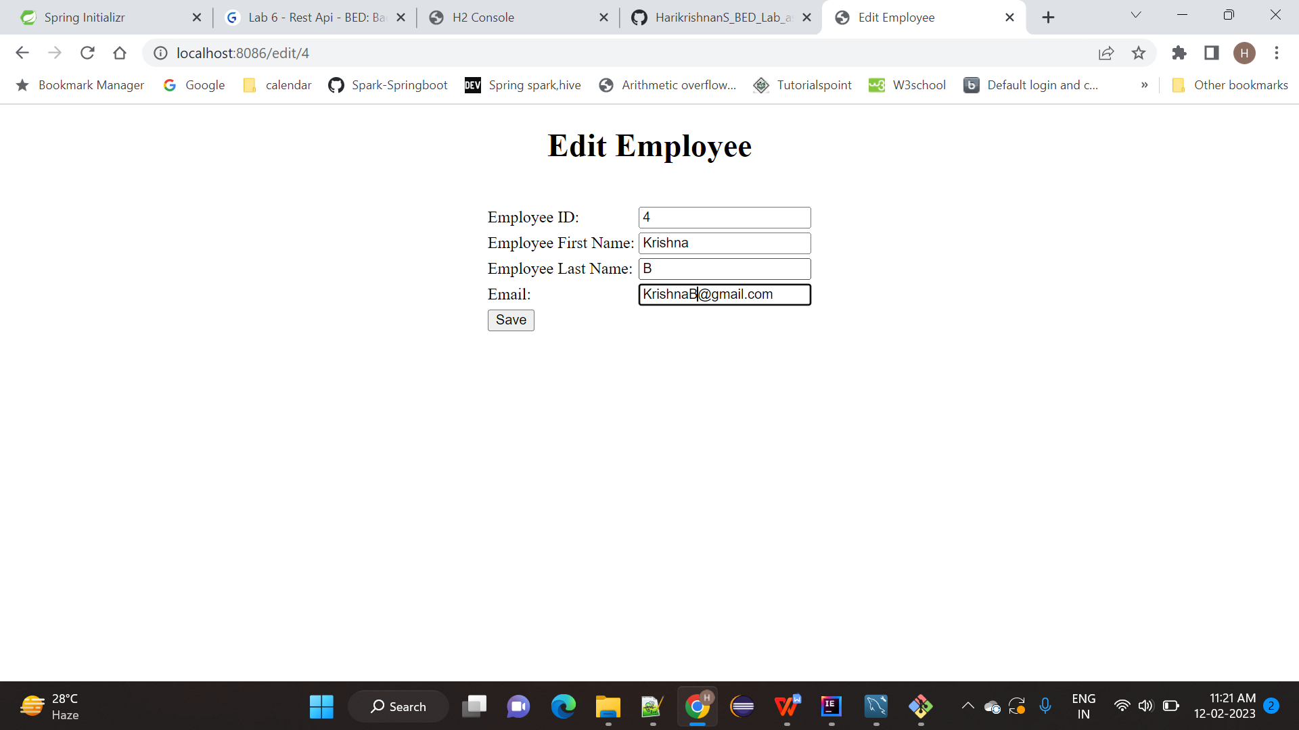  
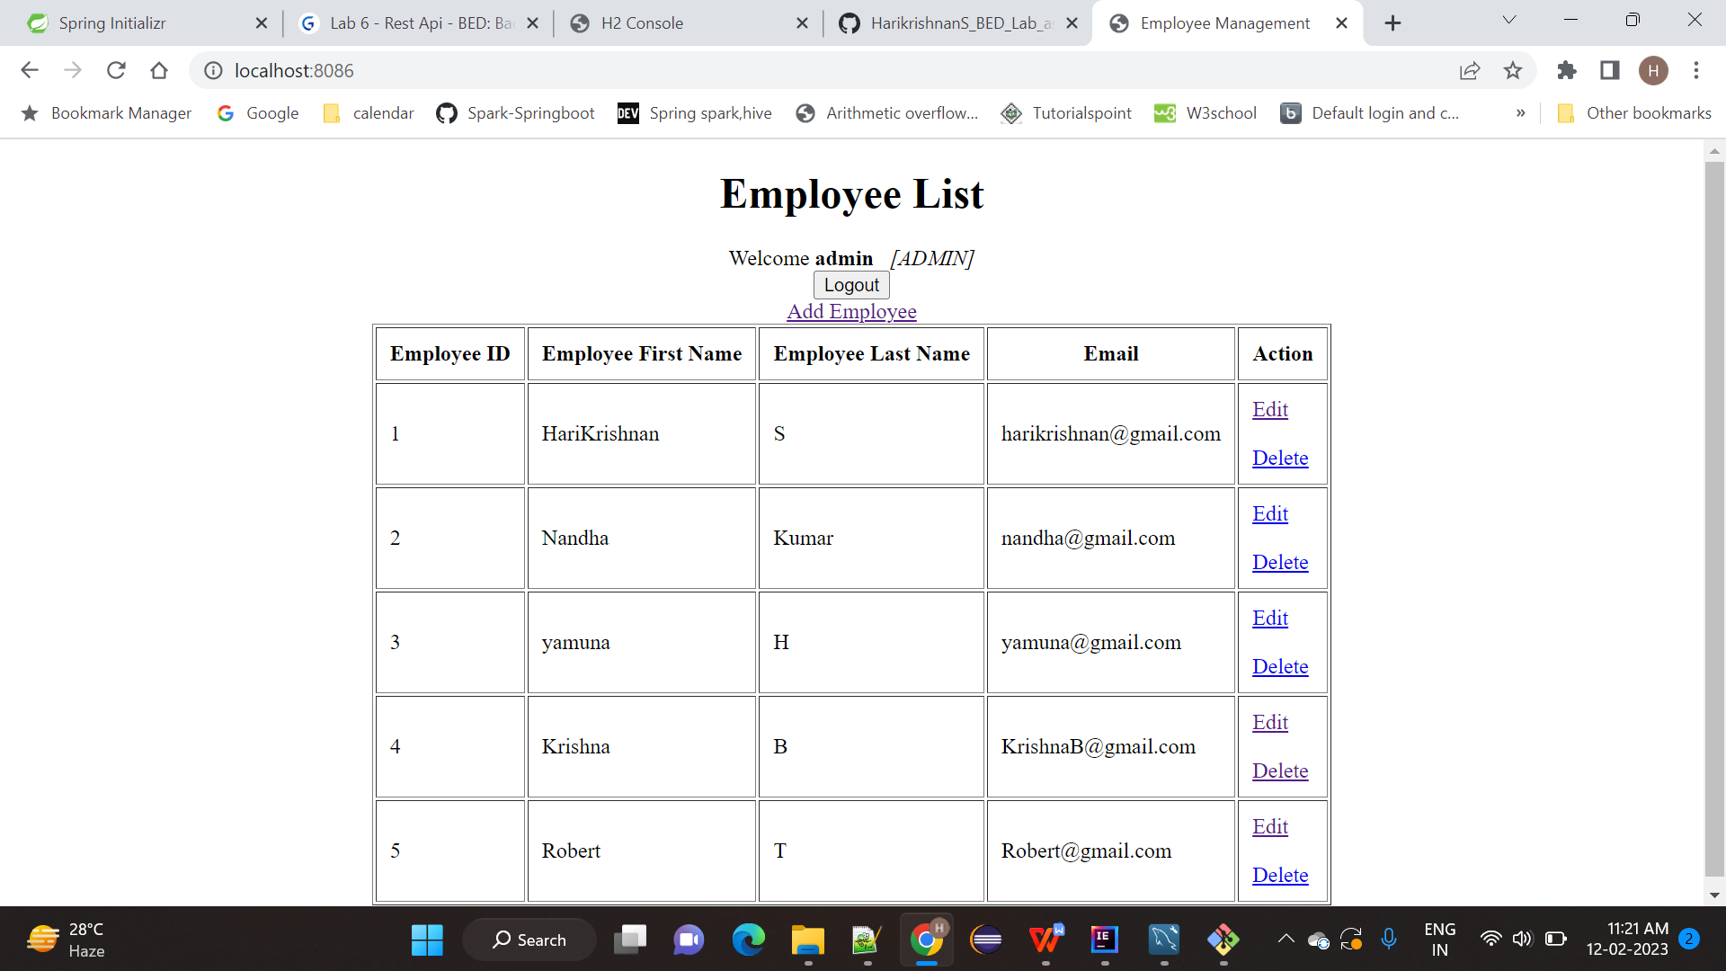  
  
Delete record no 5   
  
Click delete link  
  
