One record added  
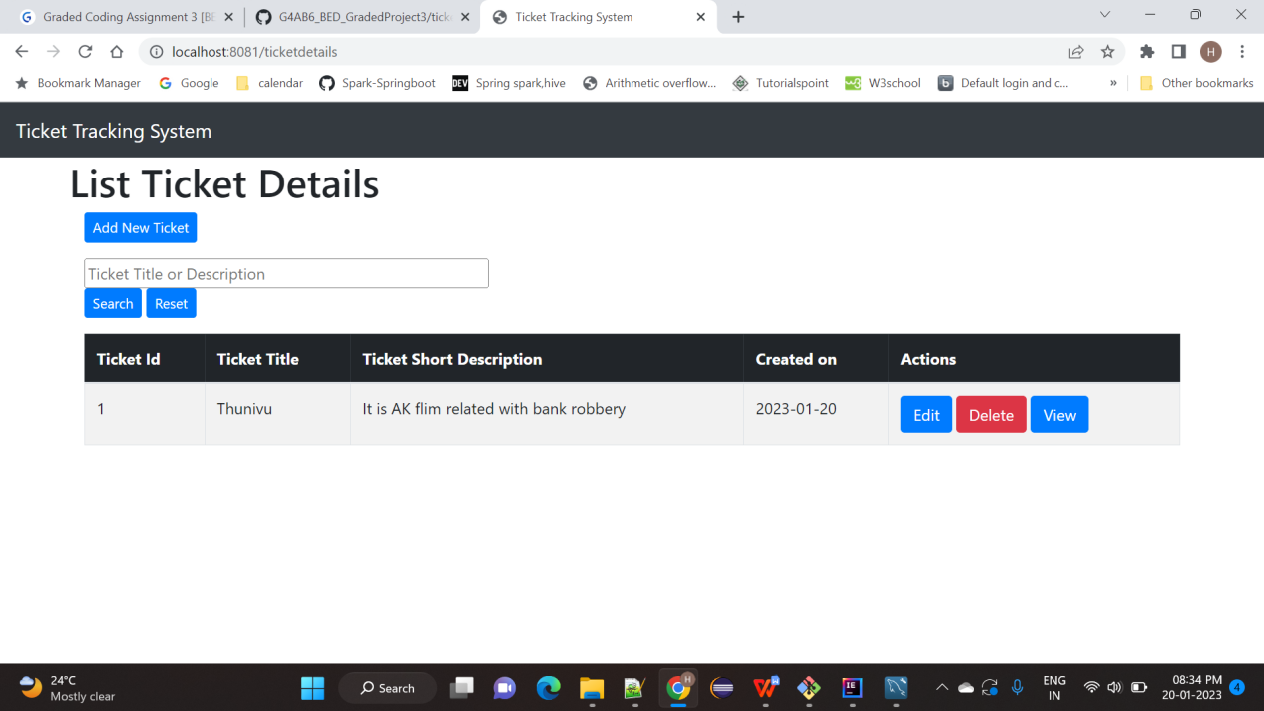  
  
Add New Ticket  
  
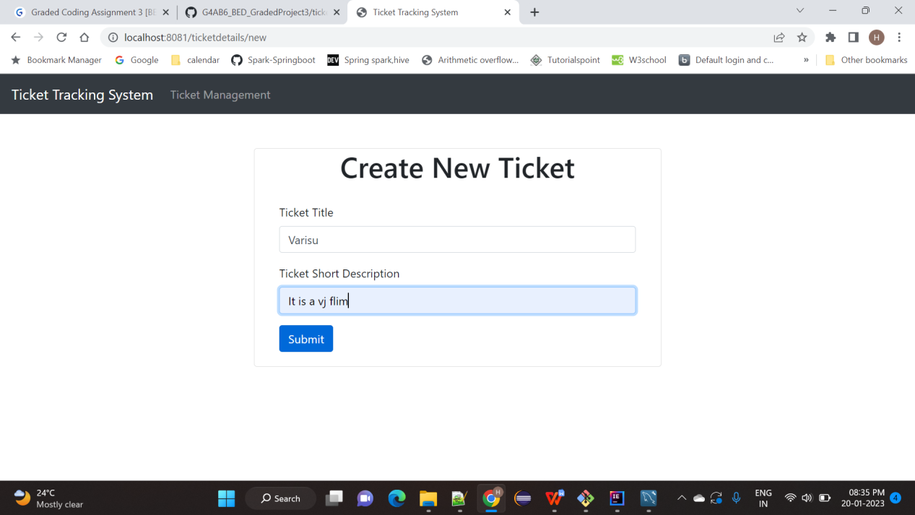  
  
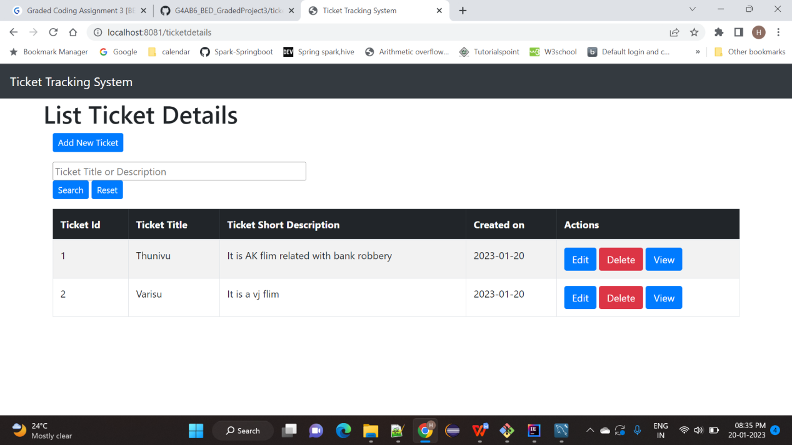  
  
Edit Page : Going to edit Short Description value AK as Ajith Kumar and Going to Edit Title Varisu as Master  
  
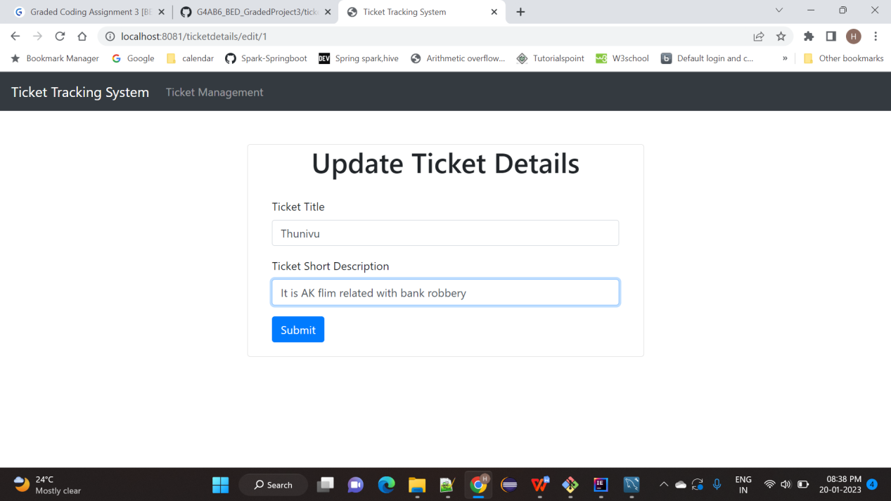  
  
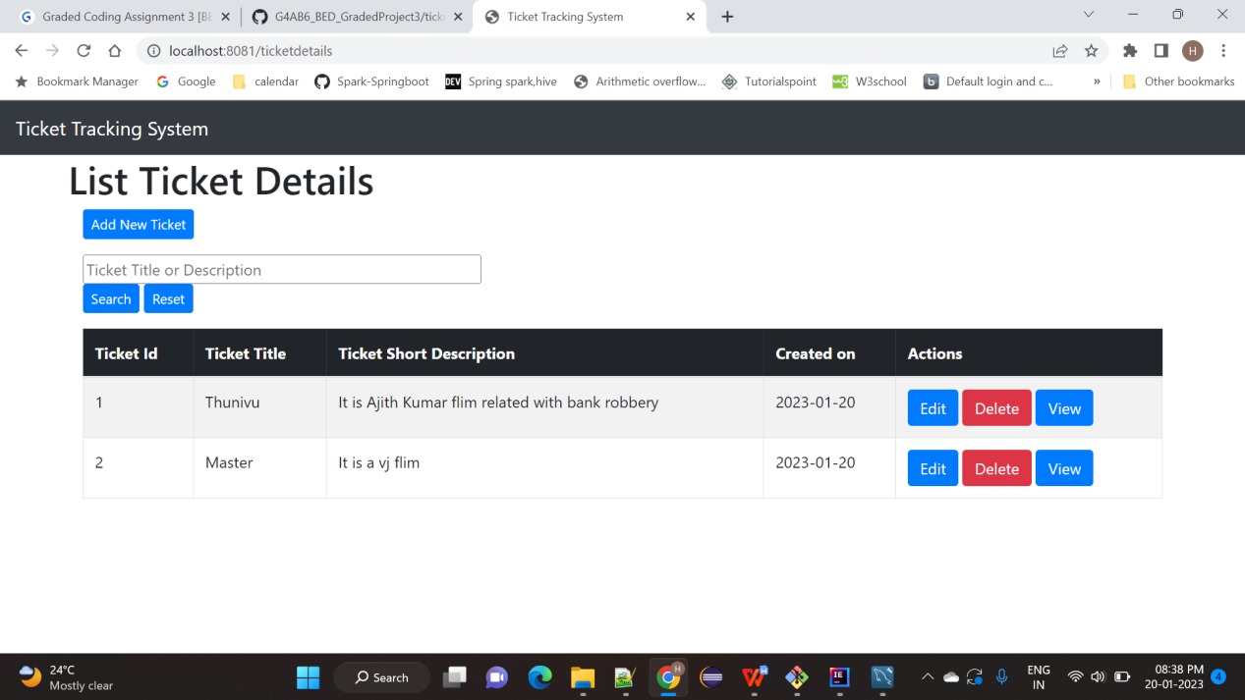

Search Button : going to Search Thunivu  
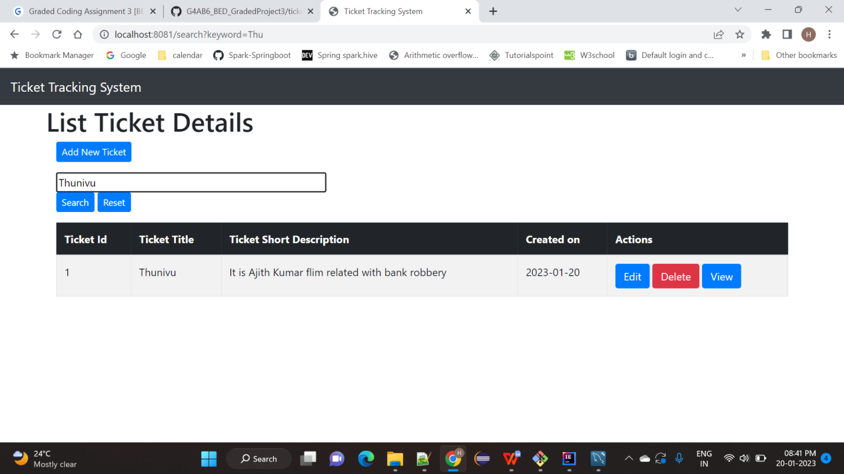  
  
  
  
  
  
  
  
  
  
  
  
  
Delete Page : Going to Delete 2nd record  
