Splunk Soc Project – Multi-agent Detection

Threat Detection & Log Monitoring Using Splunk SIEM

Report issued :03/02/2025 Submitted By: Hari Krishnan V S

TABLE OF CONTENTS
- Abstract
- Acknowledgement
- Introduction
- Literature Review
- Technology Overview
a. Splunk Enterprise
b. Splunk Universal Forwarder
c. Linux Logging (Ubuntu)
d. Windows Event Logging
- System Architecture
- Installation and Configuration
a. Splunk Server Setup
b. Ubuntu Agent Configuration
c. Windows Agent Configuration
- Log Routing and Indexing
- SSH Brute Force Detection
- FTP Brute Force Detection
- Nmap / Port Scan Detection
- Privilege Escalation Detection (Linux)
- Alerting and SOC Workflow
- FUTURE ENHANCEMENTS
- Conclusion

- ABSTRACT

This project demonstrates the implementation of a centralized log monitoring and threat detection system using Splunk SIEM. The environment consists of an Ubuntu Linux agent and a Windows agent, both configured with Splunk Universal Forwarders to securely forward security-related logs to a Splunk Enterprise server for centralized analysis.
The project focuses on detecting common security threats such as SSH and FTP brute-force attacks, Nmap-based port scanning, and privilege escalation attempts across Linux and Windows systems. Logs from authentication services, system auditing mechanisms, firewall activity, and Windows Security Event Logs were collected, indexed, and analyzed using Splunk’s Search Processing Language (SPL).
By simulating attack scenarios and configuring threshold-based alert rules, the project validates Splunk’s effectiveness as a SIEM platform for SOC monitoring, enabling real-time visibility, event correlation, and timely detection of security incidents.

- ACKNOWLEDGEMENT

I would like to express my sincere gratitude to my mentors, instructors, and peers who supported me throughout the completion of this Splunk SIEM project. Their guidance, technical insights, and constructive feedback played a vital role in enhancing my understanding of SOC operations, log analysis, and security monitoring concepts.
I am also thankful to the open-source and cybersecurity communities for providing valuable documentation, tools, and learning resources that contributed to the successful implementation of this project. Additionally, I appreciate the support of my family and friends, whose encouragement and patience helped me stay focused and motivated during the course of this work.

- INTRODUCTION

In modern IT infrastructures, systems continuously generate logs that record user activity, system events, and security incidents. These logs are critical for detecting malicious behaviour, troubleshooting issues, and maintaining compliance. However, analyzing logs manually across multiple systems is inefficient and impractical.
Security Information and Event Management (SIEM) solutions address this challenge by centralizing logs, correlating events, and generating alerts for suspicious activities. Splunk is a widely adopted SIEM platform used by enterprises and SOC teams for real-time monitoring and threat detection.
This project implements Splunk SIEM to monitor both Linux and Windows environments, focusing on detecting brute-force attacks, reconnaissance activities, and privilege escalation attempts

.

- LITERATURE REVIEW

Log monitoring and SIEM solutions play a crucial role in modern cybersecurity operations by enabling centralized visibility into system activity and security events. Traditional manual log review methods are increasingly ineffective due to the growing scale, diversity, and volume of logs generated by contemporary IT environments. To address this challenge, commercial SIEM platforms such as Splunk, IBM QRadar, and ArcSight provide advanced capabilities for log indexing, event correlation, and real-time alerting.
Among these solutions, Splunk stands out due to its powerful Search Processing Language (SPL), high scalability, and flexibility in handling logs from diverse sources across multiple platforms. Unlike rule-heavy SIEM solutions that rely primarily on predefined correlation rules, Splunk enables security analysts to build custom detections using search-based analytics, making it highly adaptable for SOC operations and proactive threat hunting.
This project leverages Splunk’s analytical capabilities to design a lightweight SOC monitoring environment focused on detecting common attack patterns, thereby demonstrating the practical application of SIEM concepts in real-world security monitoring scenarios.

- TECHNOLOGY OVERVIEW

- Splunk Enterprise

Splunk Enterprise is a log indexing and analytics platform that enables the ingestion, indexing, searching, and visualization of machine-generated data. It allows SOC analysts to detect anomalies, investigate incidents, and generate alerts in real time.
- Splunk Universal Forwarder

The Splunk Universal Forwarder is a lightweight agent installed on endpoint systems to collect logs and forward them securely to the Splunk server. It consumes minimal system resources and supports both Linux and Windows platforms.
- Linux Logging (Ubuntu)

The Ubuntu system generates security logs related to authentication, privilege escalation, and system events. Key log files include:
- /var/log/auth.log
- /var/log/audit/audit.log
- Firewall and kernel logs
- Windows Event Logging

The Windows agent forwards Security Event Logs to Splunk. These logs include authentication attempts, privilege assignments, and process execution events critical for detecting malicious behaviour.

7. INSTALLATION AND CONFIGURATION

Splunk Server Setup

Splunk Enterprise was installed on a Windows system, which acted as the centralized Splunk server. The server was configured to receive log data from endpoint agents through the default Splunk receiving port 9997 using the Splunk Universal Forwarder.

Separate indexes were created within Splunk to organize and store security logs collected from the Ubuntu Linux agent and the Windows system, enabling efficient search, analysis, and correlation of events across multiple platforms.
  - Ubuntu Agent Configuration

The Splunk Universal Forwarder was installed on the Ubuntu system to collect and forward security-relevant logs to the centralized Splunk server. The forwarder was installed using the official Splunk Universal Forwarder package and configured to start automatically on system boot.
Log monitoring was enabled for the /var/log/ directory, allowing the collection of authentication logs, system logs, and audit-related events generated by the Ubuntu operating system. The forwarder was then configured to securely transmit the collected logs to the Splunk server over port 9997. After configuration, the forwarder connection was verified to ensure successful log transmission.
c. Windows Agent Configuration
The Splunk Universal Forwarder was installed on the Windows system to collect and forward security-related event logs to the centralized Splunk server. The forwarder was configured to monitor Windows Security Event Logs, including authentication events, privilege usage, and system activity relevant to security monitoring.
The forwarder was set to run as a background service and automatically start on system boot. Collected event logs were securely transmitted to the Splunk server over port 9997, ensuring continuous and reliable log delivery for centralized analysis and correlation.

8. LOG ROUTING AND INDEXING

All collected logs from the Ubuntu and Windows agents were securely forwarded to the centralized Splunk Enterprise server using the Splunk Universal Forwarder. Upon receipt, the logs were automatically parsed, timestamped, and indexed by Splunk based on their source and event type.
Separate indexes were created for Linux and Windows security logs to improve search efficiency, data organization, and correlation accuracy. This indexing approach enabled faster investigations, simplified query construction using SPL, and ensured consistent log retention for effective security monitoring and analysis.

9. SSH BRUTE FORCE DETECTION

SSH brute-force attacks were detected by monitoring repeated failed SSH login attempts originating from the same source IP address within a defined time window. These events were identified using authentication failure logs collected from the Ubuntu system and forwarded to Splunk for analysis.
By applying threshold-based detection logic, multiple failed login attempts exceeding normal behaviour were flagged as suspicious activity. This detection method effectively identifies password-guessing attacks targeting Linux systems and provides early visibility into unauthorized access attempts, allowing timely investigation and response by SOC analysts.
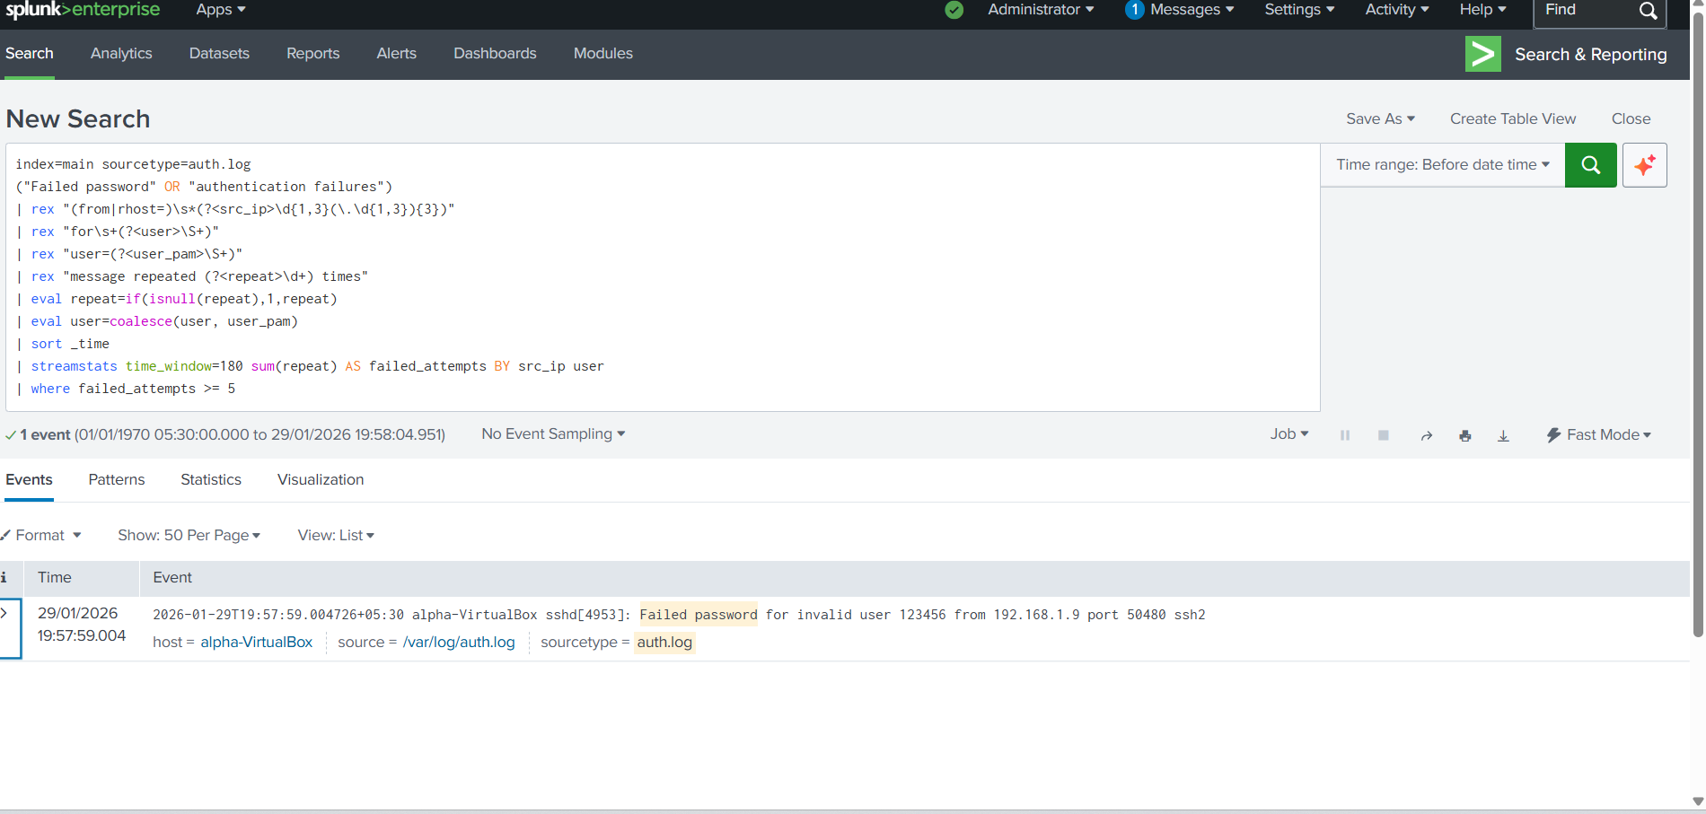

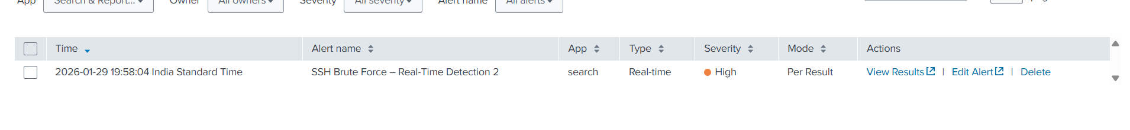

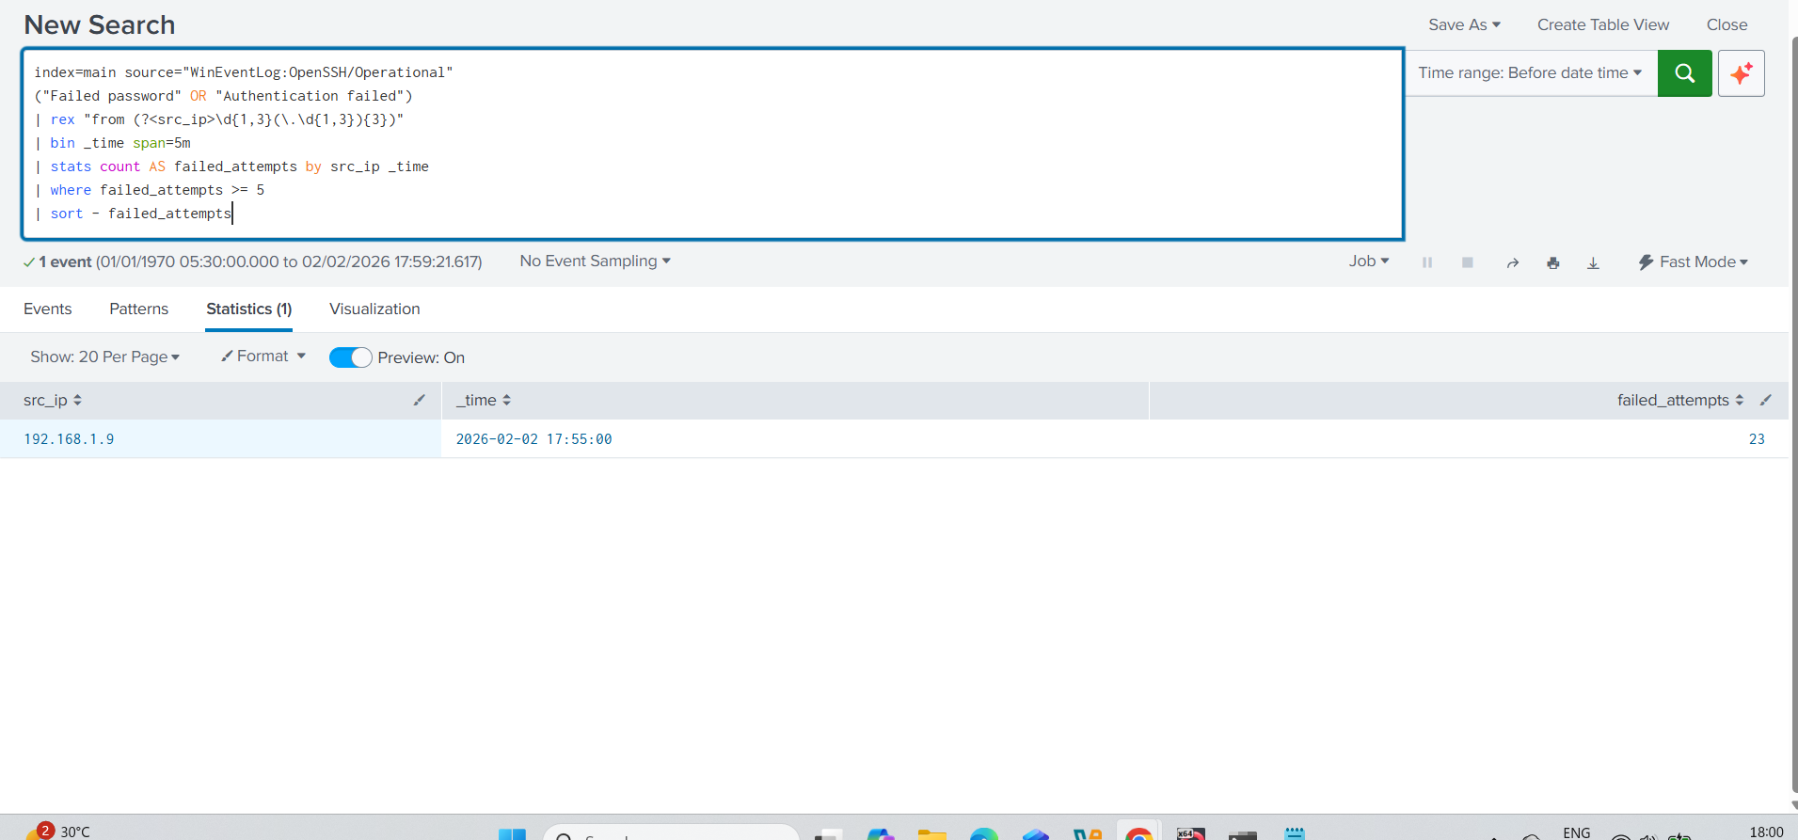

10. FTP BRUTE FORCE DETECTION
FTP brute-force attacks were detected by analyzing repeated authentication failures recorded in the FTP service logs on the Ubuntu system. These logs were collected and forwarded to the Splunk server, where failed login attempts were correlated based on source IP address and time intervals.
A threshold-based detection approach was applied to identify abnormal login behaviour exceeding normal usage patterns. Multiple consecutive authentication failures within a short time window were flagged as potential brute-force attempts against file transfer services, enabling early detection of unauthorized access attempts and supporting effective SOC monitoring.
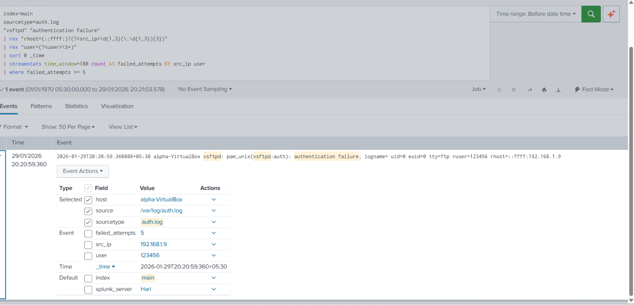

11. NMAP / PORT SCAN DETECTION
Port scanning activity was detected by identifying multiple connection attempts to different destination ports originating from a single source IP address within a short time period. Such behavior is commonly associated with network reconnaissance techniques used to identify open services and potential attack surfaces.
Firewall logs and system-level network events collected from the Ubuntu system were analyzed in Splunk to detect abnormal connection patterns. When a high number of distinct port access attempts exceeded predefined thresholds, the activity was flagged as potential scanning behavior, indicating the possible use of tools such as Nmap. This detection helps identify early-stage reconnaissance activities that often precede further exploitation attempts.

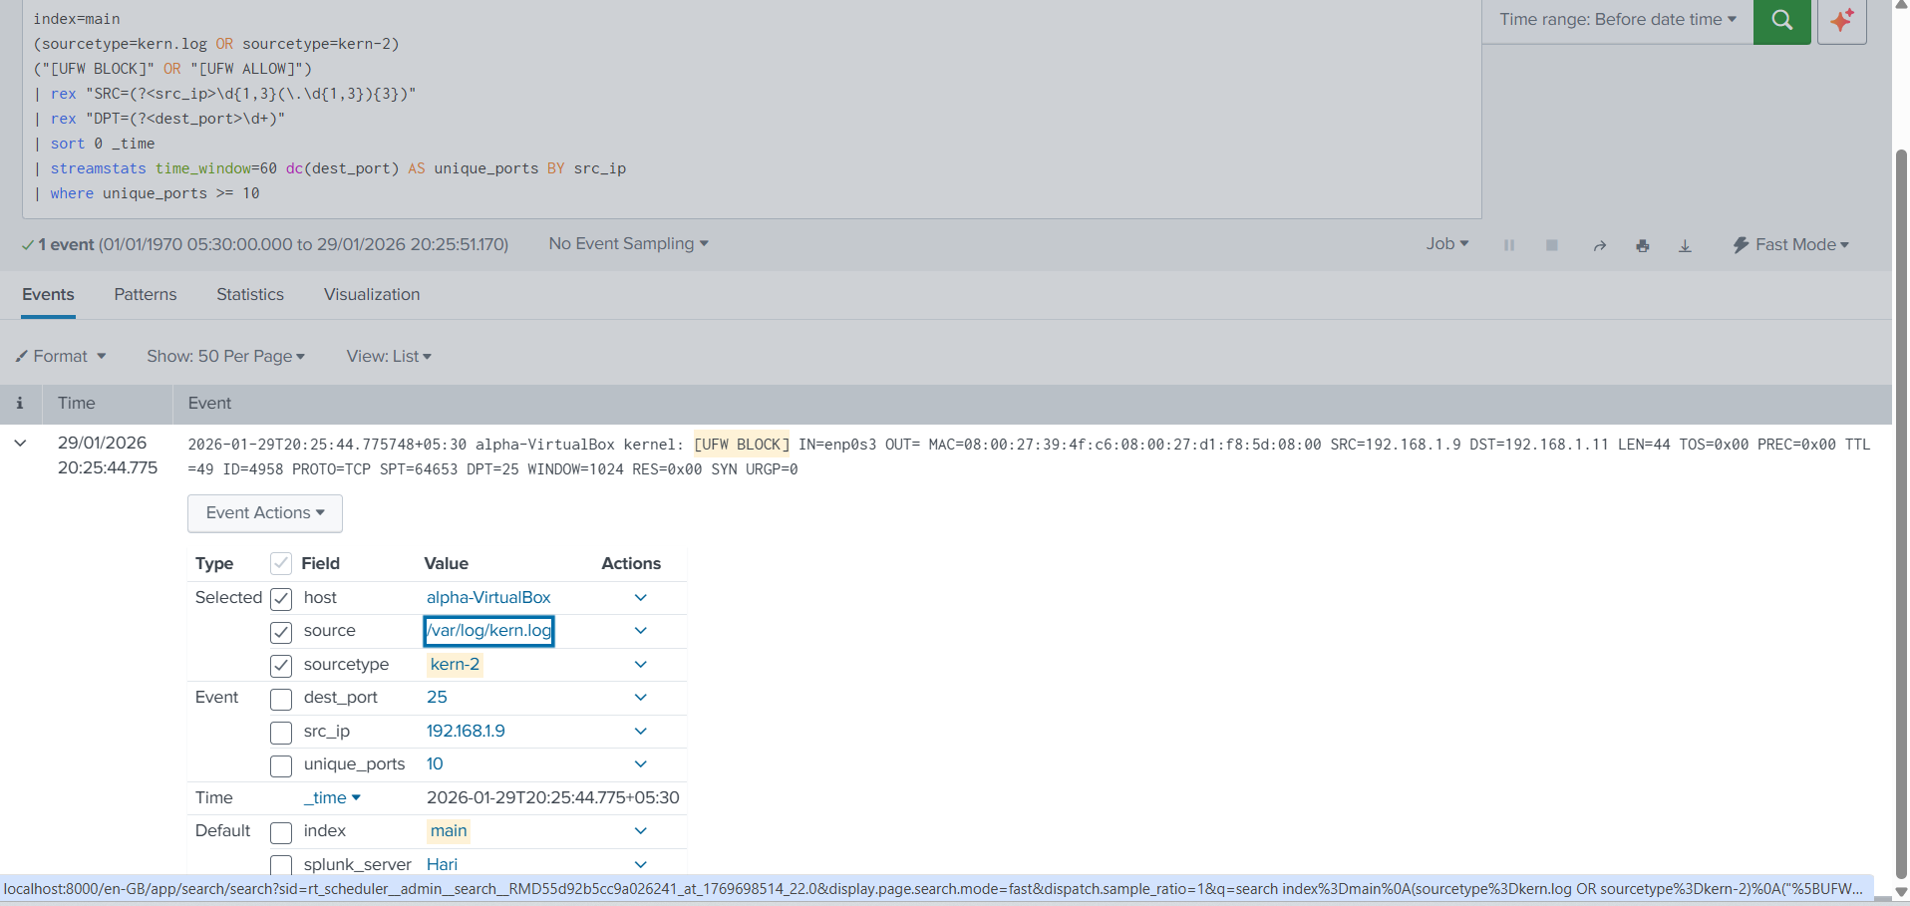

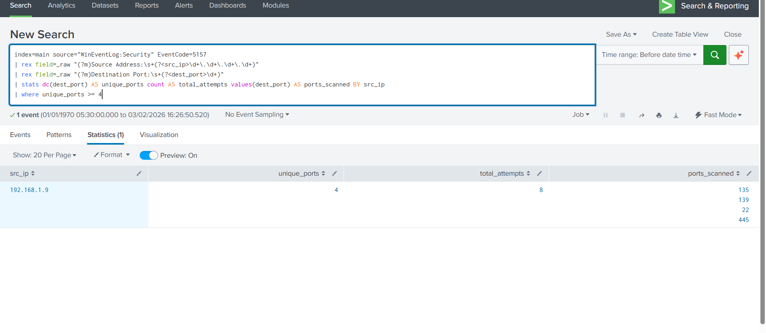

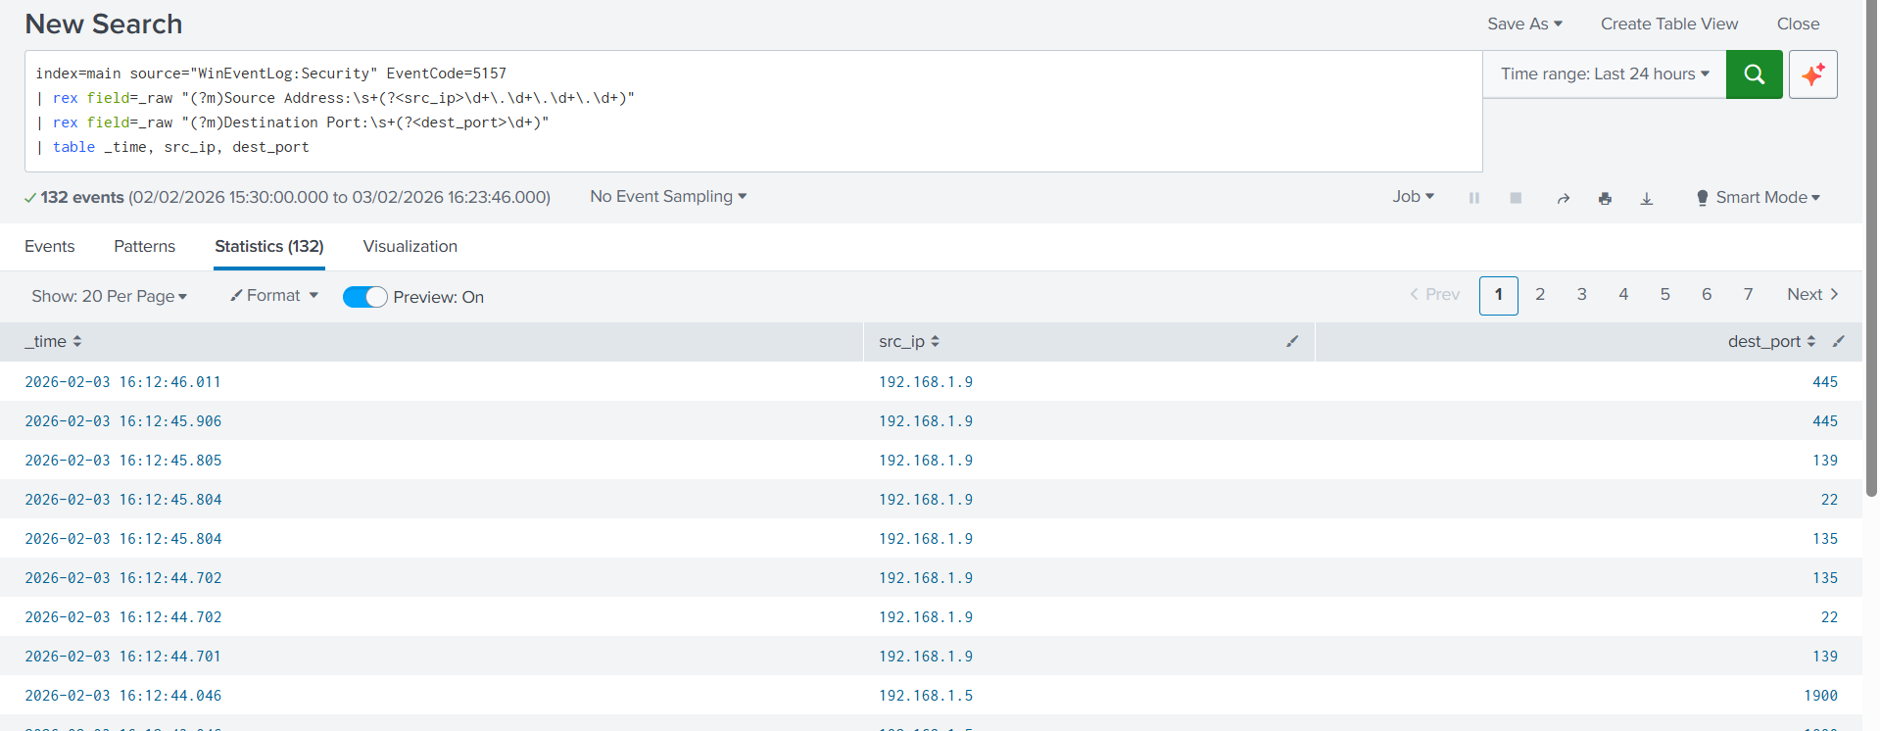

12. PRIVILEGE ESCALATION DETECTION
Linux privilege escalation attempts were detected by analyzing audit logs and sudo usage. Suspicious attempts to execute privileged commands by non-authorized users were flagged for investigation.
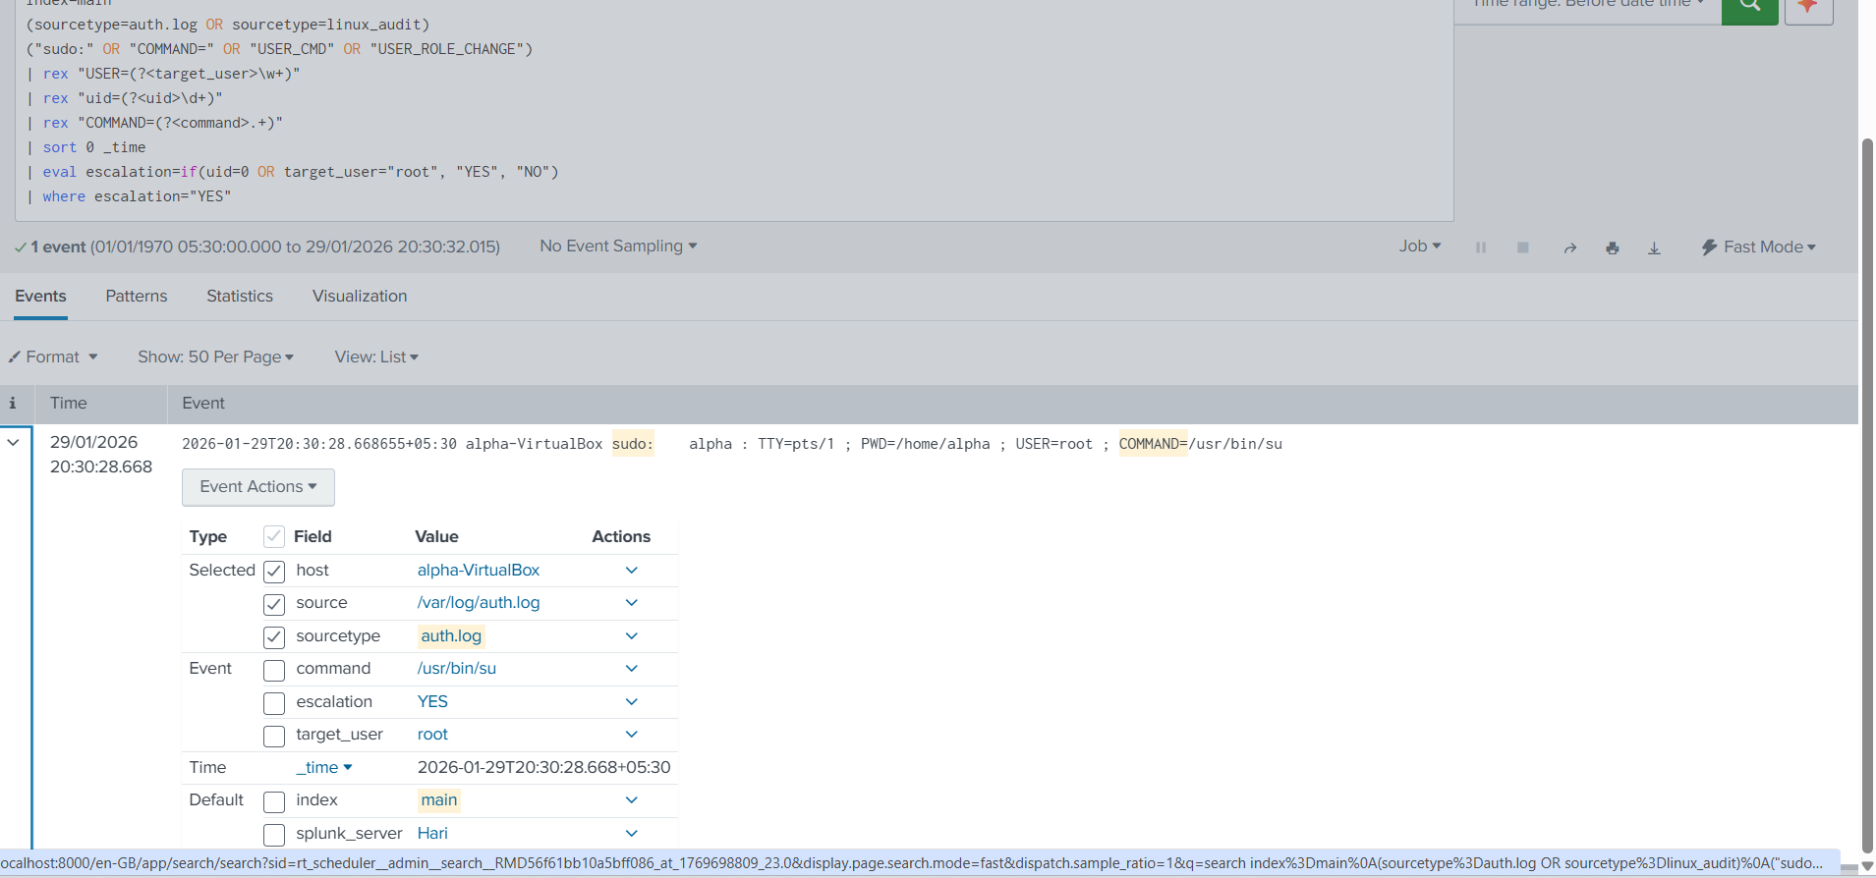
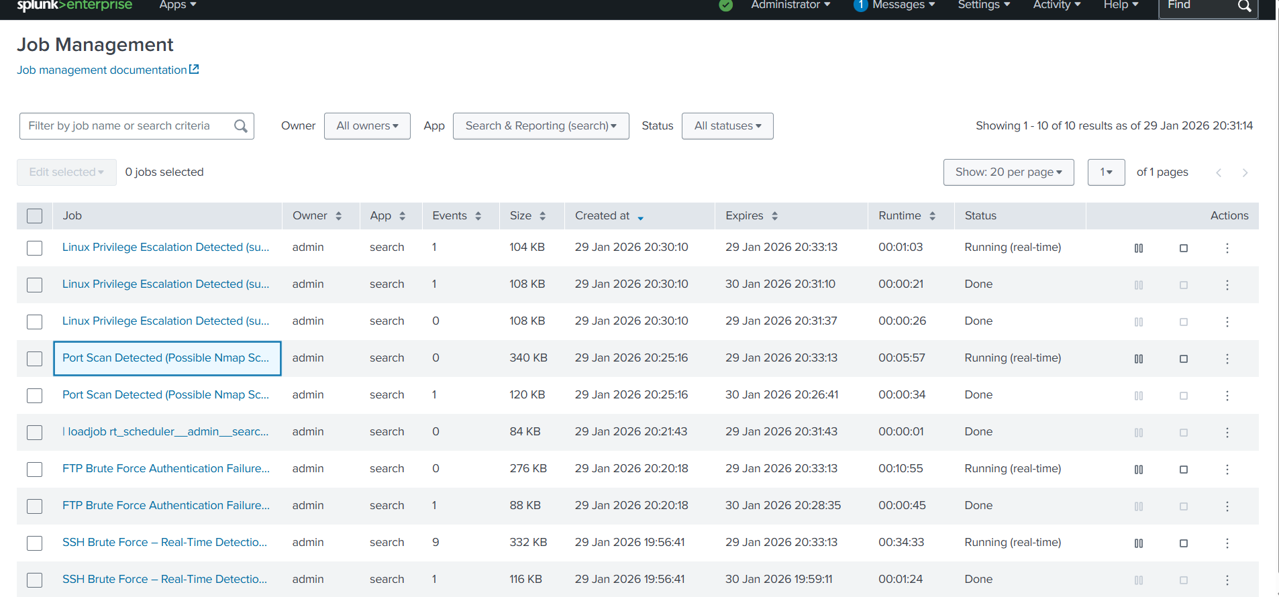

13. ALERTING AND SOC WORKFLOW
Alerts were configured in Splunk using predefined thresholds and time-based conditions to identify suspicious activities detected across Linux and Windows systems. These alerts were designed to trigger when event patterns exceeded normal behavior, such as repeated authentication failures, scanning activity, or privilege misuse.
Once an alert was triggered, it followed a standard SOC workflow that included event validation, initial investigation, and incident documentation. Analysts reviewed relevant log details, source information, and event timelines within Splunk to determine the severity and legitimacy of the alert. This workflow ensured structured incident handling, improved response efficiency, and supported continuous security monitoring operations.

14.FUTURE ENHANCEMENTS

This project can be further enhanced by implementing advanced Splunk dashboards to provide improved visual insights into security events and alert trends. Integrating external threat intelligence feeds would enable better context enrichment and more accurate threat detection.
Additional improvements include the development of correlation searches to detect complex attack chains and the automation of incident response actions using SOAR platforms. Expanding log sources to include web servers, databases, and endpoint detection tools would further strengthen the monitoring capabilities and overall security posture of the system.

15.CONCLUSION

This project successfully demonstrated the implementation of a centralized log monitoring and threat detection system using Splunk SIEM across Linux and Windows environments. By collecting, indexing, and analyzing security-relevant logs from multiple endpoints, the system provided centralized visibility into authentication activity, network behavior, and privilege usage.
Through the detection of brute-force attacks, port scanning activity, and privilege escalation attempts, the project highlighted Splunk’s effectiveness in identifying common security threats and supporting SOC monitoring workflows. The use of threshold-based alerts and structured investigation processes further emphasized the practical application of SIEM concepts.
Overall, this implementation showcases how Splunk can be effectively utilized as a SIEM solution for real-time security monitoring and incident detection, forming a strong foundation for SOC operations and future security enhancements.

