Docker build image process:

1. Docker build screenshots

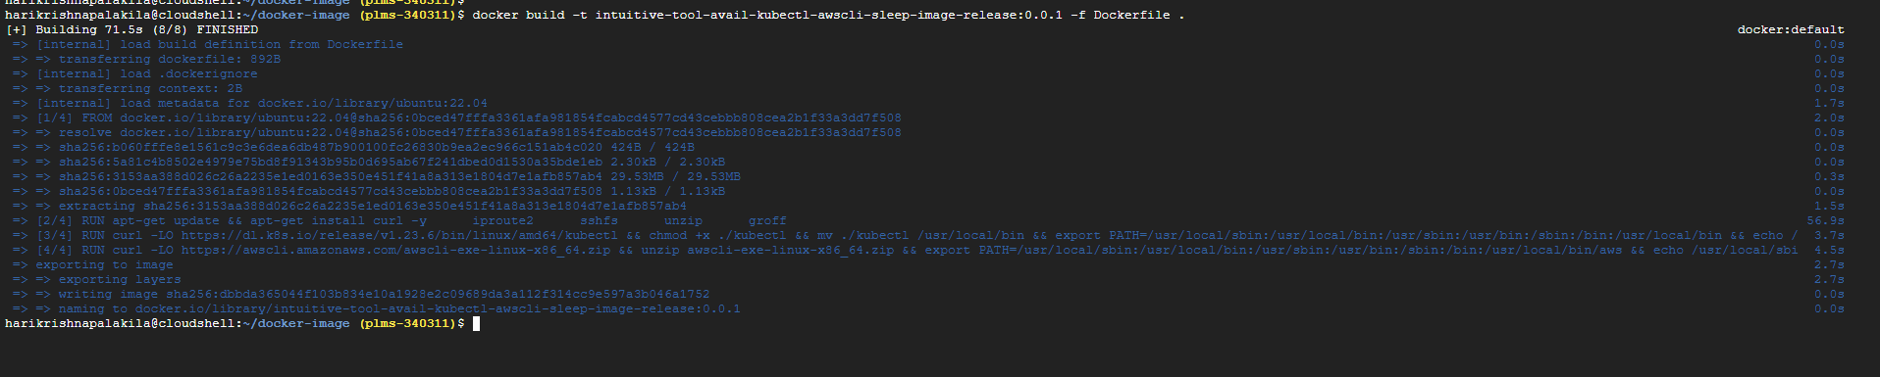

1. Tag Docker Images



1. Docker images push in DockerHUB

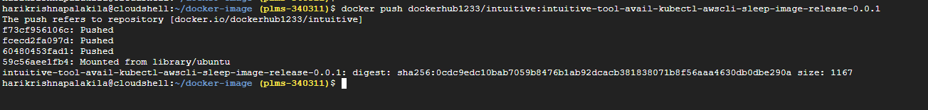

ALL Docker steps:

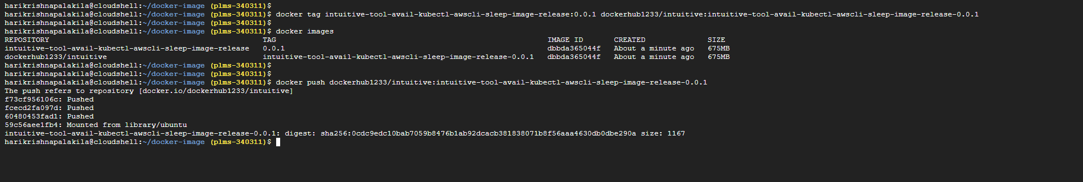

Docker Image checking in DockerHUB

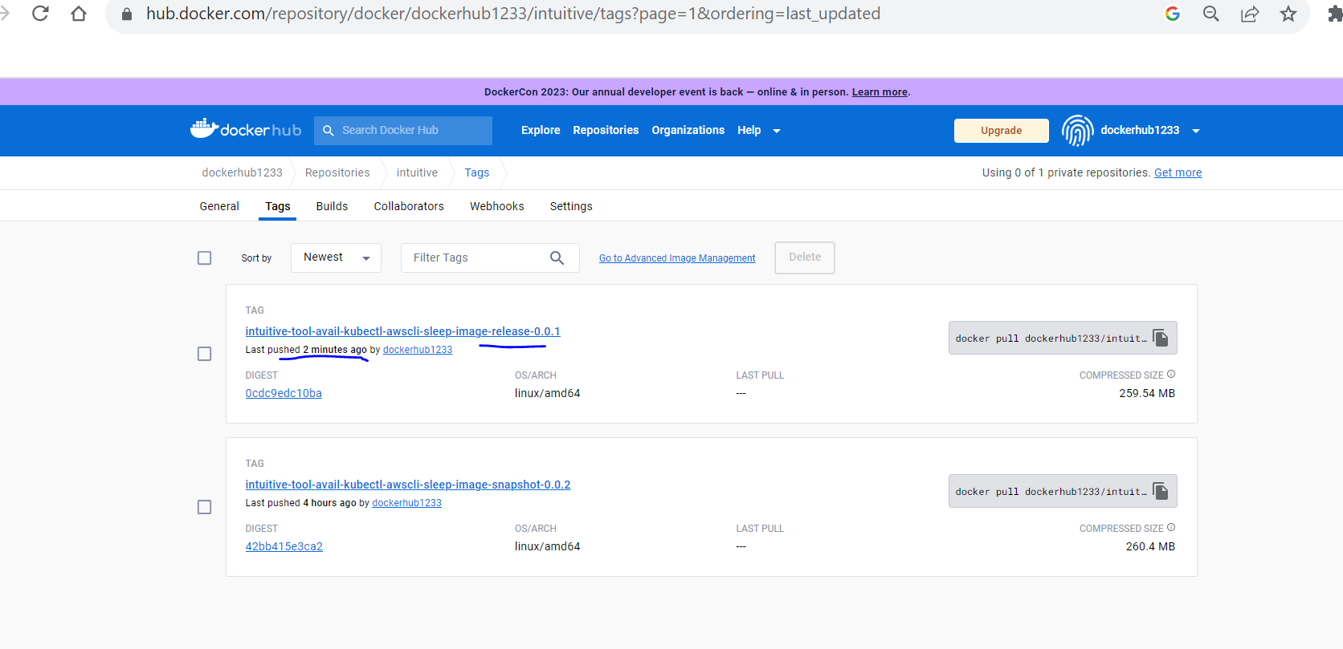

Docker Image pull command:

docker pull dockerhub1233/intuitive:intuitive-tool-avail-kubectl-awscli-sleep-image-release-0.0.1

docker pull dockerhub1233/intuitive:intuitive-tool-avail-kubectl-awscli-sleep-image-snapshot-0.0.2

**Docker Container create & start & check all containers**

**========================================================**

