Unit Test Cases:

**Scenario1:**

Getting the details of all the customers in the database.

Use the below mentioned URL to get the details:

<http://localhost:8081/api/customers>

Test Result:

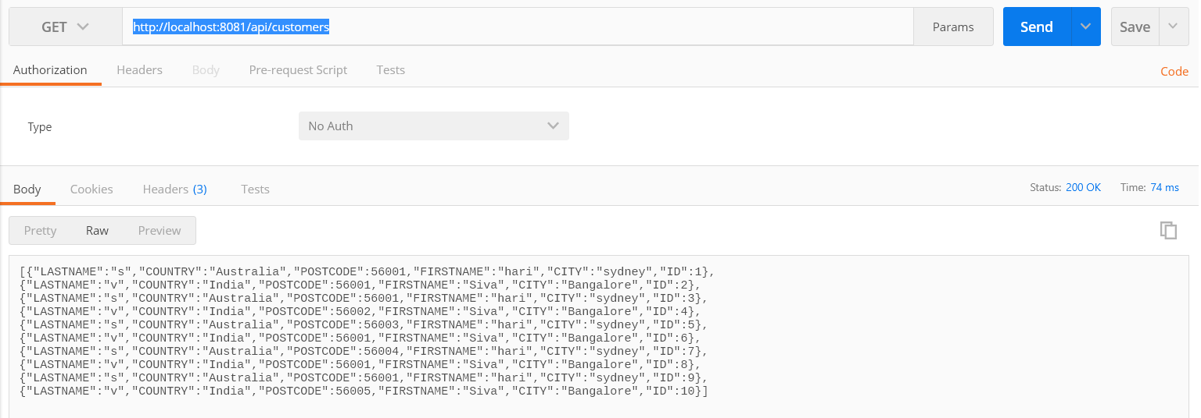

**Scenario2:**

Get the customer details based on ID

Use the below mentioned URL:

<http://localhost:8081/api/customers/8>

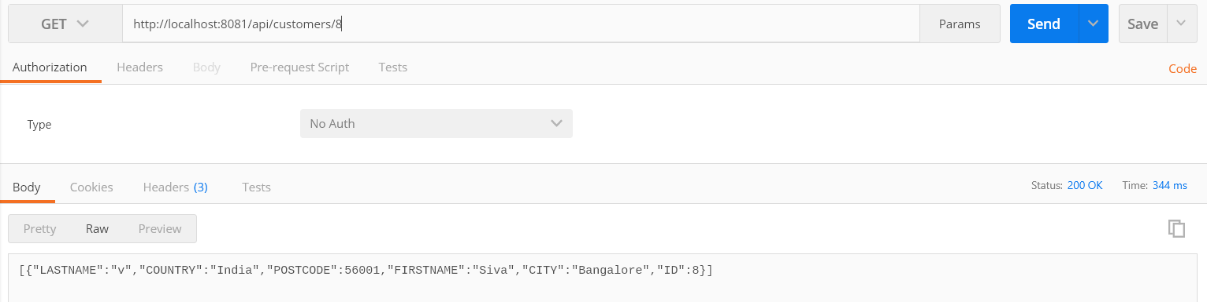

**Scenario 3:**

Get the customer details based on postcode.

Use the below mentioned url:

<http://localhost:8081/api/customers?postcode=56001>

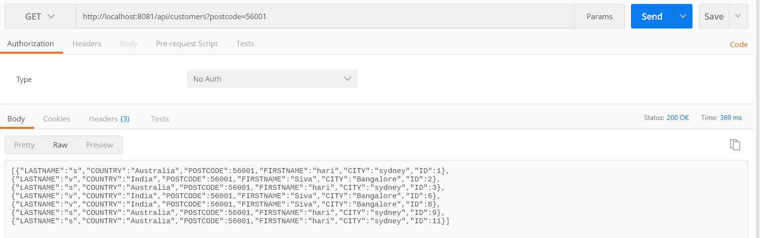

**Scenario4:**

Get the customers based on postcode using offset and limit values of pagination:

<http://localhost:8081/api/customers?offset=1&limit=5&postcode=56001>

Result:

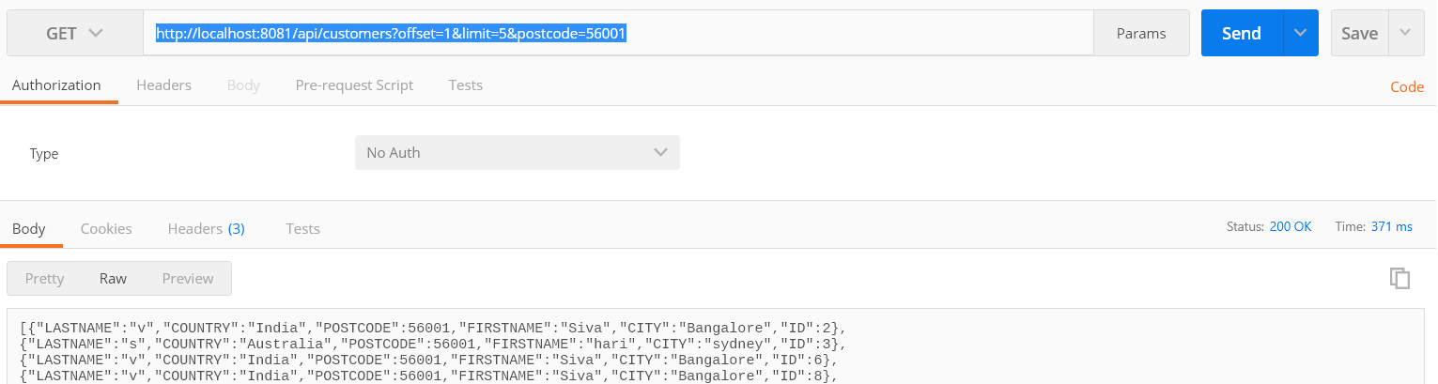

**Scenario 5:**

Getting the details of customers and usage of bypass cache.

<http://localhost:8081/api/customers?offset=3&limit=8&bypasscache=true>

If the bypasscache is true then it wil hit the Database..Please find the attached screen shot of console log for the same.

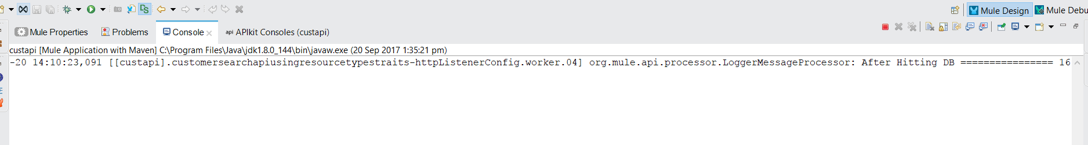

**Scenario 6:**

Getting the details of customers and usage of bypass cache .

<http://localhost:8081/api/customers?offset=3&limit=8&bypasscache=false>

No log will be written in console.

**MUNIT TESTING:**

Munit test cases were written to test the below mentioned scenarios:

**Scenario1:**

To get the details of the customers with the a valid ID. Below mentioned unit test cases executes the same.

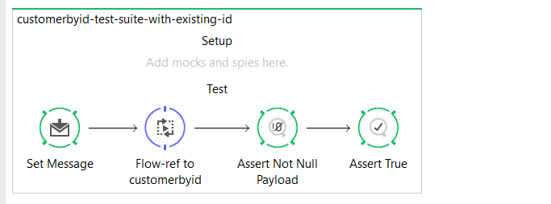

**Scenario2:**

When we try to get the details of customer who is not there in the database.

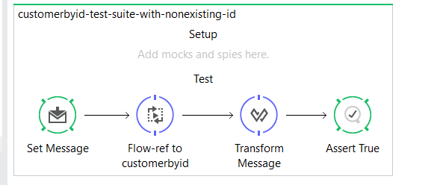

**Scenario3:**

**To verify the offset and limit parameters -Pagination**

