1. Charter Schools perform better than District schools. All top performing schools are Charter schools, all bottom performing schools are district schools.

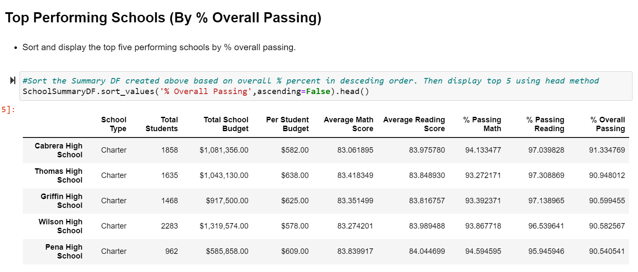

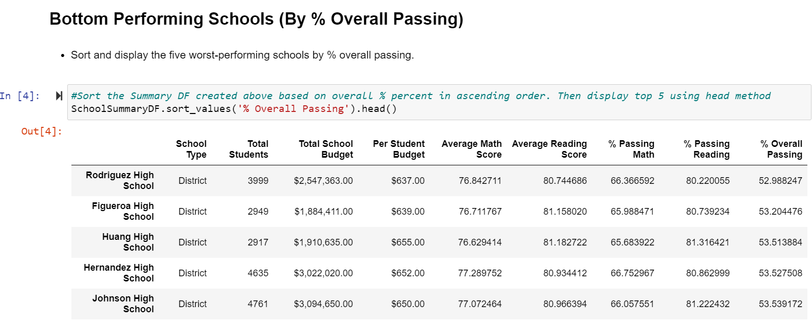

1. Higher Spend per Student does not transform into better performance. As schools with lesser budget have performed better than the schools with high spend.

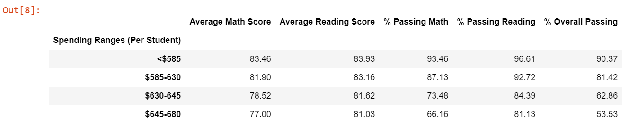

1. Small and Medium schools perform better than larger schools. Charter schools which perform better than district schools, have less students. So, looks like School size has impact on performance i.e. smaller and medium size schools perform better.

