JAVASCRIPTS:

Javascript is programming language is used for web development main purpose client side validation no need to go to server and develop interactive pages

If jscript is disabled in browser it wont work each browser have jscript engine

Chrome—v8

Mozilla –spidermonkey

We can use javascript without browser using node and jscript engine is embedded in c++ program which has vue engine that belong to google is called node

Ecma script is set of rules idha based panni javascript atha follow pannuthu

JAVASCRIPT PRACTICAL:

Javacscript can be written in under head and body

Feb – 8

Javascript can be written in head body and also write in external script

Diff bet head and body:

Things in the body tag are the things that should be displayed: the actual content. Javascript in the body is executed as it is read and as the page is rendered. **Javascript in the head is interpreted before anything is rendered --- check how webpage rendered**

**Page Rendering:**

Rendering is a process used in web development that **turns website code into the interactive pages** users see when they visit a website. The term generally refers to the use of HTML, CSS, and JavaScript codes. The process is completed by a rendering engine, the software used by a web browser to render a web page.

**External javascript :**

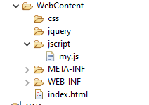



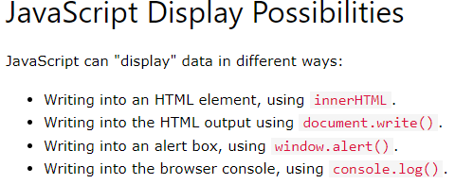

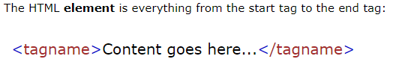

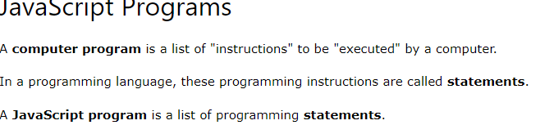

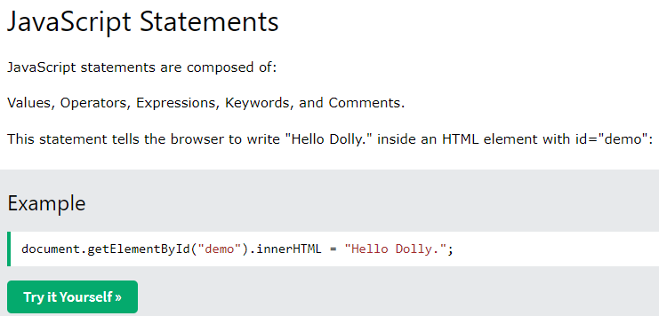

Most JavaScript programs contain many JavaScript statements.

The statements are executed, one by one, in the same order as they are written.

Semicolons same as java

Ignores whitespace

Line length and line break a =

Hari 🡪 if single line is not enough we can it break eg

Javascript code block are statements that are close in braces

Javascript keywords

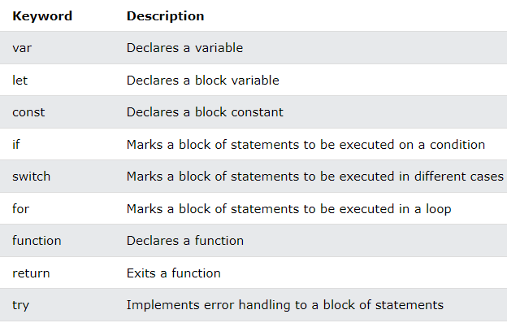

JavaScript keywords are reserved words. Reserved words cannot be used as names for variables.

Javascript comments

Singleline -- //hari

Multiline -- Multi-line comments start with /* and end with */.

VARIABLES:

Variables are containers for storing values.

Var,let,const

Let – if value is changing

Const – value doesn’t change

Var – all purpose old version until 2015

Eg:

Var = 10;// any thing

Const =20;//const value

Let = var_const; // values changing

DATA TYPES:

Dynamic,strings,Boolean,number

JavaScript Types are Dynamic

let x;           // Now x is undefined  
x = 5;           // Now x is a Number  
x = "John";

## JavaScript Strings

let carName1 = "Volvo XC60";   // Using double quotes  
let carName2 = 'Volvo XC60';   // Using single quotes

let answer1 = "It's alright";

## JavaScript Numbers

let x1 = 34.00;     // Written with decimals  
let x2 = 34;

BOOLeans has only two values

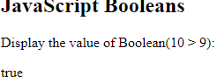

OPERATORS:

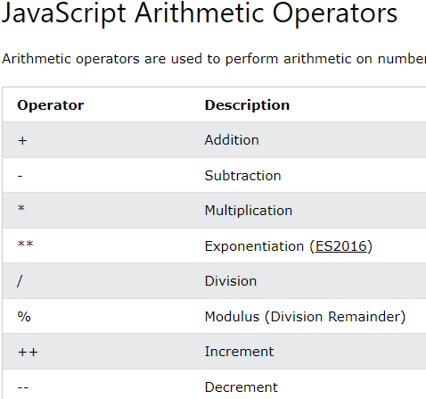

CONDITIONAL STATEMENTS:

IF ELSE:

If

If else

If else if

Switch – case,default

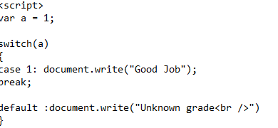

While loops:

The purpose of a **while** loop is to execute a statement or code block repeatedly as long as an **expression** is true

<script>

var count = 0;

document.write("Starting Loop ");

while (count < 10) {

document.write("Current Count : " + count + "<br />");

count++;

}

document.write("Loop stopped!");

</script>

For loops

var count;

document.write("Starting Loop" + "<br />");

for(count = 0; count < 10; count++) {

document.write("Current Count : " + count );

document.write("<br />");

}

document.write("Loop stopped!")

For in:

he **for...in** loop is used to loop through an object's properties\

Break:

var x = 1;

document.write("Entering the loop<br /> ");

while (x < 20) {

if (x == 5) {

break; // breaks out of loop completely

}

x = x + 1;

document.write( x + "<br />");

}

document.write("Exiting the loop!<br /> ");