JAVA INTERVIEW QUESTIONS
Explain hashmap internal working ?
"HashMap stores key-value pairs internally using a bucket array. When we call put(), HashMap first calculates the key's hashCode() and performs hash spreading.
hash = key.hashCode() ^ (key.hashCode() >>> 16);
So high bits + low bits mix pannitu better bucket distribution achieve panna try pannum.

It then calculates the bucket index using the hash and the current table capacity.
Then hash-ai use panni array-la which bucket nu determine pannum.
Modern Java implementation-la roughly:
index = (n - 1) & hash;
where:
n = bucket array length
Example:
array length = 16
hash = 25

index = (16 - 1) & 25
= 15 & 25
= 9
So "John" bucket 9-la pogum.

If the bucket is empty, it stores a node there. If another key already exists in the same bucket, that's a collision, so HashMap compares the hash and then uses equals() to identify the exact key. If the key already exists, its value is replaced. Otherwise a new node is added.
Same hash ↓ equals() ↓ true → SAME KEY → replace value false → DIFFERENT KEY → add new entry
Same index/bucket
↓
HashCode same?
↓ ↓
YES NO
↓ ↓
equals() New/different key
↓
true → existing value replace
false → next node check
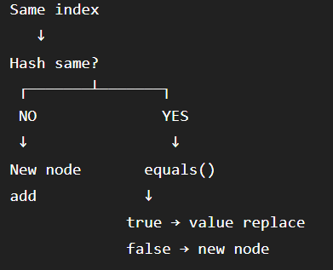
In modern Java, if a bucket becomes heavily populated, the linked structure can be converted into a Red-Black Tree. HashMap also maintains a load factor, default 0.75, and when the threshold is exceeded, it resizes the table, normally doubling its capacity."
What if two keys go to same bucket?
Both keys same bucket.
HashMap handles this using a linked structure, and in modern Java, when collisions become high, it can convert the bucket into a Red-Black Tree.
Initially:
Bucket 5
|
v
[John,100] → [David,200] → [Alex,300]
After treeification:
[David]
/ \
[Alex] [John]
What changed in Java 8?
Java 8 introduced treeification in HashMap.
- Earlier, collisions were handled using a linked list.
- Java 8 can convert a heavily-collided bucket into a Red-Black Tree.
- When bucket entries reach 8, treeification can happen.
- But table capacity should be at least 64; otherwise HashMap prefers resizing first.
2. Why treeification threshold is 8?
Because under a reasonably good hash function, having 8 or more entries in the same bucket is extremely unlikely.
This was chosen based on the Poisson distribution analysis of collision probability.
Simple interview answer:
"The threshold of 8 was chosen because, with a good hash distribution, having 8 entries in a single bucket is statistically very rare. So when it happens, converting the bucket to a Red-Black Tree helps protect performance."
If you override equals() but don't override hashCode(), the problem is:
equals() → says objects are equal
hashCode() → may give different hash values
Example:
a.equals(b) → true
a.hashCode() → 100
b.hashCode() → 200
HashMap first uses hashCode to find the bucket. Since hashes are different:
a → Bucket 4
b → Bucket 8
So HashMap may never reach the point where it can use equals() to identify them as the same key.
Objects "disappear" from HashMap — why?
Usually this happens when a mutable key is modified after insertion.
Example:
map.put(employee, "John");
Suppose initially:
employee.id = 101
hashCode → 500
bucket → 5
Later:
employee.id = 202;
Now:
hashCode → 800
bucket → 8
But the entry is still physically stored in bucket 5.
When you do:
map.get(employee);
HashMap calculates the new hash and searches bucket 8, but the entry is sitting in bucket 5.
So it looks like the object "disappeared."
Interview answer:
"If a mutable key is modified after being inserted, its hashCode can change. HashMap then searches a different bucket during lookup, while the entry remains in the old bucket, making it appear to disappear."
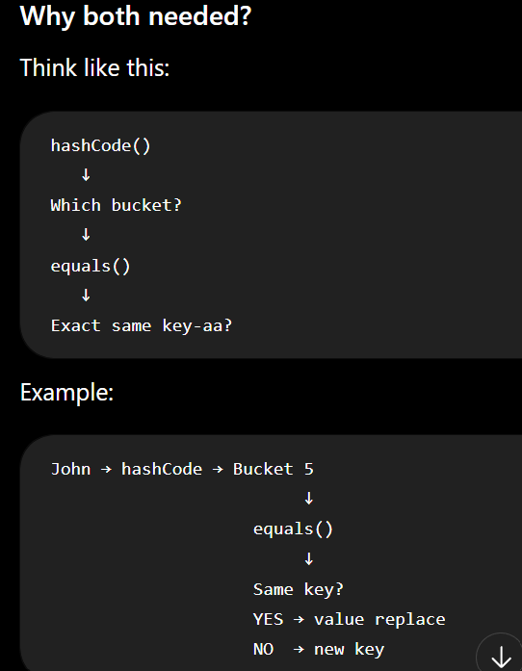
Follow Up Questions
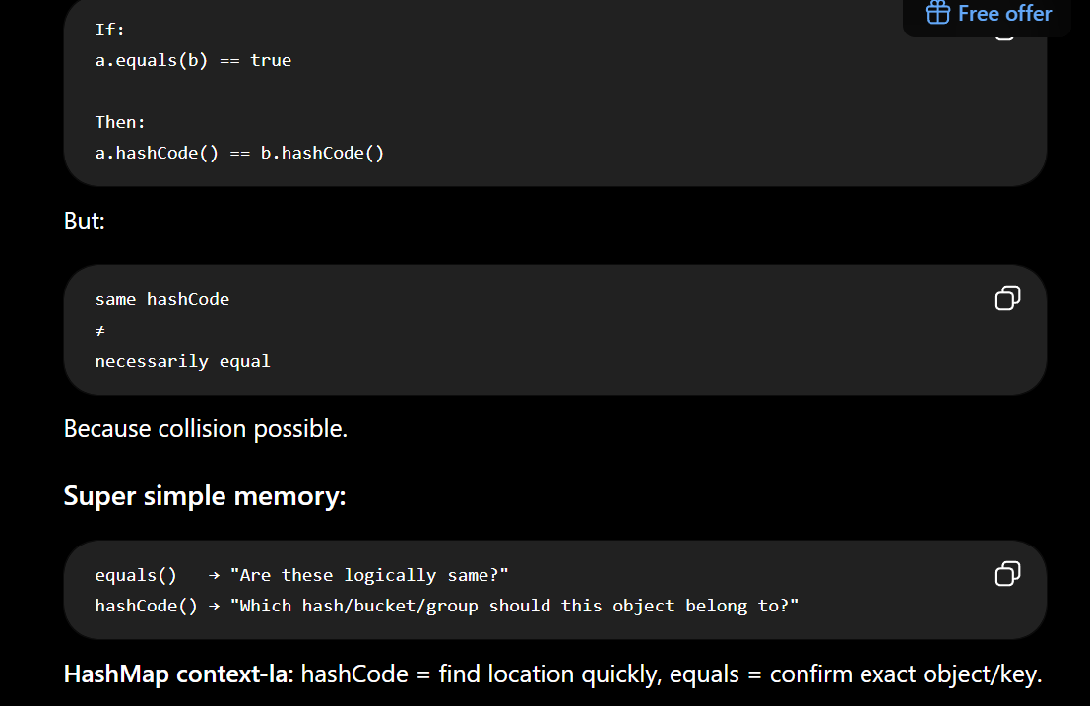
HashMap internal working
↓
What is collision?
↓
How collision handled?
↓
Why Red-Black Tree?
↓
What is treeify threshold?
↓
What is load factor?
↓
Why 0.75?
↓
When resize happens?
↓
What is default capacity?
↓
Why power of 2?
↓
Why (n-1) & hash?
↓
hashCode vs equals?
↓
Why immutable key?
↓
What if hashCode changes?
↓
HashMap vs ConcurrentHashMap?
↓
HashMap vs Hashtable?

